1. Installing docker in ec2 instance:

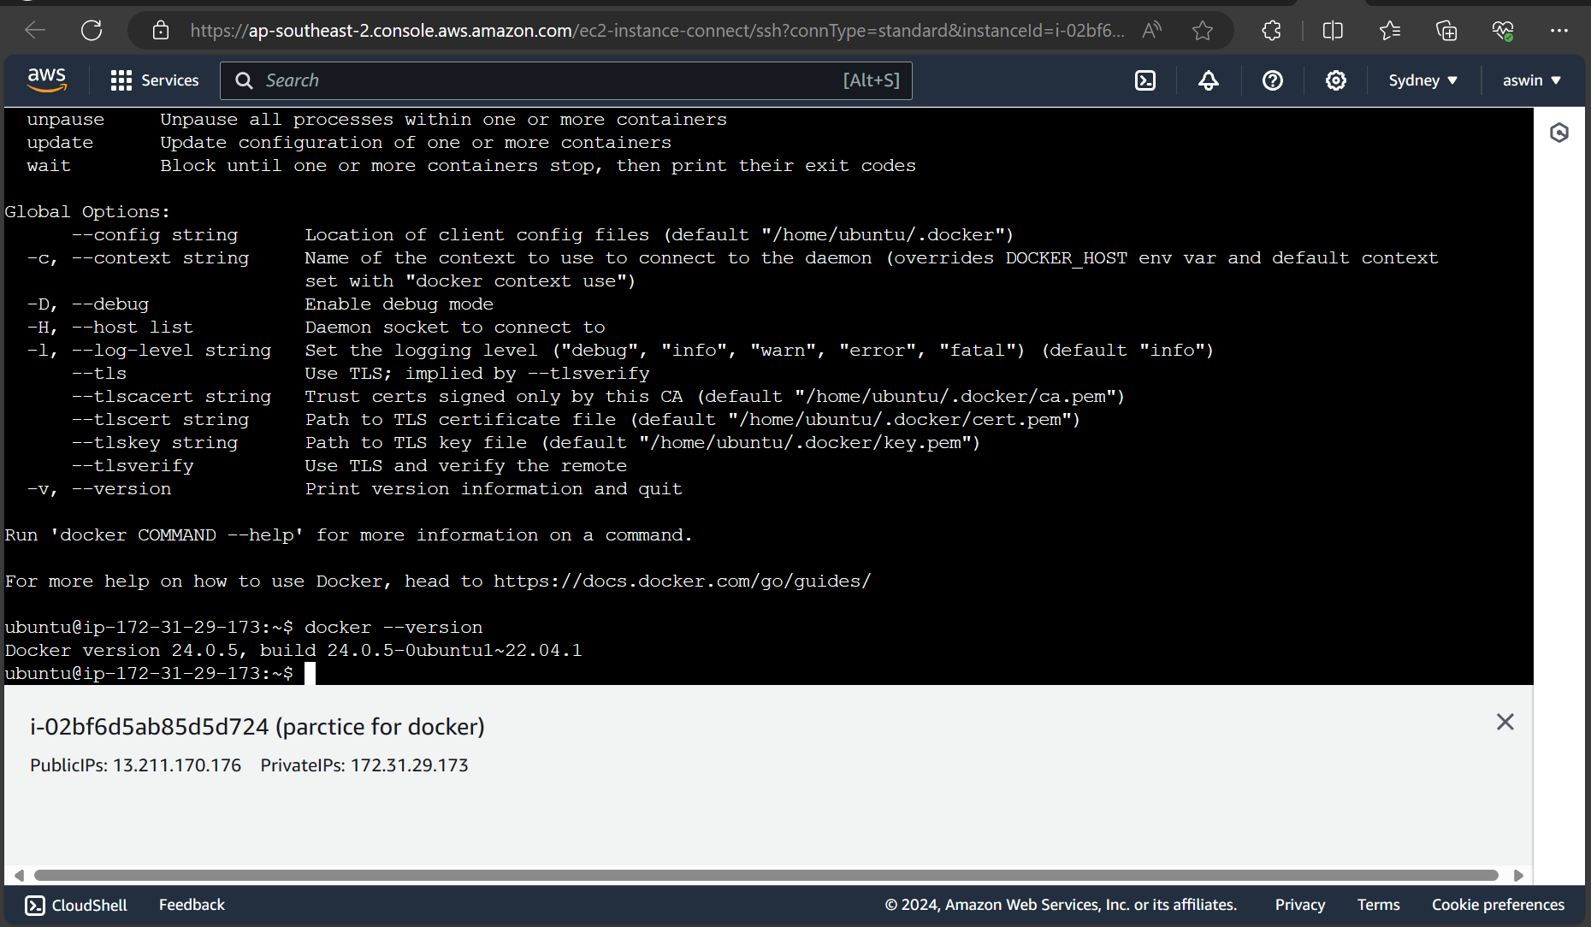

2. docker info -> command to know about the information docker installed

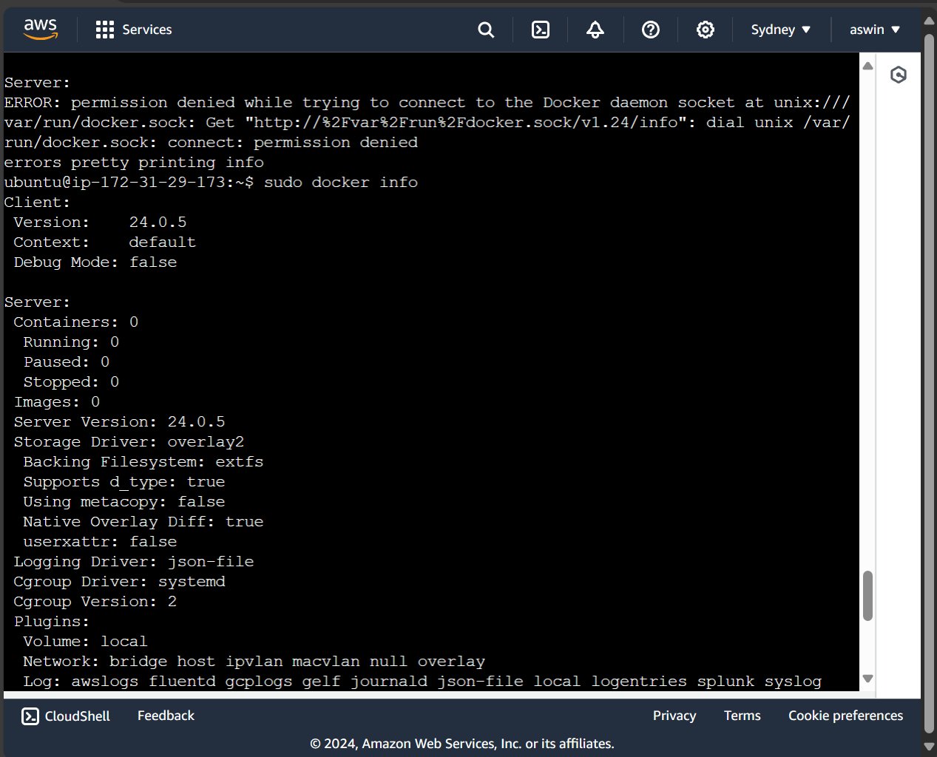

3.docker run (for run starts the container)

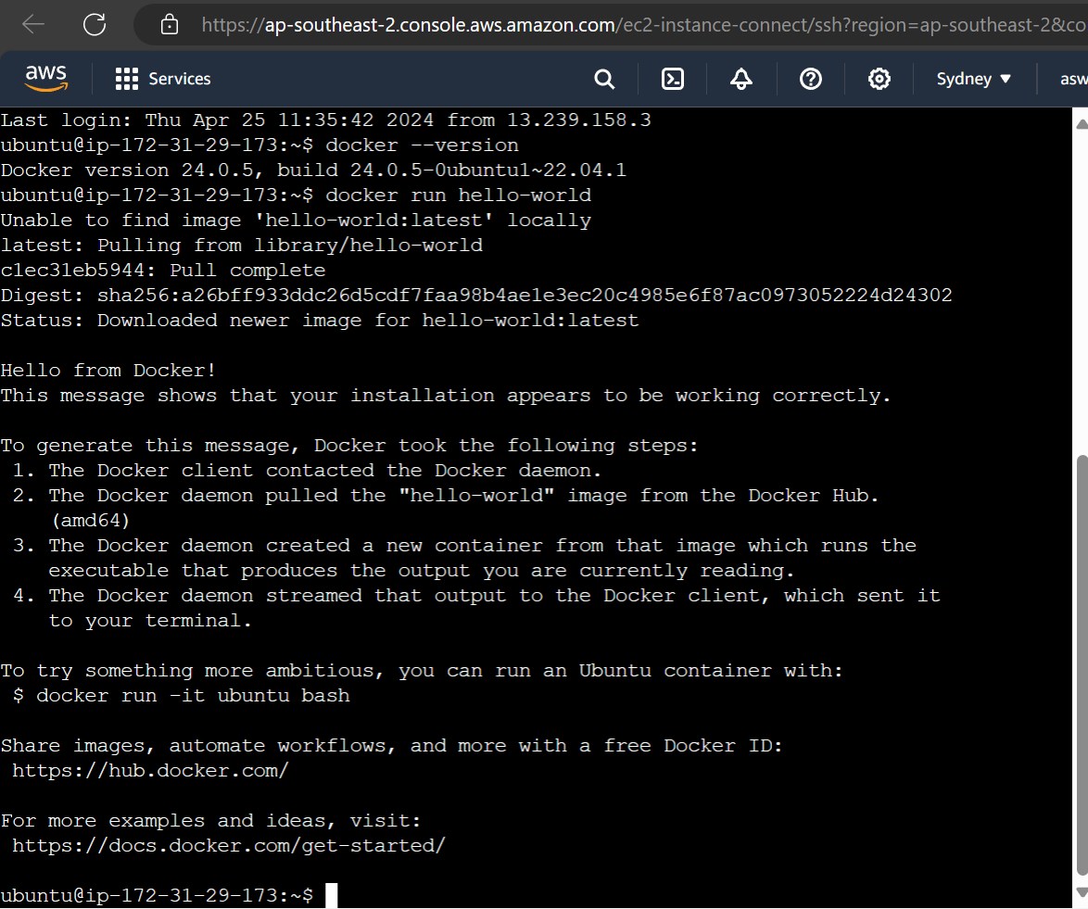

4.docker ps and docker ps -a ( used to view the running and stopped containers)

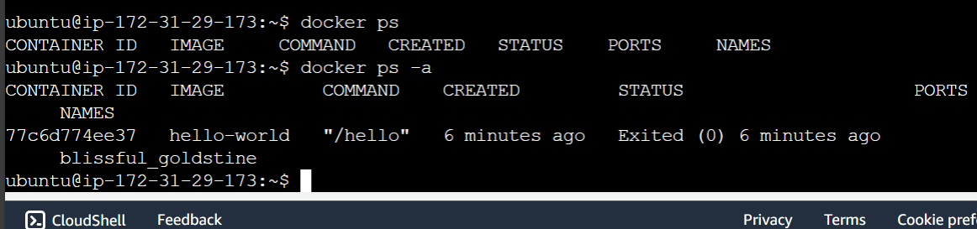

5. docker pull (pull the image from docker hub)

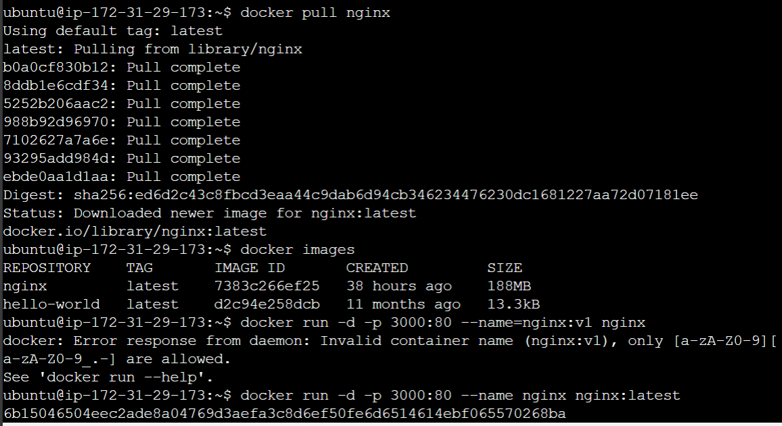

6. docker stop(stop the running container)

7. docker rm (remove stopped conatiner)

8. docker rmi (remove stopped containers images)

