1. Created index.html file and dockerfile



1. Create sample user details for website

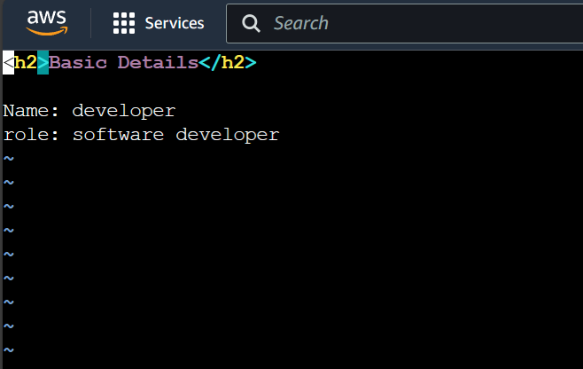

1. Creating dockerfile with commands

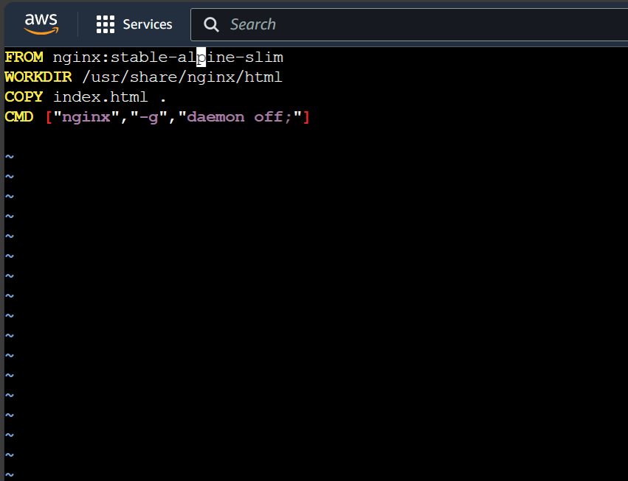

1. Building image using dockerfile

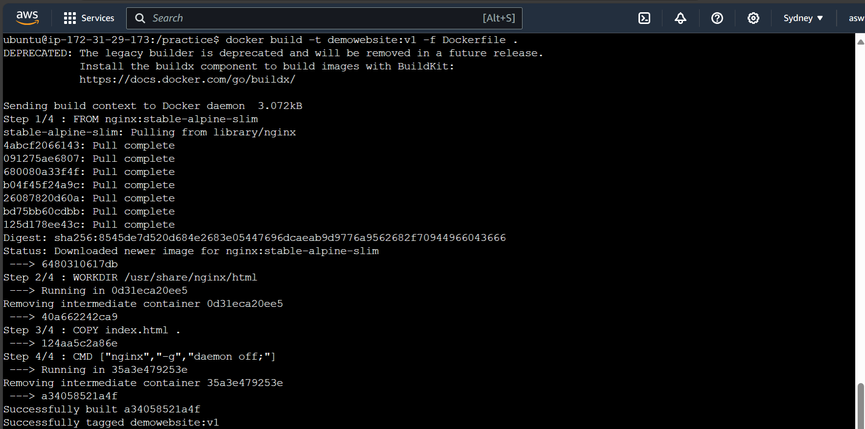

1. Starts the container

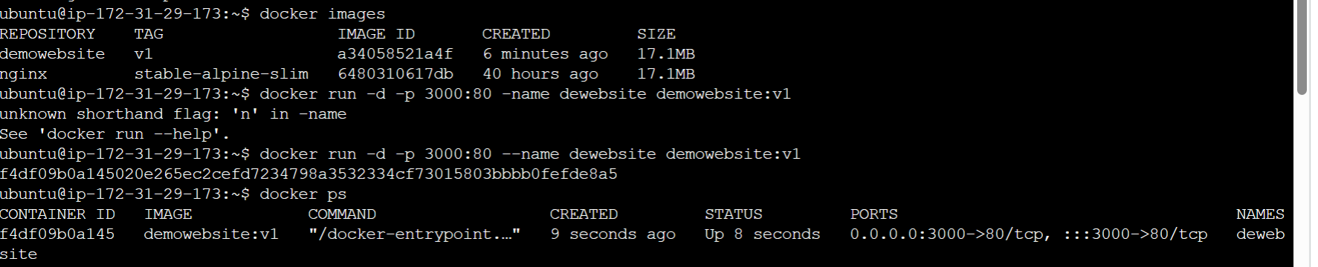

1. Output

