1. Creating dockerfile

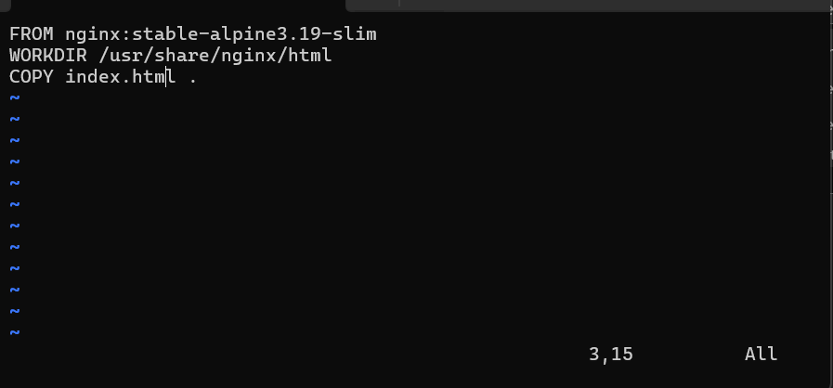

1. Building docker image

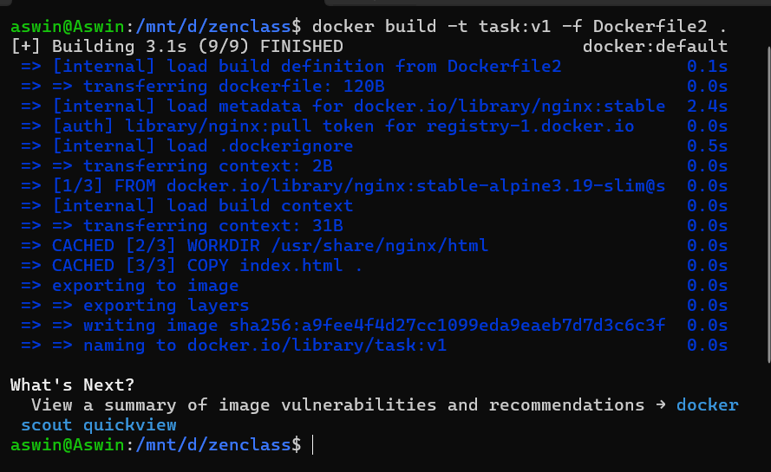

1. Creating docker-compose file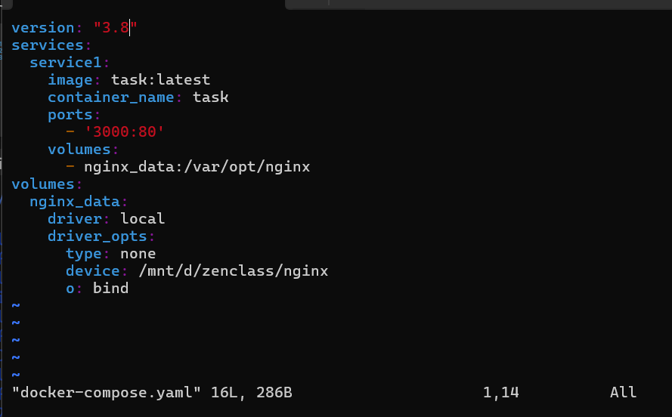se file

1. Exec docker-compose up

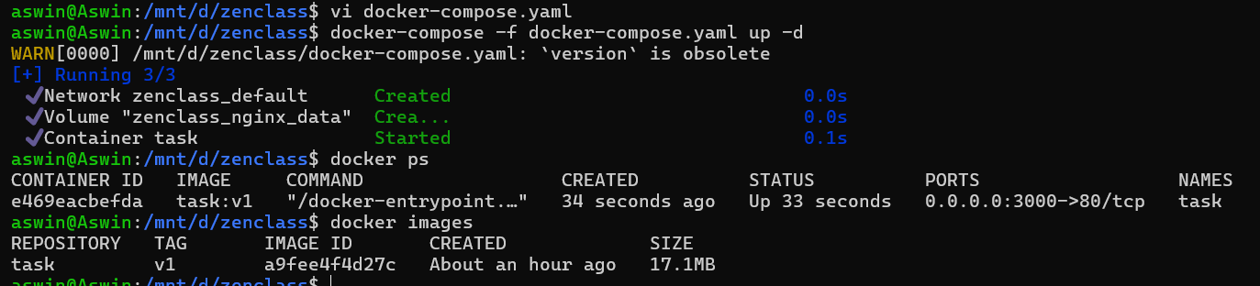

1. Checking volume path

