

ANJALAI AMMAL MAHALINGAM ENGINEERING COLLEGE KOVILVENNI – 614403 THIRUVARUR DT ENTREPRENEURSHIP DEVELOPMENT CELL
DEPARTMENT OF ELECTRONICS AND COMMUNICATION ENGINEERING

MINI PROJECT REPORT

Image Processing Based Fire
Detection

SUBMITTED BY:
Submitted to:
Dr.Sathya Bharathi
Dept of ECE

Lakshmi Narayanan B
Aswin Saranraj R S
Abishek R
Akash E

Abstract:
The aim of this project is to design and develop an intelligent fire detection system using ESP32-CAM and deep learning techniques. The system captures real-time video using the camera module and transmits it through WiFi to a computer.
The video is processed using Python with YOLOv8 algorithm to detect fire in real time. If fire is detected, the system highlights the detected region and can trigger alerts.
This system provides a low-cost and efficient solution for early fire detection.

Objectives:
The primary objective of this project is to design and develop an intelligent fire detection system using the ESP32-CAM integrated with deep learning techniques. The system aims to utilize real-time video captured by the camera module and process it using computer vision algorithms to accurately identify fire at an early stage. Unlike traditional sensor-based systems, this project focuses on visual detection, which improves the speed and reliability of fire identification.
Another important objective is to integrate the ESP32-CAM with a computer-based processing system using WiFi communication. The captured video stream is transmitted wirelessly and analyzed using Python along with image processing libraries such as OpenCV. This ensures that the system can operate remotely without requiring complex wiring, making it suitable for real-world applications.
The project also aims to implement a powerful object detection model using the YOLOv8 algorithm. This model is trained to recognize fire patterns and provide accurate detection results in real time. By using deep learning, the system reduces false alarms and increases detection accuracy compared to conventional methods.
In addition, the system is designed to provide immediate visual feedback by drawing bounding boxes around detected fire regions and displaying confidence levels. This helps users easily identify the presence of fire in the monitored area. The project can also be extended to trigger alerts or safety mechanisms, such as alarms or water sprinklers, making it a complete smart fire detection solution.
Finally, the objective of this project is to develop a low-cost, efficient, and scalable fire detection system that can be used in various environments such as homes, industries, and public spaces. The system demonstrates the practical application of IoT and artificial intelligence in improving safety and reducing fire-related risks.
Apparatus Required:
The apparatus required for this project includes both hardware and basic interfacing components necessary to implement the AI-based fire detection system. The primary hardware component used is the ESP32-CAM, which is a compact and cost-effective microcontroller integrated with a camera module. It is responsible for capturing real-time images or video and transmitting the data over a WiFi network. This module plays a crucial role as the input device of the system.
To simplify programming and power supply, the ESP32-CAM-MB is used. This base module allows the ESP32-CAM to be directly connected to a computer via USB, eliminating the need for external FTDI programmers or complex wiring. It ensures stable power delivery and easy uploading of code to the ESP32-CAM.
A standard USB cable is required to connect the ESP32-CAM-MB to the computer. This cable is used for both power supply and serial communication during programming. A computer or laptop is also an essential apparatus, as it is used to run the fire detection algorithm and process the video stream received from the ESP32-CAM. The system relies on this computing device to execute the deep learning model and display the detection results.
Additionally, a stable WiFi network is required for communication between the ESP32-CAM and the computer. The ESP32-CAM connects to the WiFi network and streams video data, which is then accessed by the Python program. Without a proper network connection, real-time data transmission would not be possible.
Overall, these apparatus components work together to form a complete system where image capture, data transmission, and fire detection processing are efficiently carried out.

Components Required:
Hardware Components:
- ESP32-CAM
- ESP32-CAM-MB
- USB Cable
- Computer / Laptop
- WiFi Network

Software Components:
- Arduino IDE
- PyCharm
- Python
- OpenCV
- Ultralytics YOLO

Pin Connections:
The ESP32-CAM module is interfaced with the ESP32-CAM-MB for easy programming and power supply. The ESP32-CAM is directly mounted onto the MB module, which eliminates the need for external wiring.

ESP32-CAM to ESP32-CAM-MB Connections
The connections between the ESP32-CAM and ESP32-CAM-MB are internally handled when the module is inserted into the base board. The important pin mappings are as follows:

ESP32-CAM Pin | ESP32-CAM-MB Connection | Function
5V | 5V | Power Supply
GND | GND | Ground
U0R (RX) | TX | Serial Communication
U0T (TX) | RX | Serial Communication
The ESP32-CAM-MB acts as a USB-to-Serial converter, enabling direct *communication between the ESP32-CAM and the computer.

Working Connection Summary
- ESP32-CAM is powered through ESP32-CAM-MB
- USB cable connects MB module to computer
- WiFi is used for communication between ESP32-CAM and Python system
- No external wiring is required for basic operation

Theory:
Fire detection using computer vision is an advanced approach that utilizes image processing and artificial intelligence techniques to identify fire in real-time. Traditional fire detection systems mainly depend on smoke sensors, heat

detectors, or gas sensors. These systems often suffer from delayed response, false alarms, and limited coverage. To overcome these limitations, camera-based fire detection systems are increasingly being used.
In this project, a smart fire detection system is developed using the ESP32-CAM and deep learning algorithms. The ESP32-CAM is a compact microcontroller with an integrated camera module that supports WiFi connectivity. It captures real-time images or video and transmits them wirelessly to a computer or processing unit. This eliminates the need for complex wired connections and allows remote monitoring.
The captured video stream is processed using Python, which is widely used for developing artificial intelligence and computer vision applications. The OpenCV library is used for handling image and video operations such as capturing frames, resizing images, and displaying output. OpenCV acts as an interface between the camera stream and the deep learning model.
The core of the fire detection system is the YOLOv8 (You Only Look Once) algorithm. YOLO is a state-of-the-art object detection model that is capable of detecting objects in real time with high accuracy. Unlike traditional methods that process images in multiple stages, YOLO processes the entire image in a single pass, making it extremely fast and efficient.
The YOLO algorithm divides an image into a grid and predicts bounding boxes along with confidence scores for each region. If fire is present in the image, the model identifies it and draws a bounding box around the detected area. It also assigns a confidence value indicating the probability of fire detection. This enables the system to differentiate between fire and non-fire objects effectively.
In this project, a pre-trained YOLO model is used or trained specifically to detect fire. The model is trained on datasets containing images of fire and non-fire scenarios. During execution, each frame from the ESP32-CAM video stream is passed through the YOLO model. The model analyzes the frame and detects fire if present.
The system also uses visualization techniques to display the detection results. When fire is detected, a rectangular bounding box is drawn around the detected region using OpenCV, and the confidence percentage is displayed. This provides a clear visual indication of fire presence to the user.
The integration of IoT and AI plays a key role in this system. The ESP32-CAM acts as an IoT device that captures and transmits data, while the AI model processes the data and makes intelligent decisions. This combination results in a smart and automated fire detection system.
Overall, the theory behind this project involves the integration of embedded systems, wireless communication, computer vision, and deep learning techniques to achieve real-time fire detection. This approach improves accuracy, reduces response time, and enhances safety compared to traditional fire detection systems.

Procedure / Working Principle
The working principle of the proposed fire detection system is based on the integration of IoT and artificial intelligence. The system captures real-time video using the ESP32-CAM, transmits it via WiFi, and processes it using a deep learning model to detect fire.
Step 1: Initialization
Initially, the ESP32-CAM is programmed using Arduino IDE with a camera web server code. The WiFi credentials are configured so that the module can connect to a local wireless network.

Step 2: Image Capture
Once powered on, the ESP32-CAM starts capturing live video through its onboard camera. The captured frames are continuously converted into a video stream.

Step 3: WiFi Streaming
The ESP32-CAM transmits the video stream over WiFi. Each device connected to the same network can access the stream using the IP address provided by the ESP32-CAM.
Example stream URL:
http://192.168.1.xxx:81/stream

Step 4: Video Processing
On the computer side, a Python program is executed using PyCharm. The program uses OpenCV to capture frames from the ESP32-CAM stream.
Each frame is resized and prepared for processing.

Step 5: Fire Detection using YOLO
The processed frames are passed to the YOLOv8 model. The model analyzes each frame and identifies fire regions using trained weights.
- Bounding boxes are drawn around detected fire
- Confidence percentage is calculated
- Only detections above a threshold (e.g., 50%) are considered valid

Step 6: Display Output
The final output is displayed on the screen using OpenCV:
- Live video feed
- Fire detection boxes
- Confidence values
This allows real-time monitoring of the environment.

Step 7: Alert System (Optional)
If fire is detected, the system can be extended to:
- Trigger a buzzer
- Send notifications
- Activate a water pump

Summary of Working Flow
ESP32-CAM → Capture Video → WiFi Streaming → Python (OpenCV)
→ YOLO Model → Fire Detection → Display / Alert

#include "esp_camera.h"
#include <WiFi.h>

// Select camera model
#define CAMERA_MODEL_AI_THINKER
#include "camera_pins.h"

// WiFi credentials
const char* ssid = "YOUR_WIFI_NAME";
const char* password = "YOUR_WIFI_PASSWORD";

void startCameraServer();

void setup() {
Serial.begin(115200);
Serial.setDebugOutput(true);
Serial.println();

camera_config_t config;
config.ledc_channel = LEDC_CHANNEL_0;
config.ledc_timer = LEDC_TIMER_0;
config.pin_d0 = Y2_GPIO_NUM;
config.pin_d1 = Y3_GPIO_NUM;
config.pin_d2 = Y4_GPIO_NUM;
config.pin_d3 = Y5_GPIO_NUM;
config.pin_d4 = Y6_GPIO_NUM;
config.pin_d5 = Y7_GPIO_NUM;
config.pin_d6 = Y8_GPIO_NUM;
config.pin_d7 = Y9_GPIO_NUM;
config.pin_xclk = XCLK_GPIO_NUM;
config.pin_pclk = PCLK_GPIO_NUM;
config.pin_vsync = VSYNC_GPIO_NUM;
config.pin_href = HREF_GPIO_NUM;
config.pin_sscb_sda = SIOD_GPIO_NUM;
config.pin_sscb_scl = SIOC_GPIO_NUM;
config.pin_pwdn = PWDN_GPIO_NUM;
config.pin_reset = RESET_GPIO_NUM;
config.xclk_freq_hz = 20000000;
config.pixel_format = PIXFORMAT_JPEG;

if(psramFound()){
config.frame_size = FRAMESIZE_VGA;
config.jpeg_quality = 10;
config.fb_count = 2;
} else {
config.frame_size = FRAMESIZE_CIF;
config.jpeg_quality = 12;
config.fb_count = 1;
}

// Init camera
esp_err_t err = esp_camera_init(&config);
if (err != ESP_OK) {
Serial.printf("Camera init failed with error 0x%x", err);
return;
}

// Connect WiFi
WiFi.begin(ssid, password);
WiFi.setSleep(false);

while (WiFi.status() != WL_CONNECTED) {
delay(500);
Serial.print(".");
}

Serial.println("");
Serial.println("WiFi connected");

startCameraServer();

Serial.print("Camera Ready! Use 'http://");
Serial.print(WiFi.localIP());
Serial.println("' to connect");
}

void loop() {
delay(10000);
}

Python Code for Fire Detection (PyCharm):
from ultralytics import YOLO
import cv2
import cvzone
import math

# ESP32-CAM stream URL
url = "http://192.168.1.45:81/stream" # change this to your IP

cap = cv2.VideoCapture(url)

# Load YOLO fire detection model
model = YOLO("fire.pt")

classnames = ['fire']

while True:
success, frame = cap.read()

if not success:
print("Camera not connected")
break

frame = cv2.resize(frame, (640, 480))

results = model(frame, stream=True)

for r in results:
boxes = r.boxes

for box in boxes:
confidence = math.ceil(box.conf[0] * 100)
cls = int(box.cls[0])

if confidence > 50:
x1, y1, x2, y2 = box.xyxy[0]
x1, y1, x2, y2 = int(x1), int(y1), int(x2), int(y2)

# Draw rectangle
cv2.rectangle(frame, (x1, y1), (x2, y2), (0, 0, 255), 3)

# Display label
cvzone.putTextRect(
frame,
f'{classnames[cls]} {confidence}%',
[x1 + 8, y1 + 50],
scale=1,
thickness=2
)

cv2.imshow("Fire Detection", frame)

# Press 'q' to exit
if cv2.waitKey(1) & 0xFF == ord('q'):
break

cap.release()
cv2.destroyAllWindows()
Block diagram:
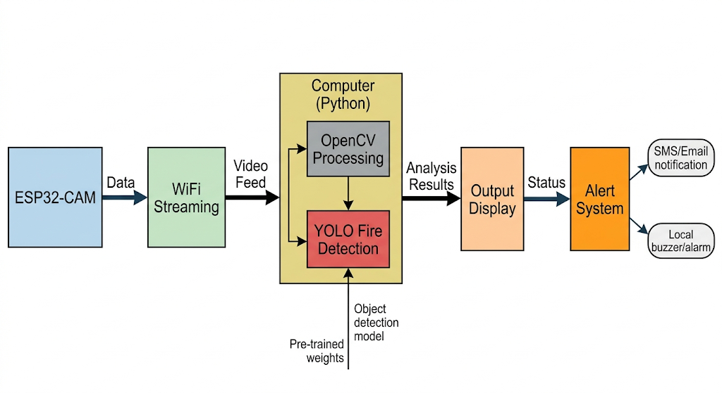
Expected Output:
The expected output of the proposed system is real-time fire detection using live video streaming from the ESP32-CAM. When the system is running, the ESP32-CAM captures continuous video and transmits it to the computer through WiFi.
The Python program processes the incoming video stream using OpenCV and the YOLOv8 model. The output is displayed in a window showing the live video feed. If fire is present in the frame, the system identifies it and highlights the detected region using a rectangular bounding box.
Along with the bounding box, the system also displays the confidence percentage of detection. This helps in understanding how accurately the model has identified fire in the given frame. The detection happens continuously, ensuring real-time monitoring.
If no fire is present, the system simply displays the normal video stream without any bounding boxes. When fire appears, the detection is immediately shown, indicating the effectiveness of the model.
Overall, the system provides a clear visual output with real-time fire detection, making it suitable for monitoring and safety applications.

Advantages:
- Low cost implementation
- Real-time fire detection
- Wireless monitoring using WiFi
- High accuracy using AI models
- Easy to install and use
- Can be integrated with IoT systems

Applications:
- Industrial fire safety systems
- Smart home monitoring
- Forest fire detection
- Warehouse surveillance
- Public building safety systems

Future Improvements:
- Integration with automatic sprinkler systems
- SMS or mobile alert notifications
- Cloud-based monitoring system
- Multi-camera support
- Improved AI model accuracy with larger datasets

Result:
The developed system successfully detects fire in real-time using the ESP32-CAM and the YOLOv8 algorithm. The integration of IoT and artificial intelligence enables accurate and fast detection of fire from live video streams.
The system effectively highlights fire regions with bounding boxes and displays confidence levels, providing a clear indication of detection. The results demonstrate that the system is reliable, efficient, and suitable for practical fire safety applications.

