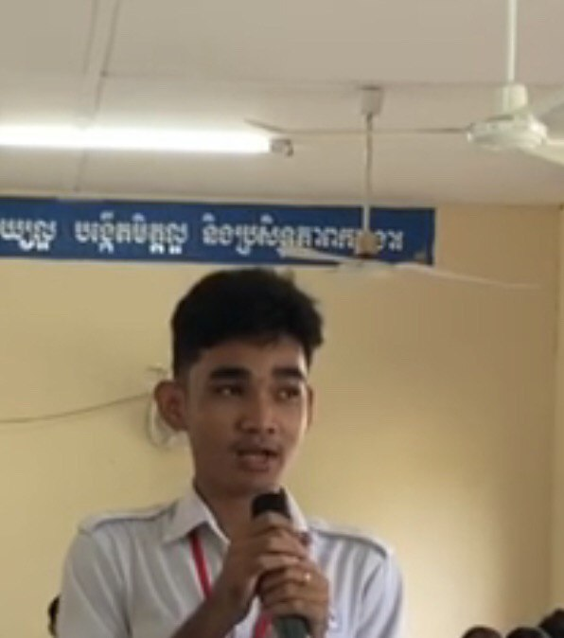

My name is Chhun Rithy, I am currently 18 years old, attending the 12th grade at Chea Sim Chamroeun Roth High School. I am very happy to have chance to practice the Chemistry experimental works that since I have studied at secondary school I have never done it before. Today, the group of Cambodian Chemical Society comes to show us the experimental works and allow us to practice it by ourselves. This experience proved to be highly significant as it allowed us to put into practice what we had learned previously. I am very excited when I did the experiment and I received the good results. Thank you to all Cambodian Chemical Society team who come to our School and allowed us to do these kinds of experiments.

