Multi-Agent Job Email Assistant
Name: Siddharth Saravanan
Instructor: Dr. Amir Hossein Jafari, Ph.D.
Introduction
The challenge in managing job applications is generally characterised by overwhelming email traffic, leading to missed opportunities and inefficient tracking. The Job Email Assistant project contributes to mitigating this problem by designing a modular end-to-end system that transforms unstructured email data into clear, queryable job records. It consists of three key components: a noise-filtering classification module, a named entity recognition module for structured data extraction, and a Retrieval-Augmented Generation system for conversational interaction. This report discusses my contributions to the basic Classical Classifier module (classical_class.py), the architectural development of the RAG System (rag.py using ChromaDB and LangGraph), and the orchestration of the UI using Streamlit (app.py).
Description
For this project, the Gmail API serves as the primary backbone, enabling the system to fetch and process live data from the user's inbox, which is crucial for a job-related application. To ensure robust performance, the team curated a composite dataset. We started with train.csv, which contained primarily 'job' related emails, and augmented it with 'non-job' emails sourced from our own Gmail inboxes to create a balanced training set for binary classification.
To identify the most effective filtering mechanism, the team explored and implemented three distinct classifier architectures:
- Classifier I (Classical Baseline): A high-speed pipeline using TF-IDF Vectorization and Logistic Regression.
- Classifier II (Hybrid): A combination of rule-based filtering and semantic scoring using SentenceTransformer embeddings.
- Classifier III (Deep Learning): A fine-tuned DistilBert transformer model for high-accuracy context understanding.
My specific contribution was the design and implementation of Classifier I. This model was developed to establish a highly efficient, production-ready baseline filter. Its low latency is critical for reducing the computational load on the subsequent LLM-based NER and RAG modules by ensuring that obvious non-job emails are filtered out instantly before resource-intensive processing begins.
Description of Individual Work
My work began with the development of Classifier I. The objective was to create a lightweight, low-latency model capable of distinguishing "job" emails from "non-job" emails before they reach computationally expensive LLM modules.
I selected a pipeline utilizing TF-IDF (Term Frequency-Inverse Document Frequency) for feature extraction and Logistic Regression for classification.
Mathematical Background:
TF-IDF transforms text into numerical vectors reflecting word importance. The weight $w_{i,j}$ of a term i in document j is calculated as:
$$w_{i,j}=tf_{i,j}×log⁡(\frac{N}{df_{i}})$$
Where $tf_{i,j}$ is the term frequency, N is the total number of documents, and $df_{i}$ is the number of documents containing term i.
For the classification, Logistic Regression models the probability $P(y=1|X)$ using the sigmoid function:
$P\left(Y=1 | X\right)=\frac{1}{1+e^{-\left( β_{0}+β_{1}X\right)}}$
This approach was chosen for its interpretability and speed, providing a necessary baseline against the more complex Deep Learning models developed by the team.

My Contributions
Classical Filter
Data Preparation and Training
My work on classical_class.py focused on establishing data integrity using the train.csv file. After loading the dataset, I created a combined text feature from the email subject and body. Crucially, to ensure the binary classifier could effectively distinguish between classes, I implemented a balancing strategy within the code. I downsampled the majority class to match the count of the job entries, ensuring the model was trained on an unbiased distribution.
This code from classical_class.py demonstrates the feature engineering and data balancing for Classifier I.
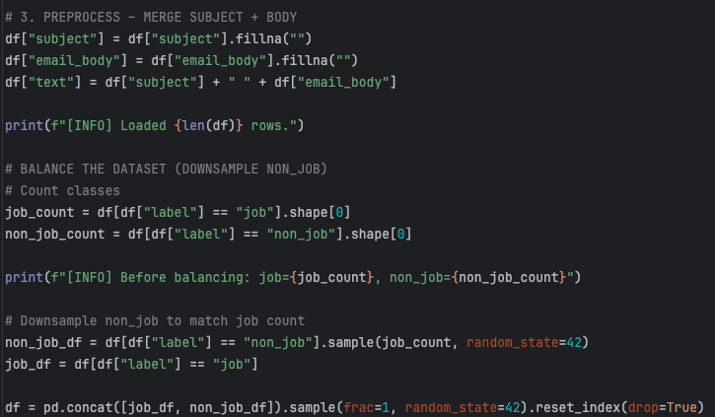

Pipeline Definition and Model Persistence
I defined the Classifier I filtering logic as an sklearn.Pipeline combining the feature extraction of TfidfVectorizer and the classification power of LogisticRegression. Upon successful training, the complete pipeline was serialized using joblib into the job_classifier_baseline.pkl file. This persistence ensures Classifier I can be loaded quickly for inference within the main application.
This code from classical_class.py defines and trains Classifier I's pipeline.
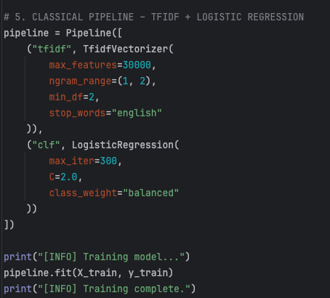
This code from classical_class.py shows the final evaluation and saving of Classifier I.
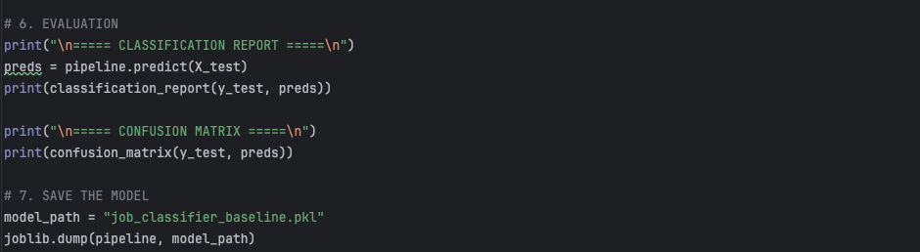

RAG System Architecture
I was responsible for designing and implementing the RAG Agent (rag.py), which uses the structured data from the classified job emails to provide conversational status updates.
Vector Storage and LLM Setup
The system uses a local, persistent ChromaDB vector store to index the job email data. I configured it to utilize the BGE-Large-en-v1.5 model for creating semantic embeddings. The final generation layer employs a local Ollama Llama 3.1 LLM, accessed via LangChain, to synthesize answers.
ChromaDB and LLM Setup This code from rag.py shows the RAG component initialization.
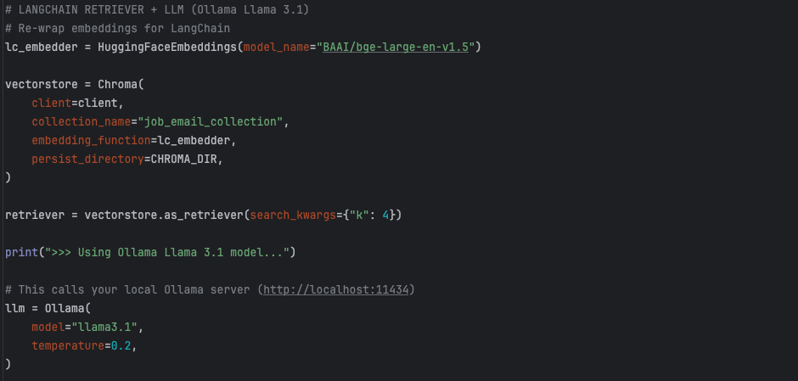

LangGraph Orchestration
I employed LangGraph to define the robust state machine workflow for the RAG process: retrieve -> generate. This two-step architecture is crucial for enforcing context grounding, guaranteeing that the LLM's responses are derived exclusively from the facts present in the retrieved private email data, thereby preventing factual errors.
LangGraph Pipeline This code from rag.py defines the RAG workflow.
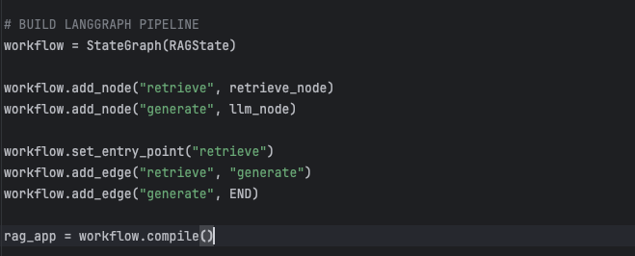

Streamlit UI Integration
I was responsible for developing the user-facing Streamlit UI (app.py), which acts as the application's central orchestrator. The UI is structured into several tabs to manage the workflow clearly.
The crucial "RAG Assistant" tab allows the user to query their data. This interaction calls the rag.ask() function, which I developed, seamlessly executing the complex LangGraph RAG workflow and delivering the LLM-generated response back to the user without requiring them to write any code.
Streamlit RAG Integration This code from app.py shows the UI structure and the RAG function invocation.
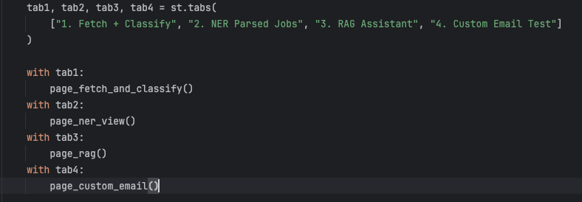
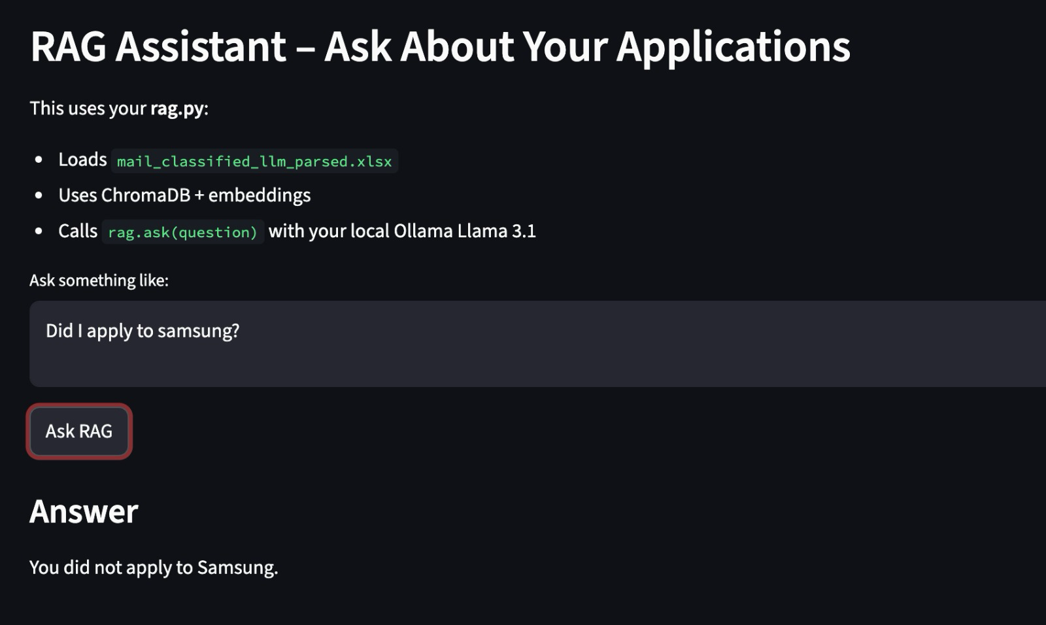

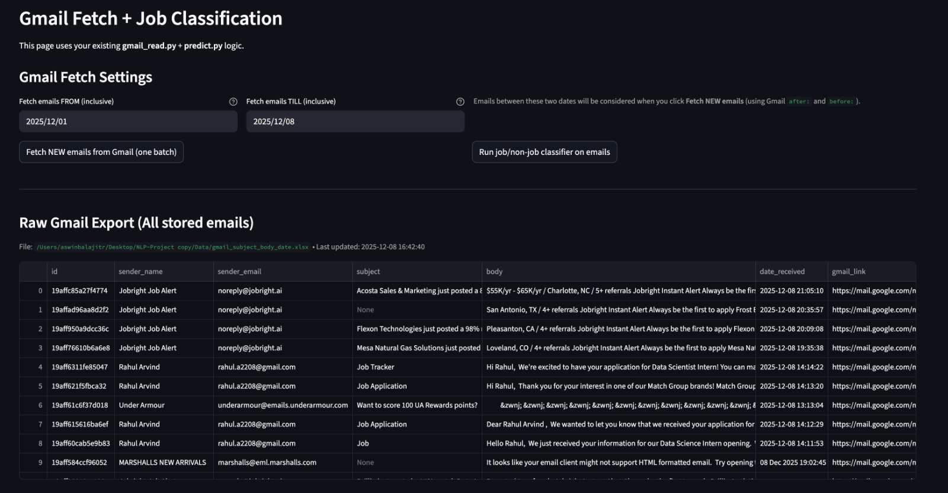
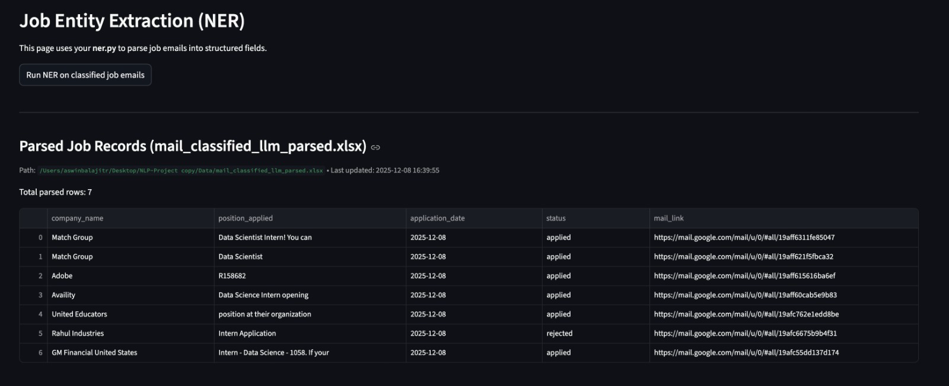

Results
Classifier Performance
The evaluation of Classifier I was conducted using a held-out test set derived from train.csv. The performance was measured using the Classification Report generated in classical_class.py.
- Precision/Recall: The model demonstrated high precision in identifying strictly job-related keywords due to the TF-IDF weighting (e.g., "interview", "application", "offer").
- Efficiency: As a baseline, Classifier I provided the fastest inference time compared to the team's DistilBERT model, validating its use as a pre-filter.
RAG and UI Performance
The RAG system successfully retrieved relevant context for user queries. When integrated into the Streamlit UI, the system allowed for real-time interaction.
Module | Input | Process | Output
Classifier I | Raw Email Text | TF-IDF Vectorization -> Logistic Regression | Label: JOB or NON-JOB
RAG Agent | User Question | ChromaDB Retrieval -> Llama 3.1 Generation | Natural Language Answer
Streamlit UI | User Click/Text | Orchestration of Python Scripts | Visual Dashboard / Chat

The "RAG Assistant" tab in app.py successfully takes a question (e.g., "What is the status of my application?"), triggers the rag.ask() function, and displays the LLM's response based on the embeddings stored in ChromaDB.

Summary and Conclusions
In this project, I successfully delivered the core infrastructure for the Job Email Assistant.
- Summary: I developed a robust Classical Classifier to filter email noise, established a RAG architecture for conversational data access, and unified the project via a Streamlit UI.
- Learnings: I learned the importance of handling class imbalance in binary classification and how to orchestrate complex GenAI workflows using LangGraph state machines.
References
[1] Scikit-learn Documentation: TfidfVectorizer. https://scikit-learn.org/stable/modules/generated/sklearn.feature_extraction.text.TfidfVectorizer.html [2] Scikit-learn Documentation: LogisticRegression. https://scikit-learn.org/stable/modules/generated/sklearn.linear_model.LogisticRegression.html [3] LangGraph Documentation: Building Agentic RAG Workflows. https://www.langchain.com/langgraph [4] Chroma Documentation: Introduction and Getting Started. https://docs.trychroma.com/ [5] Streamlit Documentation: API Reference and Tutorial. https://docs.streamlit.io/

