MobileProjectManagement
Key Features:
- Login: Users can use their Fb or Gmail to login to the application. The login page will also be encryption protected since they are taken to standard logins such as Fb or Gmail.
- Permissions: All the projects that are created in the app gives complete user permission for them to create and visualize the tasks. It is an open source project.
- Project Management: It will allow the users to create and provide the details of the project.
- Data Representation: The data will be graphical represented.
- Data Storage: The app will be available to use all days and since the storage is in app there wouldn’t be any maintenance issues frequently.
- Compatibility: The application is built on recent version of android and will be supported in all the android based devices irrespective of the brand.

Library and API USED:
- FB API [Thanks to Facebook]
- MP Android Chart [Thanks to Developer Philip]
GitHub Link:
https://github.com/AswinVasudevan21/MobileProjectManagement

#Bar Chart - PERT TIME Analysis
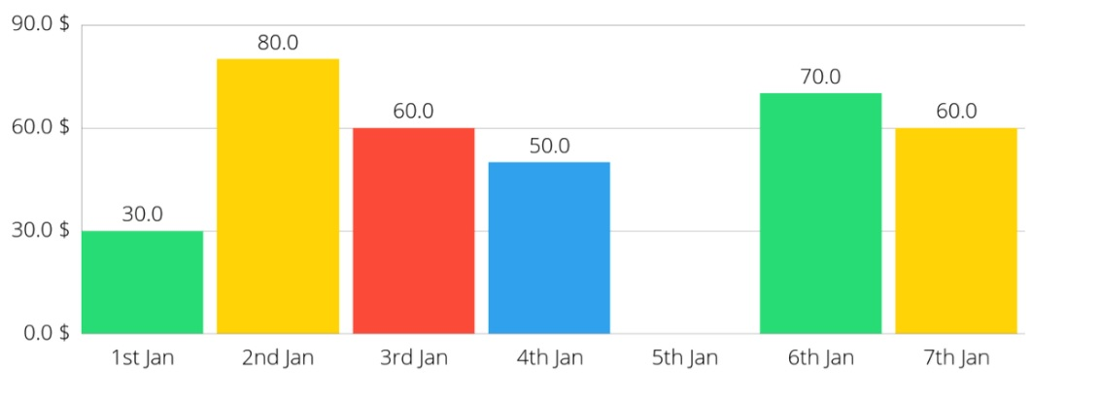
#Pie Chart - Revenue Visualization
