**Lab WorkSheet 6**

CT-2021-083

Aswini.A

**01.**

|  |
| --- |
| package Q_01; public class Number {  public static void main(String[] args) {  for (int i = 10; i <= 49; i++) {  System.*out*.print(i + " ");  if ((i + 1) % 10 == 0) {  System.*out*.println();   }  }  } } |

**Output:**

**02.**

|  |
| --- |
| import java.util.Scanner;  public class Main {  public static int countDigits(int num) {  if (num == 0) return 1;  int count = 0;  num = Math.abs(num);  while (num > 0) {  count++;  num /= 10;  }  return count;  }  public static void main(String[] args) {  Scanner sc = new Scanner(System.in);  while (true) {  System.out.print("Enter a number: ");  int n = sc.nextInt();  if (n < 0) break;  System.out.println("Digits: " + countDigits(n));  }  sc.close();  }  } |

**Output:**

**03.**

|  |
| --- |
| package Q_03; import java.util.Scanner;  public class Multi {  public static void main(String[] args) {  Scanner sc = new Scanner(System.*in*);   System.*out*.print("Enter a number: ");  int N = sc.nextInt();   for (int i = 1; i <= 10; i++) {  System.*out*.println(N + " x " + i + " = " + (N * i));  }   sc.close();  } } |

**Output:**

**04.**

|  |
| --- |
| package Q_04; import java.util.Scanner;  public class Star {  public static void main(String[] args) {  Scanner sc = new Scanner(System.*in*);   System.*out*.print("Enter number of rows: ");  int rows = sc.nextInt();   for (int i = 1; i <= rows; i++) {  // Print spaces  for (int j = 1; j <= rows - i; j++) {  System.*out*.print(" ");  }  // Print stars  for (int k = 1; k <= (2 * i - 1); k++) {  System.*out*.print("*");  }  System.*out*.println();  }   sc.close();  } } |

Output:

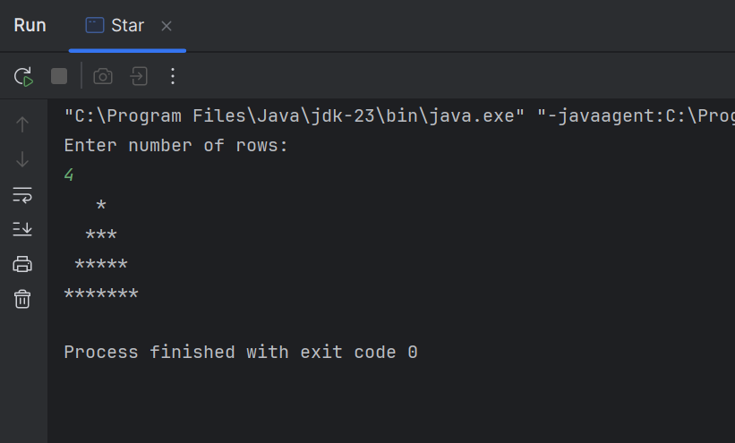

**05.**

|  |
| --- |
| package Q_05; import java.util.Scanner;  public class Fifth {  public static void main(String[] args) {  Scanner sc = new Scanner(System.*in*);   System.*out*.print("Enter a word: ");  String word = sc.nextLine();   String reversed = "";  for (int i = word.length() - 1; i >= 0; i--) {  reversed += word.charAt(i);  }   if (word.equalsIgnoreCase(reversed)) {  System.*out*.println("Palindrome");  } else {  System.*out*.println("Not a palindrome");  }   sc.close();  } } |

Output:

**06.**

|  |
| --- |
| package Q_06; import java.util.Scanner; import java.util.Random;  public class Sixth {  public static void main(String[] args) {  int number = new Random().nextInt(100) + 1;  Scanner sc = new Scanner(System.*in*);  int guess;   System.*out*.println("Guess the number (1 to 100):");   while (true) {  guess = sc.nextInt();   if (guess == number) {  System.*out*.println("You guessed it!");  break;  } else if (guess < number) {  System.*out*.println("Too low!");  } else {  System.*out*.println("Too high!");  }  }   sc.close();  } } |

Output:

**07.**

|  |
| --- |
| import java.util.Scanner;  public class Select {  public static void main(String[] args) {  Scanner sc = new Scanner(System.*in*);   System.*out*.print("Enter a sentence: ");  String sentence = sc.nextLine();   System.*out*.print("Word to replace: ");  String oldWord = sc.nextLine();   System.*out*.print("Replacement word: ");  String newWord = sc.nextLine();   String result = sentence.replace(oldWord, newWord);   System.*out*.println("Result: " + result);   sc.close();  } } |

Output:

