Q1.

|  |
| --- |
| package Q_01; import javax.swing.*;   public class Question_01 {  public static void main(String[] args) {  JFrame myWindow;  myWindow = new JFrame();  myWindow.setSize(800,600);  myWindow.setTitle("Welcome to Java");  myWindow.setVisible(true);   } } |

Output:

Q2.

|  |
| --- |
| package Q_02; import javax.swing.*; import java.util.*;  public class Question_02 {  public static void main(String[] args) {  Scanner scanner = new Scanner(System.*in*);  String firstname , lastname , fullname;  System.*out*.println("Enter your firstname : ");  firstname = scanner.next();  System.*out*.println("Enter your lastname : ");  lastname = scanner.next();  fullname = firstname + " " + lastname ;   JFrame myWindow;  myWindow = new JFrame();  myWindow.setSize(800,600);  myWindow.setTitle(fullname);  myWindow.setVisible(true);  } } |

Output

Q3.

|  |
| --- |
| package Q_03; import java.util.Scanner;  public class Question_03{  public static void main(String[] args) {   Scanner scanner = new Scanner(System.*in*);  String firstname, lastname,middlename , fullname;  char middle_name_initial;  System.*out*.println("Enter your firstname : ");  firstname = scanner.next();   System.*out*.println("Enter your middlename : ");  middlename = scanner.next();  middle_name_initial = middlename.charAt(0);   System.*out*.println("Enter your lastname : ");  lastname = scanner.next();   fullname = firstname+" "+ middle_name_initial +". "+ lastname +"." ;  System.*out*.println(fullname);   } } |

Output:

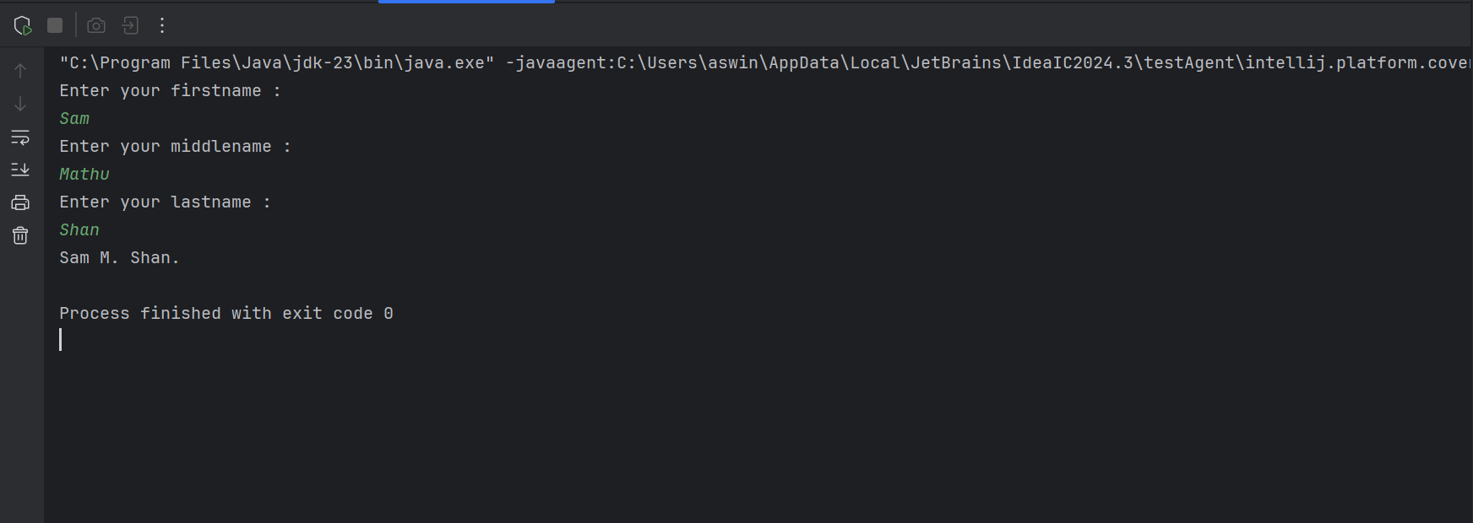

Q4.

|  |
| --- |
| package Q_04; import java.text.SimpleDateFormat; import java.util.*;  public class Question_04 {  public static void main(String[] args) {   Date today;  SimpleDateFormat sdf;  today = new Date( );  sdf = new SimpleDateFormat("dd MMM yyyy");  System.*out*.println(sdf.format(today));  } } |

Output:

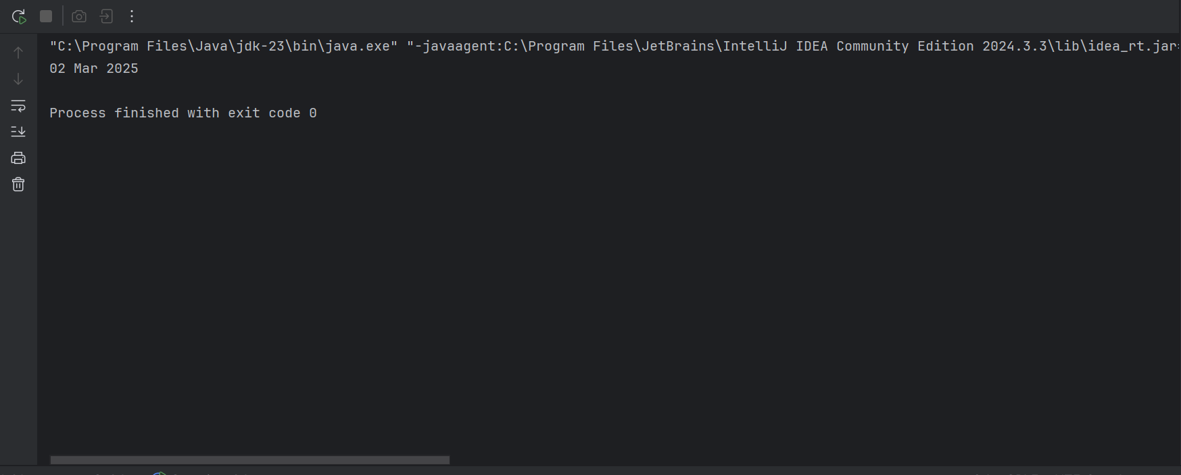

Q5.

|  |
| --- |
| package Q_05; import java.text.SimpleDateFormat; import java.util.*;   public class Question_05 {  public static void main(String[] args) {  Date today;  SimpleDateFormat sdf;  today = new Date( );  sdf = new SimpleDateFormat("EEEE, MMM dd,yyyy");  System.*out*.println(sdf.format(today));  } } |

Output:

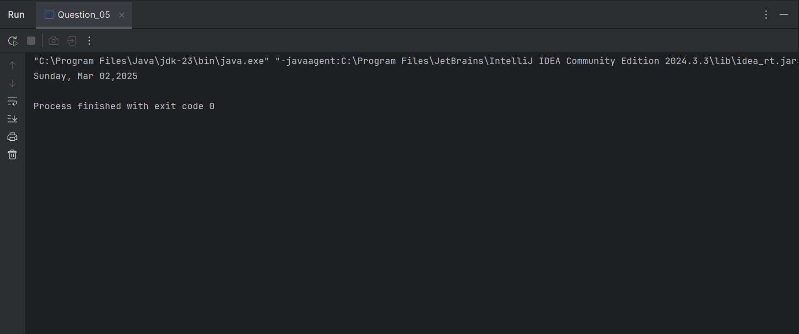

Q6.

|  |
| --- |
| import javax.swing.*; import java.util.*;  public class Question_06{  public static void main(String[] args) {  Scanner scanner = new Scanner(System.*in*);   //getting user input  int w ,h ;  String title;  System.*out*.println("enter the Title of the window :");  title = scanner.nextLine();  System.*out*.println("enter the width :");  w = scanner.nextInt();  System.*out*.println("enter the height :");  h = scanner.nextInt();   //window process  JFrame myWindow;  myWindow = new JFrame();  myWindow.setSize(w,h);  myWindow.setTitle(title);  myWindow.setVisible(true);  } } |

Output:

Q_07

|  |
| --- |
| package Q_07; import java.text.SimpleDateFormat; import java.util.*; import javax.swing.*;  public class Question_07 {  public static void main(String[] args) {   Date today;  SimpleDateFormat sdf;  today = new Date( );  sdf = new SimpleDateFormat("hh:mm:ss a.");  //System.out.println(sdf.format(today));   JFrame myWindow;  myWindow = new JFrame();  myWindow.setSize(600,400);  myWindow.setTitle(sdf.format(today));  myWindow.setVisible(true);  } } |

Output:

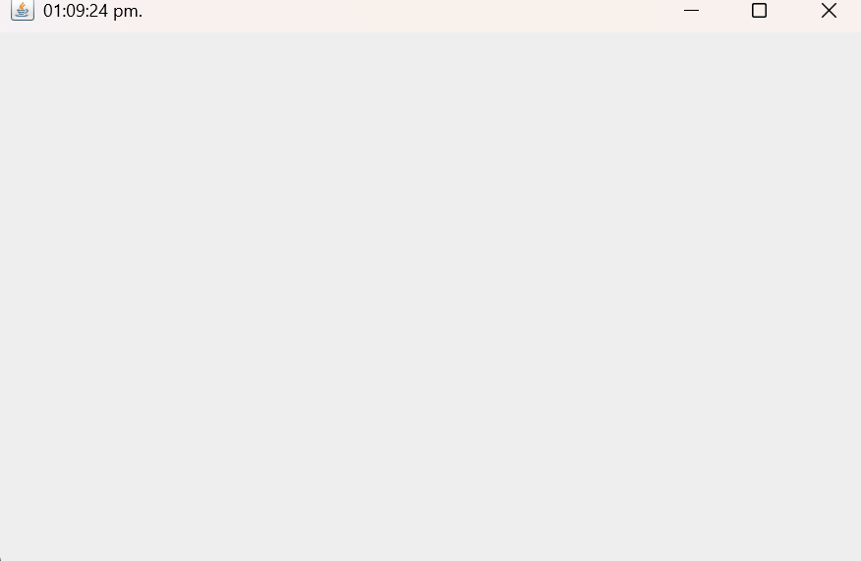

Q8.

|  |
| --- |
| package Q_08; import java.util.*;  public class Question_08 {  public static void main(String[] args) {  String word ,a,b ;  //new array  Scanner scanner = new Scanner(System.*in*);  System.*out*.println("Enter the word :");  word = scanner.nextLine();   String[] sentence = word.split("!",2);   if (sentence.length == 2){  System.*out*.println(sentence[0].trim());  System.*out*.println(sentence[1].trim());  }  } } |

Output:

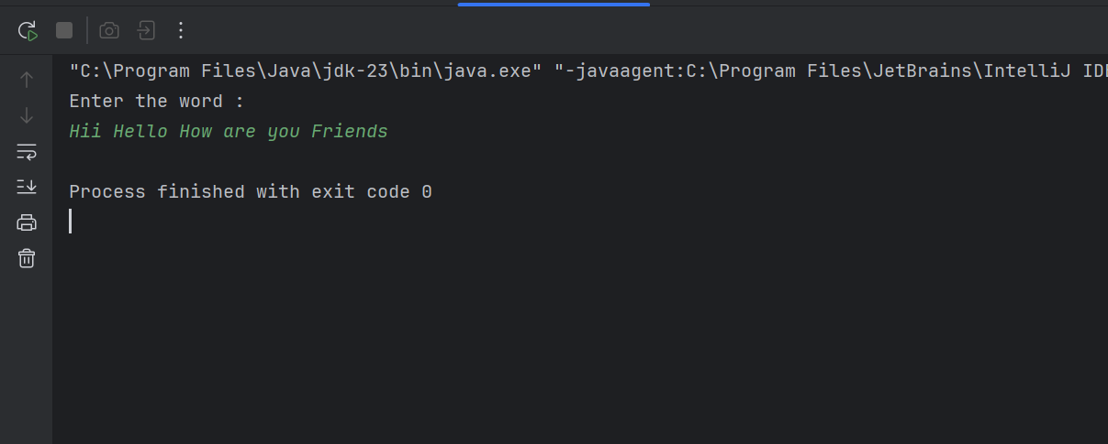

Q_09

|  |
| --- |
| import java.util.*;  public class Question_09 {  public static void main(String[] args) {  Scanner scanner = new Scanner(System.*in*);  System.*out*.println("Enter the text : ");  String text = scanner.nextLine();  int length = text.length();   System.*out*.println(length);  System.*out*.println(text.charAt(0));  System.*out*.println(text.charAt(length-1));   } } |

Output:

Q10.

|  |
| --- |
| import java.util.Scanner;  public class Question_10 {  public static void main(String[] args) {  Scanner scanner =new Scanner(System.*in*);  System.*out*.println("Enter the odd length String : ");  String text = scanner.nextLine();   int length = text.length();  char middle_letter;  middle_letter = text.charAt((length / 2));  System.*out*.println(middle_letter);    } } |

Output:

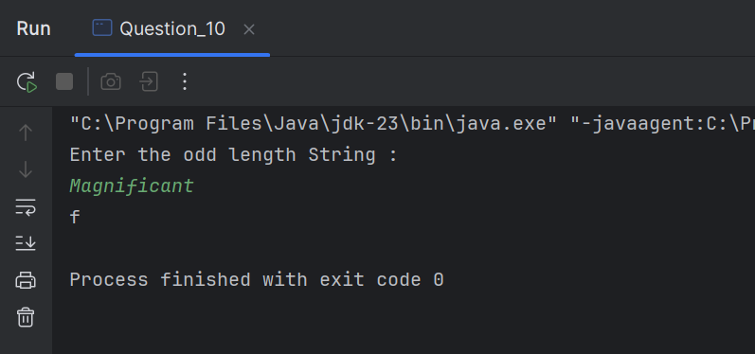

Q11.

|  |
| --- |
| import java.util.*;  public class Question_11 {  public static void main(String[] args) {  Scanner scanner = new Scanner(System.*in*);  System.*out*.println("Enter the full name (first middle last) with spaces :");  String text = scanner.nextLine();  System.*out*.println(text);   String[] parts = text.split(" ");  String fname = parts[0];  String mname = parts[1];  String lname = parts[2];   System.*out*.println(lname+","+" "+fname+" "+mname.charAt(0)+".");   } } |

Output:

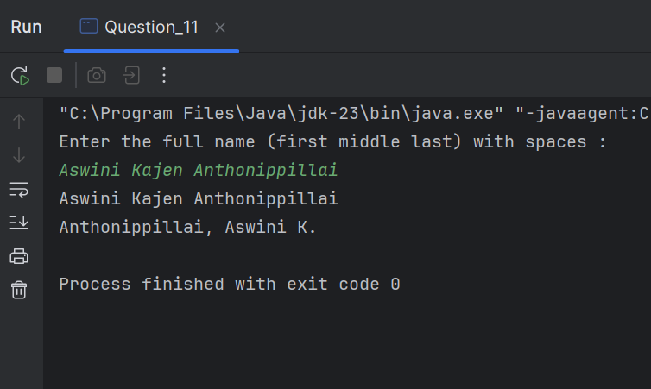

Q12.

|  |
| --- |
| ***import javax.swing.*;  public class Question_12 {  public static void main(String[] args) {  JFrame myWindow;  myWindow = new JFrame();  myWindow.setSize(300,200);  myWindow.setLocation(50,100);  myWindow.setTitle("My First Frame");  myWindow.setVisible(true);   } }*** |

Output:

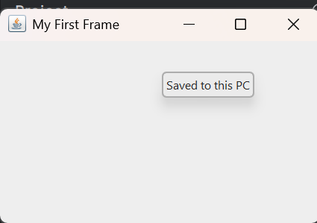

Q13.

|  |
| --- |
| package Q_13; import javax.swing.*; class Question_13 {  public static void main(String[] args) {  JFrame myWindow;  myWindow = new JFrame();  myWindow.setSize(500, 250);  myWindow.setTitle("UOK");  myWindow.setVisible(true);  try {Thread.*sleep*(500);} catch(Exception e) { }  myWindow.setVisible(false);  try {Thread.*sleep*(500);} catch(Exception e) { }  myWindow.setVisible(true);  } } |

Output:

