**LAB WORKSHEET 02**

**Q1.**

**a.**

Code:

|  |
| --- |
| ***package Q_01; public class Square_root {  public static void main(String[] args) {  double A = 2, B = 3, C = 4;    double result = Math.sqrt(B * B + 4 * A * C);   System.out.println("The result is: " + result);  } }*** |

Output:

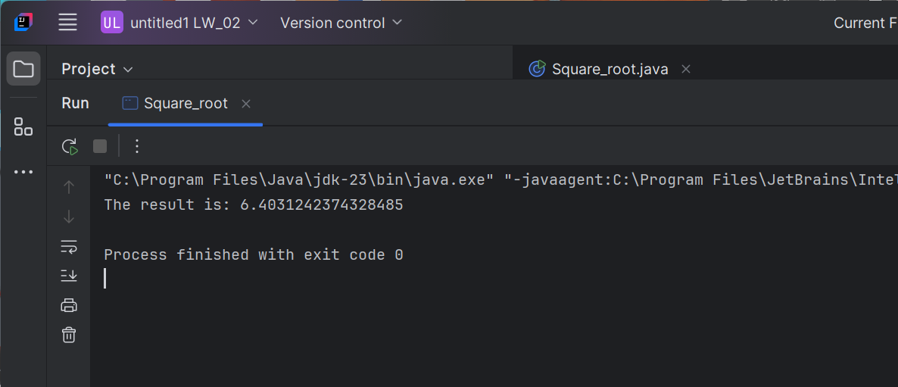

**b. Question is X+4Y2**

|  |
| --- |
| package Q_01b; public class Squareroot_rootcal {  public static void main(String[] args) {  double X = 5, Y = 3; // Example values   double result = Math.*sqrt*(X + 4 * Y * Y);   System.*out*.println("The result is: " + result);  } } |

Output:

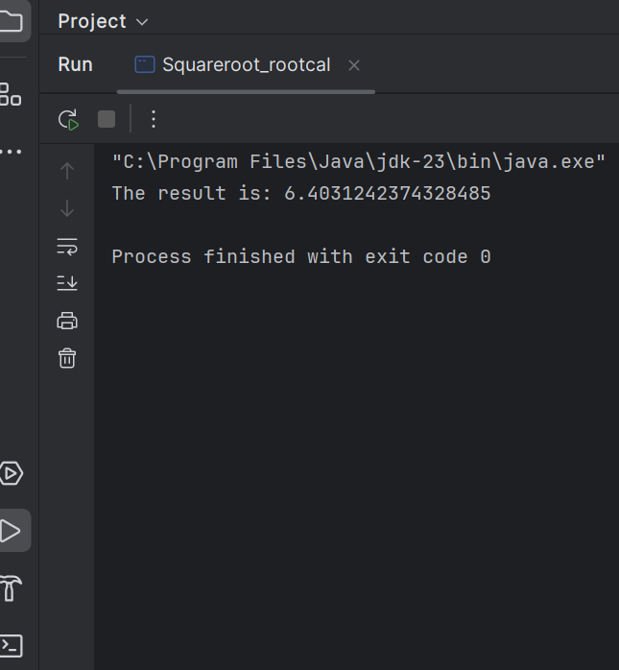

**c.**

|  |
| --- |
| package Q_01c; public class Cube {  public static void main(String[] args) {  double X = 8, Y = 2; // Example values   double result = Math.*cbrt*(X * Y);   System.*out*.println("The result is: " + result);  } } |

Output:

**d.**

|  |
| --- |
| package Q_01d; public class Circlearea {  public static void main(String[] args) {  double radius = 5; // Example radius   double area = Math.*PI* * radius * radius;   System.*out*.println("The area of the circle is: " + area);  } } |

Output:

**Q2.**

|  |
| --- |
| package Q_02; public class Feet {  public static void main(String[] args) {  double cm = 170; // Example input in centimeters   double inches = cm / 2.54;  int feet = (int) (inches / 12);  double remainingInches = inches % 12;   System.*out*.println(cm + " cm is " + feet + " feet and " + remainingInches + " inches.");  } } |

Output:

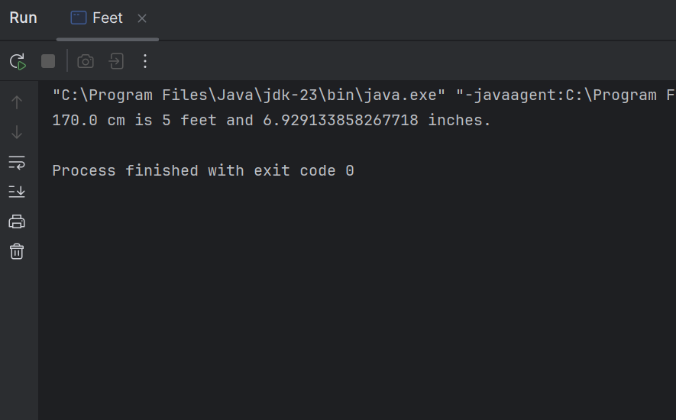

**Q3.**

|  |
| --- |
| import java.util.Scanner;  public class Chance {  public static void main(String[] args) {  Scanner scanner = new Scanner(System.*in*);   // Input temperature in Celsius  System.*out*.print("Enter temperature in Celsius: ");  double celsius = scanner.nextDouble();   // Convert to Fahrenheit  double fahrenheit = (1.8 * celsius) + 32;   // Print the result  System.*out*.println("Temperature in Fahrenheit: " + fahrenheit);   scanner.close();  } } |

Output:

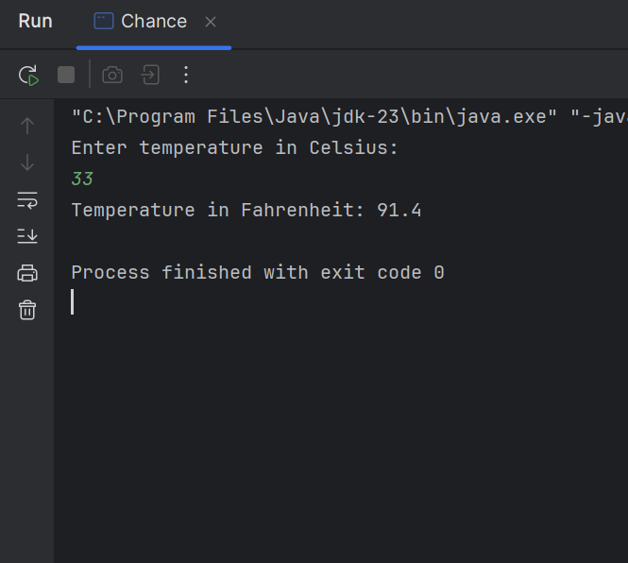

**Q4.**

|  |
| --- |
| import java.util.Scanner;  public class Person {  public static void main(String[] args) {  Scanner scanner = new Scanner(System.*in*);   // Input body weight  System.*out*.print("Enter your weight in pounds: ");  double weight = scanner.nextDouble();   // Calculate the number of calories needed  double calories = weight * 19;   // Display the result  System.*out*.println("You need " + calories + " calories per day.");   scanner.close();  } } |

Output:

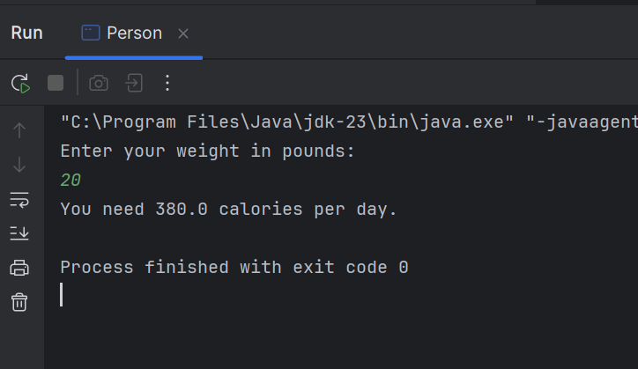

**Q5.**

|  |
| --- |
| import java.util.Scanner;  public class Convert {  public static void main(String[] args) {  Scanner scanner = new Scanner(System.*in*);   // Input temperature in Fahrenheit  System.*out*.print("Enter temperature in Fahrenheit: ");  double fahrenheit = scanner.nextDouble();   // Convert to Celsius  double celsius = (5.0 / 9.0) * (fahrenheit - 32);   // Print the result  System.*out*.println("Temperature in Celsius: " + celsius);   scanner.close();  } } |

Output:

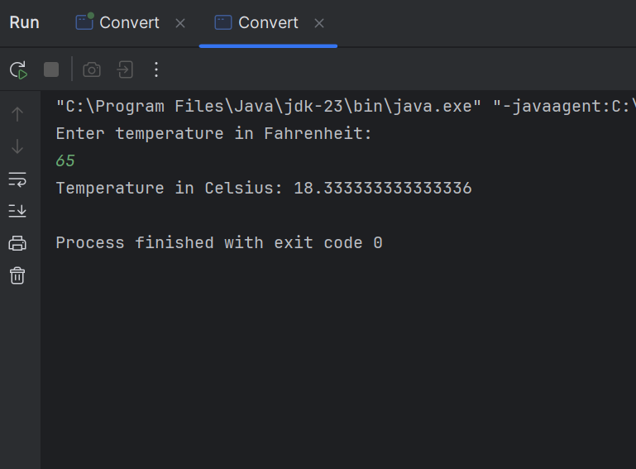

**Q6.**

|  |
| --- |
| import java.util.Scanner;  public class Currentage {  public static void main(String[] args) {  Scanner scanner = new Scanner(System.*in*);   // Input year of birth  System.*out*.print("Enter your birth year: ");  int birthYear = scanner.nextInt();   // Get the current year  int currentYear = 2025; // You can replace this with `java.time.LocalDate.now().getYear()` for the current year dynamically   // Calculate age  int age = currentYear - birthYear;   // Output the result  System.*out*.println("You were born in " + birthYear + " and will be " + age + " this year.");   scanner.close();  } } |

Output:

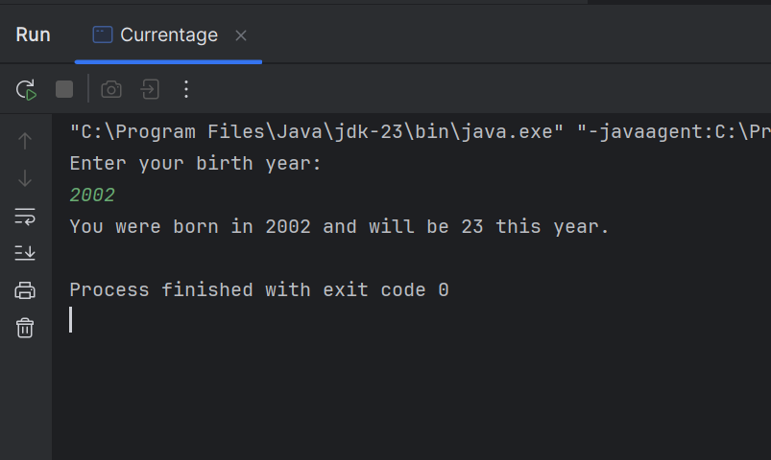

**Q7**.

|  |
| --- |
| import java.util.Scanner;  public class Bmiresult {  public static void main(String[] args) {  Scanner scanner = new Scanner(System.*in*);   // Input weight and height  System.*out*.print("Enter your weight in kg: ");  int weight = scanner.nextInt();   System.*out*.print("Enter your height in cm: ");  int height = scanner.nextInt();   // Calculate BMI  double bmi = weight / (Math.*pow*(height / 100.0, 2));   // Output the result  System.*out*.println("Your BMI is: " + bmi);   scanner.close();  } } |

Output:

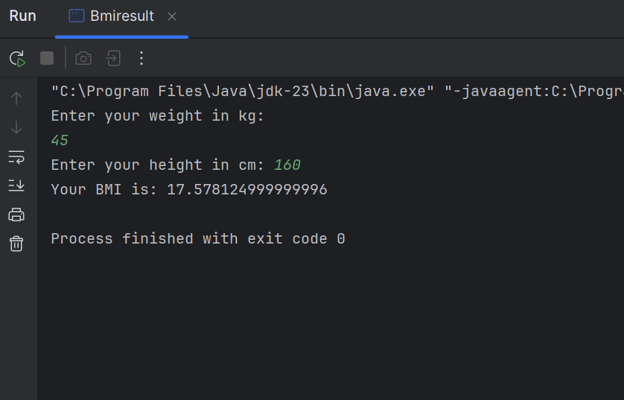

**Q8.**

|  |
| --- |
| package Q_08; public class Volume {  public static void main(String[] args) {  double radius = 5; // Example radius (you can change it as needed)   // Calculate the volume of the sphere  double volume = (4.0 / 3.0) * Math.*PI* * Math.*pow*(radius, 3);   // Output the result  System.*out*.println("The volume of the sphere with radius " + radius + " is: " + volume);  } } |

Output:

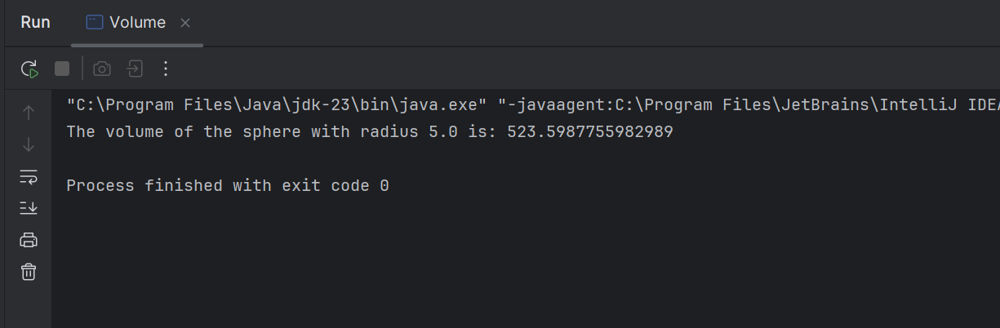

**Q9**.

|  |
| --- |
| import java.util.Scanner;  public class Invest {  public static void main(String[] args) {  Scanner scanner = new Scanner(System.*in*);   // Input principal, interest rate, and number of years  System.*out*.print("Enter the principal amount (P): ");  double P = scanner.nextDouble();   System.*out*.print("Enter the annual interest rate (R) in percentage: ");  double R = scanner.nextDouble();   System.*out*.print("Enter the number of years (N): ");  int N = scanner.nextInt();   // Calculate the total amount after N years using the compound interest formula  double amount = P * Math.*pow*((1 + (R / 100)), N);   // Calculate the money earned (difference between total amount and principal)  double moneyEarned = amount - P;   // Output the result  System.*out*.println("The money earned after " + N + " years is: " + moneyEarned);   scanner.close();  } } |

Output:

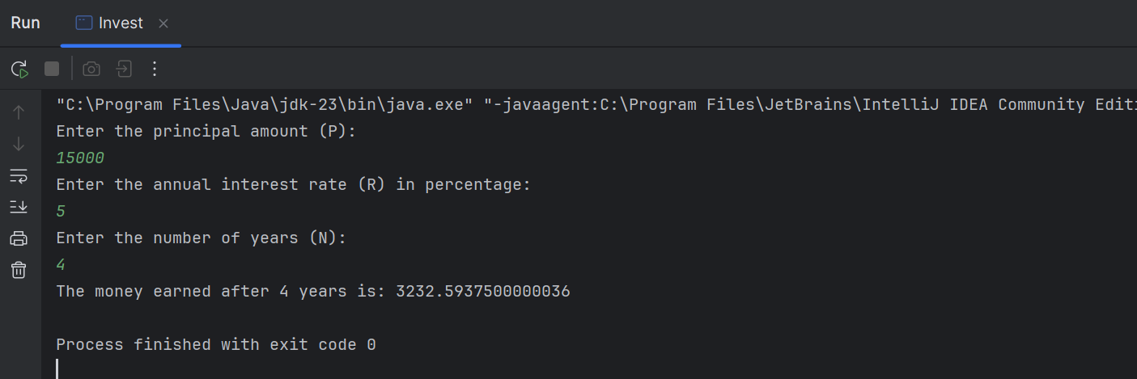

**Q10.**

|  |
| --- |
| import java.util.Scanner;  public class Loancase {  public static void main(String[] args) {  final int MONTHS_IN_YEAR = 12; // Constant for the number of months in a year   Scanner scanner = new Scanner(System.*in*);   // Input loan amount, annual interest rate, and loan period  System.*out*.print("Enter loan amount: ");  double loanAmount = scanner.nextDouble();   System.*out*.print("Enter annual interest rate (in percentage): ");  double annualInterestRate = scanner.nextDouble();   System.*out*.print("Enter loan period in years: ");  int loanPeriod = scanner.nextInt();   // Calculate the monthly interest rate  double monthlyInterestRate = annualInterestRate / 100.0 / MONTHS_IN_YEAR;   // Calculate the number of payments (months)  int numberOfPayments = loanPeriod * MONTHS_IN_YEAR;   // Calculate the monthly payment  double monthlyPayment = (loanAmount * monthlyInterestRate) /  (1 - Math.*pow*(1 / (1 + monthlyInterestRate), numberOfPayments));   // Calculate the total payment  double totalPayment = monthlyPayment * numberOfPayments;   // Output the result  System.*out*.println("Monthly Payment: " + String.*format*("%.2f", monthlyPayment));  System.*out*.println("Total Payment: " + String.*format*("%.2f", totalPayment));   scanner.close();  } } |

Output:

