**Lab WorkSheet -04**

**CT-2021-083**

**01.**

|  |
| --- |
| package Q_01; import java.util.Scanner;  public class Simplenumber {  public static void main(String[] args) {  Scanner scanner = new Scanner(System.*in*);   // Input three integers  System.*out*.print("Enter first number: ");  int a = scanner.nextInt();   System.*out*.print("Enter second number: ");  int b = scanner.nextInt();   System.*out*.print("Enter third number: ");  int c = scanner.nextInt();   int smallest = a;   if (b < smallest) {  smallest = b;  }   if (c < smallest) {  smallest = c;  }   System.*out*.println("The smallest number is: " + smallest);  } } |

**Output:**

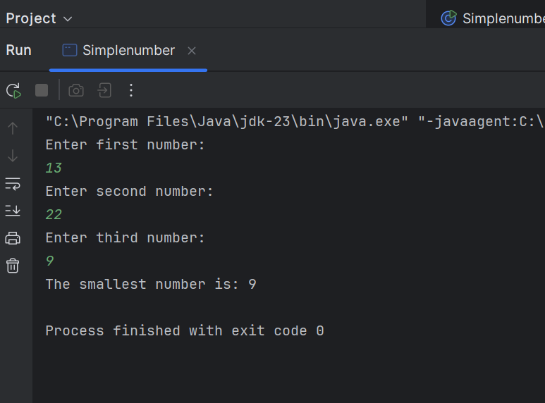

**02**

|  |
| --- |
| package Q_02; import java.util.Scanner;  public class Switchcase {  public static void main(String[] args) {  Scanner scanner = new Scanner(System.*in*);   System.*out*.println("0. Magenta");  System.*out*.println("1. Cyan");  System.*out*.println("2. Red");  System.*out*.println("3. Blue");  System.*out*.println("4. Green");  System.*out*.println("Select one color from the above list:");   int selection = scanner.nextInt();   switch (selection) {  case 0:  System.*out*.println("You selected Magenta");  break;  case 1:  System.*out*.println("You selected Cyan");  break;  case 2:  System.*out*.println("You selected Red");  break;  case 3:  System.*out*.println("You selected Blue");  break;  case 4:  System.*out*.println("You selected Green");  break;  default:  System.*out*.println("Invalid selection");  }   scanner.close();  } } |

**Output:**

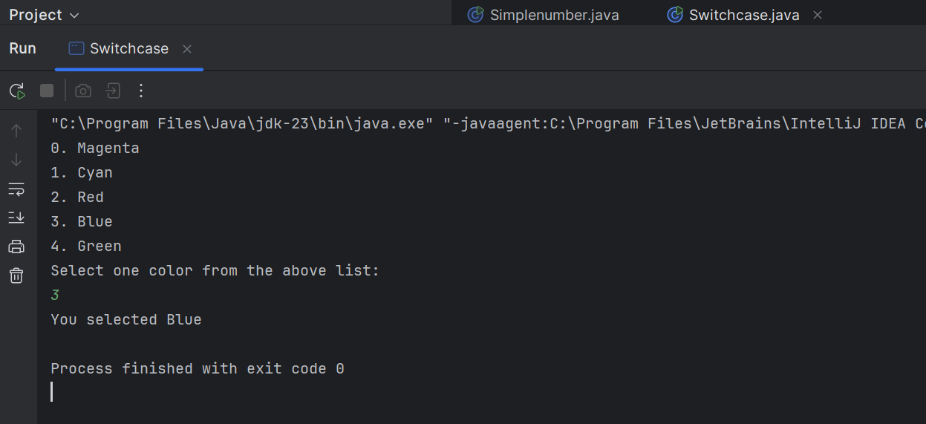

**03.**

|  |
| --- |
| package Q_03; import java.util.Scanner;  public class Power {  public static void main(String[] args) {   Scanner scanner = new Scanner(System.*in*);    System.*out*.print("Enter a power of 10 (6, 9, 12, etc.): ");  int power = scanner.nextInt();    switch (power) {  case 6:  System.*out*.println("Million");  break;  case 9:  System.*out*.println("Billion");  break;  case 12:  System.*out*.println("Trillion");  break;  case 15:  System.*out*.println("Quadrillion");  break;  case 18:  System.*out*.println("Quintillion");  break;  case 21:  System.*out*.println("Sextillion");  break;  case 30:  System.*out*.println("Nonillion");  break;  case 100:  System.*out*.println("Googol");  break;  default:  System.*out*.println("No corresponding word for this power of 10.");  }    scanner.close();  } } |

**Output:**

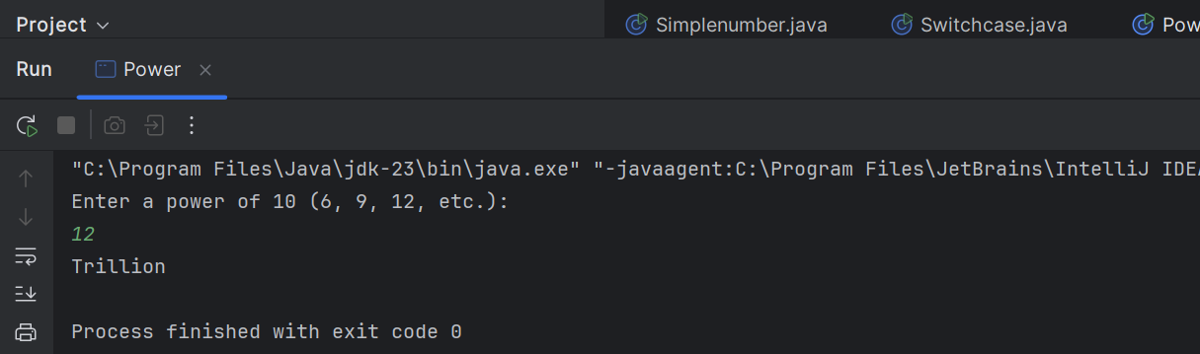

**04.**

|  |
| --- |
| import java.util.Scanner;  public class Leapyear {  public static void main(String[] args) {  Scanner scanner = new Scanner(System.*in*);   System.*out*.print("Enter a year: ");  int year = scanner.nextInt();   if ((year % 4 == 0 && year % 100 != 0) || (year % 400 == 0)) {  System.*out*.println("Leap Year");  } else {  System.*out*.println("Not a Leap Year");  }   scanner.close();  } } |

**Output:**

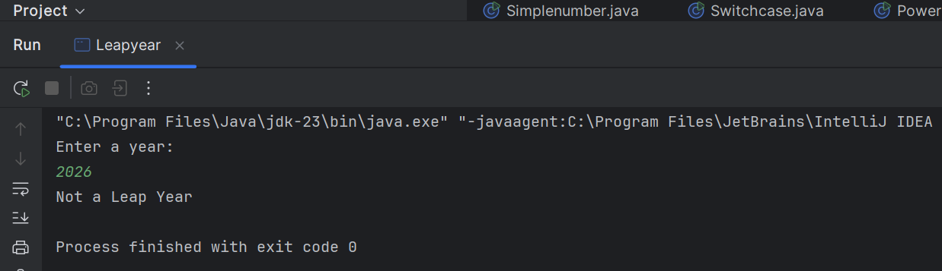

**05.**

|  |
| --- |
| import java.util.Scanner;  public class Fastfood {   public static void main(String[] args) {   String[] entrees = {"Tofu Burger", "Cajun Chicken", "Buffalo Wings", "Rainbow Fillet"};  double[] entreePrices = {3.49, 4.59, 3.99, 2.99};   String[] sideDishes = {"Rice Cracker", "No-Salt Fries", "Zucchini", "Brown Rice"};  double[] sideDishPrices = {0.79, 0.69, 1.09, 0.59};   String[] drinks = {"Cafe Mocha", "Cafe Latte", "Espresso", "Oolong Tea"};  double[] drinkPrices = {1.99, 1.90, 2.49, 0.99};    Scanner scanner = new Scanner(System.*in*);    System.*out*.println("Welcome to MyJava Lo-Fat Burgers! Here is our menu:");    int entreeChoice = *getValidChoice*(scanner, entrees, "entree");    int sideDishChoice = *getValidChoice*(scanner, sideDishes, "side dish");   int drinkChoice = *getValidChoice*(scanner, drinks, "drink");    double totalPrice = entreePrices[entreeChoice] + sideDishPrices[sideDishChoice] + drinkPrices[drinkChoice];    System.*out*.println("\nYour Order:");  System.*out*.println("Entree: " + entrees[entreeChoice] + " - $" + entreePrices[entreeChoice]);  System.*out*.println("Side Dish: " + sideDishes[sideDishChoice] + " - $" + sideDishPrices[sideDishChoice]);  System.*out*.println("Drink: " + drinks[drinkChoice] + " - $" + drinkPrices[drinkChoice]);    System.*out*.printf("\nTotal Price: $%.2f\n", totalPrice);    scanner.close();  }    private static int getValidChoice(Scanner scanner, String[] items, String category) {  int choice;  while (true) {  System.*out*.println("\n" + category + " options:");  for (int i = 0; i < items.length; i++) {  System.*out*.println((i + 1) + ". " + items[i]);  }  System.*out*.print("Please choose a " + category + " by entering the number (1-" + items.length + "): ");  choice = scanner.nextInt() - 1;  if (choice >= 0 && choice < items.length) {  break;  } else {  System.*out*.println("Invalid choice! Please enter a number between 1 and " + items.length + ".");  }  }  return choice;  } } |

**Output:**

