**Lab WorkSheet 06**

CT-2021-083

01.

I) package Q_01;  
**// Pet.java**public class Pet {  
 private String name;  
  
 public String getName() {  
 return name;  
 }  
  
 public void setName(String petName) {  
 name = petName;  
 }  
  
 public String speak() {  
 return "I'm your cuddly little pet.";  
 }  
}

ii) package Q_01;  
**// Dog.java**public class Dog extends Pet {  
 @Override  
 public String speak() {  
 return "Woof!";  
 }  
}

iii) package Q_01;  
**// Cat.java**public class Cat extends Pet {  
 @Override  
 public String speak() {  
 return "Meow!";  
 }  
}

|  |
| --- |
| package Q_01; **// Main.java** public class Main {  public static void main(String[] args) {  Dog dog = new Dog();  dog.setName("Buddy");  System.*out*.println(dog.getName() + " says: " + dog.speak());   Cat cat = new Cat();  cat.setName("Whiskers");  System.*out*.println(cat.getName() + " says: " + cat.speak());  } } |

**Output:**

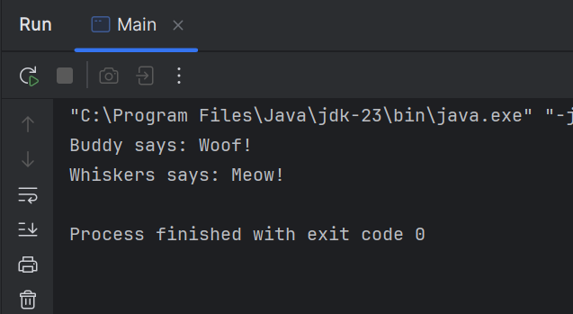

**02.**

|  |
| --- |
| package Q_02; import java.util.Scanner;  class Pet {  private String name;   public void setName(String name) {  this.name = name;  }   public String getName() {  return name;  }   public String getType() {  return "Pet";  } }  class Dog extends Pet {  @Override  public String getType() {  return "Dog";  } }  class Cat extends Pet {  @Override  public String getType() {  return "Cat";  } }  public class SimplePetArray {  public static void main(String[] args) {  Scanner scanner = new Scanner(System.*in*);  Pet[] pets = new Pet[100]; // array of pets  int count = 0;   while (true) {  System.*out*.print("Enter pet name (or STOP to end): ");  String name = scanner.nextLine();   if (name.equalsIgnoreCase("STOP")) {  break;  }   System.*out*.print("Enter pet type ('c' for cat, 'd' for dog): ");  String type = scanner.nextLine();   Pet pet;  if (type.equalsIgnoreCase("c")) {  pet = new Cat();  } else if (type.equalsIgnoreCase("d")) {  pet = new Dog();  } else {  System.*out*.println("Invalid type. Try again.");  continue;  }   pet.setName(name);  pets[count] = pet;  count++;  }   System.*out*.println("\nList of Pets:");  for (int i = 0; i < count; i++) {  System.*out*.println(pets[i].getName() + " is a " + pets[i].getType());  }   scanner.close();  } } |

**Output:**

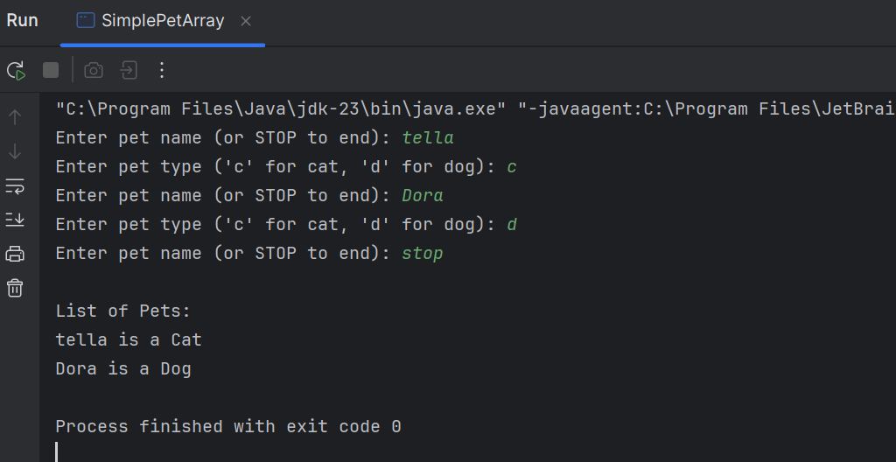

**03.**

|  |
| --- |
| package Q_03; import java.util.Scanner;  public class Petgroup {  public static void main(String[] args) {  Scanner scanner = new Scanner(System.*in*);  String[] catNames = new String[100];  String[] dogNames = new String[100];  int catCount = 0;  int dogCount = 0;   while (true) {  System.*out*.print("Enter pet name (or STOP to end): ");  String name = scanner.nextLine();  if (name.equalsIgnoreCase("STOP")) {  break;  }   System.*out*.print("Enter pet type ('c' for cat, 'd' for dog): ");  String type = scanner.nextLine();   if (type.equalsIgnoreCase("c")) {  catNames[catCount] = name;  catCount++;  } else if (type.equalsIgnoreCase("d")) {  dogNames[dogCount] = name;  dogCount++;  } else {  System.*out*.println("Invalid type. Try again.");  }  }   System.*out*.println("\nCats:");  for (int i = 0; i < catCount; i++) {  System.*out*.println(catNames[i]);  }   System.*out*.println("\nDogs:");  for (int i = 0; i < dogCount; i++) {  System.*out*.println(dogNames[i]);  }   scanner.close();  } } |

**Output:**

**04.**

|  |
| --- |
| package Q_04; import java.util.Scanner;  class Pet {  String name;  public void setName(String name) { this.name = name; }  public String getName() { return name; } }  class Dog extends Pet {  double weight;  public void setWeight(double weight) { this.weight = weight; }  public double getWeight() { return weight; } }  class Cat extends Pet {  String coatColor;  public void setCoatColor(String coatColor) { this.coatColor = coatColor; }  public String getCoatColor() { return coatColor; } }  public class PetInform {  public static void main(String[] args) {  Scanner scanner = new Scanner(System.*in*);  Dog[] dogs = new Dog[100];  Cat[] cats = new Cat[100];  int dogCount = 0, catCount = 0;   while (true) {  System.*out*.print("Enter pet name (or STOP to end): ");  String name = scanner.nextLine();  if (name.equalsIgnoreCase("STOP")) break;   System.*out*.print("Enter pet type ('c' for cat, 'd' for dog): ");  String type = scanner.nextLine();   if (type.equalsIgnoreCase("c")) {  Cat cat = new Cat();  cat.setName(name);  System.*out*.print("Enter coat color: ");  String color = scanner.nextLine();  cat.setCoatColor(color);  cats[catCount++] = cat;  } else if (type.equalsIgnoreCase("d")) {  Dog dog = new Dog();  dog.setName(name);  System.*out*.print("Enter weight: ");  double weight = scanner.nextDouble();  scanner.nextLine(); // clear newline  dog.setWeight(weight);  dogs[dogCount++] = dog;  } else {  System.*out*.println("Invalid type. Try again.");  }  }   System.*out*.println("\nCats:");  for (int i = 0; i < catCount; i++) {  System.*out*.println(cats[i].getName() + " - Coat Color: " + cats[i].getCoatColor());  }   System.*out*.println("\nDogs:");  for (int i = 0; i < dogCount; i++) {  System.*out*.println(dogs[i].getName() + " - Weight: " + dogs[i].getWeight() + " kg");  }   scanner.close();  } } |

Output:

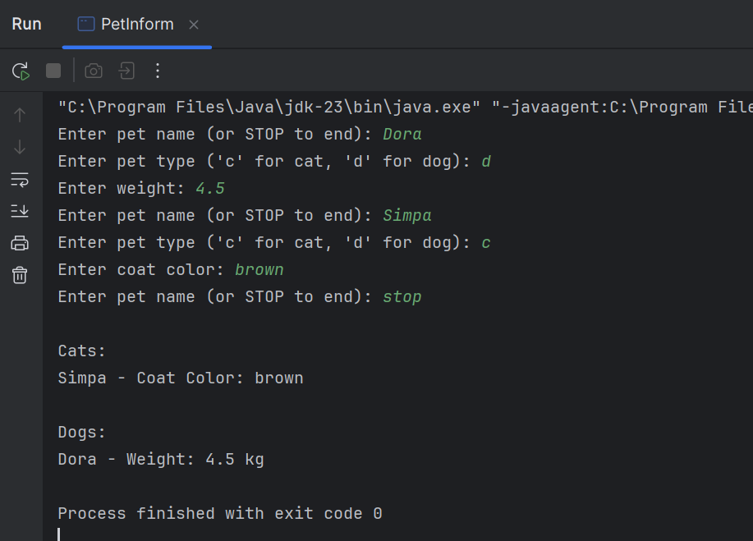

**05.**

|  |
| --- |
| package Q_05; import java.util.Scanner;  class Pet {  String name;  public void setName(String name) { this.name = name; }  public String getName() { return name; } }  class Dog extends Pet {  double weight;  public void setWeight(double weight) { this.weight = weight; }  public double getWeight() { return weight; } }  class Cat extends Pet {  String coatColor;  public void setCoatColor(String coatColor) { this.coatColor = coatColor; }  public String getCoatColor() { return coatColor; } }  public class Dogweight {  public static void main(String[] args) {  Scanner scanner = new Scanner(System.*in*);  Pet[] pets = new Pet[100];  int petCount = 0;   while (true) {  System.*out*.print("Enter pet name (or STOP to end): ");  String name = scanner.nextLine();  if (name.equalsIgnoreCase("STOP")) break;   System.*out*.print("Enter pet type ('c' for cat, 'd' for dog): ");  String type = scanner.nextLine();   if (type.equalsIgnoreCase("c")) {  Cat cat = new Cat();  cat.setName(name);  System.*out*.print("Enter coat color: ");  String color = scanner.nextLine();  cat.setCoatColor(color);  pets[petCount++] = cat;  } else if (type.equalsIgnoreCase("d")) {  Dog dog = new Dog();  dog.setName(name);  System.*out*.print("Enter weight: ");  double weight = scanner.nextDouble();  scanner.nextLine(); // consume newline  dog.setWeight(weight);  pets[petCount++] = dog;  } else {  System.out.println("Invalid type. Try again.");  }  }   // Create Dog-only array  Dog[] dogs = new Dog[petCount];  int dogCount = 0;  for (int i = 0; i < petCount; i++) {  if (pets[i] instanceof Dog) {  dogs[dogCount++] = (Dog) pets[i];  }  }   // Compute average, min, and max weight of dogs  if (dogCount > 0) {  double sum = 0;  double min = dogs[0].getWeight();  double max = dogs[0].getWeight();   for (int i = 0; i < dogCount; i++) {  double w = dogs[i].getWeight();  sum += w;  if (w < min) min = w;  if (w > max) max = w;  }   double avg = sum / dogCount;   System.out.println("\nDog Weight Statistics:");  System.out.println("Average weight: " + avg + " kg");  System.out.println("Minimum weight: " + min + " kg");  System.out.println("Maximum weight: " + max + " kg");  } else {  System.out.println("\nNo dogs entered.");  }   scanner.close();  } } |

**Output:**

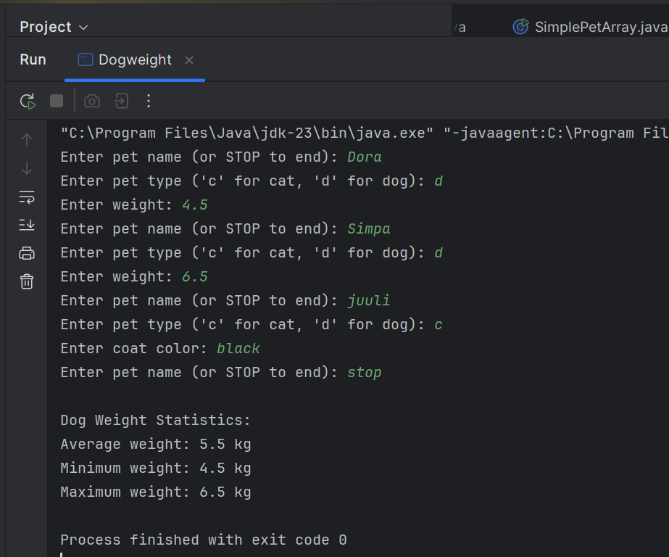  
**06.**

|  |
| --- |
| package Q_06; import java.util.Scanner;  class Pet {  String name;  public Pet(String name) { this.name = name; }  public String getName() { return name; } }  class Dog extends Pet {  double weight;  public Dog(String name, double weight) {  super(name);  this.weight = weight;  }  public double getWeight() { return weight; } }  class Cat extends Pet {  String coatColor;  public Cat(String name, String coatColor) {  super(name);  this.coatColor = coatColor;  }  public String getCoatColor() { return coatColor; } }  public class Petmanager {  public static void main(String[] args) {  Scanner sc = new Scanner(System.*in*);  Dog[] dogs = new Dog[10];  Cat[] cats = new Cat[10];  int dogCount = 0, catCount = 0;   int choice;  do {  System.*out*.println("\nMenu: 1-Add Cat, 2-Add Dog, 3-Remove Cat, 4-Remove Dog, 0-Quit");  System.*out*.print("Choose: ");  choice = sc.nextInt();  sc.nextLine(); // consume newline   switch (choice) {  case 1: // Add Cat  System.*out*.print("Cat name: ");  String cname = sc.nextLine();  System.*out*.print("Coat color: ");  String color = sc.nextLine();  cats[catCount++] = new Cat(cname, color);  System.*out*.println("Added cat: " + cname);  break;   case 2: // Add Dog  System.*out*.print("Dog name: ");  String dname = sc.nextLine();  System.*out*.print("Weight: ");  double weight = sc.nextDouble();  sc.nextLine();  dogs[dogCount++] = new Dog(dname, weight);  System.*out*.println("Added dog: " + dname);  break;   case 3: // Remove Cat  System.*out*.print("Remove cat name: ");  String rcat = sc.nextLine();  boolean foundCat = false;  for (int i = 0; i < catCount; i++) {  if (cats[i].getName().equalsIgnoreCase(rcat)) {  cats[i] = cats[catCount - 1];  cats[--catCount] = null;  foundCat = true;  System.*out*.println("Removed cat: " + rcat);  break;  }  }  if (!foundCat) System.*out*.println("Cat not found.");  break;   case 4: // Remove Dog  System.*out*.print("Remove dog name: ");  String rdog = sc.nextLine();  boolean foundDog = false;  for (int i = 0; i < dogCount; i++) {  if (dogs[i].getName().equalsIgnoreCase(rdog)) {  dogs[i] = dogs[dogCount - 1];  dogs[--dogCount] = null;  foundDog = true;  System.*out*.println("Removed dog: " + rdog);  break;  }  }  if (!foundDog) System.*out*.println("Dog not found.");  break;   case 0:  System.*out*.println("Goodbye!");  break;   default:  System.*out*.println("Invalid choice.");  }   // Show current pets  System.*out*.println("\nCurrent Cats:");  for (int i = 0; i < catCount; i++) {  System.*out*.println("- " + cats[i].getName() + ", Color: " + cats[i].getCoatColor());  }  System.*out*.println("Current Dogs:");  for (int i = 0; i < dogCount; i++) {  System.*out*.println("- " + dogs[i].getName() + ", Weight: " + dogs[i].getWeight() + "kg");  }   } while (choice != 0);   sc.close();  } } |

**Output:**



