DATA ANALYTICS PROJECT
Bank Loan Report
Power BI Dashboards | SQL Query Documentation | Data Dictionary
An end-to-end analysis of a bank's lending portfolio: KPI tracking, good vs. bad loan performance, and trend, regional and borrower-profile analysis, delivered through three Power BI dashboards backed by SQL queries.
CONTENTS
1. Problem Statement
2. Power BI Dashboards
3. SQL Query Document
4. Terminologies Used in Data

1. Problem Statement
In order to monitor and assess our bank's lending activities and performance, we need to create a comprehensive Bank Loan Report. This report aims to provide insights into key loan-related metrics and their changes over time. The report will help us make data-driven decisions, track our loan portfolio's health, and identify trends that can inform our lending strategies.

Dashboard 1: Summary

Key Performance Indicators (KPIs) Requirements
Total Loan Applications | The total number of loan applications received during a specified period, with Month-to-Date (MTD) Loan Applications tracked and changes Month-over-Month (MoM) monitored.
Total Funded Amount | The total amount of funds disbursed as loans, with the MTD Total Funded Amount and its Month-over-Month (MoM) changes analysed.
Total Amount Received | The total amount received from borrowers, essential for assessing cash flow and loan repayment. Analysed as Month-to-Date (MTD) with Month-over-Month (MoM) changes.
Average Interest Rate | The average interest rate across all loans and MTD, with Month-over-Month (MoM) variations providing insight into the overall cost of the lending portfolio.
Average Debt-to-Income Ratio (DTI) | The average DTI of borrowers, which gauges their financial health. Computed for all loans and MTD, with Month-over-Month (MoM) fluctuations tracked.

Good Loan v Bad Loan KPIs
To evaluate the performance of our lending activities and the quality of the loan portfolio, the report distinguishes between Good Loans and Bad Loans based on loan status criteria.
Good Loan KPIs (Loan Status: Fully Paid or Current)
Good Loan Application Percentage | The percentage of loan applications classified as Good Loans.
Good Loan Applications | The total number of applications in the Good Loan category.
Good Loan Funded Amount | The total principal disbursed on Good Loans.
Good Loan Total Received Amount | The total amount received from borrowers on Good Loans, covering all payments made.
Bad Loan KPIs (Loan Status: Charged Off)
Bad Loan Application Percentage | The percentage of loan applications categorised as Bad Loans.
Bad Loan Applications | The total number of applications in the Bad Loan category.
Bad Loan Funded Amount | The total principal disbursed on Bad Loans.
Bad Loan Total Received Amount | The total amount received from borrowers on Bad Loans, covering all payments made.

Loan Status Grid View
To gain a comprehensive overview of lending operations, a grid view report is categorised by Loan Status. It presents Total Loan Applications, Total Funded Amount, Total Amount Received, MTD Funded Amount, MTD Amount Received, Average Interest Rate and Average Debt-to-Income Ratio (DTI) for each status, supporting data-driven decisions on portfolio health.

Dashboard 2: Overview
The Overview dashboard visually represents critical loan-related metrics and trends using a variety of chart types, giving a clear view of lending operations. Every chart plots the same three metrics: Total Loan Applications, Total Funded Amount and Total Amount Received.
1. Monthly Trends by Issue Date
Chart Type | Line Chart
Metrics | Total Loan Applications, Total Funded Amount, Total Amount Received
X-Axis | Month (based on Issue Date)
Y-Axis | Metric values
Objective: Shows how the metrics vary over time, revealing seasonality and long-term trends in lending activity.
2. Regional Analysis by State
Chart Type | Filled Map
Metrics | Total Loan Applications, Total Funded Amount, Total Amount Received
Geography | States
Objective: Represents lending metrics by state, highlighting regions with significant activity and regional disparities.
3. Loan Term Analysis
Chart Type | Donut Chart
Metrics | Total Loan Applications, Total Funded Amount, Total Amount Received
Segments | Loan Terms (e.g. 36 months, 60 months)
Objective: Depicts loan statistics by term, showing how loans are distributed across term lengths.
4. Employee Length Analysis
Chart Type | Bar Chart
Metrics | Total Loan Applications, Total Funded Amount, Total Amount Received
X-Axis | Employee length categories (e.g. 1 year, 5 years, 10+ years)
Y-Axis | Metric values
Objective: Illustrates how lending metrics are distributed across employment lengths, showing the impact of employment history.
5. Loan Purpose Breakdown
Chart Type | Bar Chart
Metrics | Total Loan Applications, Total Funded Amount, Total Amount Received
X-Axis | Loan purpose (e.g. debt consolidation, credit card refinancing)
Y-Axis | Metric values
Objective: Breaks down loan metrics by stated purpose, revealing the primary reasons borrowers seek financing.
6. Home Ownership Analysis
Chart Type | Tree Map
Metrics | Total Loan Applications, Total Funded Amount, Total Amount Received
Hierarchy | Home ownership (e.g. own, rent, mortgage)
Objective: Displays loan metrics by home ownership status, giving a hierarchical view of how housing affects applications and disbursements.

Dashboard 3: Details
The Details Dashboard provides a consolidated view of all essential information within the loan data, offering a holistic snapshot of key loan-related metrics and data points so users can access critical information efficiently.
Objective: provide a comprehensive, user-friendly interface for accessing vital loan data. It serves as a one-stop solution for detailed insights into the loan portfolio, borrower profiles and loan performance.

2. Power BI Dashboards
The three dashboards below were built in Power BI and implement the requirements in Section 1. Filters for State, Grade and Good vs. Bad Loan are applied across the report pages.
Dashboard 1: Summary
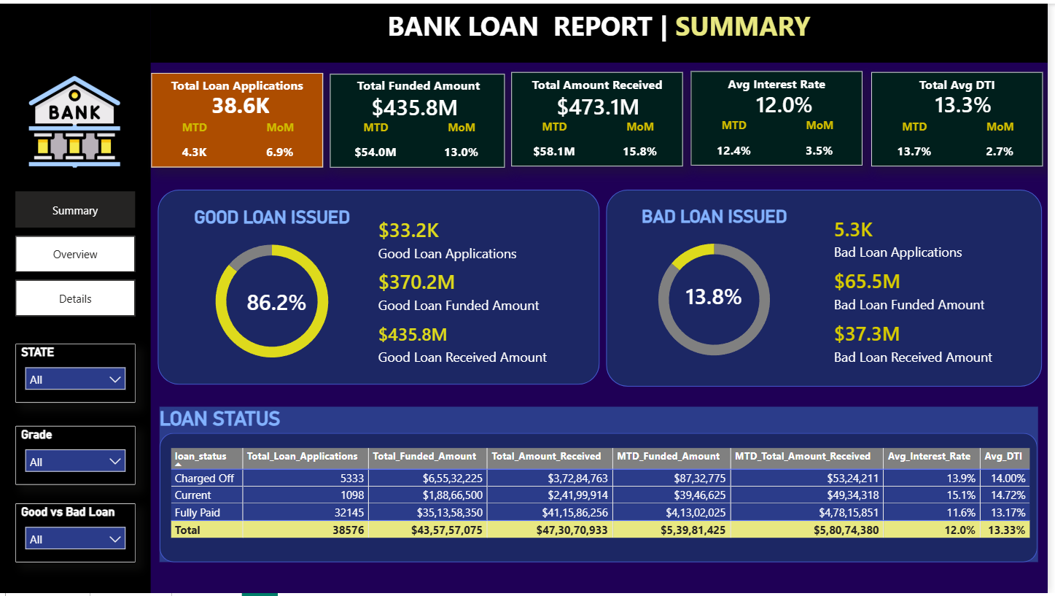
Dashboard 2: Overview
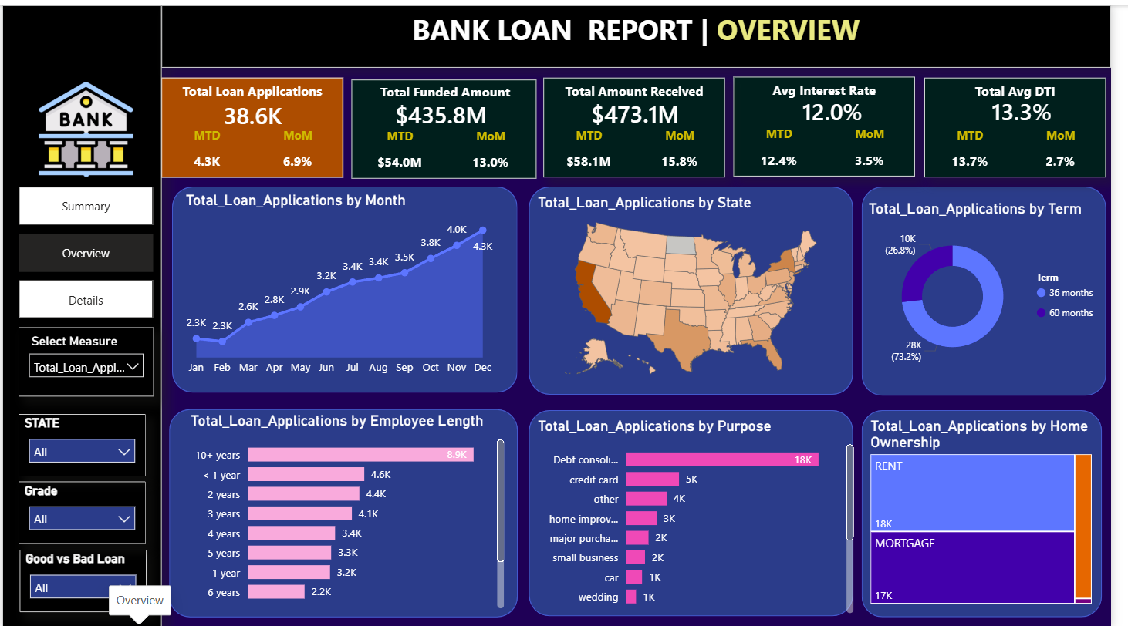
Dashboard 3: Details
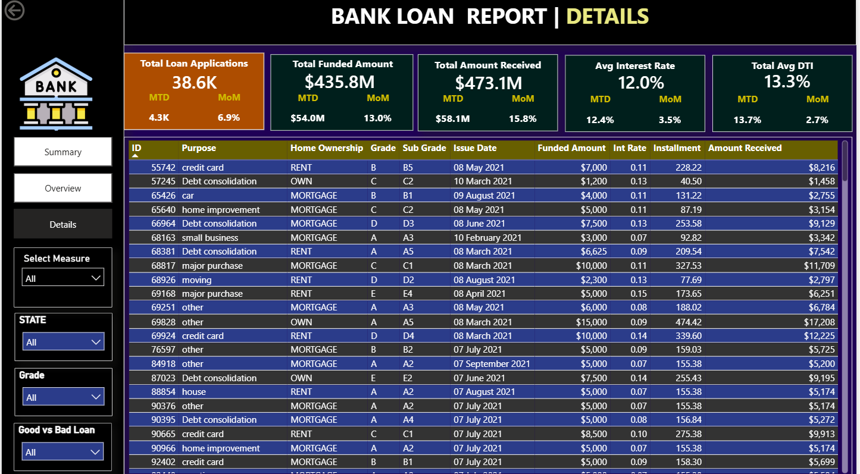

3. SQL Query Document

A. Bank Loan Report | Summary

KPIs
Total Loan Applications
SELECT COUNT(id) AS Total_Applications FROM bank_loan_data

Output
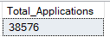
MTD Loan Applications
SELECT COUNT(id) AS Total_Applications FROM bank_loan_data
WHERE MONTH(issue_date) = 12

Output
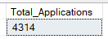
PMTD Loan Applications
SELECT COUNT(id) AS Total_Applications FROM bank_loan_data
WHERE MONTH(issue_date) = 11

Output
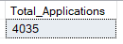
Total Funded Amount
SELECT SUM(loan_amount) AS Total_Funded_Amount FROM bank_loan_data

Output
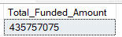
MTD Total Funded Amount
SELECT SUM(loan_amount) AS Total_Funded_Amount FROM bank_loan_data
WHERE MONTH(issue_date) = 12

Output
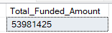
PMTD Total Funded Amount
SELECT SUM(loan_amount) AS Total_Funded_Amount FROM bank_loan_data
WHERE MONTH(issue_date) = 11

Output
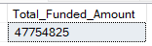
Total Amount Received
SELECT SUM(total_payment) AS Total_Amount_Collected FROM bank_loan_data

Output
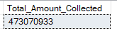
MTD Total Amount Received
SELECT SUM(total_payment) AS Total_Amount_Collected FROM bank_loan_data
WHERE MONTH(issue_date) = 12

Output
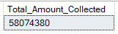
PMTD Total Amount Received
SELECT SUM(total_payment) AS Total_Amount_Collected FROM bank_loan_data
WHERE MONTH(issue_date) = 11

Output
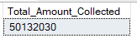
Average Interest Rate
SELECT AVG(int_rate)*100 AS Avg_Int_Rate FROM bank_loan_data

Output
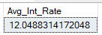
MTD Average Interest Rate
SELECT AVG(int_rate)*100 AS MTD_Avg_Int_Rate FROM bank_loan_data
WHERE MONTH(issue_date) = 12

Output
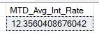
PMTD Average Interest Rate
SELECT AVG(int_rate)*100 AS PMTD_Avg_Int_Rate FROM bank_loan_data
WHERE MONTH(issue_date) = 11

Output
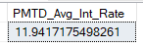
Average DTI
SELECT AVG(dti)*100 AS Avg_DTI FROM bank_loan_data

Output
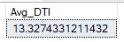
MTD Average DTI
SELECT AVG(dti)*100 AS MTD_Avg_DTI FROM bank_loan_data
WHERE MONTH(issue_date) = 12

Variant restricted to a specific year:
SELECT ROUND(AVG(dti),4)*100 AS MTD_Avg_DTI FROM bank_loan_data
WHERE MONTH(issue_date) = 12 AND YEAR(issue_date) = 2021

Output
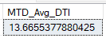
PMTD Average DTI
SELECT AVG(dti)*100 AS PMTD_Avg_DTI FROM bank_loan_data
WHERE MONTH(issue_date) = 11

Output
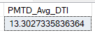

Good Loan Issued
Good Loan = Fully Paid + Current. The basic formula is:
Good Loan % = (Good Loans / Total Loans) × 100
Good Loan Percentage
SELECT
(COUNT(CASE WHEN loan_status = 'Fully Paid' OR loan_status = 'Current' THEN id END) * 100.0)
/ COUNT(id) AS Good_Loan_Percentage
FROM bank_loan_data

Output
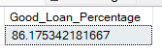
Good Loan Applications
SELECT COUNT(id) AS Good_Loan_Applications FROM bank_loan_data
WHERE loan_status = 'Fully Paid' OR loan_status = 'Current'

Output
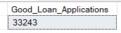
Good Loan Funded Amount
SELECT SUM(loan_amount) AS Good_Loan_Funded_amount FROM bank_loan_data
WHERE loan_status = 'Fully Paid' OR loan_status = 'Current'

Output
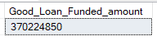
Good Loan Amount Received
SELECT SUM(total_payment) AS Good_Loan_amount_received FROM bank_loan_data
WHERE loan_status = 'Fully Paid' OR loan_status = 'Current'

Output
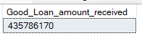

Bad Loan Issued
Bad Loan Percentage
SELECT
(COUNT(CASE WHEN loan_status = 'Charged Off' THEN id END) * 100.0)
/ COUNT(id) AS Bad_Loan_Percentage
FROM bank_loan_data

Output
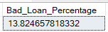
Bad Loan Applications
SELECT COUNT(id) AS Bad_Loan_Applications FROM bank_loan_data
WHERE loan_status = 'Charged Off'

Output
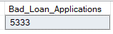
Bad Loan Funded Amount
SELECT SUM(loan_amount) AS Bad_Loan_Funded_amount FROM bank_loan_data
WHERE loan_status = 'Charged Off'

Output
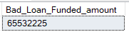
Bad Loan Amount Received
SELECT SUM(total_payment) AS Bad_Loan_amount_received FROM bank_loan_data
WHERE loan_status = 'Charged Off'

Output
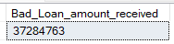

Loan Status
Loan Status Grid View
SELECT
loan_status,
COUNT(id) AS LoanCount,
SUM(total_payment) AS Total_Amount_Received,
SUM(loan_amount) AS Total_Funded_Amount,
AVG(int_rate * 100) AS Interest_Rate,
AVG(dti * 100) AS DTI
FROM bank_loan_data
GROUP BY loan_status

Output
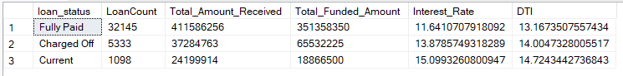
Loan Status Grid View (MTD)
SELECT
loan_status,
SUM(total_payment) AS MTD_Total_Amount_Received,
SUM(loan_amount) AS MTD_Total_Funded_Amount
FROM bank_loan_data
WHERE MONTH(issue_date) = 12
GROUP BY loan_status

Output
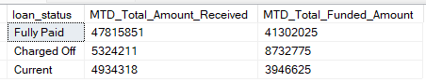

B. Bank Loan Report | Overview

Month
SELECT
MONTH(issue_date) AS Month_Number,
DATENAME(MONTH, issue_date) AS Month_Name,
COUNT(id) AS Total_Loan_Applications,
SUM(loan_amount) AS Total_Funded_Amount,
SUM(total_payment) AS Total_Amount_Received
FROM bank_loan_data
GROUP BY MONTH(issue_date), DATENAME(MONTH, issue_date)
ORDER BY MONTH(issue_date)

Output
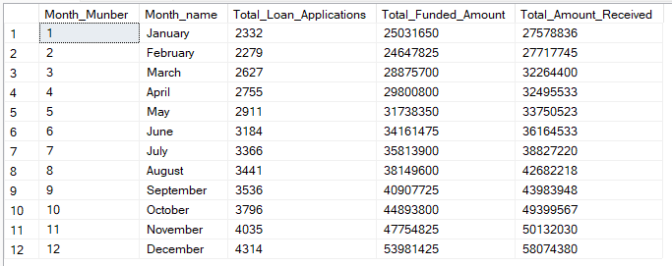

State
Sorted by name / default order
SELECT
address_state AS State,
COUNT(id) AS Total_Loan_Applications,
SUM(loan_amount) AS Total_Funded_Amount,
SUM(total_payment) AS Total_Amount_Received
FROM bank_loan_data
GROUP BY address_state
ORDER BY address_state

Sorted by funded amount (descending)
SELECT
address_state AS State,
COUNT(id) AS Total_Loan_Applications,
SUM(loan_amount) AS Total_Funded_Amount,
SUM(total_payment) AS Total_Amount_Received
FROM bank_loan_data
GROUP BY address_state
ORDER BY SUM(loan_amount) DESC

Sorted by number of applications (descending)
SELECT
address_state AS State,
COUNT(id) AS Total_Loan_Applications,
SUM(loan_amount) AS Total_Funded_Amount,
SUM(total_payment) AS Total_Amount_Received
FROM bank_loan_data
GROUP BY address_state
ORDER BY COUNT(id) DESC

Output
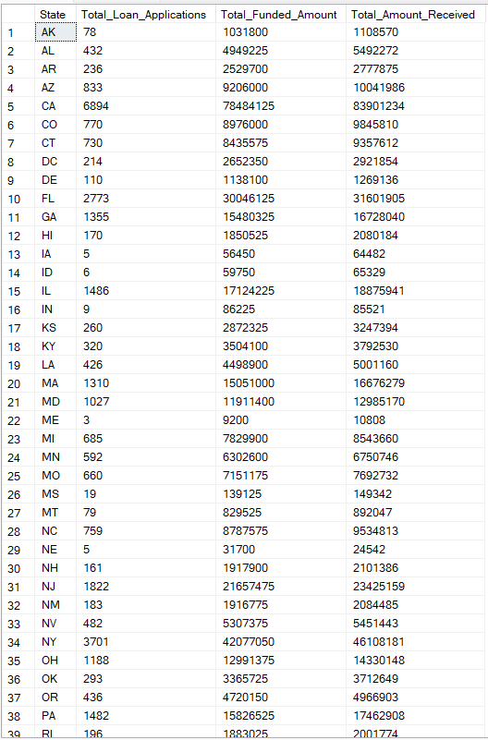

Term
SELECT
term AS Term,
COUNT(id) AS Total_Loan_Applications,
SUM(loan_amount) AS Total_Funded_Amount,
SUM(total_payment) AS Total_Amount_Received
FROM bank_loan_data
GROUP BY term
ORDER BY term

Output
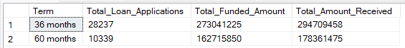

Employee Length
Sorted by name / default order
SELECT
emp_length AS Employee_Length,
COUNT(id) AS Total_Loan_Applications,
SUM(loan_amount) AS Total_Funded_Amount,
SUM(total_payment) AS Total_Amount_Received
FROM bank_loan_data
GROUP BY emp_length
ORDER BY emp_length

Sorted by number of applications (descending)
SELECT
emp_length AS Employee_Length,
COUNT(id) AS Total_Loan_Applications,
SUM(loan_amount) AS Total_Funded_Amount,
SUM(total_payment) AS Total_Amount_Received
FROM bank_loan_data
GROUP BY emp_length
ORDER BY COUNT(id) DESC

Output
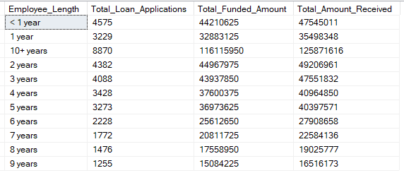

Purpose
Sorted by name / default order
SELECT
purpose AS Purpose,
COUNT(id) AS Total_Loan_Applications,
SUM(loan_amount) AS Total_Funded_Amount,
SUM(total_payment) AS Total_Amount_Received
FROM bank_loan_data
GROUP BY purpose
ORDER BY purpose

Sorted by number of applications (descending)
SELECT
purpose AS Purpose,
COUNT(id) AS Total_Loan_Applications,
SUM(loan_amount) AS Total_Funded_Amount,
SUM(total_payment) AS Total_Amount_Received
FROM bank_loan_data
GROUP BY purpose
ORDER BY COUNT(id) DESC

Output
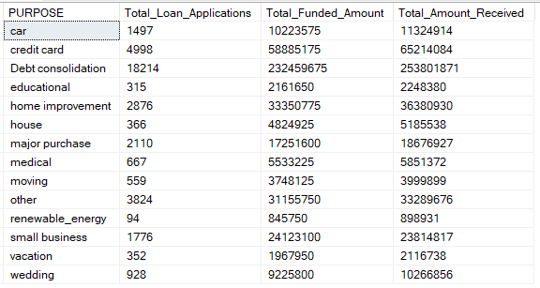

Home Ownership
Sorted by name / default order
SELECT
home_ownership AS Home_Ownership,
COUNT(id) AS Total_Loan_Applications,
SUM(loan_amount) AS Total_Funded_Amount,
SUM(total_payment) AS Total_Amount_Received
FROM bank_loan_data
GROUP BY home_ownership
ORDER BY home_ownership

Sorted by number of applications (descending)
SELECT
home_ownership AS Home_Ownership,
COUNT(id) AS Total_Loan_Applications,
SUM(loan_amount) AS Total_Funded_Amount,
SUM(total_payment) AS Total_Amount_Received
FROM bank_loan_data
GROUP BY home_ownership
ORDER BY COUNT(id) DESC

Output
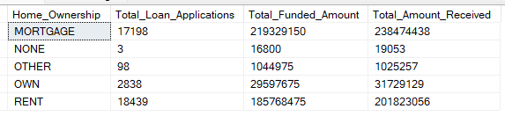
Note: multiple filters are applied on all dashboards. You can check the results for any filter by modifying the query and comparing the results. For example, to see the results when Grade A is selected in the dashboard filters:
SELECT
purpose AS Purpose,
COUNT(id) AS Total_Loan_Applications,
SUM(loan_amount) AS Total_Funded_Amount,
SUM(total_payment) AS Total_Amount_Received
FROM bank_loan_data
WHERE grade = 'A'
GROUP BY purpose
ORDER BY purpose

SELECT
home_ownership AS Home_Ownership,
COUNT(id) AS Total_Loan_Applications,
SUM(loan_amount) AS Total_Funded_Amount,
SUM(total_payment) AS Total_Amount_Received
FROM bank_loan_data
WHERE grade = 'A'
GROUP BY home_ownership
ORDER BY COUNT(id) DESC

4. Terminologies Used in Data
The table below describes each field used in the loan dataset, its purpose, and how banks use it.
Field | Purpose | Use for Banks
Loan ID | Unique identifier assigned to each loan application or loan account. It serves as a primary key for tracking and managing individual loans. | Banks use Loan IDs to manage and track loans throughout their lifecycle, organise loan records, monitor repayments and address customer inquiries.
Address State | Indicates the borrower's location. It helps in assessing regional risk factors, compliance with state regulations and estimating default probabilities. | Banks identify regional trends in loan demand, adjust marketing strategies and manage risk portfolios by geography.
Employee Length | Provides insight into the borrower's employment stability. Longer employment durations may indicate greater job security. | Considered when assessing a borrower's ability to repay. Stable employment often translates to a lower default risk.
Employee Title | Specifies the borrower's occupation or job title and helps lenders understand the source of income. | Used to verify income sources, assess financial capacity and tailor loan offers to different professions.
Grade | A risk classification assigned to the loan based on creditworthiness. Higher grades signify lower risk. | Used to price loans and manage risk. Higher-grade loans typically receive lower interest rates and are more attractive to investors.
Sub Grade | Refines the risk assessment within a grade, providing additional risk differentiation. | Offers a finer level of risk assessment, helping banks tailor interest rates and lending terms to borrower risk profiles.
Home Ownership | Indicates the borrower's housing status and offers insight into financial stability. | Used to assess collateral availability and borrower stability. Homeowners may have lower default rates.
Issue Date | Marks the loan's origination date. Crucial for loan tracking and maturity calculations. | Used to track loan aging, calculate interest accruals and manage loan portfolios.
Last Credit Pull Date | Records when the borrower's credit report was last accessed. Helps monitor creditworthiness. | Used to track credit history updates, assess credit risk and make informed lending decisions.
Last Payment Date | Marks the most recent loan payment received and tracks the borrower's payment history. | Used to assess payment behaviour, calculate delinquency and project future payments.
Loan Status | Indicates the current state of the loan (e.g. Fully Paid, Current, Charged Off) and tracks loan performance. | Used to monitor loan health, categorise loans for risk analysis and determine provisioning requirements.
Next Payment Date | Estimates the date of the next loan payment and assists in cash flow forecasting. | Used for liquidity planning and to project revenue from loan portfolios.
Purpose | Specifies the reason for the loan (e.g. debt consolidation, education) and helps understand borrower intentions. | Used to segment and customise loan offerings, aligning loan terms with borrower needs.
Term | Defines the duration of the loan in months and sets the repayment period. | Used to structure loan agreements, calculate interest payments and manage loan maturities.
Verification Status | Indicates whether the borrower's financial information has been verified and assesses data accuracy. | Used to gauge data reliability, verify income and evaluate loan application credibility.
Annual Income | Reflects the borrower's total yearly earnings and assesses repayment capacity. | Used to determine loan eligibility, calculate debt-to-income ratios and evaluate creditworthiness.
DTI (Debt-to-Income Ratio) | Measures the borrower's debt burden relative to income and gauges capacity to take on additional debt. | Used to assess a borrower's ability to handle loan payments and make responsible lending decisions.
Instalment | The fixed monthly payment amount for loan repayment, including principal and interest. | Used to structure loan terms, calculate amortisation schedules and assess payment affordability.
Interest Rate | The annual cost of borrowing, expressed as a percentage. It determines the loan's cost. | Used to price loans, manage profit margins and attract investors.
Loan Amount | The total borrowed sum; it defines the principal amount. | Used to determine loan size and the bank's exposure on each loan.

