**Assigment Description**

Develops a web application with Java on the server side and HTML / Java script on the client side

The web application must be able to store data to a database

In the web application one should be able to register the following:

1.Personal data with first name, last name and address

2.Vehicle data with owner, year model, brand and registration number

3.A person should be able to own several vehicles

4.One should be able to look up a person to find that person's vehicle

5.One should be able to look up a vehicle brand to find out who owns the vehicle of this vehicle brand.

**Welcome Page**

[**http://localhost:8080/VehicleRegistration/**](http://localhost:8080/VehicleRegistration/)

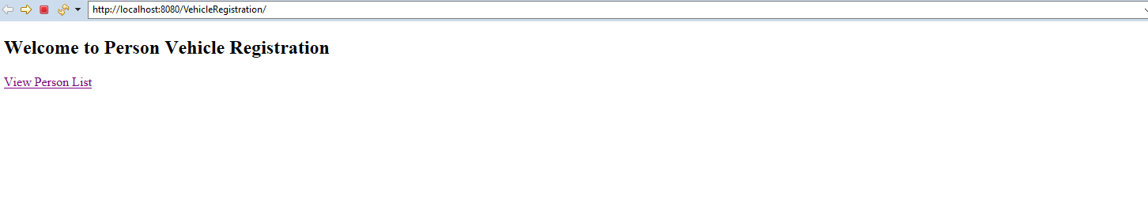

1. Personal data with first name, last name and address

<http://localhost:8080/VehicleRegistration/list>

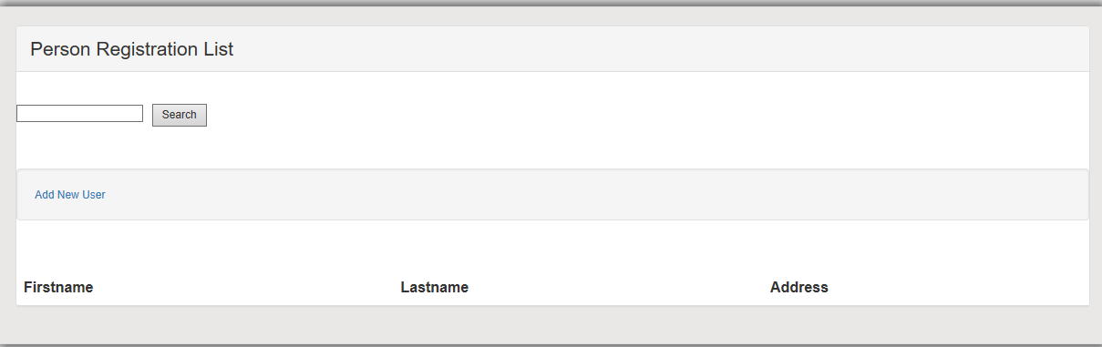

<http://localhost:8080/VehicleRegistration/addVehicle/40>

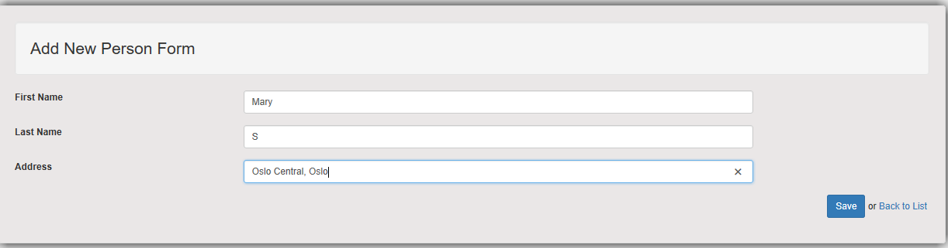

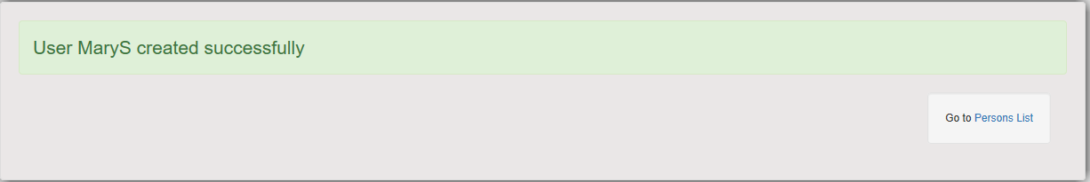

2.Vehicle data with owner, year model, brand and registration number

<http://localhost:8080/VehicleRegistration/addVehicle/37>

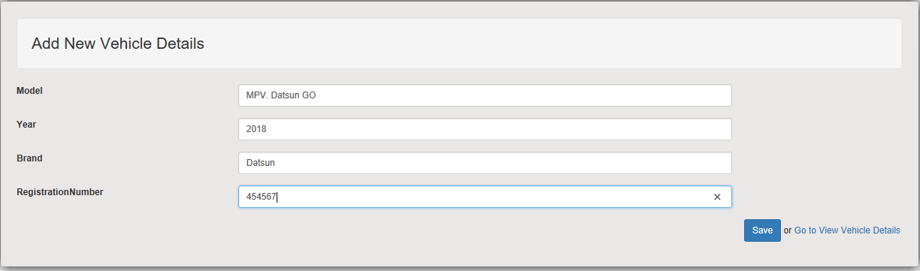



3.A person should be able to own several vehicles

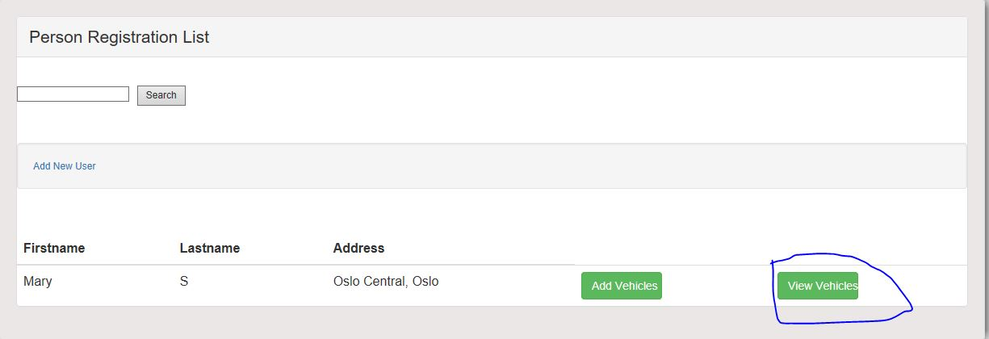

4.One should be able to look up a person to find that person's vehicle

<http://localhost:8080/VehicleRegistration/listVehicles/40>

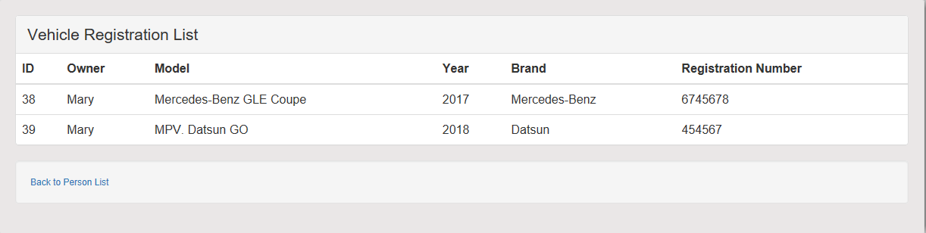

5.One should be able to look up a vehicle brand to find out who owns the vehicle of this vehicle brand.

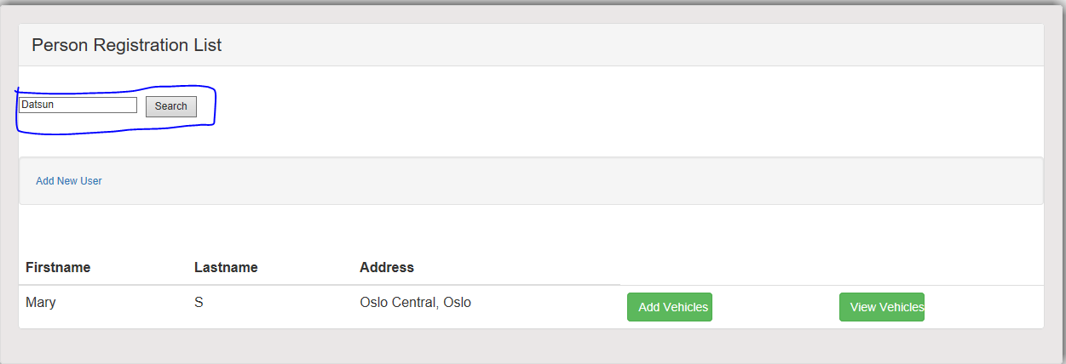

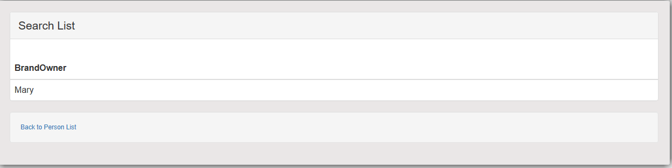

**Date Base Schema:**

1.Person Table with Personid, First Name, Last Name, Address

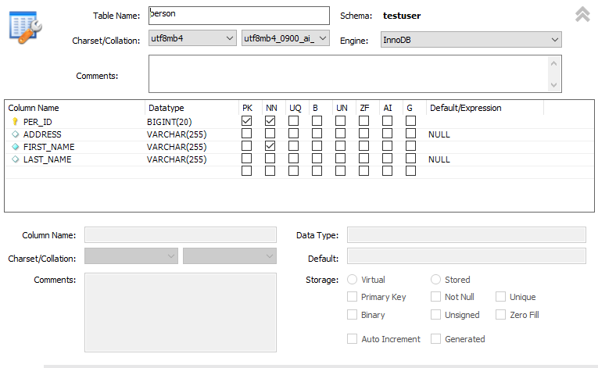

2.Vehicle Table with vehicleId, Model, OwnerName, Registration Number, Year, Brand ,PersonId(Foreign Key from Person Table)

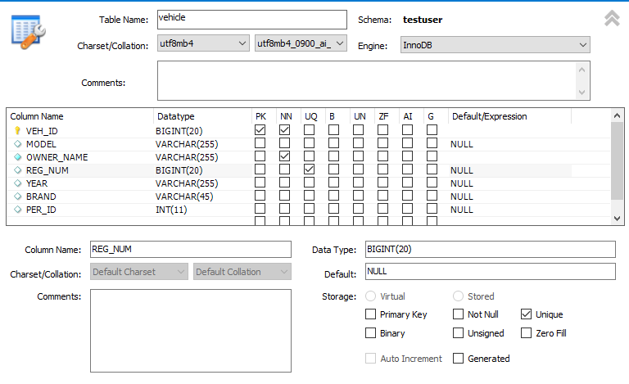

Technologies Used: Spring Html with Jsp, styling Css, Spring 5 , Hibernate 5

DateBase : MySql Server-8.0.16

WebServer : Apache Tomcat 8.5

DateBase Configuration:

driverClassName = com.mysql.jdbc.Driver

url = jdbc:mysql://localhost:3307/testuser?useUnicode=true&useJDBCCompliantTimezoneShift=true&useLegacyDatetimeCode=false&serverTimezone=UTC

username = root

password = system

**Schema for Tables :**

1. CREATE TABLE `person` (

`PER_ID` bigint(20) NOT NULL,

`ADDRESS` varchar(255) DEFAULT NULL,

`FIRST_NAME` varchar(255) NOT NULL,

`LAST_NAME` varchar(255) DEFAULT NULL,

PRIMARY KEY (`PER_ID`)

) ENGINE=InnoDB DEFAULT CHARSET=utf8mb4 COLLATE=utf8mb4_0900_ai_ci;

INSERT INTO `testuser`.`person`

(`PER_ID`,

`ADDRESS`,

`FIRST_NAME`,

`LAST_NAME`)

VALUES

(<{PER_ID: }>,

<{ADDRESS: }>,

<{FIRST_NAME: }>,

<{LAST_NAME: }>);

2.CREATE TABLE `vehicle` (

`VEH_ID` bigint(20) NOT NULL,

`MODEL` varchar(255) DEFAULT NULL,

`OWNER_NAME` varchar(255) NOT NULL,

`REG_NUM` bigint(20) DEFAULT NULL,

`YEAR` varchar(255) DEFAULT NULL,

`BRAND` varchar(45) DEFAULT NULL,

`PER_ID` int(11) DEFAULT NULL,

PRIMARY KEY (`VEH_ID`),

UNIQUE KEY `REG_NUM_UNIQUE` (`REG_NUM`)

) ENGINE=InnoDB DEFAULT CHARSET=utf8mb4 COLLATE=utf8mb4_0900_ai_ci;

INSERT INTO `testuser`.`vehicle`

(`VEH_ID`,

`MODEL`,

`OWNER_NAME`,

`REG_NUM`,

`YEAR`,

`BRAND`,

`PER_ID`)

VALUES

(<{VEH_ID: }>,

<{MODEL: }>,

<{OWNER_NAME: }>,

<{REG_NUM: }>,

<{YEAR: }>,

<{BRAND: }>,

<{PER_ID: }>);