React.js Component Creation

*Name: Sankepalli Aswini*

*Rollno:209F1A0599*

*College name: Sri Venkateswara institute of technology*

*Email id: sankepalliaswini@gmail.com*

source code :

CARD COMPONENT :

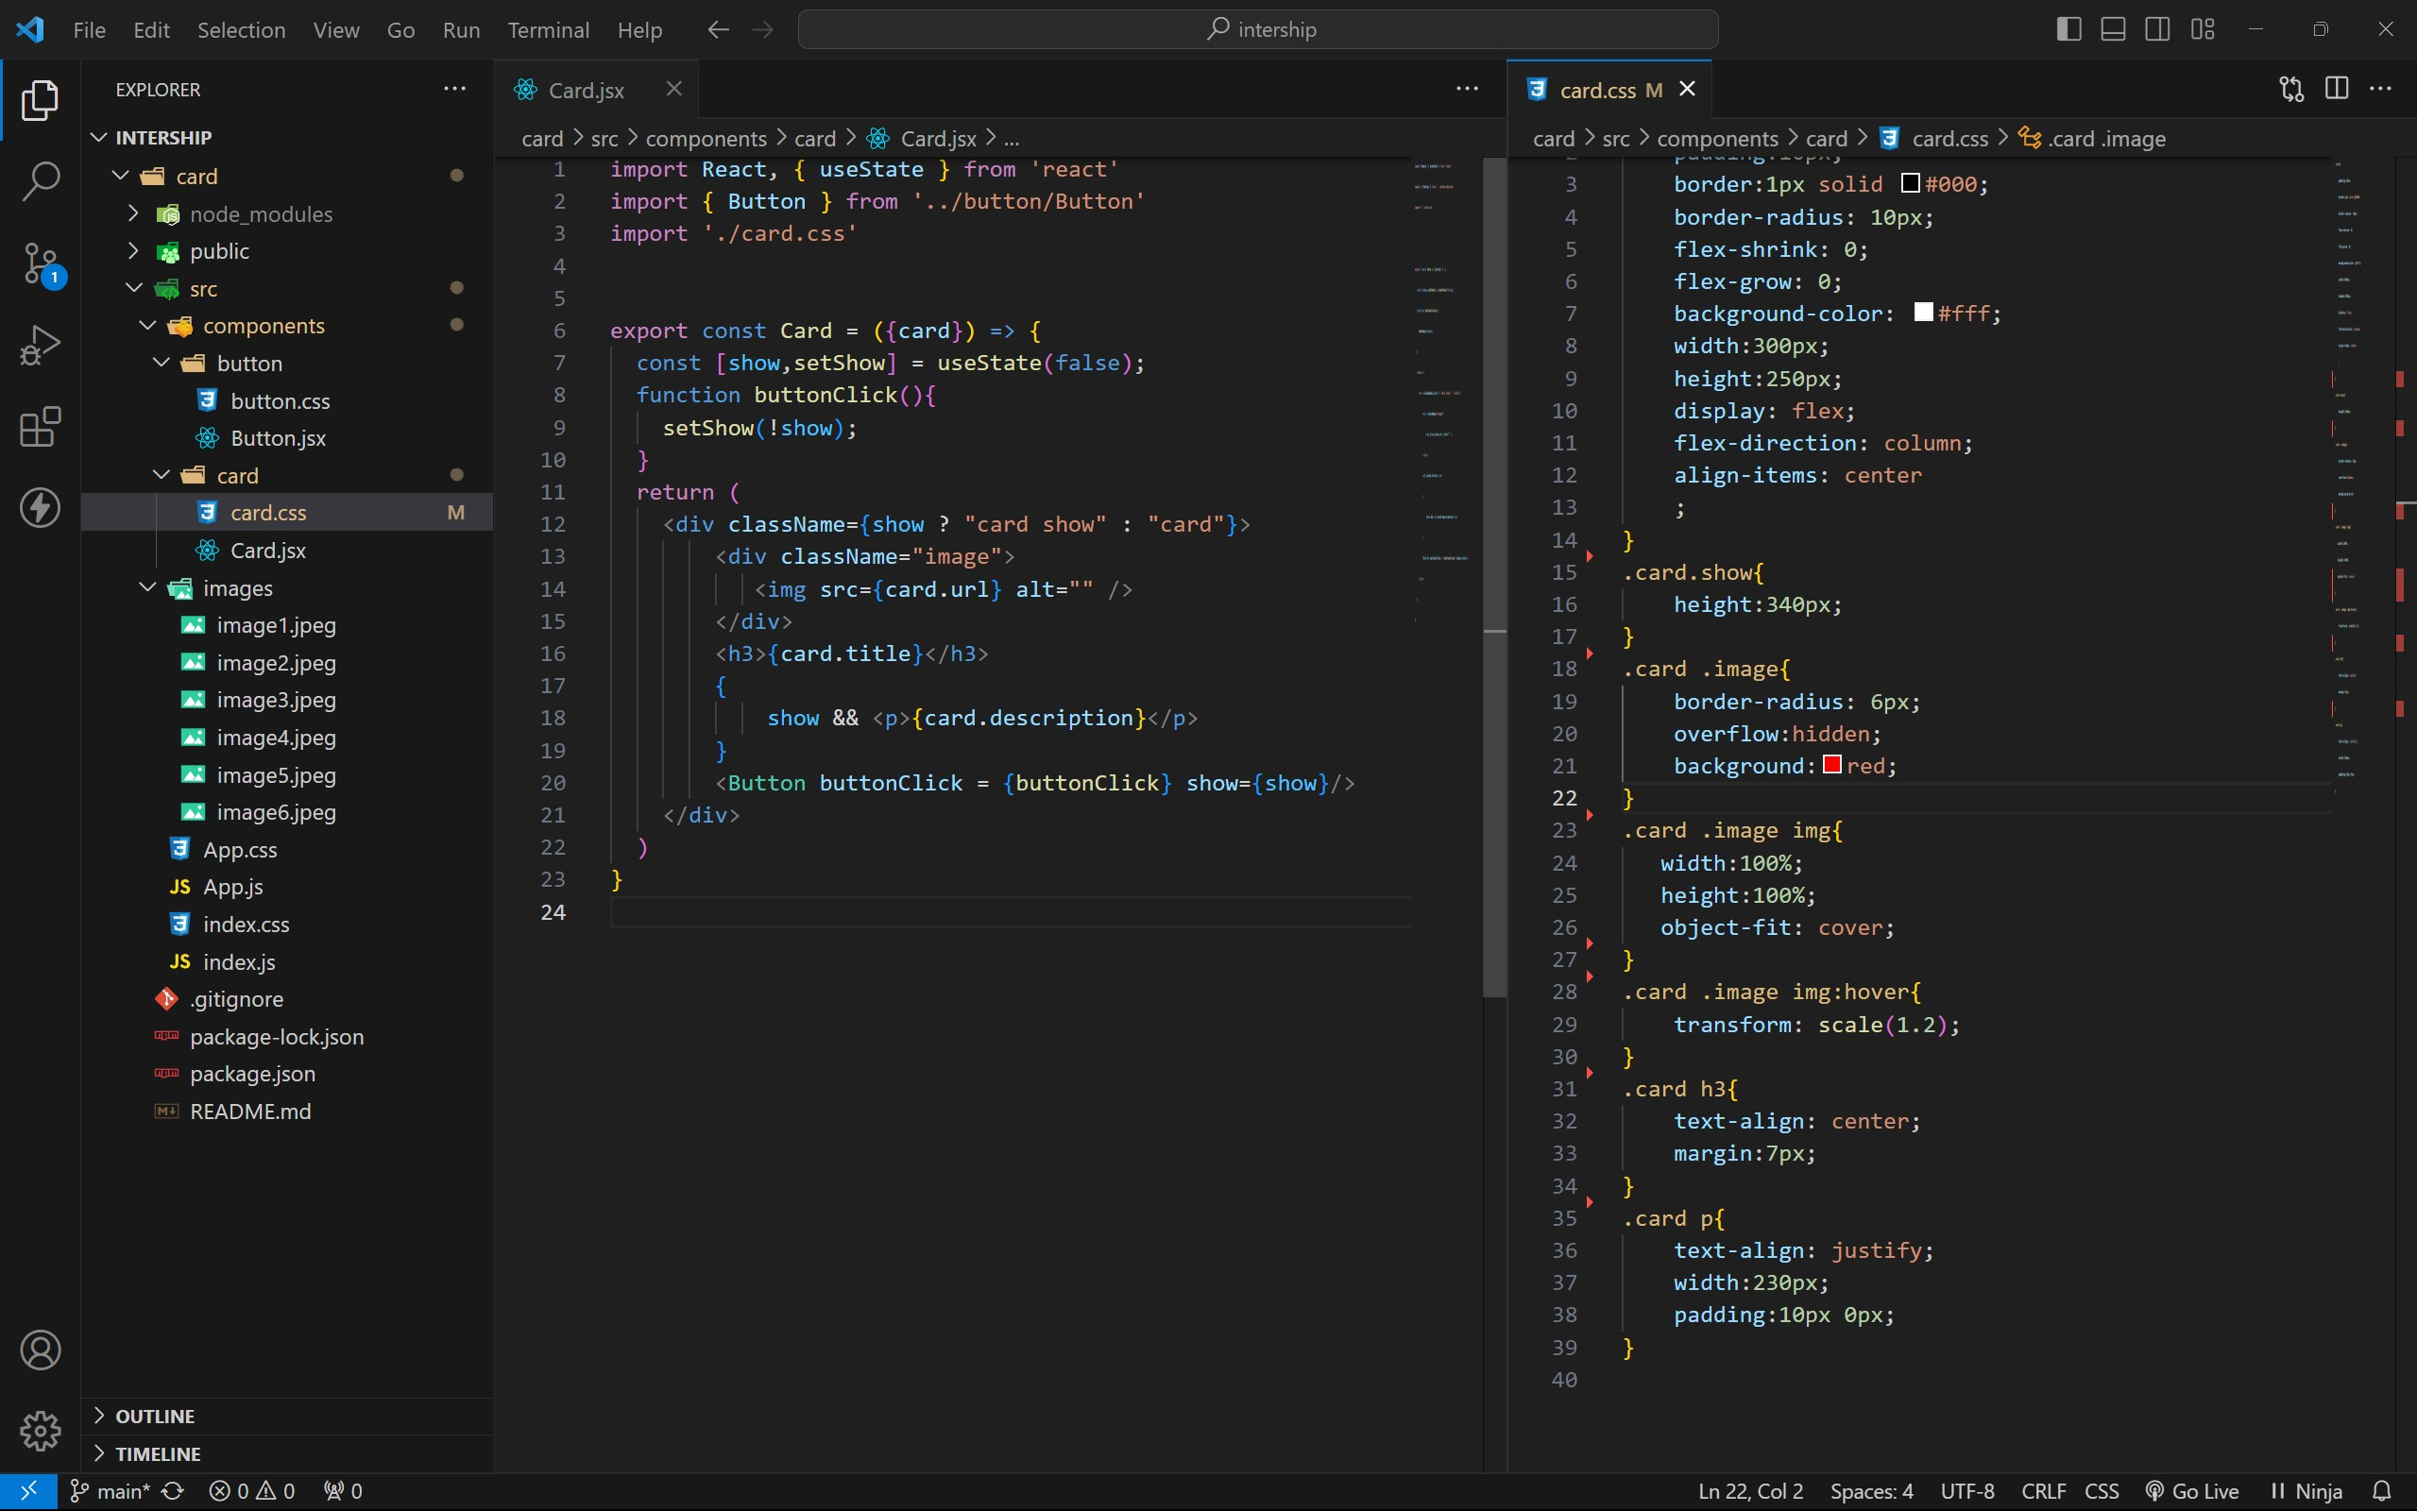

BUTTON COMPONENT :

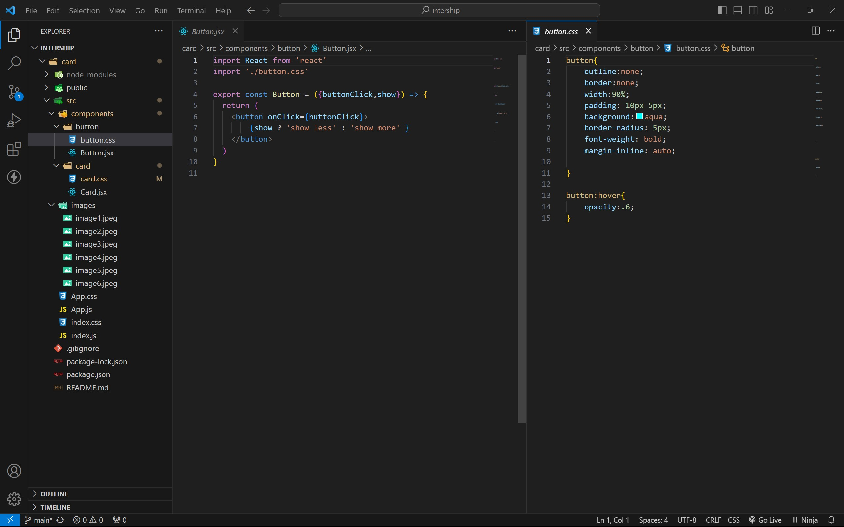

APP COMPONENT :

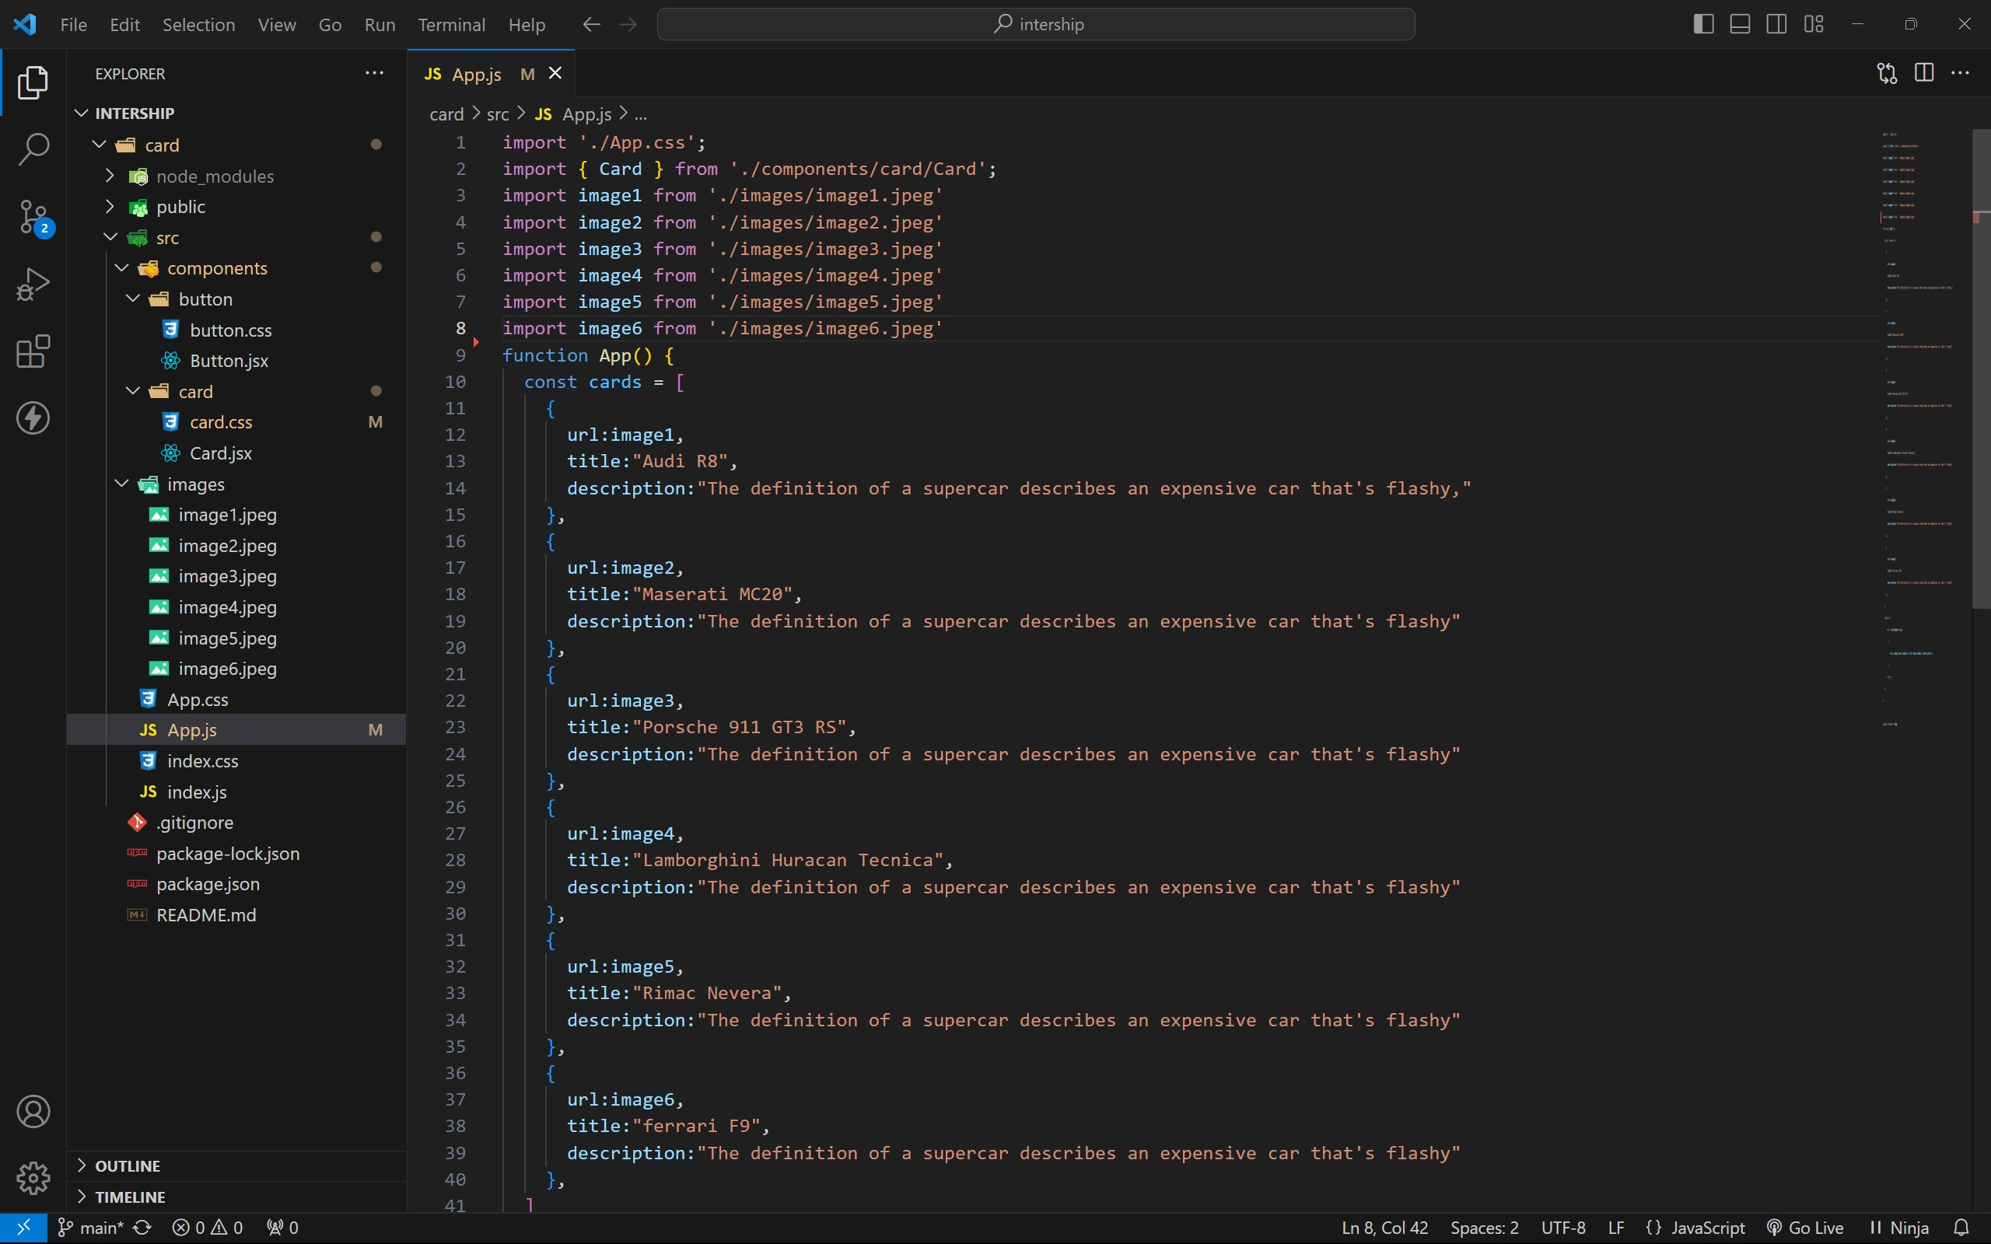

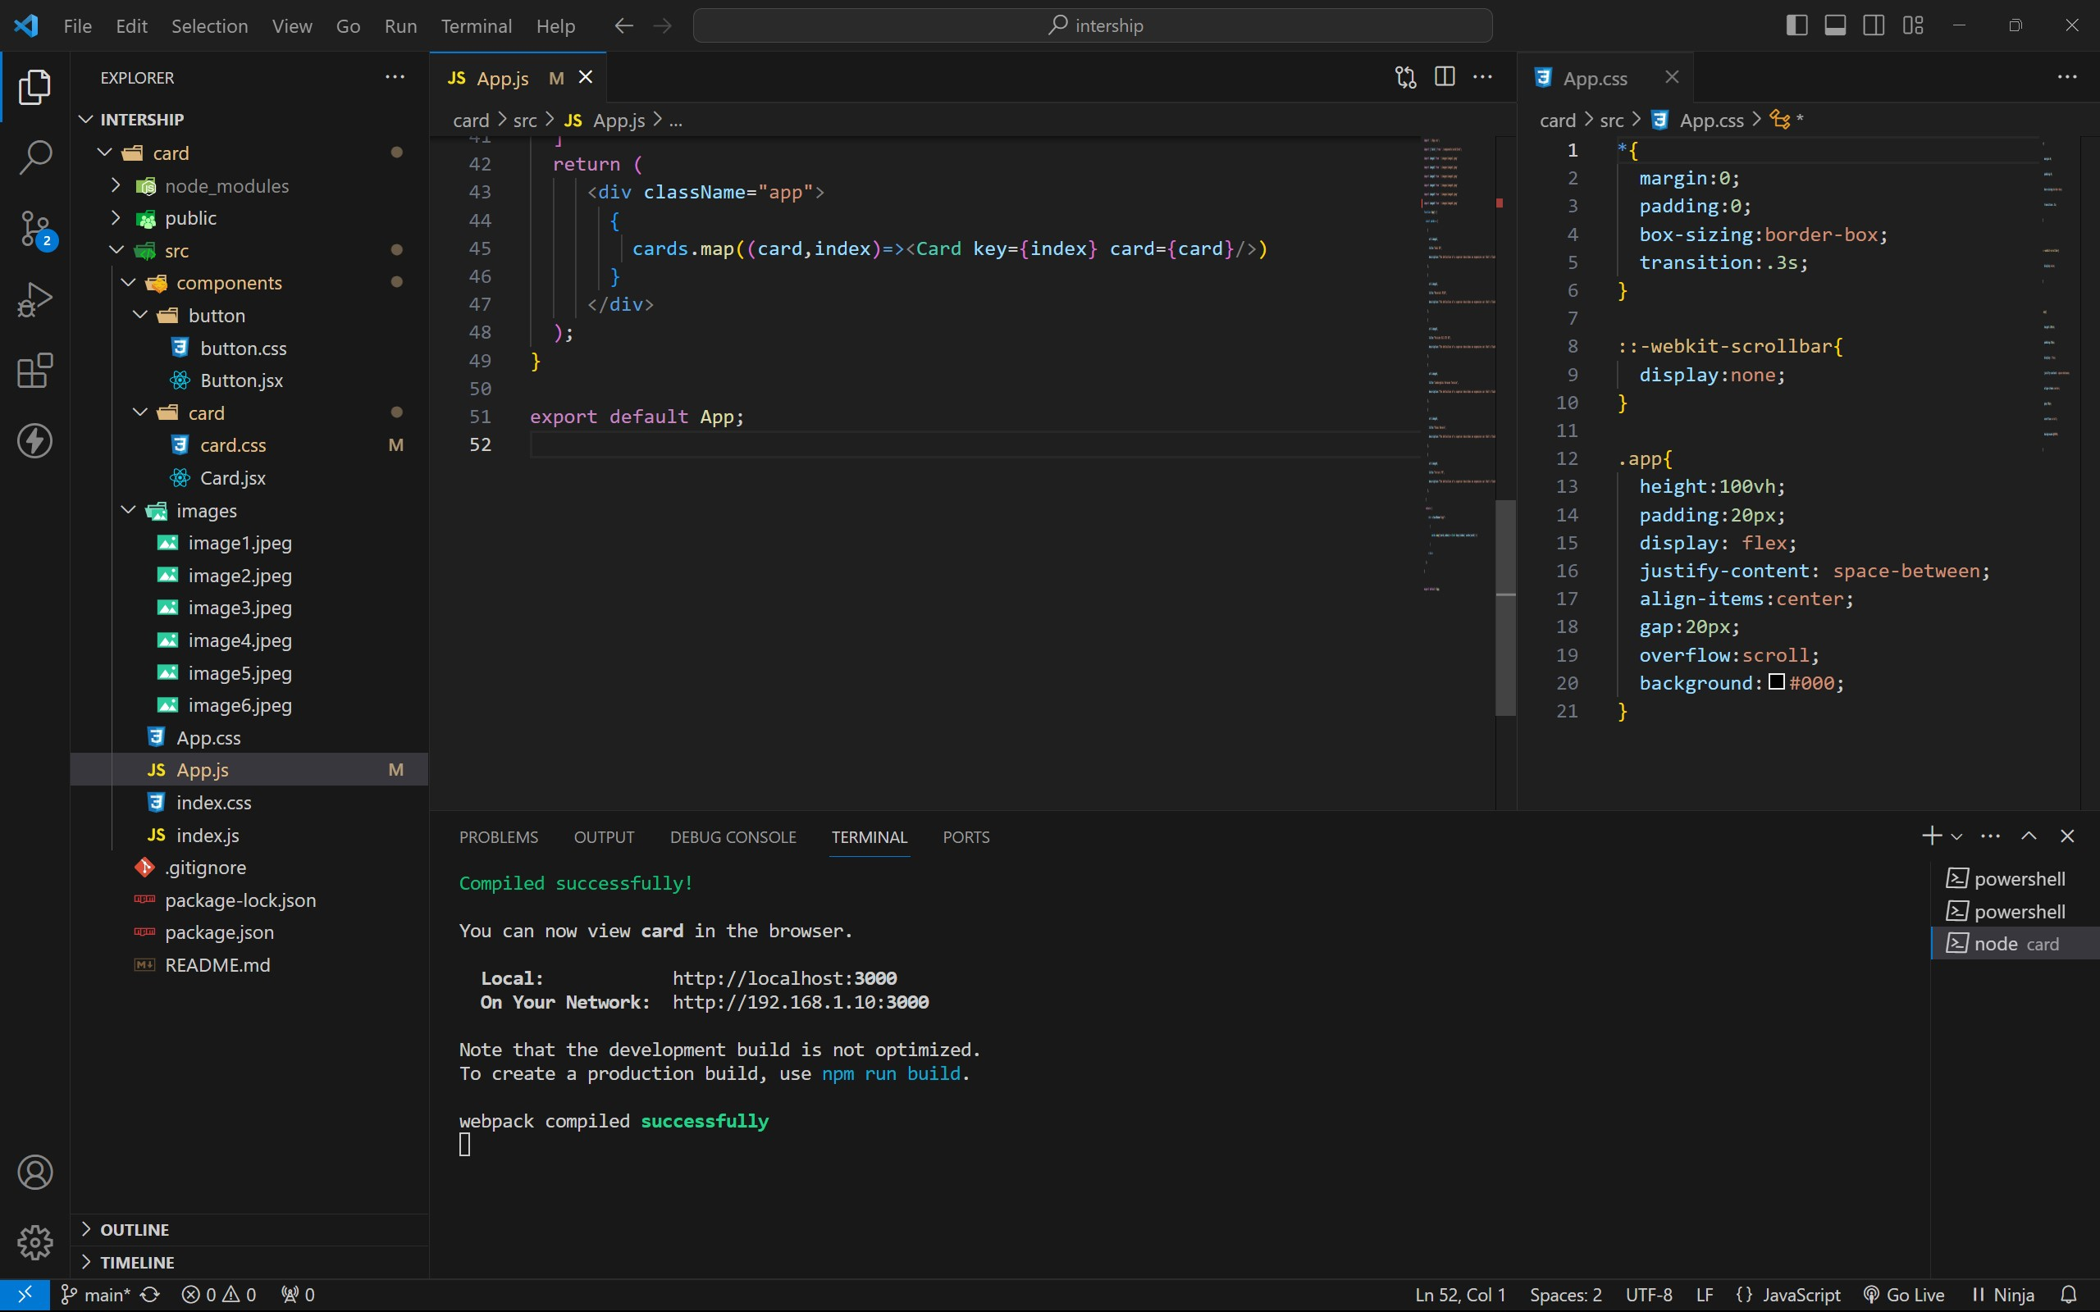

approach :

1. . initially taking an array of objects like below

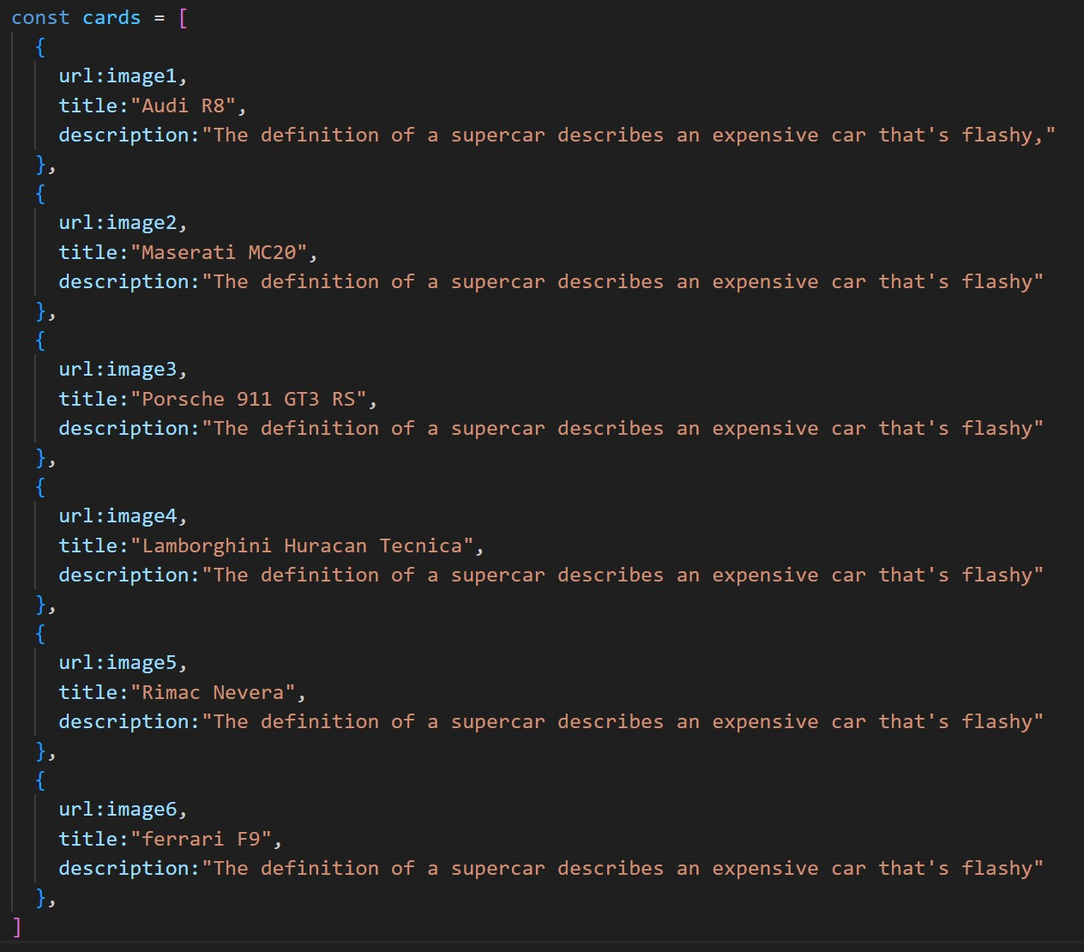

1. . Passing this card array to child (card component) of App component by using props;
2. . getting data as argument like {card} in card component.
3. . in card component i use one state [show, setShow] to get extra info as

description.

1. . When we click the button then show becomes true by assigning setShow (!show) .

OUTPUT :

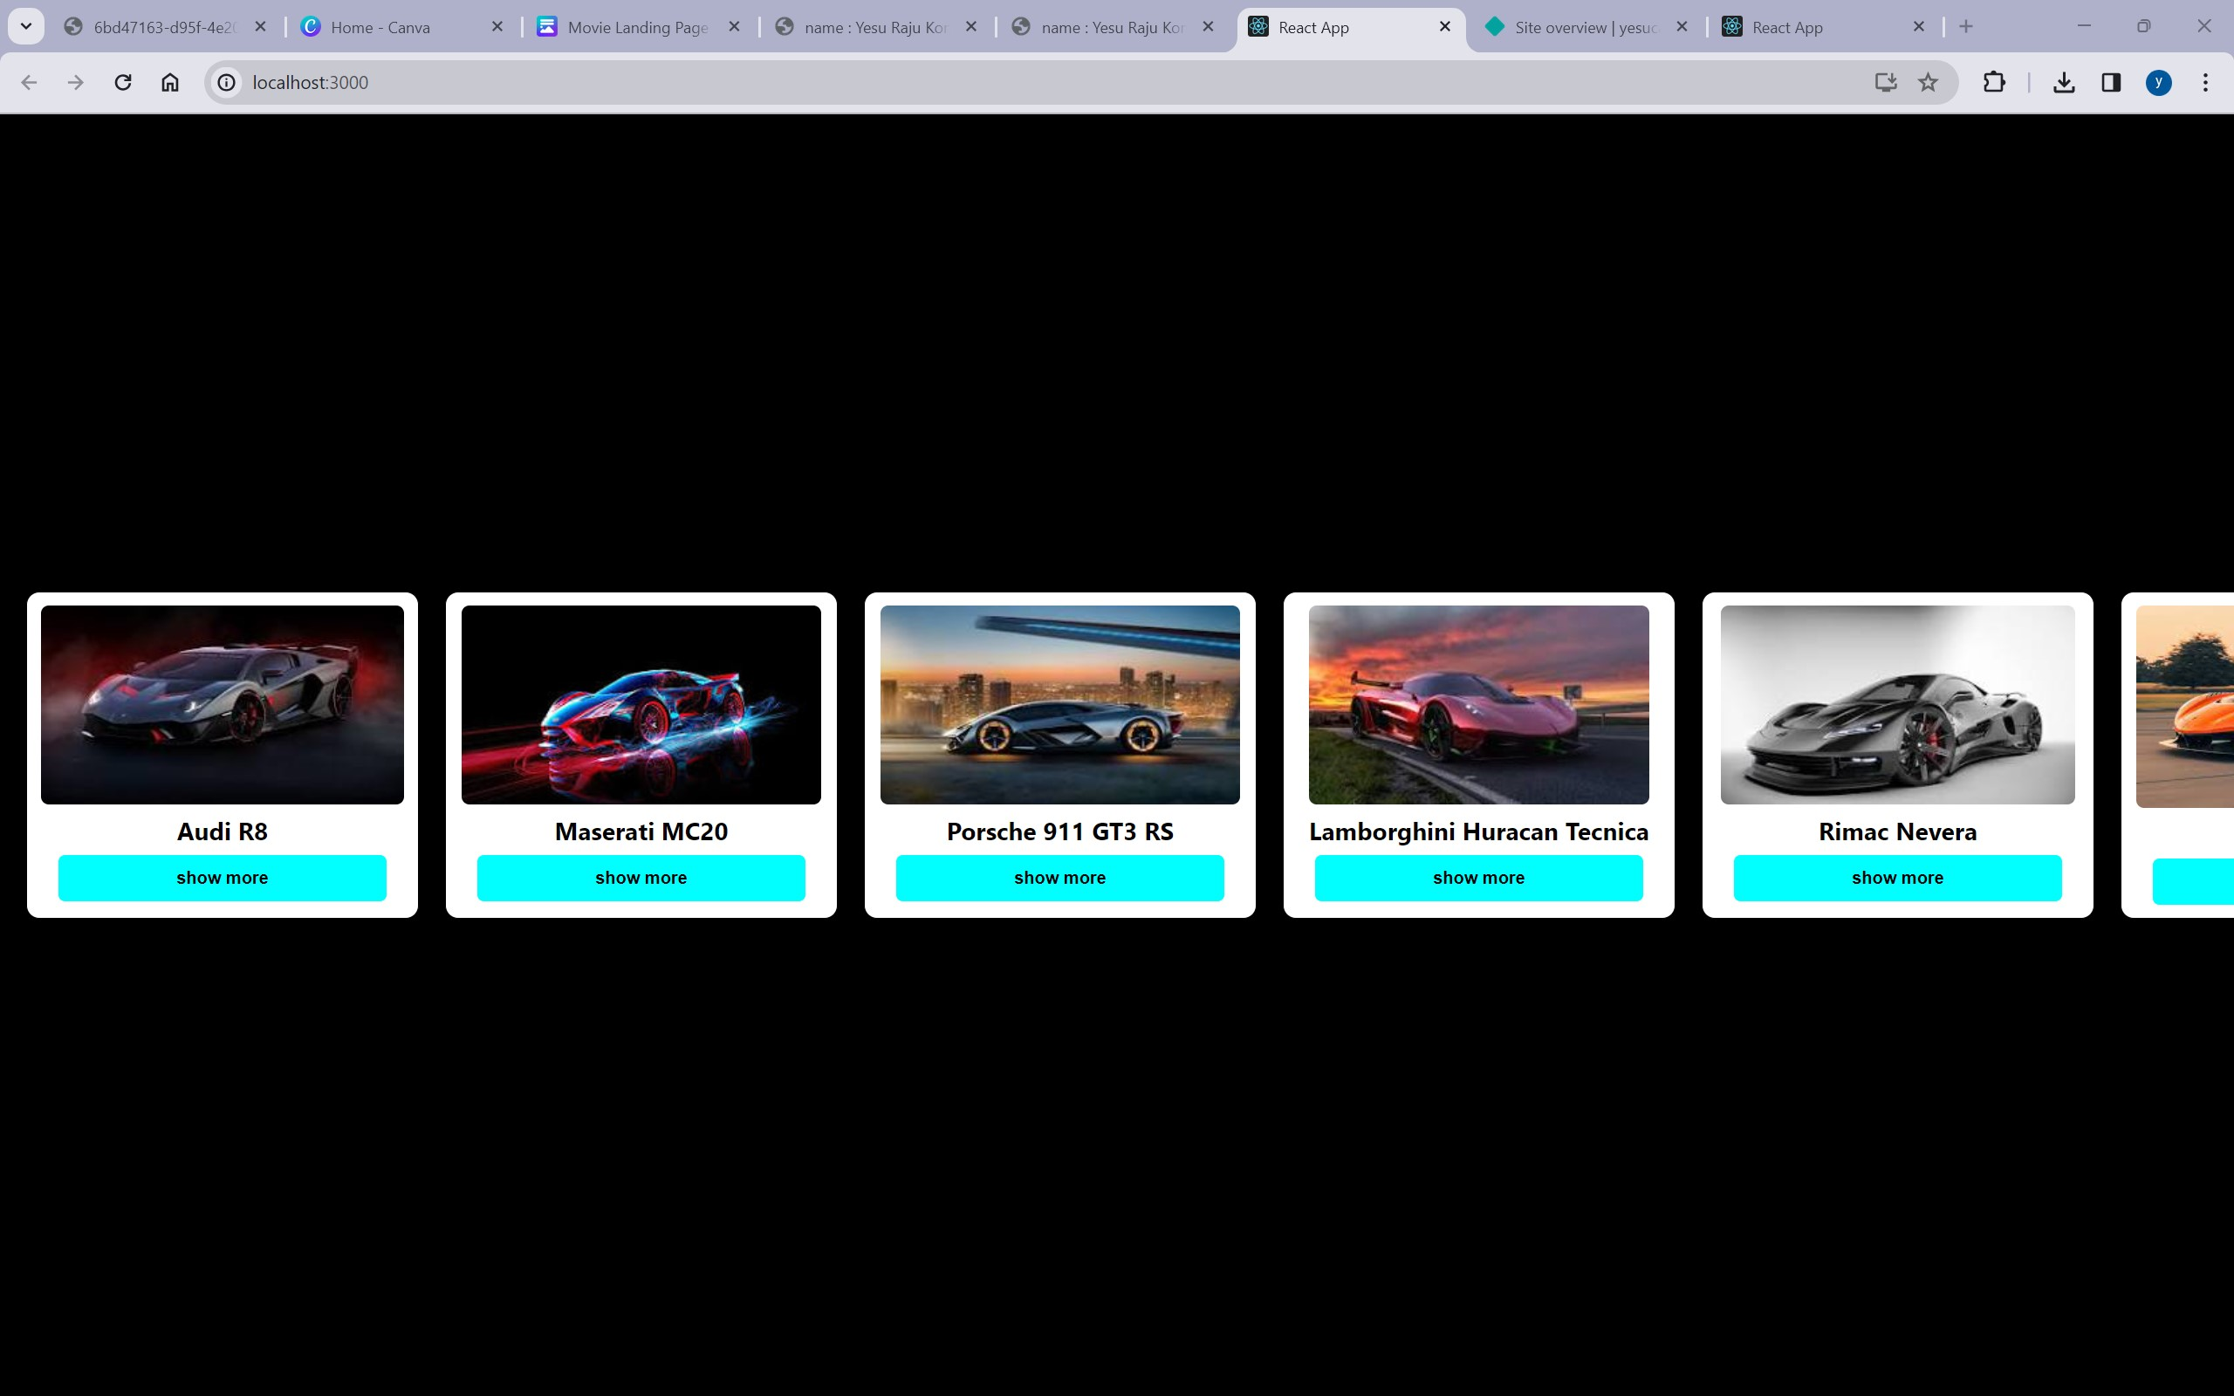

AFTER BUTTON CLICKS :

