Creating a RESTful API using express.js and creating a database and index in MongoDB.

Name: Sankepalli Aswini

Rollno:209F1A0599

Email id: sankepalliaswini@gmail.com

College Name: Sri Venkateswara Institute of Technology

source code :

index.js file :

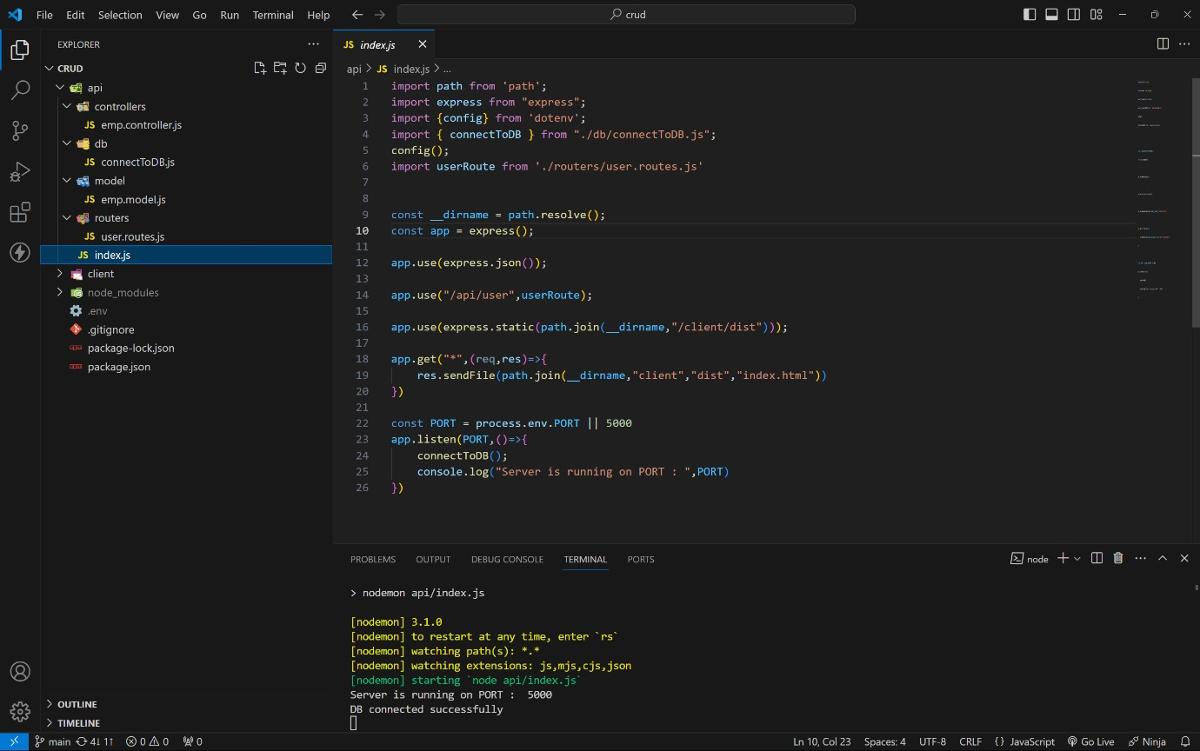

MONGODB CONNECTION :

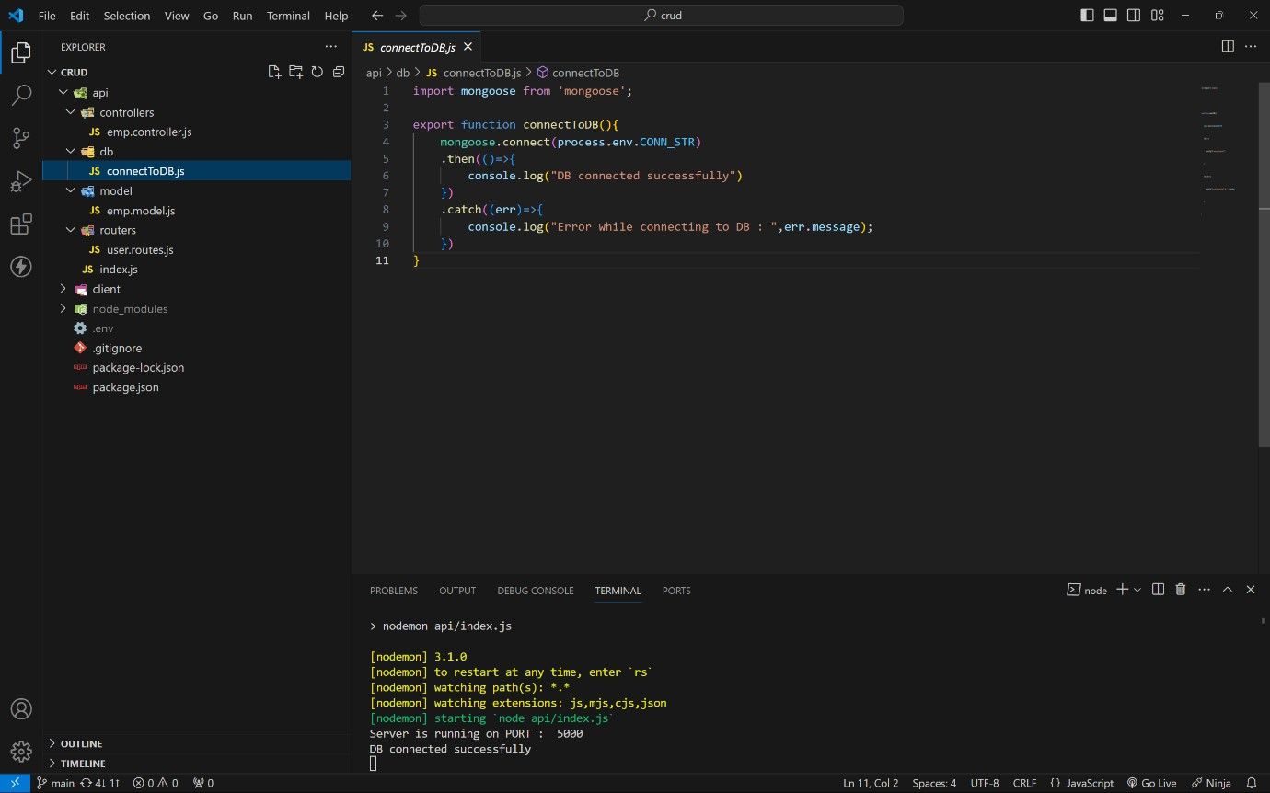

MODEL :

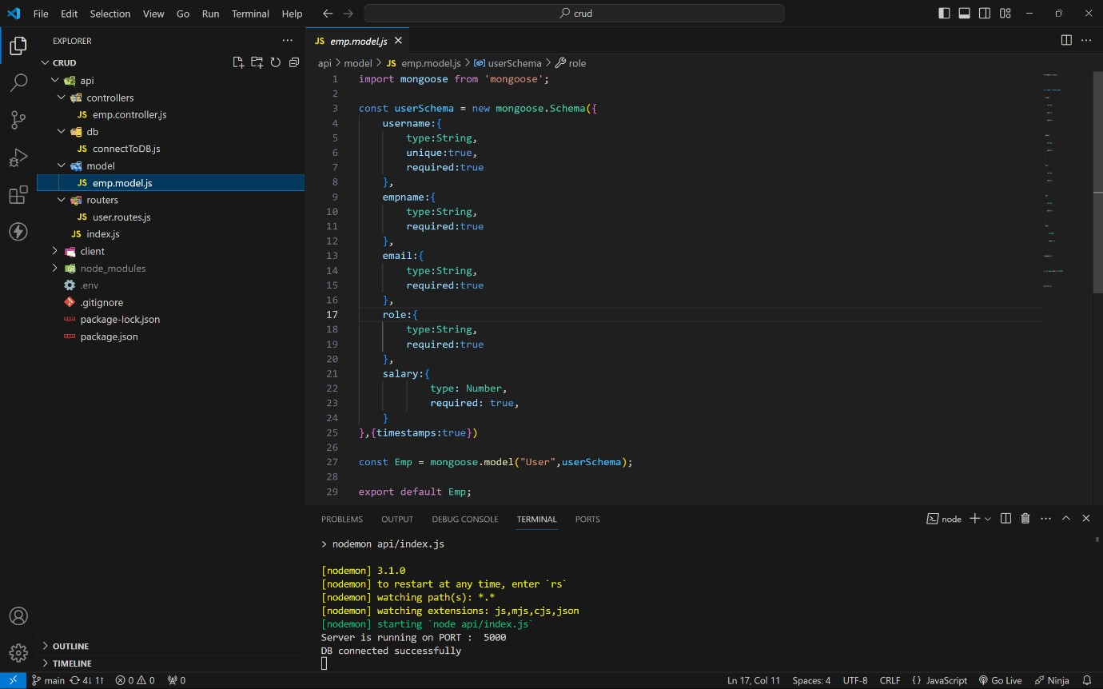

ROUTES:

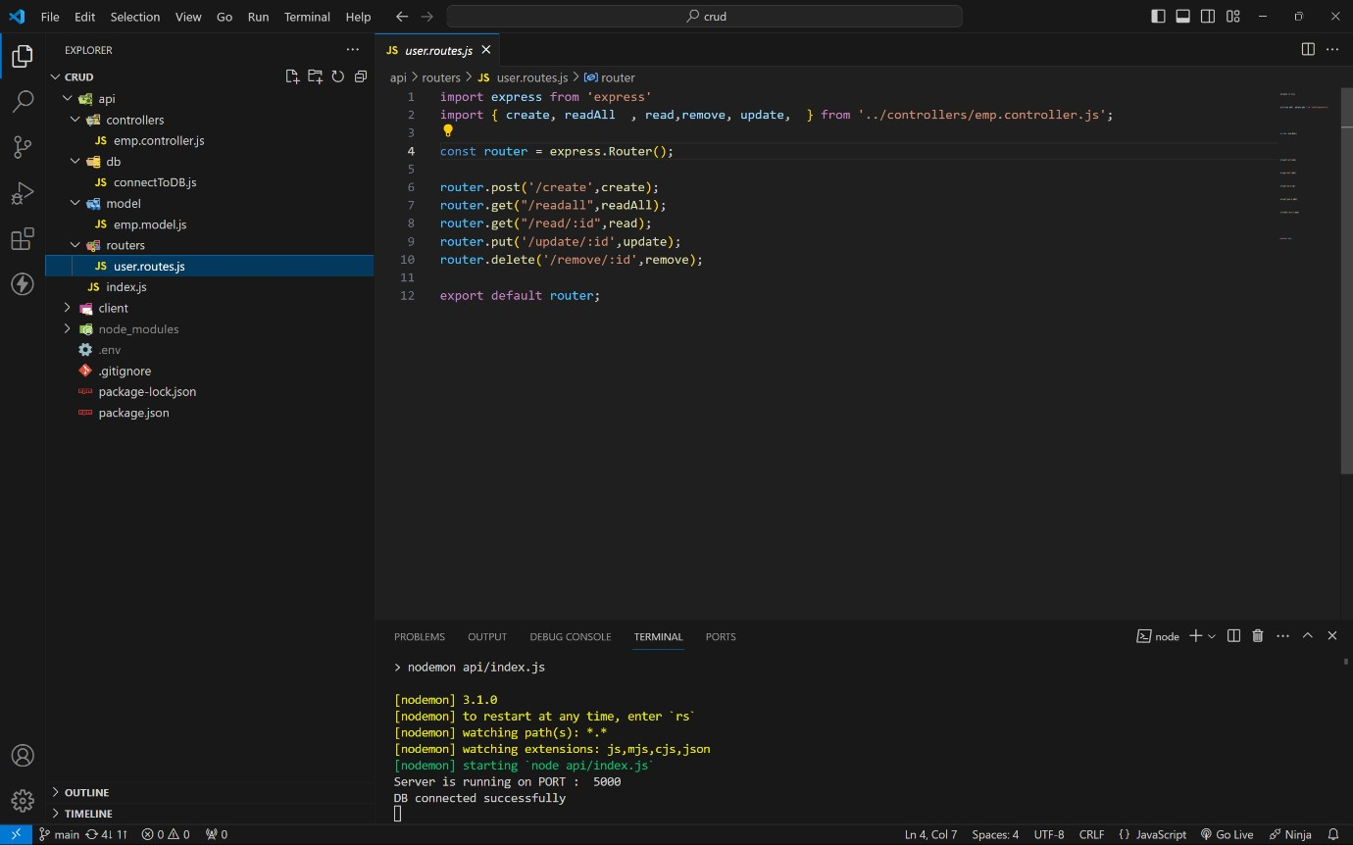

CONTROLLERS :

CREATE :

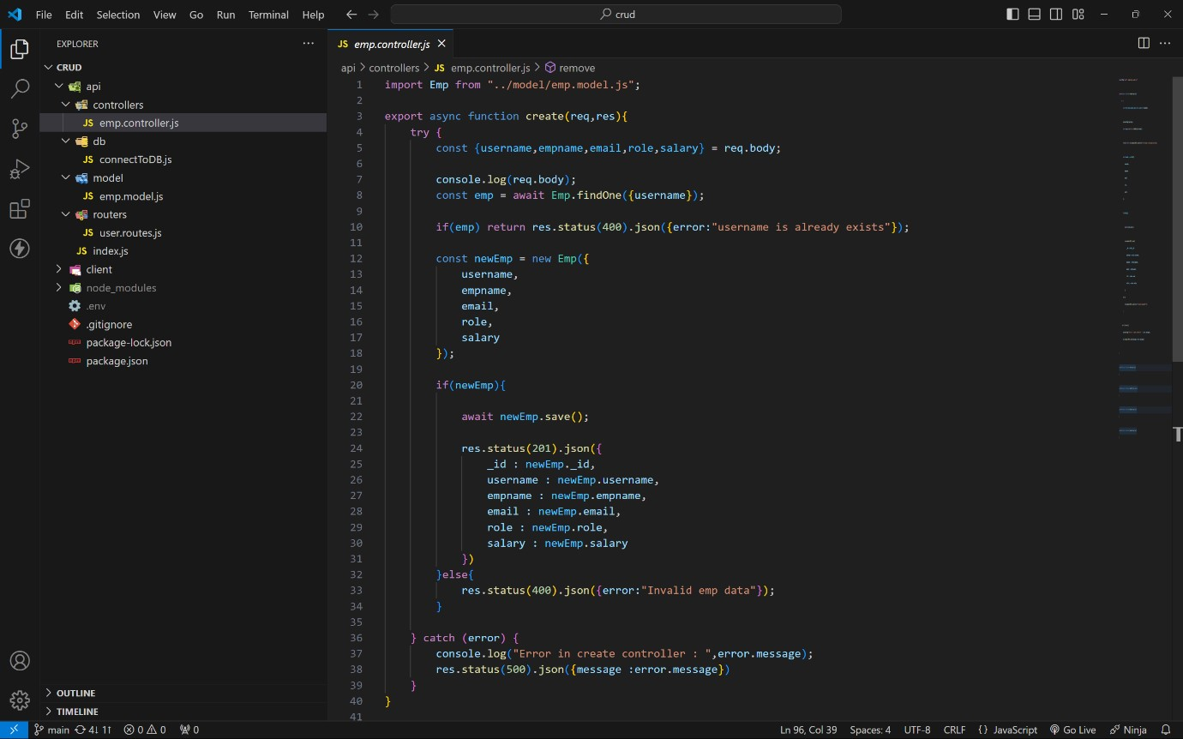

READALL:

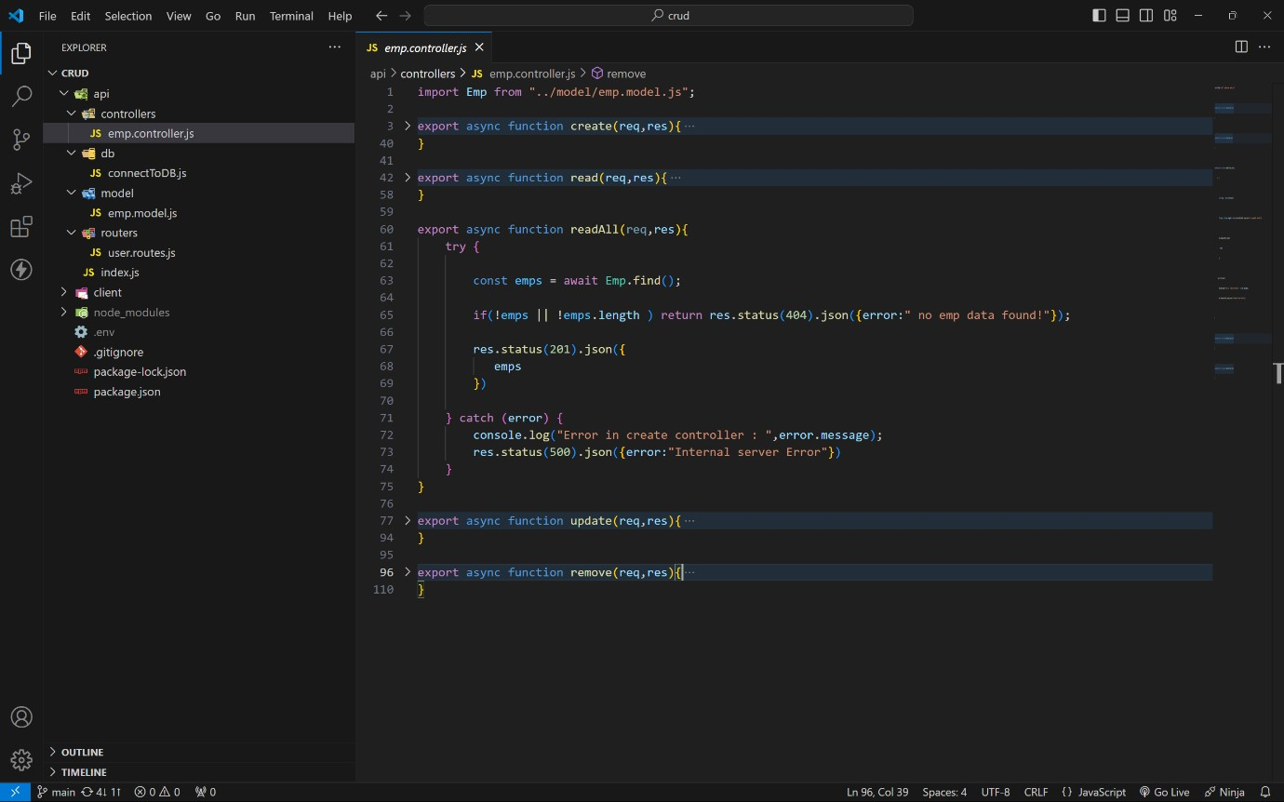

READONE :

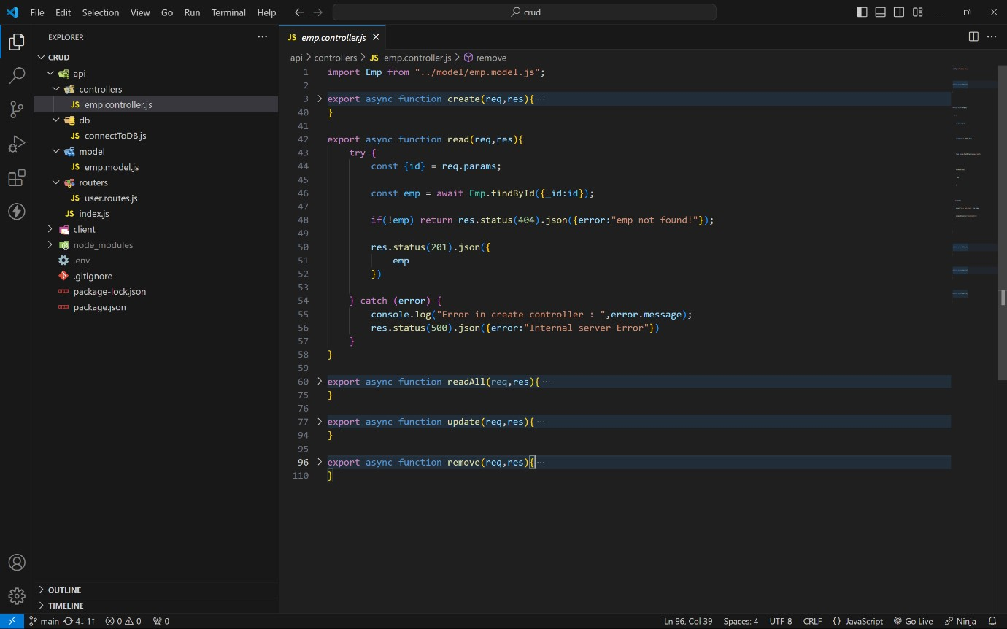

UPDATE :

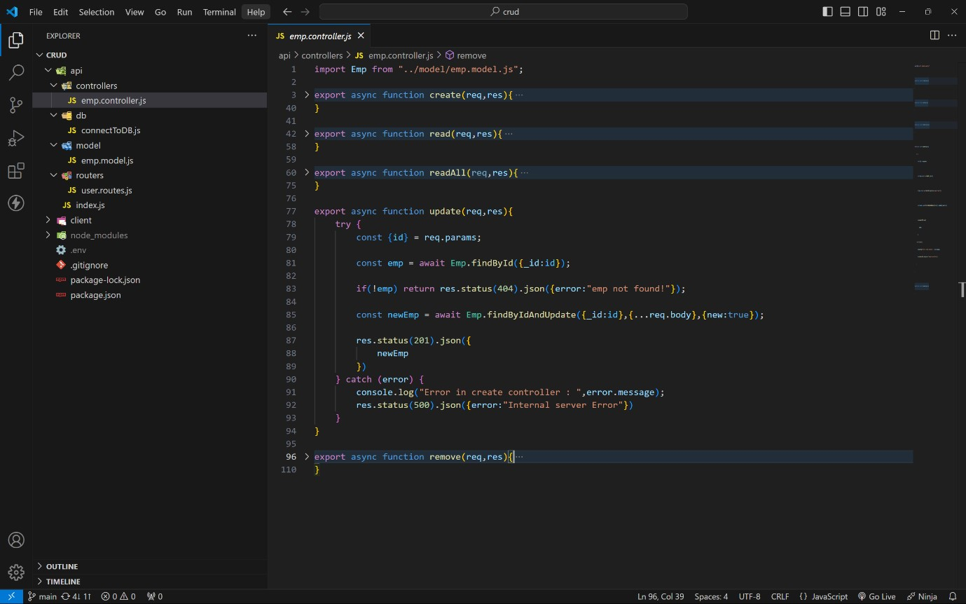

DELETE :

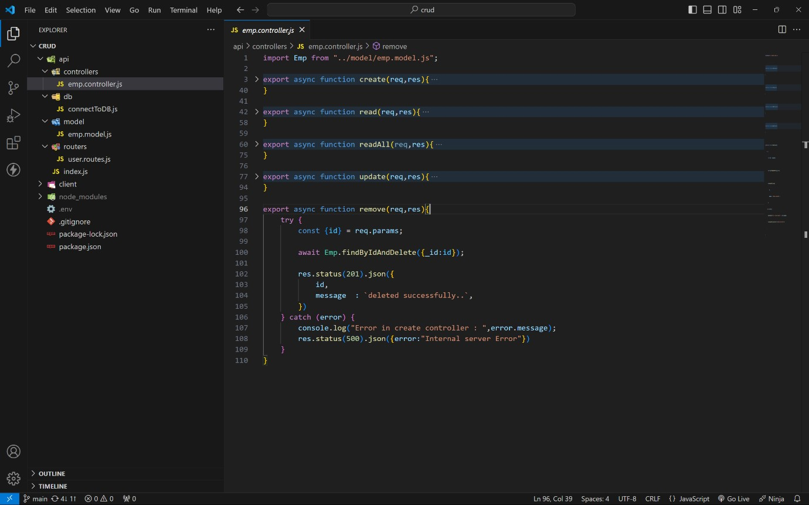

HOW TO RUN ON LOCALLY :

1. . Create a folder as any name.
2. . Open that folder in any code editor (vs code).
3. . Open terminal on code editor.
4. . Type this code to get code locally. git clone
5. . Now move to crud folder (cd crud in terminal)
6. . Ignore client folder.
7. . Here crud is root folder.
8. . In root folder create a .env file and create a PORT and

CONN_STR variables and assign value.

ex : PORT = 3000 ( commonly any number between 3000 - 8080).

CONN_STR = your mongodb_connection_string.

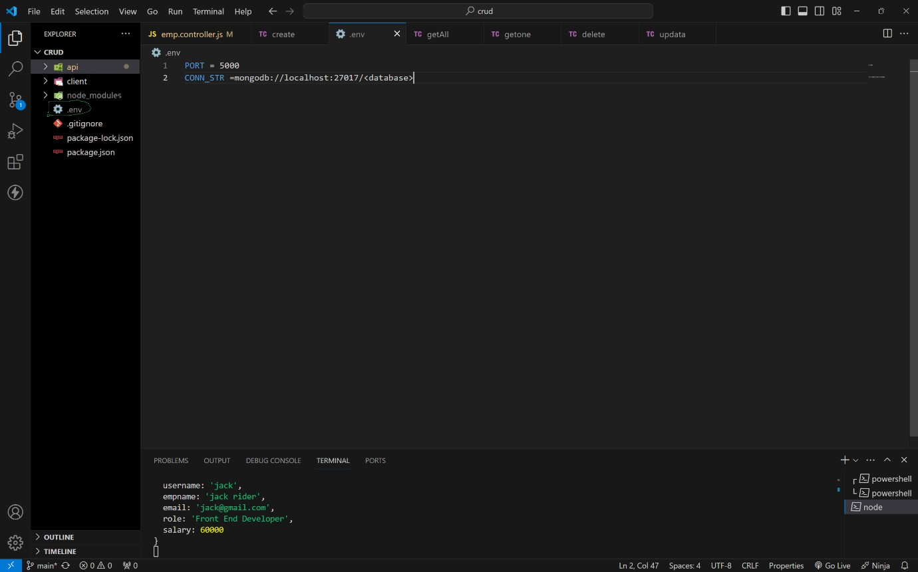

1. . After in terminal (in crud folder as root folder) type this command to run server.

npm i (installing all dependencies) npm run dev (to run server)

1. . if you get below message in terminal then your server will running successfully.

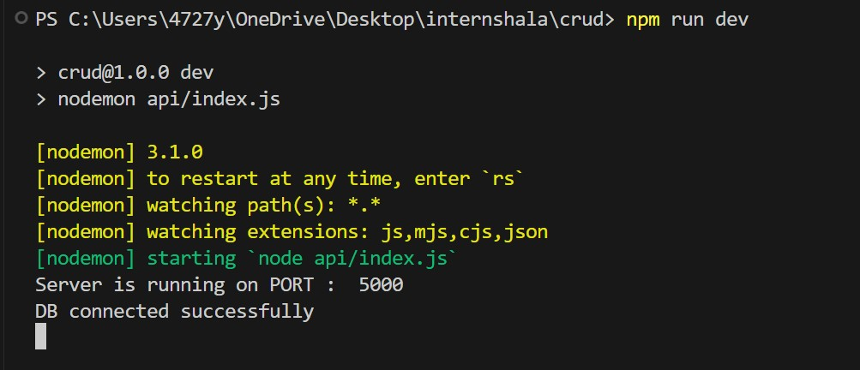

route and its functionality :

For this use any API using tools like Postman or Thunder Client.

i use THUNDER CLIENT.

CREATE ROUTE :

1. . This route is used to create a new employee in database with a

below fields.

username, empname, email, role, salary

1. . in thunder client click on new request and select this options

method as post url as http://localhost:5000/api/user/create pass this json data as a body as your required value.

{

"username": "jack",

"empname": "jack rider",

"email": "jack@gmail.com",

"role": "Front End Developer",

"salary": 60000

}

1. . finally press send to insert data in mongodb data base and get a

inserted data as a response.

1. . If user is already in db it will return User is already exist as response. for more details visit below output images...

READONE :

1. . This route is used to read specific user info by passing that user id

as a param. method

UPDATE:

1. . This route is used to update specific user by passing that user id as

a param. method as put

url as http://localhost:5000/api/user/update/65ed7b3d76e1dcc9a51654ca

1. . After sending you will get updated user details as response.

DELETE :

1. . This route is used to delete specific user by passing that user id as

a param. method as delete

url as http://localhost:5000/api/user/delete/65ed7b3d76e1dcc9a51654ca

1. . After sending you will deleted successfully as response.

OUTPUT :

CREATE A NEW USER :

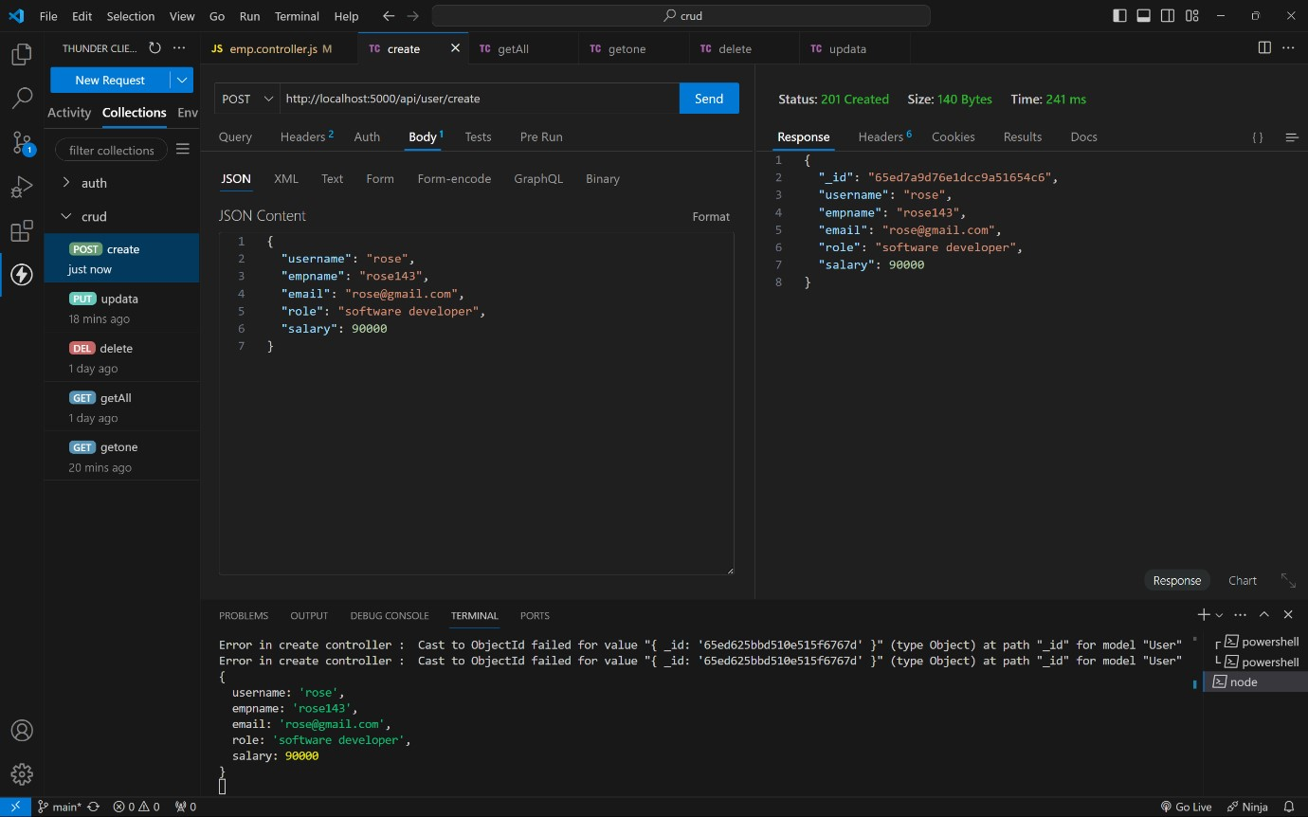

CREATING USER WITH EXISTING USERNAEM :

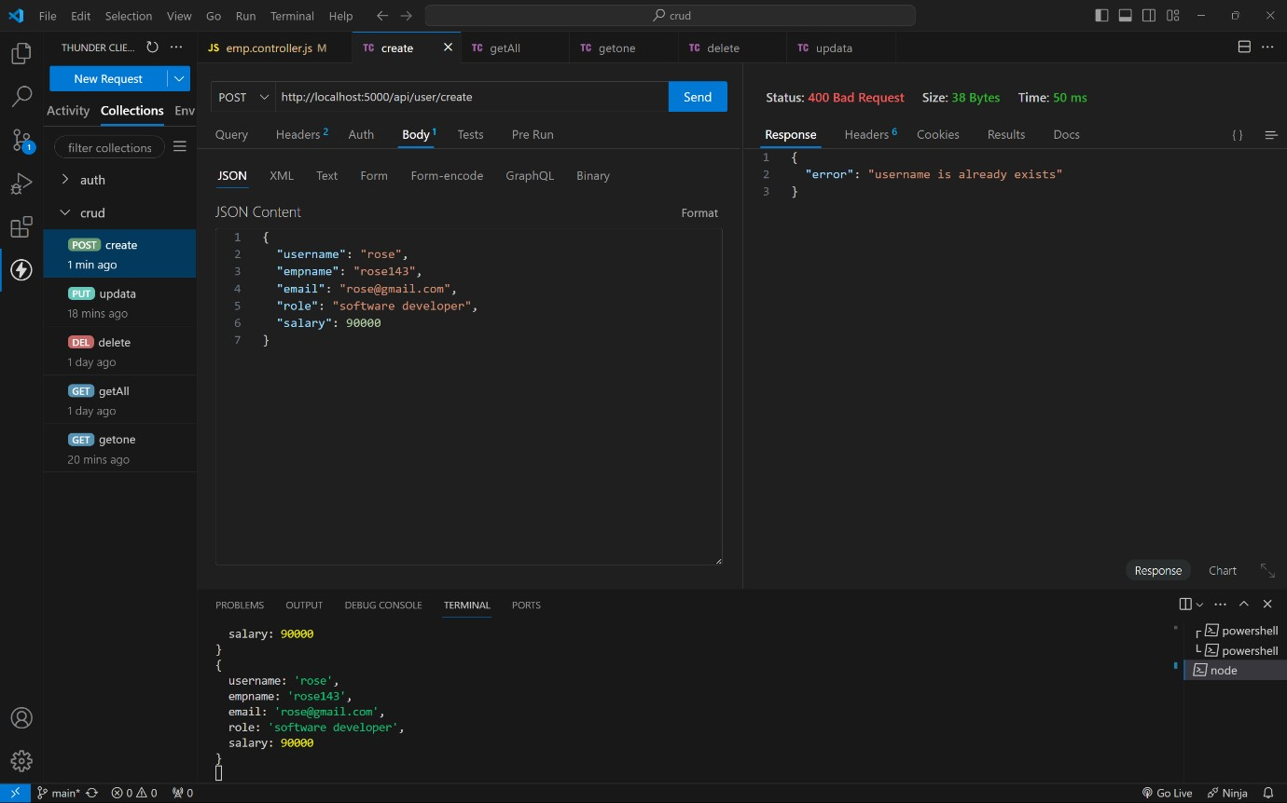

READONE :

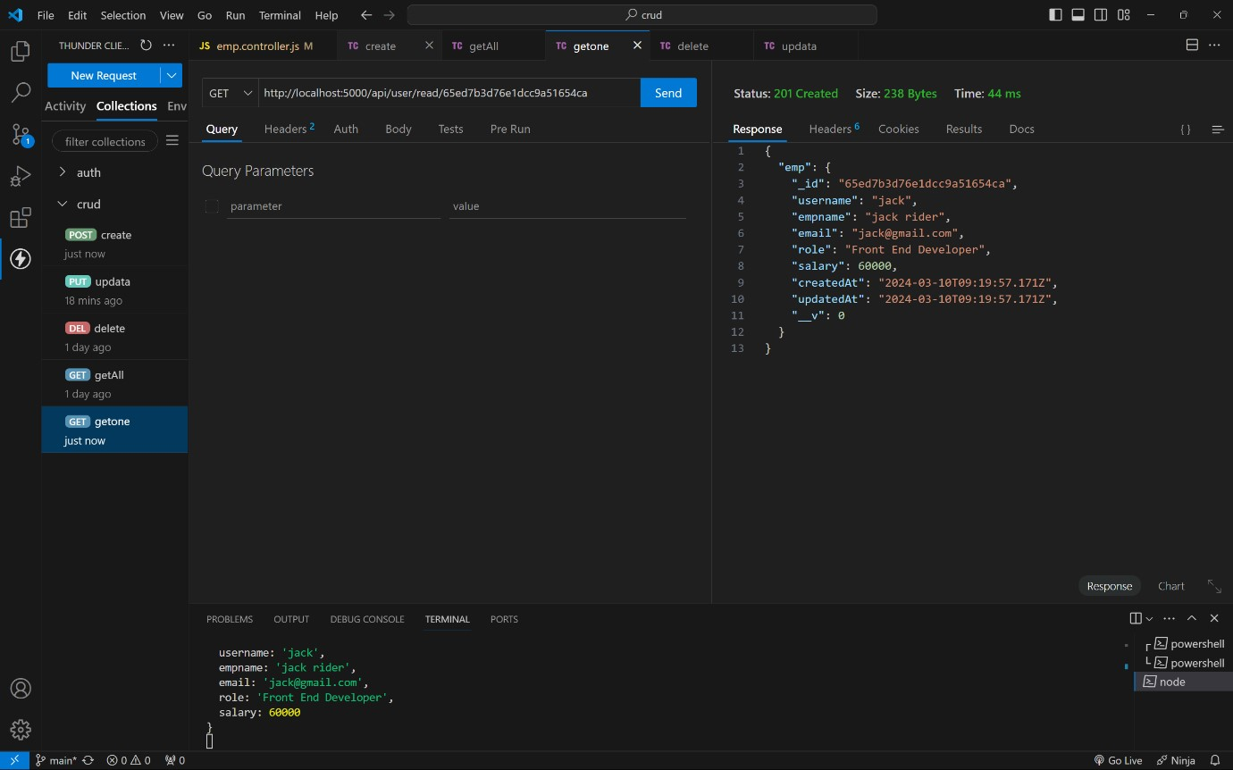

READ ALL :

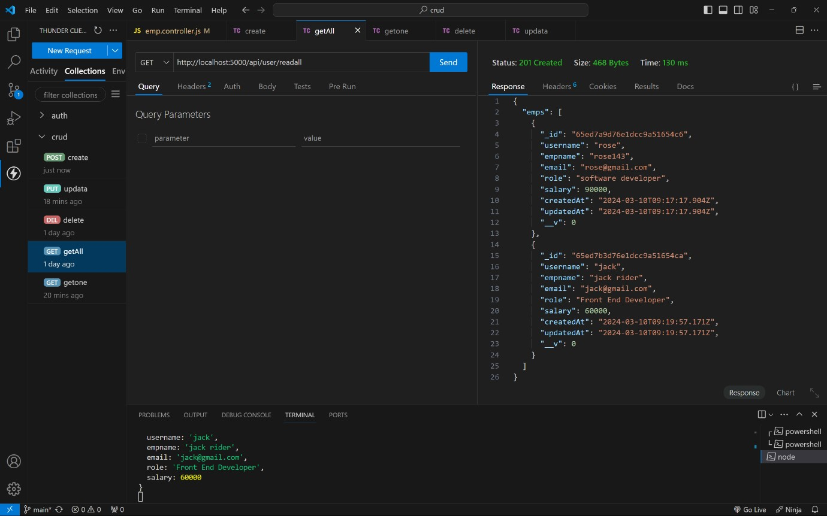

UPDATE :

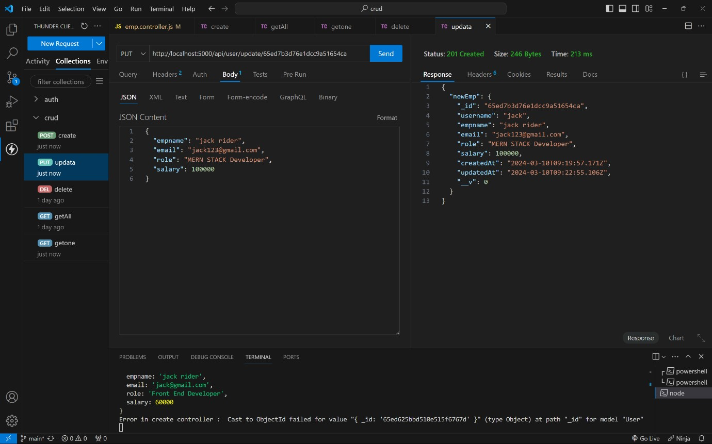

DELETE :

