KaarTech
KEOS ontology rollout guide
From the first namespace to governed answers, in five steps
Prepared for: the KEOS rollout team
Version: 1.0 draft
Date: 14 October 2026

About the screenshots
The screenshots in this guide come from the KEOS prototype and use sample data. Names, counts and dates will differ in your own environment. The suggested timings, roles and targets are proposals to agree with your team, not product limits.

1. What this guide is for
This guide helps a team roll out the KEOS ontology: the shared map of your business terms (classes), how they relate, and the numbers (metrics) people ask about. When it is in place, KEOS can answer questions from one governed source instead of many private spreadsheets.
It walks through the five steps in the order a team does them, shows what each screen looks like, and says what good looks like and what to do if something goes wrong.

The path at a glance
Step | Where in KEOS | What you do | You are done when
1 | Ontology > Namespaces | Create a namespace and connect its sources | Every source shows Completed
2 | Ontology > Induction | Run an induction to propose classes | A proposal appears in the list
3 | Induction > open a proposal | Review, rename, validate and accept | The proposal shows Accepted
4 | Ontology > Explorer and Metrics | Check the result and add governed metrics | Classes and metrics match what the business expects
5 | Ontology > Playground | Ask test questions against the result | Sample questions give correct, explainable answers

2. Who does what
Roles are suggestions. One person can hold more than one role in a small team.
Role | Responsibility | Works mostly in
Sponsor | Owns the outcome, clears blockers, signs off go-live | Playground, status updates
Ontology owner | Decides class names and meaning; accepts or rejects proposals | Induction, Explorer
Data steward | Connects and checks sources; fixes failed or stuck sources | Namespaces
Metrics owner | Defines and approves governed metrics | Metrics
Platform admin | Creates namespaces, sets access and permissions | Namespaces, Admin and governance
Reviewers | Business experts who check classes and answers | Induction, Playground

3. Rollout plan
A pilot first, then expand. The timings below assume one pilot namespace and a small team. Adjust them to your calendar.
Phase | Suggested time | Main activities | Exit criteria
0. Prepare | Week 1 | Pick the pilot area and owners. List the sources. Agree 20 test questions. | Owners named; sources listed; question list agreed
1. Pilot namespace | Weeks 2 to 3 | Create the namespace. Connect sources. Fix any failed source. | All sources Completed
2. Induce and review | Weeks 3 to 4 | Run induction. Review classes with business experts. Rename. Validate. Accept. | Proposal accepted; owner signed off
3. Govern metrics | Weeks 4 to 5 | Import or create the agreed metrics. Check each definition. | Agreed metrics listed and checked
4. Validate | Weeks 5 to 6 | Run the 20 test questions in the Playground. Record results. Fix gaps. | Agreed pass mark reached
5. Expand | Week 7 onward | Repeat for the next namespace. Share lessons. Plan training. | Next namespace started

4. Step by step

Step 1. Create a namespace and connect sources
A namespace is a separate scope in your knowledge graph. It has its own sources, ontology and access rules, so one team’s data does not mix with another’s. Start with one namespace for the pilot area.
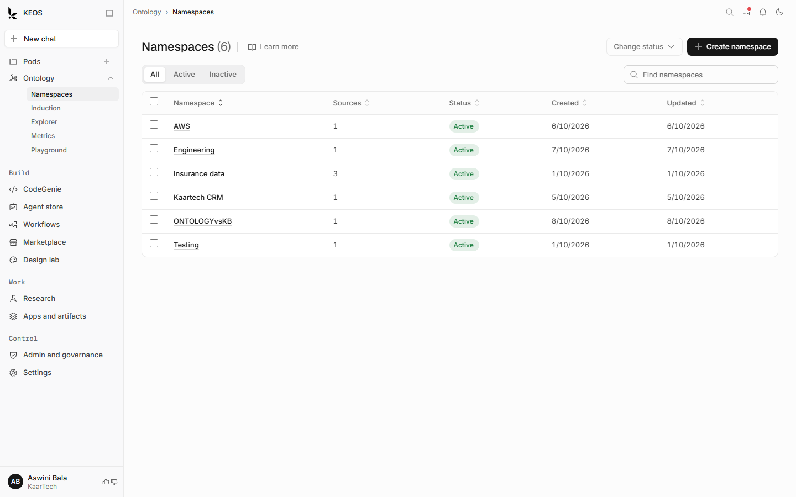
Figure 1. The Namespaces list. Filter by All, Active or Inactive, or search by name.

How to do it
- Open Ontology, then Namespaces.
- Select Create namespace.
- Enter a clear name that the business will recognise, and an optional description. Select Create.
- Open the new namespace and connect its sources.
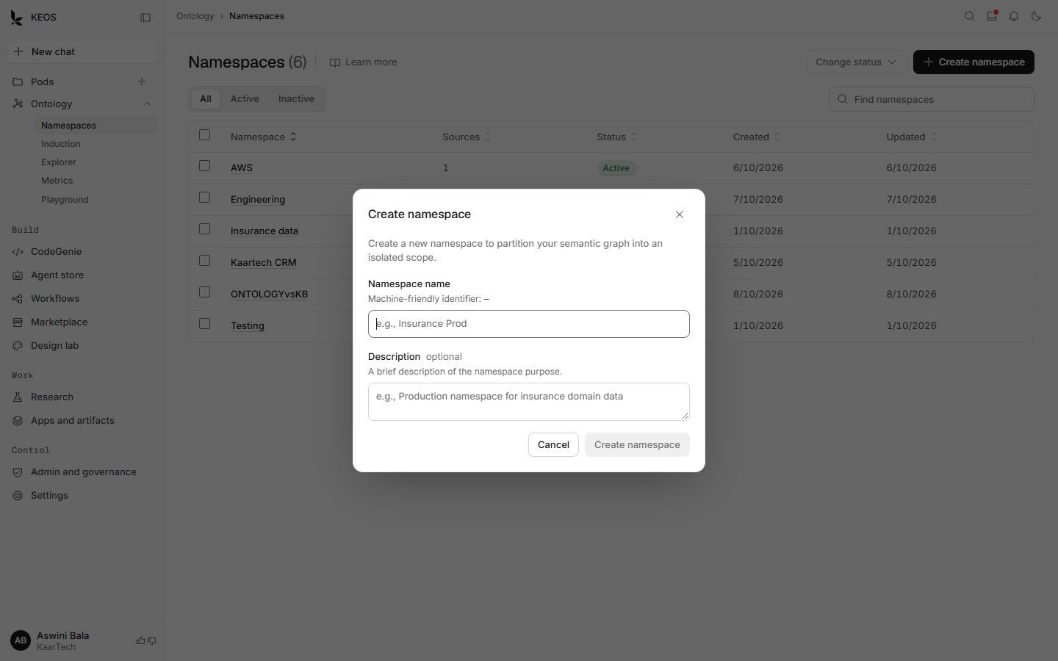
Figure 2. The Create namespace dialog. Names should describe a business area, for example Insurance data.

What good looks like
- One namespace per business area, with a name people recognise.
- Every source shows Completed before you move on.

If something goes wrong
- A source shows Failed. Open the namespace, check the source, fix the connection and try again. Do not start an induction on a failed source.
- A source shows Processing for a long time. Wait, then check again. If it does not clear, ask the data steward.
- The namespace shows Degraded. Open View more to see its health, then raise it with the platform admin.
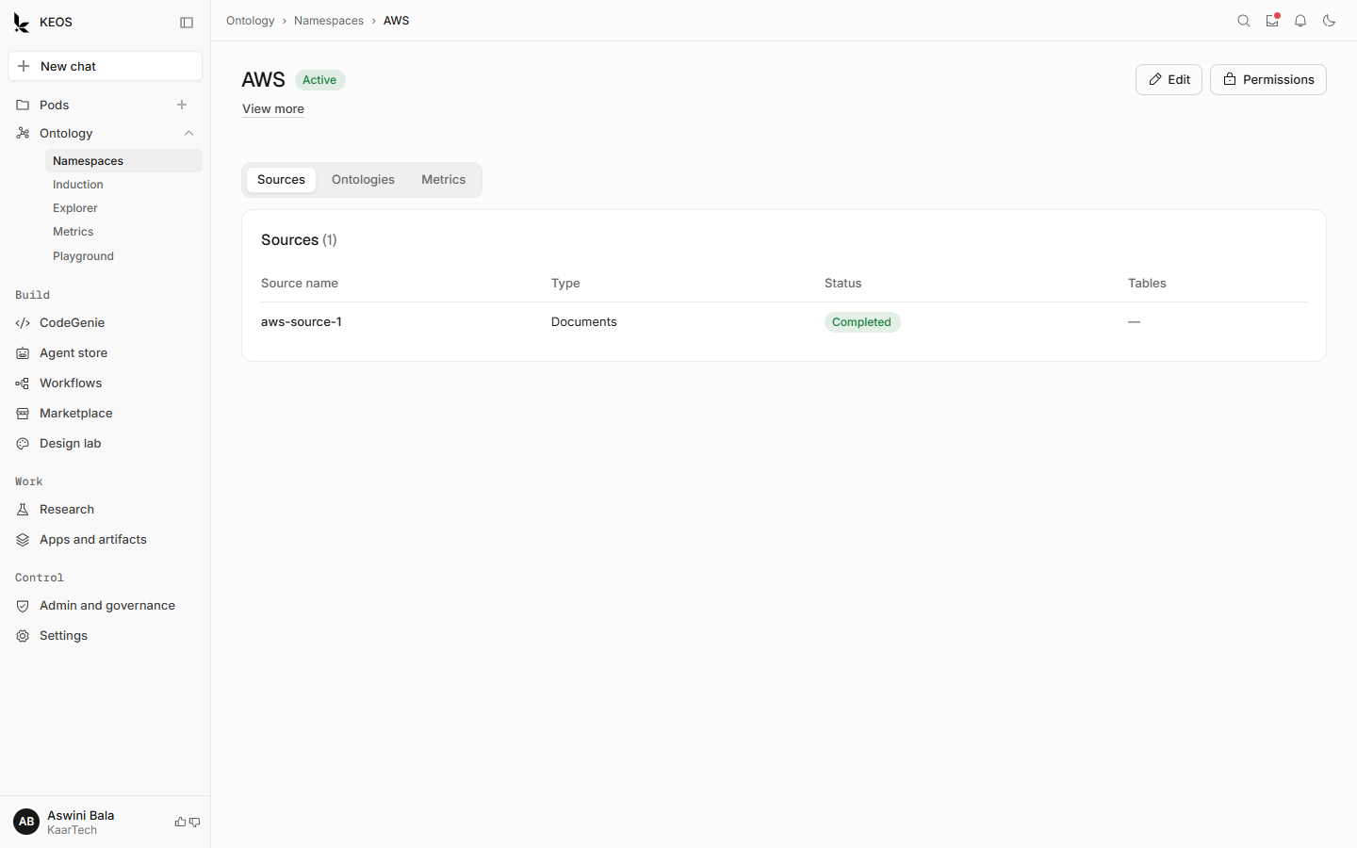
Figure 3. A namespace page. The Sources tab shows each source with its type, status and table count.
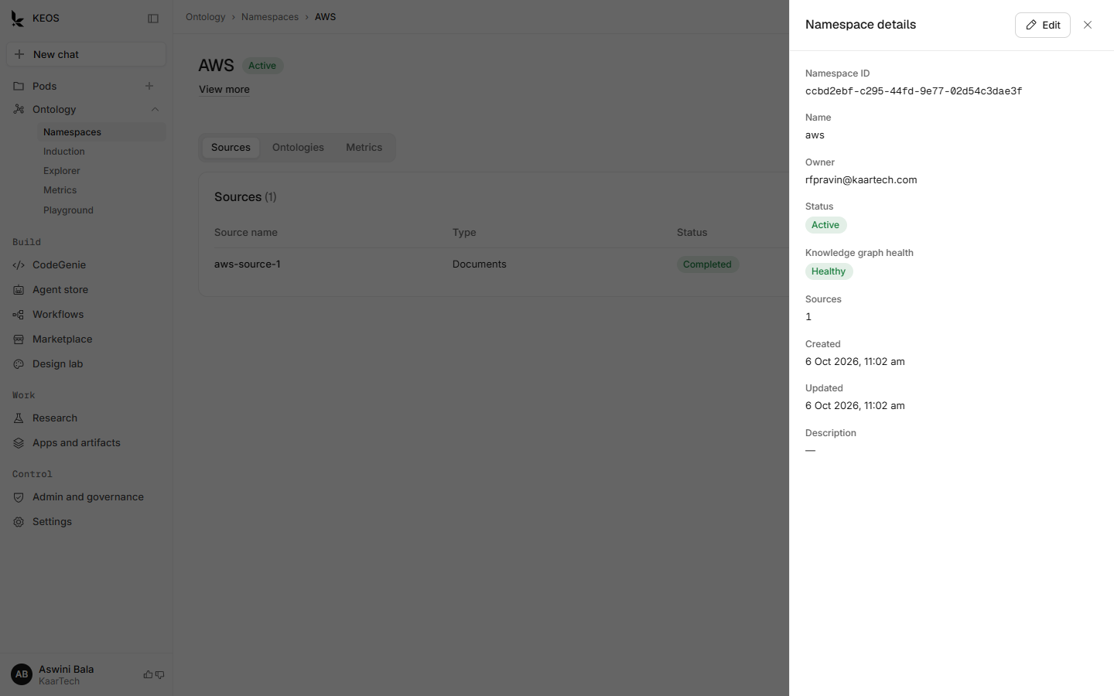
Figure 4. View more opens the namespace details on the right: its ID, owner, status and health. Edit changes the description.
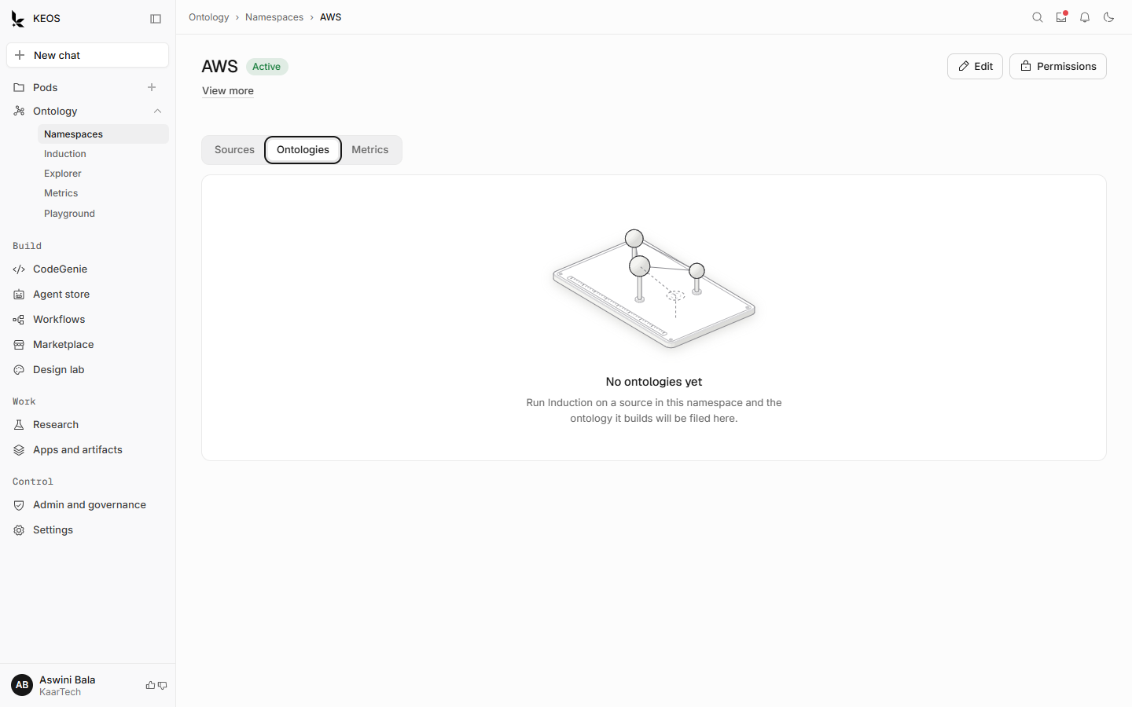
Figure 5. Before any induction, the Ontologies tab is empty and explains the next step.

Step 2. Run an induction
Induction reads the sources you choose and proposes classes and relationships. Nothing is published until someone accepts the proposal, so it is safe to run.
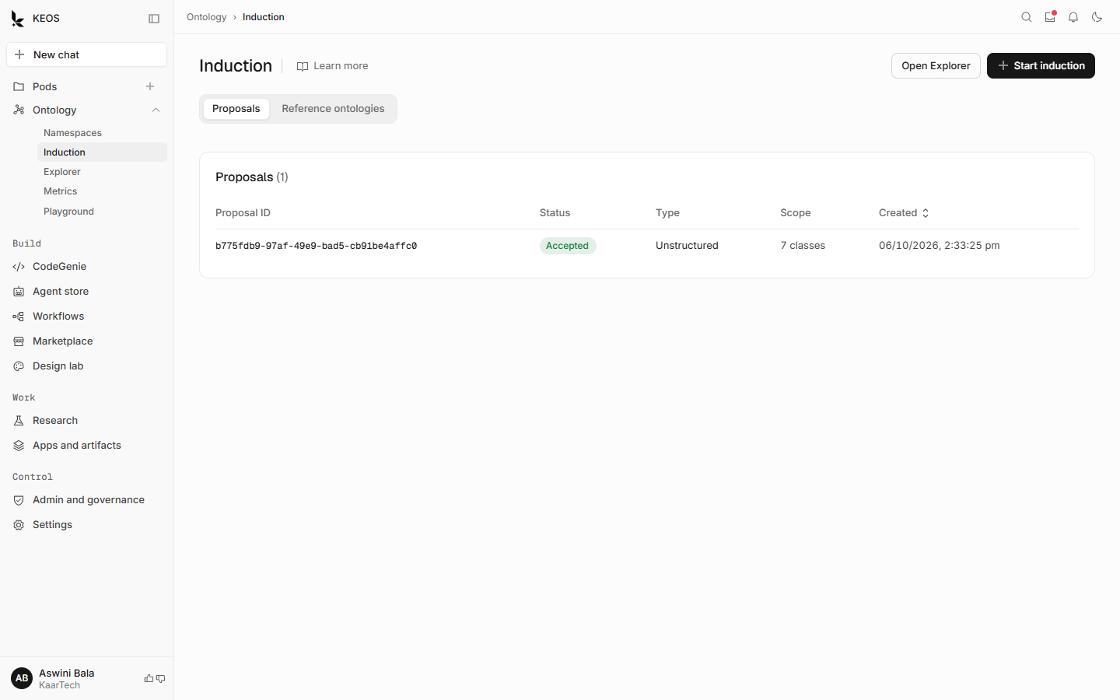
Figure 6. The Induction page lists every proposal with its status, type and scope.

How to do it
- Open Ontology, then Induction.
- Select Start induction.
- Choose the sources KEOS should read.
- Choose the type: Unstructured for documents and notes, or Structured for tables and schemas.
- Select Start induction. A new proposal appears in the list.
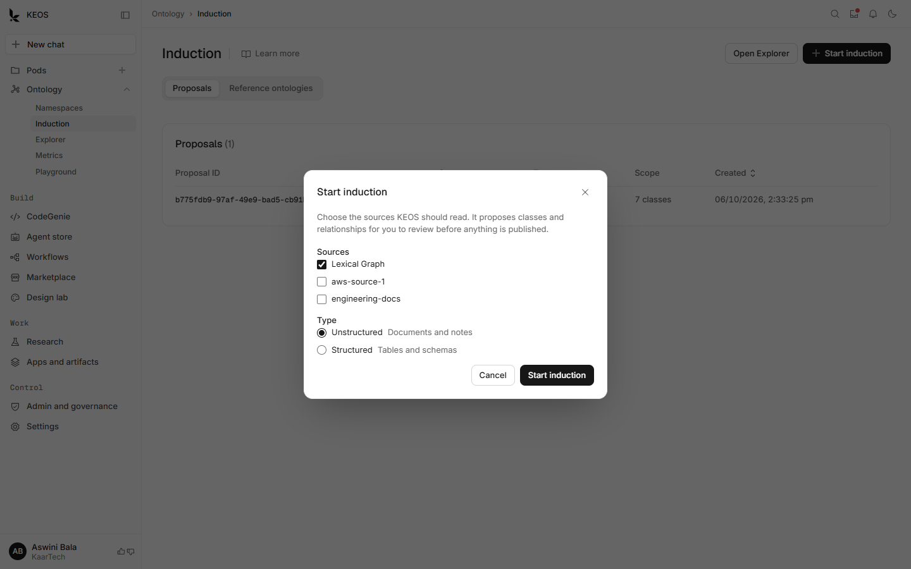
Figure 7. The Start induction dialog. Pick the sources, then the type of data.

What good looks like
- Start with a small set of sources so the review stays manageable.
- Use the type that matches the data. Mixed data is easier to review as two inductions.

If something goes wrong
- The proposal shows Failed. Open it to read the reason, fix the source and run the induction again.
- The list does not load. Select Try again. If it still fails, check your connection and tell the platform admin.

Step 3. Review, validate and accept
This is the most important step. KEOS proposes; people decide. The ontology owner and business reviewers check that class names and relationships match how the business talks.
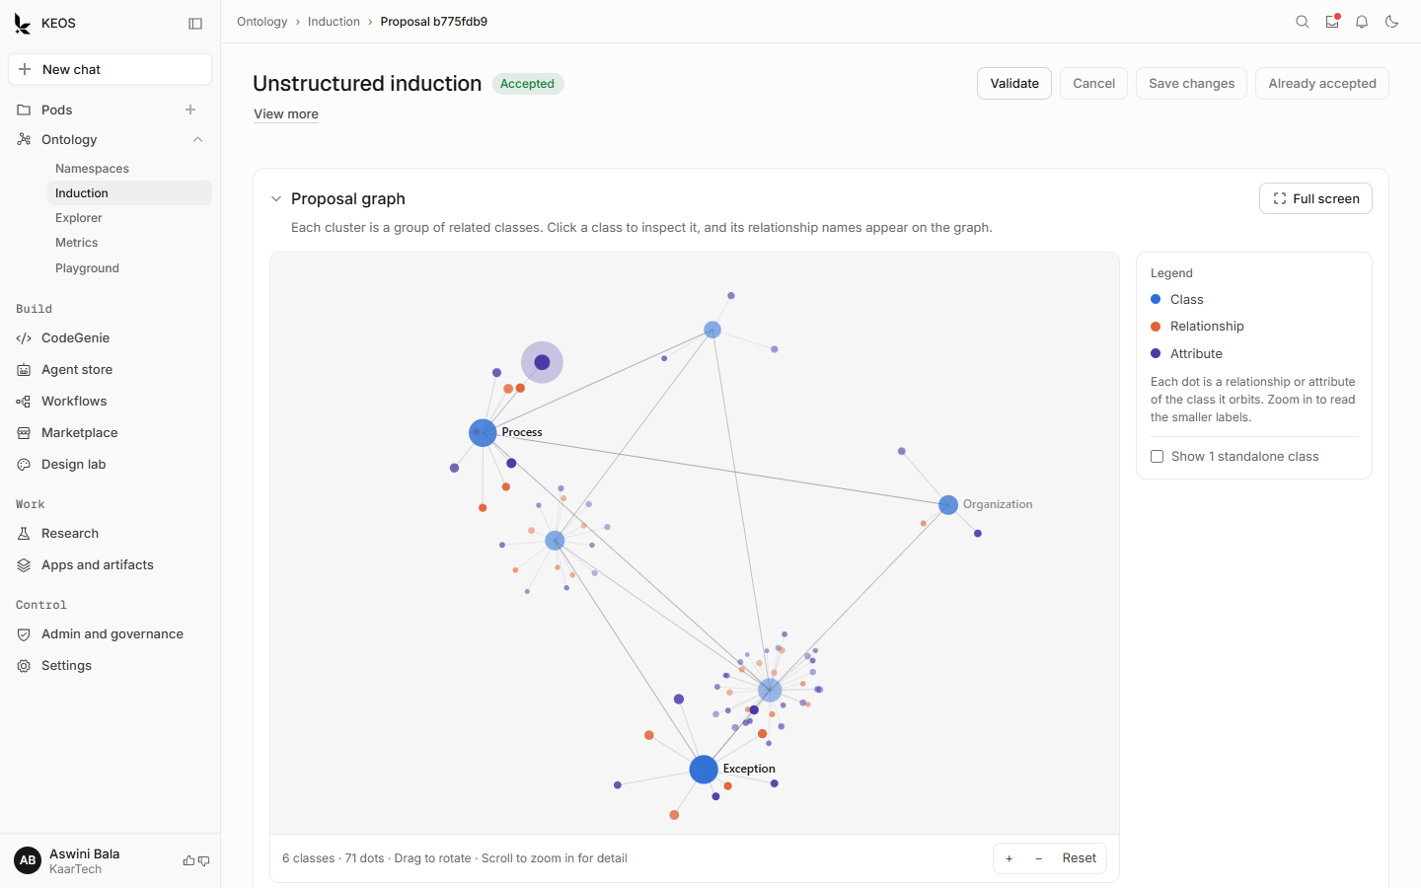
Figure 8. A proposal. The graph shows classes (large dots) with their relationships and attributes around them. Drag to rotate and scroll to zoom.
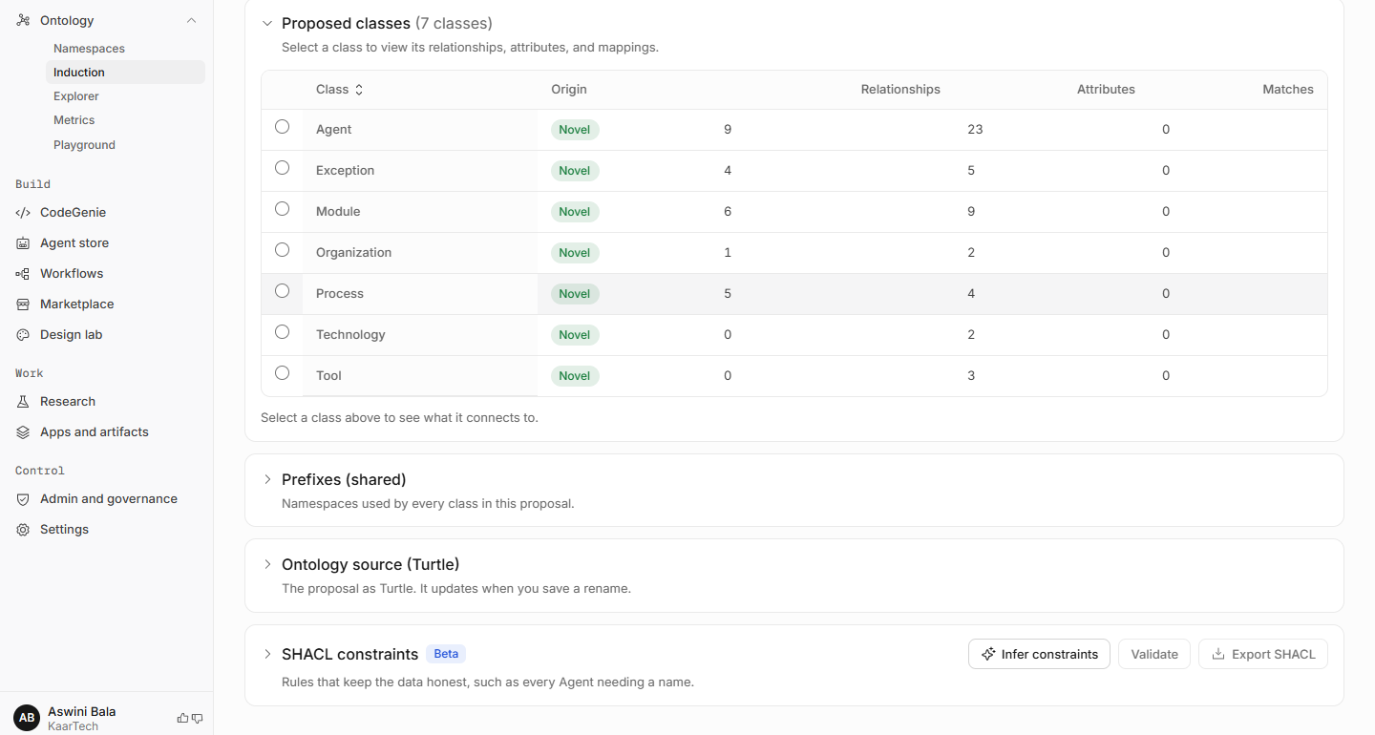
Figure 9. The class table. Select a class to see what it connects to, and rename it if the name is unclear. Turtle and SHACL sections sit below.

How to do it
- Open the proposal from the Induction list.
- Look at the graph, then work down the class table.
- Select a class to see its relationships and attributes. Rename any class with an unclear name, then save.
- Open SHACL constraints. Use Infer constraints to suggest rules, then select Validate.
- When the owner is satisfied, select Accept. This publishes the classes to the namespace.

What good looks like
- Every class has a name the business would use in conversation.
- No duplicate classes for the same idea.
- Validation passes before you accept.
Check before you accept
Accepting publishes the classes to the namespace. Review names first. Renaming later is possible, but anything already using the old name needs to be updated.

If something goes wrong
- Validation fails. Read the message, fix the class or rule it names and validate again.
- A class looks wrong or missing. Do not accept. Note it for the ontology owner and run another induction with better sources.

Step 4. Check the result and add metrics

Explore the ontology
Explorer shows the published ontology. It is read only, so it is safe for anyone to browse. Use it to confirm the result matches what the business expects.
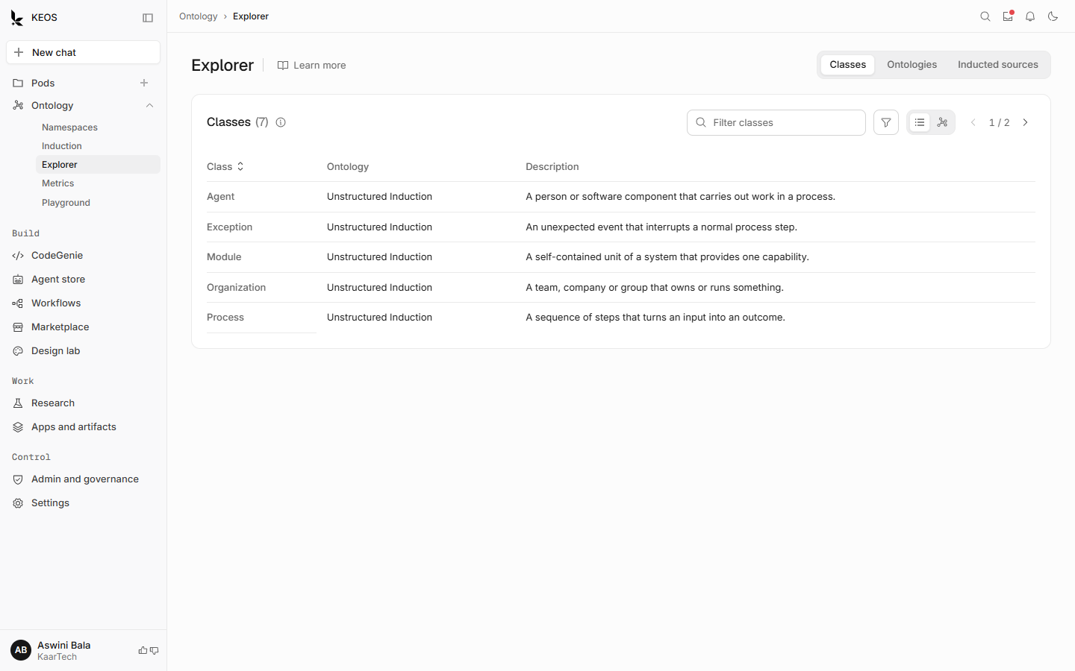
Figure 10. Explorer, Classes tab. Search by name, choose an ontology with the filter, switch between list and graph, and page through results.
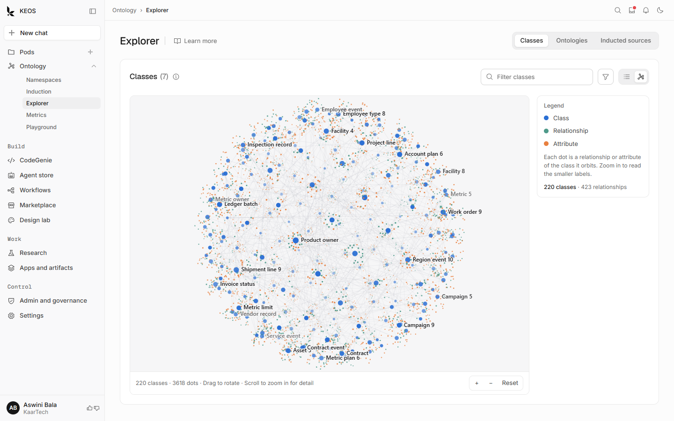
Figure 11. The graph view scales to large ontologies. Here it shows a large sample set of 220 classes. Drag to rotate, scroll to zoom in for detail.
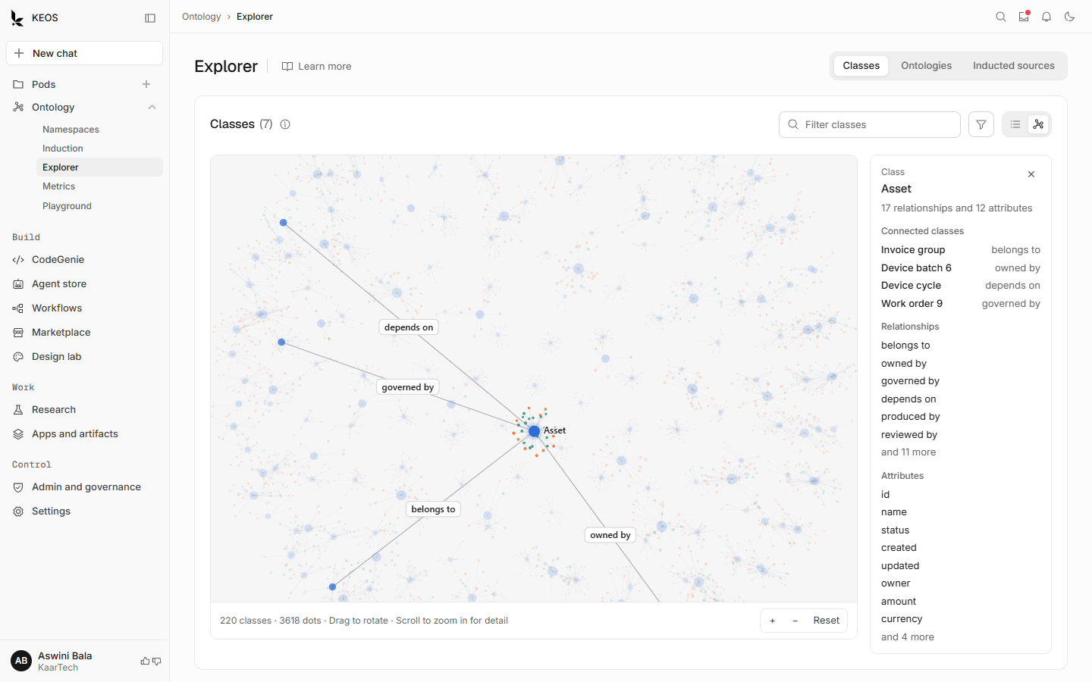
Figure 12. Select a class and its details replace the legend: connected classes, relationships and attributes.

Define governed metrics
A metric is a business number, such as revenue or downtime, with one agreed definition. When metrics are governed, everyone who asks gets the same answer.
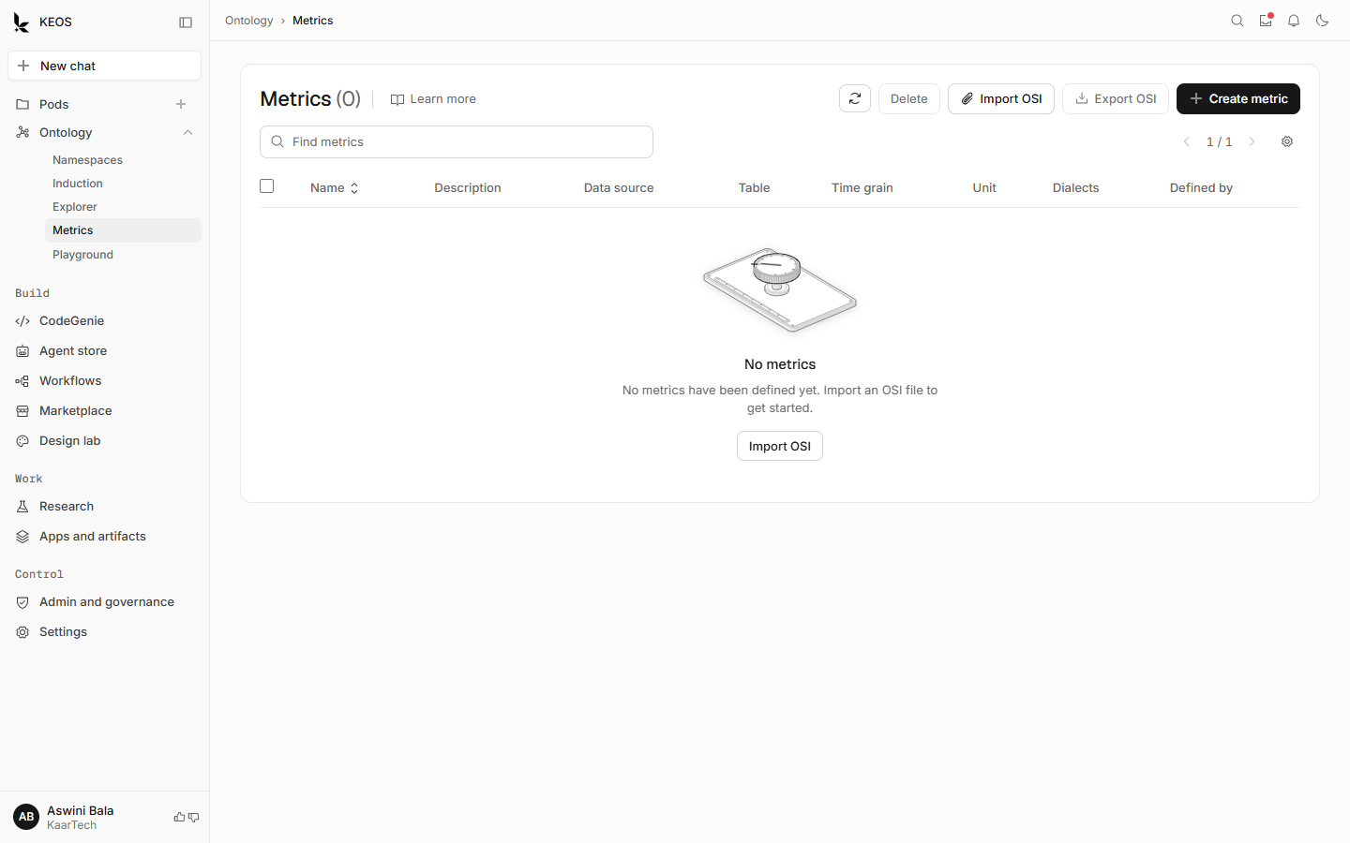
Figure 13. The Metrics page before any metric exists. Import an OSI file (a .yaml or .json file), or create a metric by hand.

How to do it
- Open Ontology, then Metrics.
- Select Import OSI to load an Open Semantic Interchange file, or select Create metric.
- Check each metric’s name, data source, table and definition with the metrics owner.
- Use Export OSI to keep a copy or to share the definitions with other tools.

If something goes wrong
- The list does not load. A banner explains it. Select the reload button.
- Removing a metric. Anything that uses the metric stops working until you add it back, so check before you delete.

Step 5. Validate with the Playground
The Playground lets you ask questions against the result before anyone depends on it. Run your 20 agreed test questions here and record whether each answer is right.
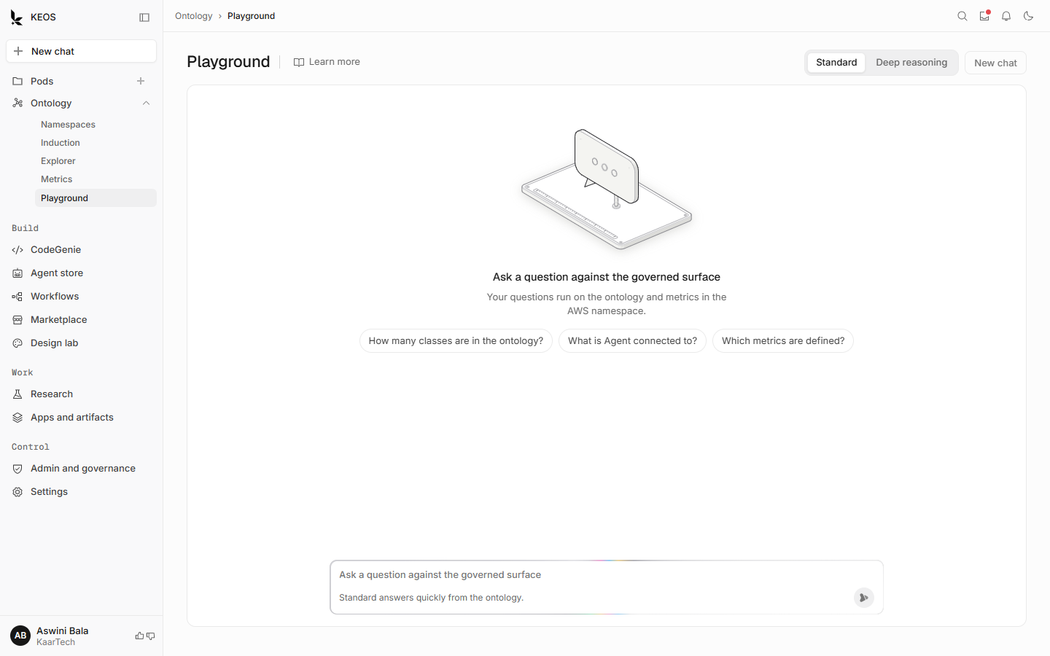
Figure 14. The Playground starts with example questions. Choose Standard for quick answers or Deep reasoning to check more before answering.
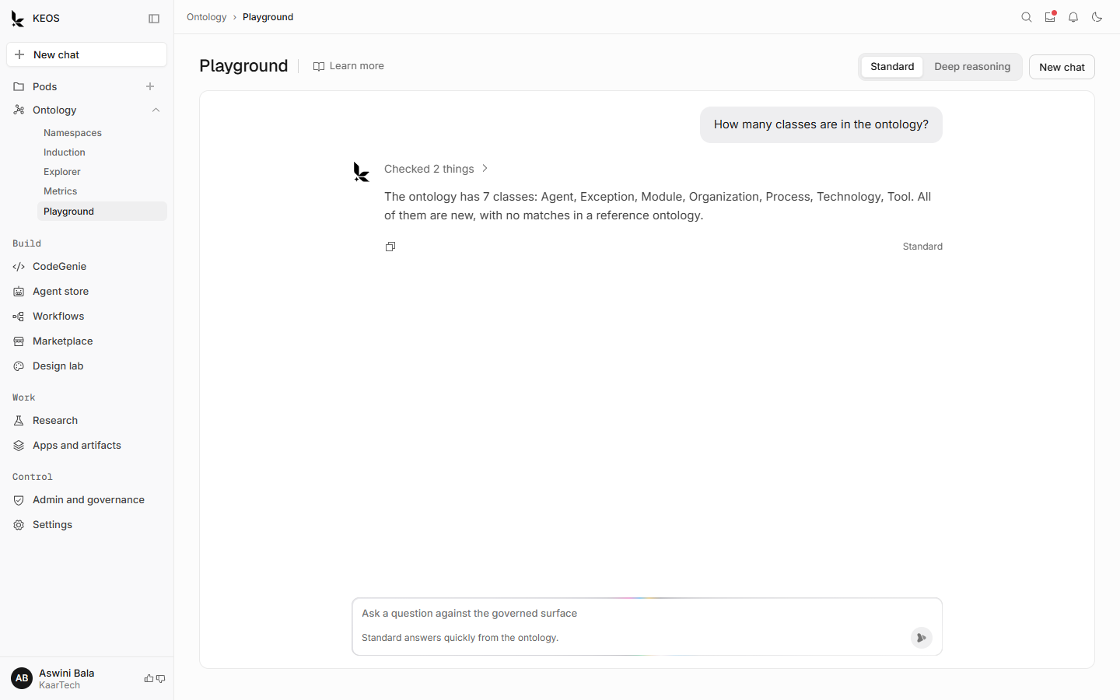
Figure 15. An answer. Open “Checked 2 things” to see what KEOS looked at to reach it.

How to do it
- Open Ontology, then Playground.
- Choose a mode. Use Deep reasoning for questions that combine several metrics.
- Ask each test question. Open the steps to see how the answer was reached.
- Record the result: correct, partly correct or wrong. For anything not correct, note whether the cause is a class, a relationship or a metric.
- Fix the cause, then ask the question again.

If something goes wrong
- An answer says it could not run. Check your connection, then select Try again.
- You want to stop an answer. Press Esc or select the stop button.
- A banner says previous history may not have loaded. New questions still work.

Help inside the product
Each ontology page has a Learn more link next to its title. It opens a short guide on the right with how the page works, good-to-know points and tips.
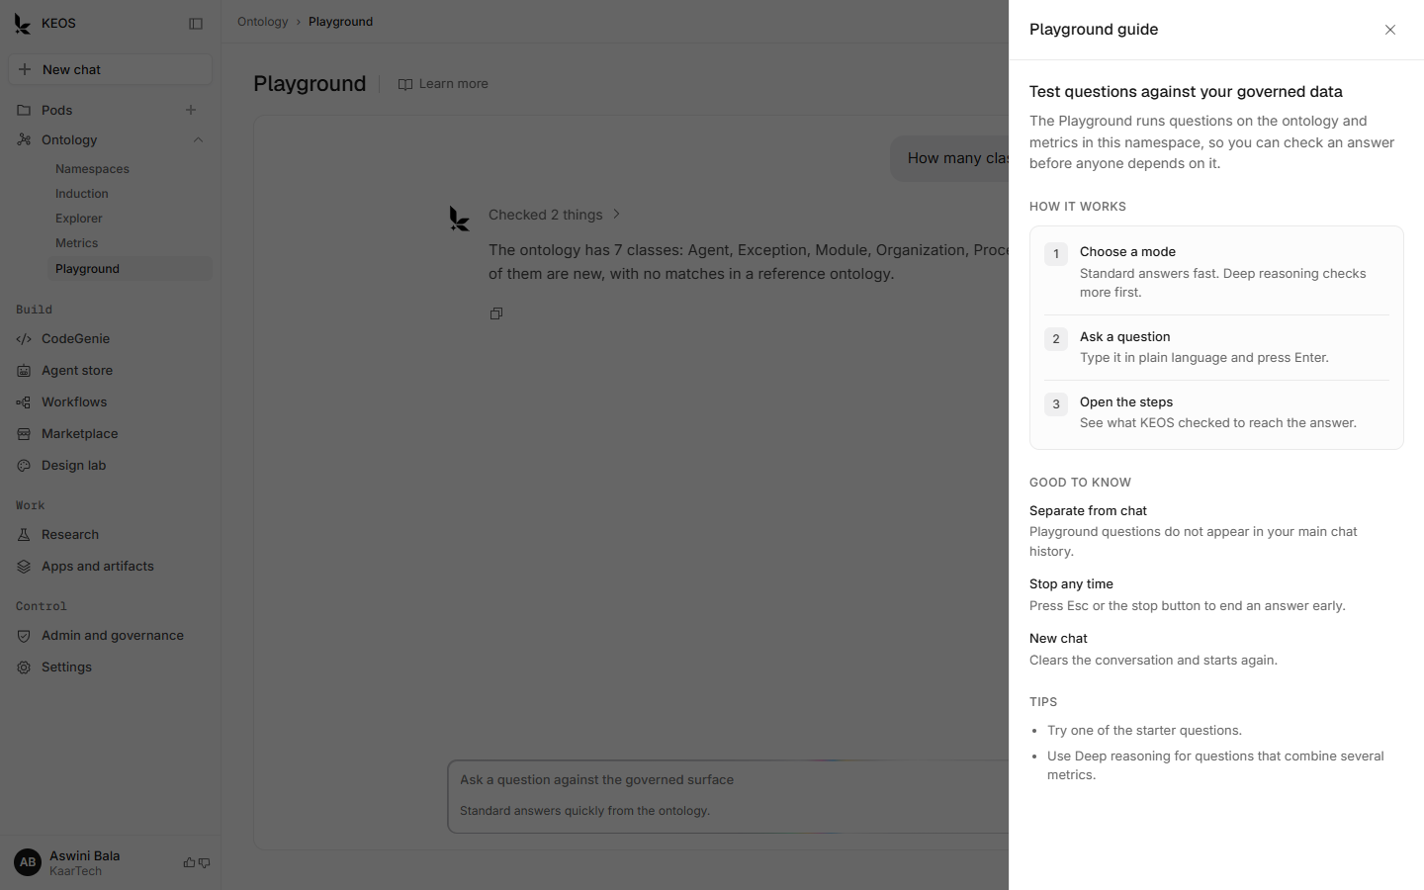
Figure 16. The Learn more guide on the Playground page.

5. When something is not right
Where | What you see | What to do
Namespaces | A source shows Failed | Check and fix the source, then reconnect. Do not run an induction on it.
Namespaces | A source shows Processing for a long time | Wait, then check again. Ask the data steward if it does not clear.
Namespaces | Namespace shows Degraded | Open View more to see health. Raise with the platform admin.
Induction | Proposal shows Failed | Read the reason, fix the source, run again.
Induction | Validation fails | Fix the class or rule named in the message, then validate again.
Any list | A load error with a Try again button | Select Try again. If it repeats, check your connection.
Metrics | List banner says metrics did not load | Reload. Contact the metrics owner if it persists.
Playground | The question did not run | Check your connection, then select Try again.

6. Go-live checklist
Done | Item
☐ | Pilot area, owners and reviewers named
☐ | List of sources agreed and access confirmed
☐ | 20 test questions written, with the expected answer for each
☐ | Namespace created with a clear name and description
☐ | All sources show Completed
☐ | Induction run on the agreed sources
☐ | Every class reviewed with business experts; unclear names changed
☐ | Validation passes
☐ | Proposal accepted by the ontology owner
☐ | Explorer checked: classes, relationships and attributes look right
☐ | Agreed metrics imported or created and checked
☐ | Test questions run in the Playground; results recorded
☐ | Agreed pass mark reached, or gaps fixed and questions re-run
☐ | Sponsor sign-off
☐ | Training or walkthrough planned for the next group of users

7. How to know it is working
Suggested measures. Agree the targets with your team before you start.
Measure | How to check it | Suggested target
Test questions answered correctly | Run the 20 questions in the Playground | At least 18 of 20 (90%)
Classes reviewed before accept | Count reviewed against proposed | 100%
Time from sources ready to accepted ontology | Dates on the proposal | Within 2 weeks for the pilot
Governed metrics in use | Count on the Metrics page | All agreed metrics listed
Failed or stuck sources | Namespace Sources tab | None at go-live

8. Risks and how to reduce them
Risk | Why it matters | What to do
Classes accepted without business review | Wrong names spread into answers | Require owner sign-off; use the review step with experts
Sources are incomplete or out of date | Answers look right but are wrong | Check sources before induction; note the date of each
Same metric defined twice | Different numbers for the same question | One metrics owner; check before creating
Too many namespaces at once | Review quality drops | Pilot first; add one namespace at a time
Nobody owns the ontology after launch | It drifts out of date | Name an ontology owner and a review rhythm

9. Decisions needed from you
- Which business area is the pilot?
- Who is the ontology owner, the data steward and the metrics owner?
- Which sources go into the pilot, and who approves access?
- Who writes the 20 test questions, and what pass mark do you want?
- Do you want to start from a reference ontology, or from your own sources only?
- What review rhythm will keep the ontology current after launch?

Appendix. Terms used in this guide
Term | Meaning
Namespace | A separate scope in the knowledge graph, with its own sources, ontology and access.
Source | Where data comes from: documents, a database or an API.
Ontology | The shared map of business terms and how they relate.
Class | A kind of thing in the business, for example Customer or Contract.
Relationship | How two classes connect, for example “owned by”.
Attribute | A fact about a class, for example a status or a date.
Induction | KEOS reading your sources and proposing classes and relationships.
Proposal | The result of an induction, waiting for review. Nothing is published until it is accepted.
SHACL | A set of rules that checks the data against the ontology, for example every Agent needs a name.
Metric | A business number with one agreed definition.
OSI | Open Semantic Interchange: a file format for sharing metric definitions.
Governed surface | The ontology and metrics together, which KEOS uses to answer questions.

