1. Open PowerShell ISE using Administration permission from start menu.

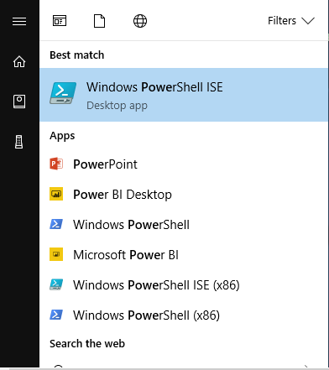

1. Download the script from below link. Open the downloaded file as shown below.

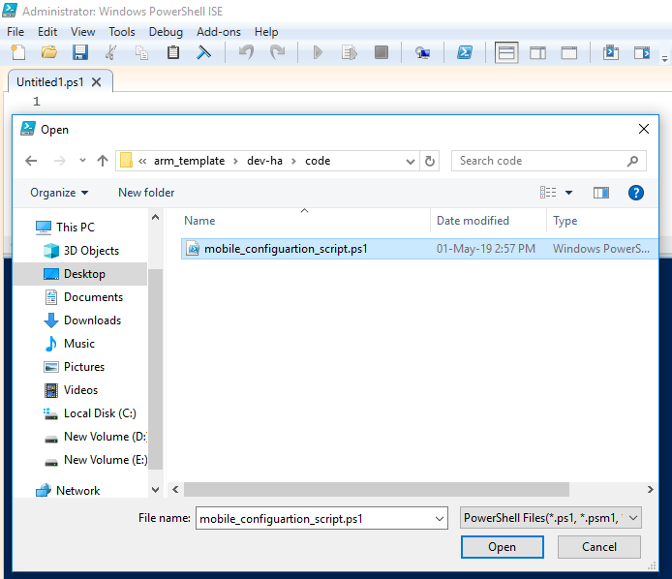

1. Click on Run script (icon).

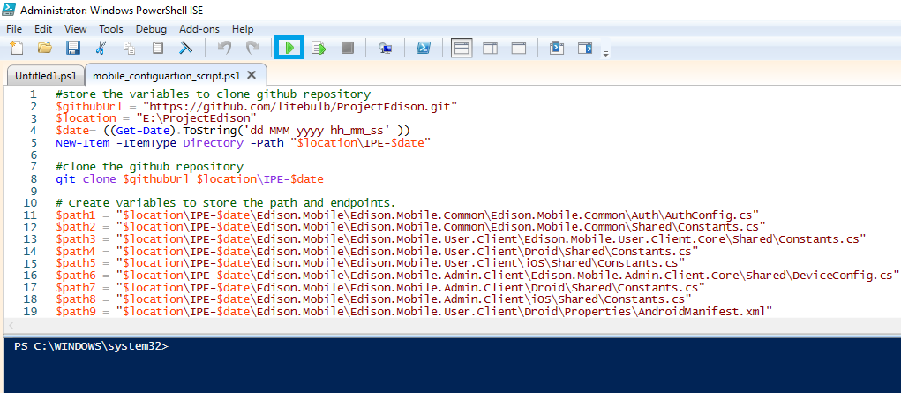

1. The above script downloads the mobile application code and required values will be updated.
2. Configuration and build of User Mobile application can be done in two ways.
3. Open **Edison.Mobile.Common.sln** solution and add Nu-get packages.
4. Open **Edison.Mobile.User.Client.sln** solution and add dependencies projects and Nu-get packages.
5. Configuration and Build User Mobile application using **Edison.Mobile.Common.sln**
6. Open **Edison.Mobile.Common.sln** by double clicking on it.

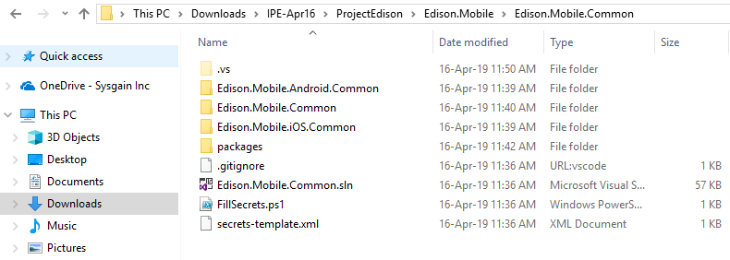

8. Wait for some time visual Studio will restore the dependencies automatically, until you see **Ready** on left side bottom of the screen of the output section.

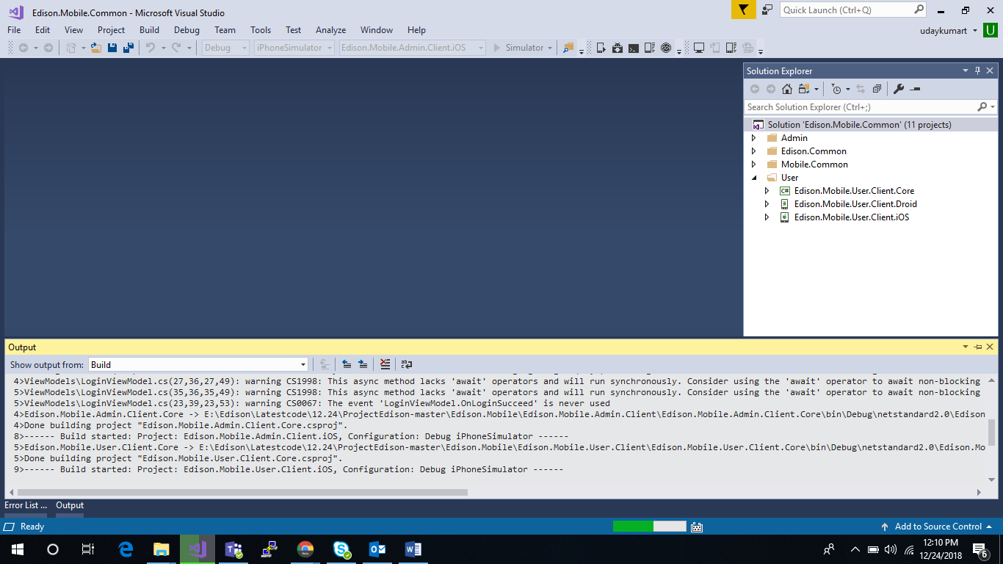

1. Right click on the solution and click on **Build Solution.**

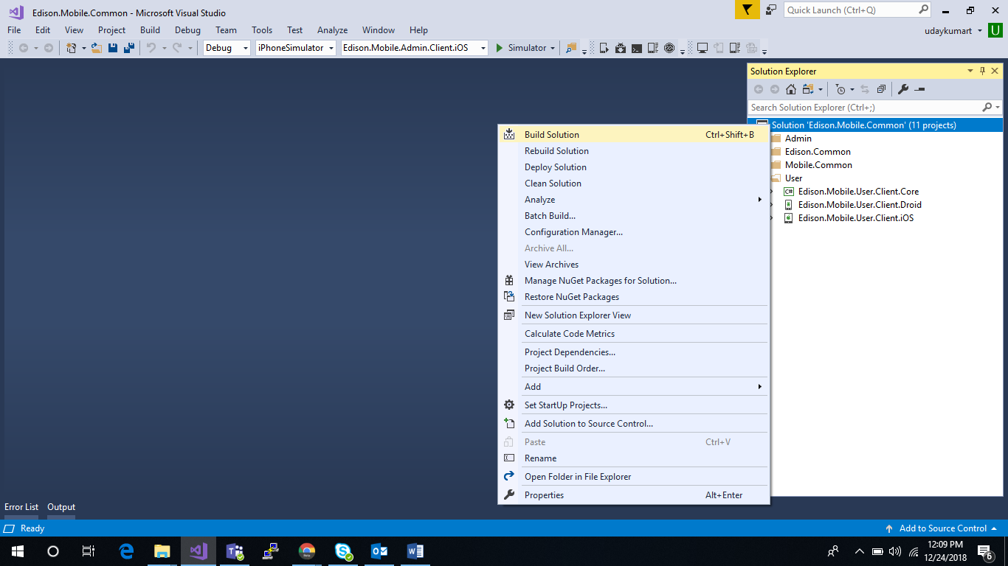

1. Once the build is succeeded. Paste the **google-services.json** copied from **step 6** of **Section5**, in shared folder of **Edison.Mobile.User.Client.Droid** Project as shown in below screen shot.

