DELHIVERY LOGISTICS & DELIVERY PERFORMANCE ANALYSIS
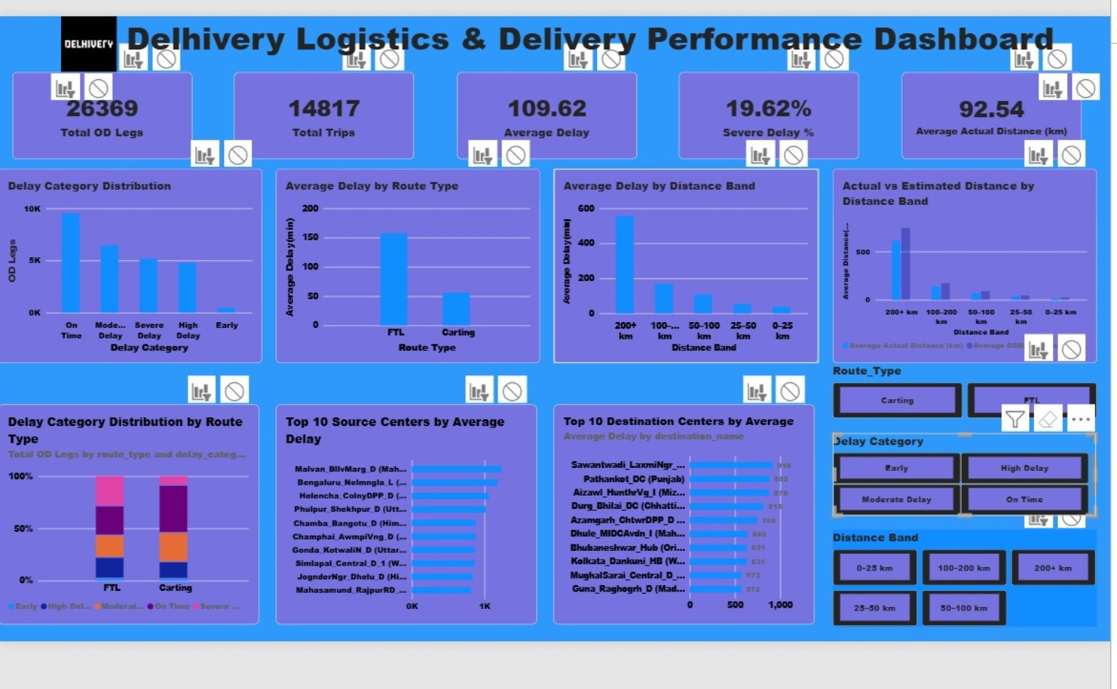
Power BI dashboard

1. Executive Summary
This project analyzes Delhivery logistics trip and OD-leg data to understand delivery delay patterns, route performance, distance-related delays, cutoff-status patterns, and hub-level variation. The analysis covers 26,369 OD legs across 14,817 unique trips and uses Python/Jupyter Notebook, MySQL, and Power BI.

2. Project Objectives
- Assess overall delivery and trip performance.
- Measure average delay and severe-delay levels.
- Compare FTL and Carting route performance.
- Analyze the relationship between distance and delay.
- Compare actual distance with OSRM-estimated distance.
- Identify source and destination centers with high average delays.
- Build an interactive Power BI dashboard.

3. Dataset Overview
Metric | Value
OD legs | 26,369
Unique trips | 14,817
Average delay | 109.62 minutes
Minimum delay | -64 minutes
Maximum delay | 3,137 minutes
Average actual distance | 92.54 km
Average OSRM distance | 115.25 km

4. Data Preparation & Validation
The final analysis dataset contained 26,369 rows and 25 columns. Data types were checked in Jupyter Notebook before creating the MySQL-ready file. The cutoff status fields were validated, and key data-quality checks were performed.
- 66 source_name values and 81 destination_name values were missing.
- 0 missing trip UUIDs.
- 0 missing source centers.
- 0 missing destination centers.
- 0 negative actual-time values.
- 0 negative OSRM-time values.
- 0 negative actual-distance values.
- 0 negative OSRM-distance values.

5. Key Business Insights

5.1 Overall Delay Distribution
There are 26,369 OD legs across 14,817 trips. The average delay is 109.62 minutes. On Time accounts for 36.10% of OD legs, followed by Moderate Delay at 24.44%, Severe Delay at 19.62%, High Delay at 18.07%, and Early at 1.76%.

5.2 FTL vs Carting
FTL records an average delay of 157.49 minutes, compared with 55.92 minutes for Carting. The severe-delay rate is 28.90% for FTL and 9.20% for Carting. This shows a substantial difference in observed delay patterns between the two route types.

5.3 Distance and Delay
Average delay increases strongly across the distance bands. The average delay is 37.96 minutes for 0–25 km, 53.03 minutes for 25–50 km, 107.43 minutes for 50–100 km, 168.95 minutes for 100–200 km, and 556.19 minutes for 200+ km. The corresponding severe-delay rates are 4.74%, 6.19%, 19.85%, 53.45%, and 98.54%.

5.4 Actual vs Estimated Distance
The dashboard compares actual distance with OSRM-estimated distance across distance bands. This provides a route-distance benchmarking view that can be used to investigate differences between observed and estimated route lengths.

5.5 Hub-Level Variation
The Top 10 Source Centers and Top 10 Destination Centers visuals identify locations with high average delay. These locations can be used for further operational investigation. The analysis identifies where delays are concentrated but does not establish the causes of those delays.

5.6 Cutoff Status
OD legs where both cutoff_initial_status and cutoff_final_status were 1 recorded an average delay of 12.24 minutes and a severe-delay rate of 0.40% in the analyzed dataset.

6. Power BI Dashboard
- 5 KPI cards: Total OD Legs, Total Trips, Average Delay, Severe Delay %, and Average Actual Distance.
- 7 analytical charts covering delay distribution, route type, distance bands, actual vs estimated distance, and top source/destination centers.
- 3 interactive slicers: Route Type, Delay Category, and Distance Band.

7. Tools & Technologies
- Python / Jupyter Notebook — data inspection, cleaning, transformation, and validation.
- MySQL — data storage and SQL-based analysis.
- Power BI — dashboard, KPI cards, charts, and slicers.
- CSV — cleaned and MySQL-ready data exchange.

8. Recommendations for Further Analysis
- Investigate high-delay source and destination hubs at the lane level.
- Examine operational factors associated with longer-distance trips.
- Compare delay patterns across route type and cutoff-status combinations.
- Investigate routes with large actual-versus-estimated distance differences.
- Track these KPIs over time if a reliable time dimension is available.

9. Conclusion
The project provides a structured view of Delhivery logistics performance using 26,369 OD legs. The analysis highlights differences by route type, distance band, cutoff status, and logistics center. The Power BI dashboard converts these findings into an interactive reporting tool for further operational investigation and data-driven decision making.

