PRDA - 03 HR Analytics
KPI Analysis Report (Power BI Dashboard)

Name | Nettem Aswini Naidu
Team ID | PTID-CDA-OCT-26-11122
Course | CDA
Members | Individual project

Objective and data
This report summarises the key performance indicators (KPIs) and insights from the HR Analytics dashboard built in Power BI Desktop. The dataset has 22,214 employee records with 17 fields (such as gender, department, race, state, location, age and hire year). Hires cover the years 2000 to 2020 across 7 states.

KPI values
KPI | Value | Note
Total employees | 22,214 | All employee records
HQ employees | 16,715 | 75.2% of employees
Remote employees | 5,499 | 24.8% of employees
% HQ | 75.2% | HQ employees / total employees
% Remote | 24.8% | Remote employees / total employees
Average age | 38.4 years | Average of the Age column
Active employees | 18,285 | Employees without a termination date
Terminated employees | 3,929 | Employees with a termination date
Termination (attrition) rate | 17.7% | 3,929 / 22,214
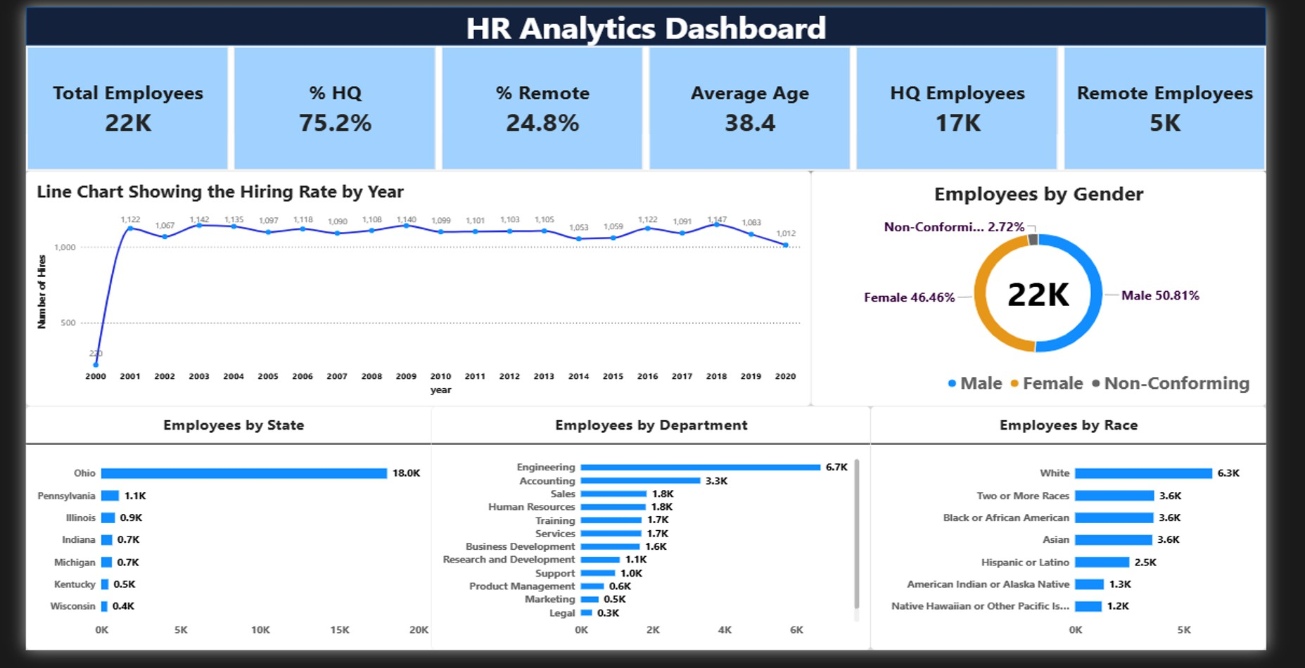

Figure 1: HR Analytics dashboard.

Chart values

Employees by gender

Gender | Employees | Share
Male | 11,288 | 50.81%
Female | 10,321 | 46.46%
Non-Conforming | 605 | 2.72%

Employees by state

State | Employees
Ohio | 18,025
Pennsylvania | 1,115
Illinois | 868
Indiana | 700
Michigan | 673
Kentucky | 451
Wisconsin | 382

Employees by race

Race | Employees
White | 6,328
Two or More Races | 3,648
Black or African American | 3,619
Asian | 3,562
Hispanic or Latino | 2,501
American Indian or Alaska Native | 1,327
Native Hawaiian or Other Pacific Islander | 1,229

Employees by department

Department | Employees | Terminated | Attrition rate
Engineering | 6,686 | 1,185 | 17.7%
Accounting | 3,333 | 586 | 17.6%
Sales | 1,832 | 335 | 18.3%
Human Resources | 1,807 | 309 | 17.1%
Training | 1,692 | 291 | 17.2%
Services | 1,686 | 293 | 17.4%
Business Development | 1,642 | 275 | 16.7%
Research and Development | 1,084 | 212 | 19.6%
Support | 954 | 182 | 19.1%
Product Management | 641 | 114 | 17.8%
Marketing | 494 | 72 | 14.6%
Legal | 311 | 63 | 20.3%
Auditing | 52 | 12 | 23.1%

Hires by year

Year | Hires | Year | Hires | Year | Hires
2000 | 220 | 2007 | 1,090 | 2014 | 1,053
2001 | 1,122 | 2008 | 1,108 | 2015 | 1,059
2002 | 1,067 | 2009 | 1,140 | 2016 | 1,122
2003 | 1,142 | 2010 | 1,099 | 2017 | 1,091
2004 | 1,135 | 2011 | 1,101 | 2018 | 1,147
2005 | 1,097 | 2012 | 1,103 | 2019 | 1,083
2006 | 1,118 | 2013 | 1,105 | 2020 | 1,012

Attrition by group
Group | Employees | Terminated | Attrition rate
Headquarters | 16,715 | 3,005 | 18.0%
Remote | 5,499 | 924 | 16.8%
Male | 11,288 | 1,960 | 17.4%
Female | 10,321 | 1,866 | 18.1%
Non-Conforming | 605 | 103 | 17.0%
Under 25 | 2,705 | 506 | 18.7%
25-34 | 6,067 | 1,081 | 17.8%
35-44 | 5,979 | 1,038 | 17.4%
45-54 | 6,036 | 1,068 | 17.7%
55+ | 1,427 | 236 | 16.5%

Key insights
  - Workforce concentration: Ohio has 81% of employees (18,025). The other six states share the remaining 19%.
  - Departments: Engineering is the largest (6,686, about 30%), followed by Accounting (3,333). Auditing is the smallest with 52 employees.
  - Work location: 75.2% work at headquarters and 24.8% work remotely.
  - Gender: The split is balanced: Male 50.81%, Female 46.46% and Non-Conforming 2.72%.
  - Race: White employees are the largest group (6,328), but no group is above 30%. Two or More Races, Black or African American and Asian are close to each other (about 3,600 each).
  - Age: The average age is 38.4. About 54% of employees are aged 25 to 44, and only about 6% are 55 or older.
  - Hiring: Hiring is steady at about 1,000 to 1,150 a year. It peaked at 1,147 in 2018. 2020 was the lowest full year at 1,012.
  - Attrition: The overall rate is 17.7%. It is highest in Auditing (23.1%), Legal (20.3%), Research and Development (19.6%) and Support (19.1%), and lowest in Marketing (14.6%).
  - Remote vs HQ: Remote employees leave less often (16.8%) than HQ employees (18.0%).
  - Age and attrition: Employees under 25 leave most often (18.7%); those aged 55 and above leave least often (16.5%).
  - Gender and attrition: Female attrition (18.1%) is slightly above Male attrition (17.4%).

Conclusion
The workforce is concentrated in Ohio and in Engineering, mostly on site, and balanced by gender. Hiring has been steady for two decades. About 1 in 6 employees (17.7%) has left, with higher rates in the small Auditing and Legal teams, so retention in those groups deserves attention.

