**Predict High-Potential HR Service Leads**

**Introduction:**

This challenge involves predicting which companies are likely to become high-potential leads for HR services based on their funding and hiring trends. The dataset includes synthetic data designed to mimic real-world information, allowing participants to develop and test predictive models. The objective is to classify companies as either a "hot lead" or not using machine learning techniques.

**Problem Statement:**

The goal is to predict whether a company is a "hot lead" for HR services based on various financial, hiring, and growth-related features. The target variable, “is_hot_lead”, indicates whether a company engaged with HR services within a specific period. Participants will submit predicted probabilities for each company in the holdout dataset.

**Dataset:**

The dataset includes the following features:

| **Feature** | **Description** | **Data Type** |
| --- | --- | --- |
| company_id | Unique identifier for the company. | String |
| company_name | Name of the company. | String |
| industry | Industry the company operates in. | String |
| funding_rounds | Number of funding rounds the company has undergone. | Integer |
| total_funding | Total amount of funding the company has received. | Float |
| last_funding_date | Date of the company's most recent funding round. | Date |
| job_postings_30d | Number of job postings by the company in the last 30 days. | Integer |
| employee_growth_pct | Percentage change in employee count over the last six months. | Float |
| hiring_roles | Types of roles the company is hiring for. | String |
| industry_growth_rate | Growth rate of the company's industry. | Float |
| regional_employment_trend | Employment trend in the company's region. | Float |
| funding_per_employee | Ratio of total funding to employee count. | Float |
| days_since_last_funding | Number of days since the company's last funding round. | Integer |
| growth_momentum | Composite feature combining funding and hiring activity. | Float |
| is_hot_lead | Binary variable indicating whether the company is a high-potential lead for HR services. | Int |

**Data Preprocessing:**

* **Dealing with Infinite Values**: inf values in numerical columns were replaced with NaN and dropped the NaN values.
* **Encoding Categorical Variables**: Label encoding was applied to categorical features to convert them into numerical format.
* **Feature Scaling**: Numerical features were standardized using StandardScaler to ensure consistency across different scales.
* **Class Imbalance Handling**: The dataset exhibited an imbalance in the target variable. To mitigate this, **SMOTE (Synthetic Minority Over-sampling Technique)** was applied to generate synthetic samples for the minority
* Since there are three datasets available, performed all the preprocessing steps mentioned before in all the datasets.

**Feature Engineering:**

Feature engineering was performed to extract and create new features that enhance model performance:

* **Extracting Features from Datetime Columns**:
  + last_funding_year, last_funding_month, last_funding_day
  + last_funding_day_of_week, last_funding_day_of_year, last_funding_week_of_year
  + last_funding_is_weekend (binary indicator for weekends)
  + The original last_funding_date column was then removed.

**Model Training:**

Multiple machine learning models were trained to evaluate their performance:

* **Logistic Regression**: Used with class_weight="balanced" to handle imbalanced data.
* **Support Vector Machine (SVC)**: Trained with an RBF kernel and probability estimation, with class_weight="balanced".
* **Decision Tree**: Implemented with class_weight="balanced" to reduce bias towards the majority class.
* **Random Forest**: A robust ensemble method trained with n_estimators=100 and class_weight="balanced".
* **Gradient Boosting**: Applied with n_estimators=100 to enhance generalization.
* **K-Nearest Neighbors (KNN)**: Trained with n_neighbors=5 for classification.
* **Naïve Bayes**: Implemented as a probabilistic model without class weighting.
* **Multi-Layer Perceptron (MLP)**: Used with hidden_layer_sizes=(100,) and max_iter=500.
* **XGBoost**: Applied with n_estimators=100, learning_rate=0.1, and eval_metric="logloss", optimizing scale_pos_weight to handle class imbalance.

**Model Testing & Evaluation:**

The models were tested using a separate test dataset. The evaluation included:

* **Confusion Matrix Analysis**: Understanding false positives and false negatives.
* **Primary Metric (F1-Score)**: Balancing precision and recall for imbalanced data.
* **Secondary Metrics**:
  + **Accuracy**: Overall correctness of predictions.
  + **Precision**: Proportion of true positives among predicted positives.
  + **Recall**: Proportion of actual positives correctly identified.

**Evaluation Metrics Before Hyper-Parameter Tuning:**

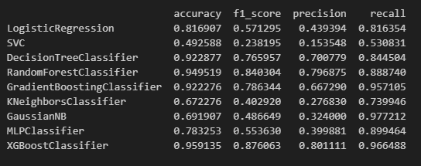

**Classification report and Confusion Matrix for model:**

**Logistic Regression**

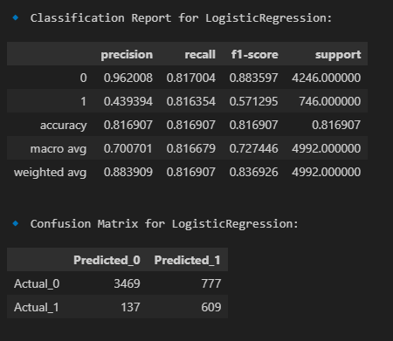

**SVC**

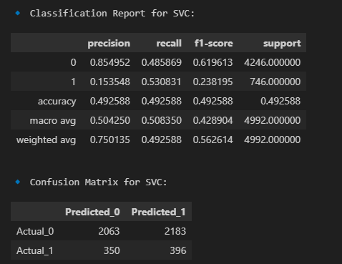

**Decision Tree Classifier**

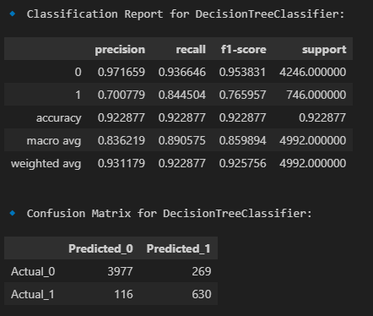

**Random Forest Classifier**

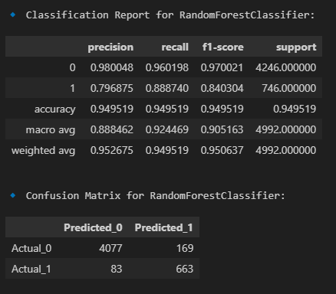

**Gradient Boosting Classifier**

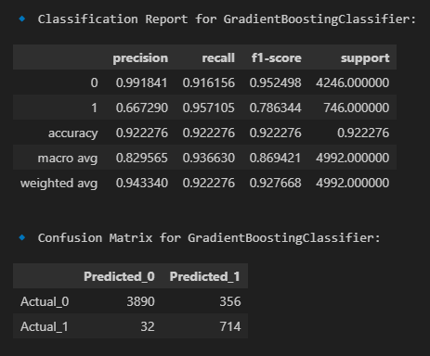

**K-Neighbors Classifier**

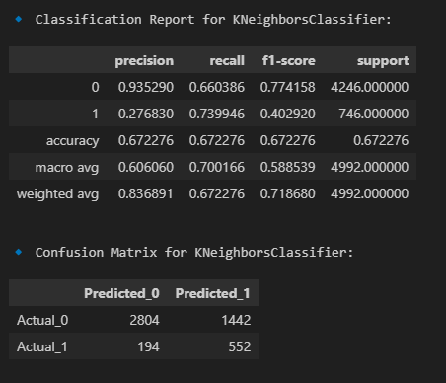

**GaussianNB**

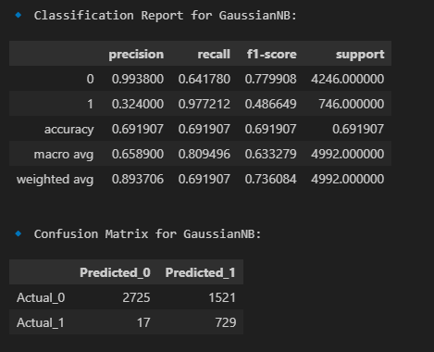

**MLP Classifier**

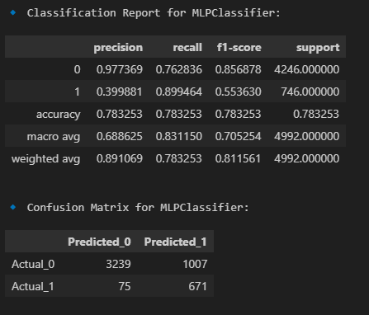

**Xgb Classifier**

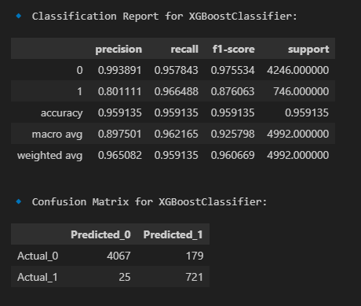

**Best Models:**

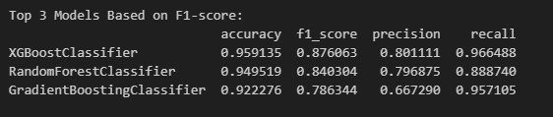

Out of these three XGBClassifier have higher accuracy, f1 score, precision, recall values.so need to perform hyperparameter tuning for that model

**Hyperparameter Tuning:**

Hyperparameter tuning was performed using **RandomizedSearchCV** for XGBoost:

* **XGBoost**: Optimized n_estimators, learning_rate, max_depth, subsample, min_child_weight, colsample_bytree, gamma, reg_alpha, and reg_lambda using a randomized search strategy.

**Best parameters for XGBoost:**

{'subsample': 0.9, 'reg_lambda': 0, 'reg_alpha': 1.5, 'n_estimators': 400, 'min_child_weight': 3, 'max_depth': 10, 'learning_rate': 0.01, 'gamma': 0.2, 'colsample_bytree': 0.8}

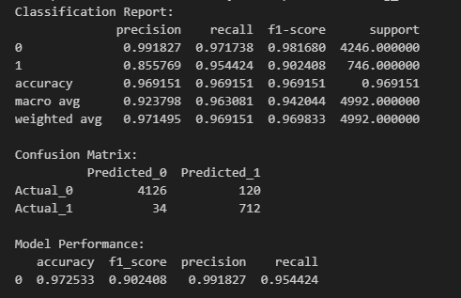

**Submission:**

The submission.csv is stored in submission folder.