**Chicago Crime Analyzer Report**

**Problem Statement:**

The growing complexity of crime data challenges law enforcement in identifying patterns, high-risk areas, and trends. Limited insights hinder resource allocation, crime prediction, and safety measures. This project tackles these gaps by analysing crime data to provide actionable insights, enhancing crime prevention and public safety.

**MySQL-based Insights:**

***Insight 1***: Wards with the Highest Number of Reported Crimes (Top 10)

**Approach**: Ranked wards by crime frequency for each year using window functions (RANK ()) to identify the top 10 high-crime wards annually.

**Key Findings**: Certain wards consistently appear in the top 10, indicating persistent crime hotspots requiring focused interventions.

**Actionable Insights:** Deploy targeted law enforcement in high-crime wards, implement crime prevention programs, and enhance surveillance systems in these areas.

***Insight 2***: Locations with the Most Reported Crimes Across All Years

**Approach:** Used **RANK ()** to identify the **top 10 crime-prone locations per year**, based on reported incidents.

**Key Findings:** Certain locations (e.g., streets, residences, and parking lots) consistently rank high, indicating recurring crime hotspots.

**Actionable Insights:** Increase security in high-crime locations, deploy surveillance cameras, and strengthen law enforcement presence in these areas.

***Insight 3***: Distribution of Crimes by Severity Based on FBI Codes

**Approach**: Categorized crimes by FBI offense codes, analysing their distribution across different years.

**Key Findings:** High-severity crimes (violent offenses) occur less frequently but require urgent attention, whereas low-severity crimes (thefts, vandalism) are more common but widespread.

**Actionable Insights:** Allocate more resources for severe crimes, enhance preventive measures for frequent low-severity crimes, and implement stricter policies for recurring offenses.

***Insight 4***: Crime Types with the Most Improvement or Decline in Arrest Rates

**Approach**: Compared arrest rates of different crimes between the first and last year in the dataset to track changes.

**Key Findings:** Certain violent crimes showed improvement in arrests, while petty crimes saw a decline, possibly due to policy changes.

**Actionable Insights:** Enhance enforcement on crimes with declining arrest rates, optimize police strategies, and allocate more resources to underperforming areas.

***Insight 5***: Arrest Success Rate of Different Police Beats

**Approach**: Evaluated arrest success rates for each police beat by calculating the percentage of successful arrests per total crimes.

**Key Findings**: Some beats consistently have high arrest success rates, while others struggle, indicating differences in efficiency and resource availability.

**Actionable Insights**: Analyse high-performing beats to replicate their strategies, provide additional training/resources to low-performing beats, and optimize patrol distribution.

***Insight 6***: Top 3 Locations Reporting Multiple Crimes of the Same Type

**Approach**: Identified locations with repeated reports of the same crime type across different years.

**Key Findings:** Certain areas (e.g., streets, stores, parking lots) frequently experience repeat offenses, highlighting crime-prone locations.

**Actionable Insights:** Increase surveillance in repeat-crime locations, implement security reinforcements, and conduct crime awareness programs for businesses/residents.

***Insight 7***: Blocks with the Highest Number of Crimes Each Year

**Approach**: Ranked city blocks by total reported crimes per year, identifying the most crime-affected blocks annually.

**Key Findings:** Certain blocks consistently report high crime rates, making them persistent hotspots for illegal activities.

**Actionable Insights:** Deploy targeted patrols, improve lighting/infrastructure, and collaborate with communities to reduce criminal activities in high-crime blocks.

**Pandas-based Insights:**

**Temporal Analysis 🡪 *Insight 1***: Crime Trends Over Time

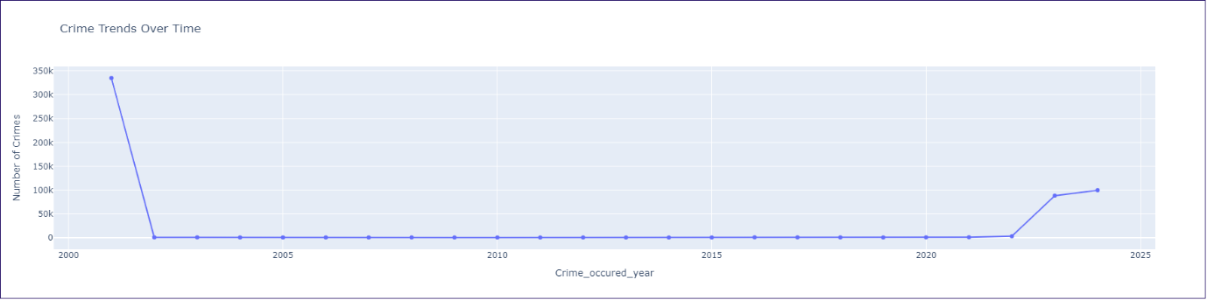

**Approach:**

To analyse crime trends over the years, the dataset was grouped by the year in which crimes occurred, and the total number of crimes per year was calculated.

A line chart was used to visualize fluctuations in crime rates over time. This method helps in identifying long-term patterns and any significant changes in crime occurrences.

**Visualization:** The line chart illustrates the number of reported crimes each year

The **line chart** represents the number of crimes reported each year.

* The **y-axis** indicates the number of crimes.
* The **x-axis** represents the crime occurrence year.
* Markers highlight each data point, making it easier to identify fluctuations.
* The **steep drop after 2001** and **rise after 2020** are key observations.

**Findings:**

* A significant drop in crime numbers after 2001.
* From 2002 to 2019, the crime rate remained relatively stable with minimal fluctuations.
* A noticeable increase in crime rates after 2020.

**Actionable Insights:**

* Investigate the post-2001 drop to determine if changes in data collection or policies influenced the decrease in reported crimes.

**Seasonal Analysis 🡪 *Insight 2*: Crimes Reported by Season**

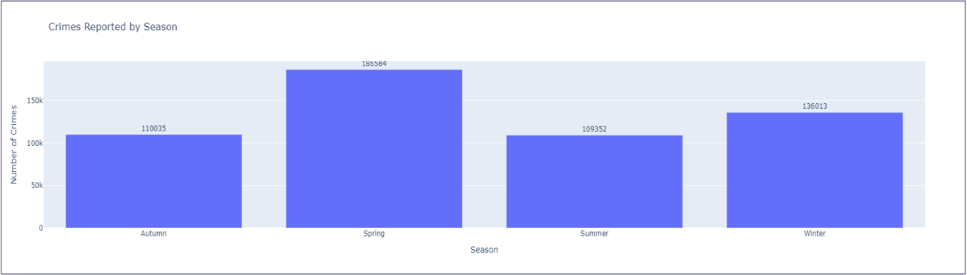

**Approach:**

To examine seasonal crime patterns, the dataset was grouped by **season** (Spring, Summer, Autumn, and Winter) to determine crime distribution across different periods of the year.

A **bar chart** was used to visualize the total number of crimes per season.

**Visualization Explanation:**

* The **bar chart** compares crime counts across the four seasons.
* The **x-axis** represents different seasons.
* The **y-axis** shows the total number of crimes reported.
* Labels on each bar display exact crime counts for clarity.

**Key Findings:**

* **Spring** records the **highest** number of crimes (186,584), indicating a peak in criminal activities during this period.
* **Winter** follows with 136,013 reported crimes, which may be influenced by holiday-related crimes or reduced outdoor monitoring.
* **Autumn** (110,035) and Summer (109,352) report relatively **lower** crime rates, suggesting different seasonal factors influencing crime occurrences.

**Actionable Insights:**

* Increased crime prevention strategies should be implemented during Spring to reduce incidents.
* Focus on crime prevention programs, especially targeting property crimes and holiday-related offenses.

**Temporal Analysis 🡪 *Insight 3*: Crime Distribution - Weekend vs. Weekday**

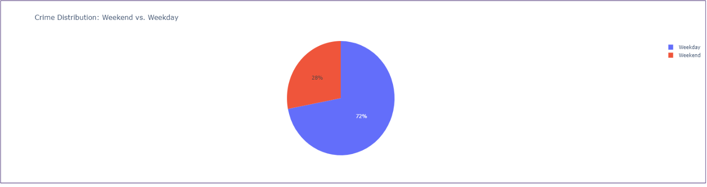

**Approach:**

To determine whether crimes are more prevalent on weekends or weekdays, the dataset was categorized into **two groups**:

* Weekday Crimes (Monday to Friday)
* Weekend Crimes (Saturday and Sunday)

A **pie chart** was used to visualize the proportion of crimes occurring on weekdays versus weekends.

**Visualization Explanation:**

* The **pie chart** represents the proportion of crimes occurring on weekdays and weekends.
* The blue segment (72%) represents weekday crimes, while the red segment (28%) represents weekend crimes.
* A legend is included for better readability.

**Key Findings:**

* **72%** of crimes occur on **weekdays**, suggesting that crime rates are significantly higher during workdays.
* **28%** of crimes occur on **weekends**, indicating a relatively lower frequency of criminal activities during weekends.

**Actionable Insights:**

* Since most crimes occur on weekdays, law enforcement should allocate more resources for weekday surveillance

**Arrest Analysis 🡪 *Insight 4*: Crimes and Arrests by Primary Type**

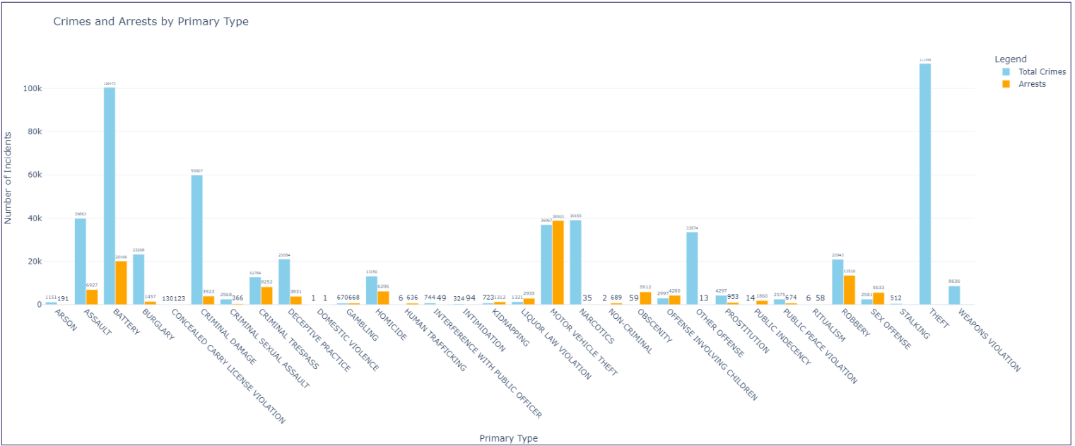

**Approach:**

To analyse arrest patterns, the dataset was grouped by **Primary Type**, calculating:

* The total number of reported crimes for each type.
* The number of incidents that resulted in arrests for each crime type.

A **grouped bar chart** was used to compare total crime occurrences versus arrests.

**Visualization Explanation:**

* The **x-axis** represents different crime types.
* The **y-axis** indicates the number of reported incidents.
* **Sky blue bars** show total crimes, while **orange bars** show the corresponding arrests.
* The gap between total crimes and arrests highlights disparities in law enforcement effectiveness across crime types.

**Key Findings:**

* **Theft** is the **most frequently committed crime**, yet it has a **low arrest rate**, indicating challenges in apprehending offenders.
* **Crimes like assault, battery, and narcotics violations** show a relatively **higher arrest rate**, suggesting these offenses are more actively pursued by law enforcement.
* **Motor vehicle theft and burglary** have **low arrest rates**, possibly due to difficulties in tracking offenders.
* **Prostitution and gambling crimes** have **nearly 100% arrest rates**

**Actionable Insights:**

* Given theft’s high frequency but low arrest rate, police should focus on surveillance, tracking, and anti-theft strategies.

**Crime Type Analysis** 🡪 ***Insight 5*: Crimes Reported by Primary Type**

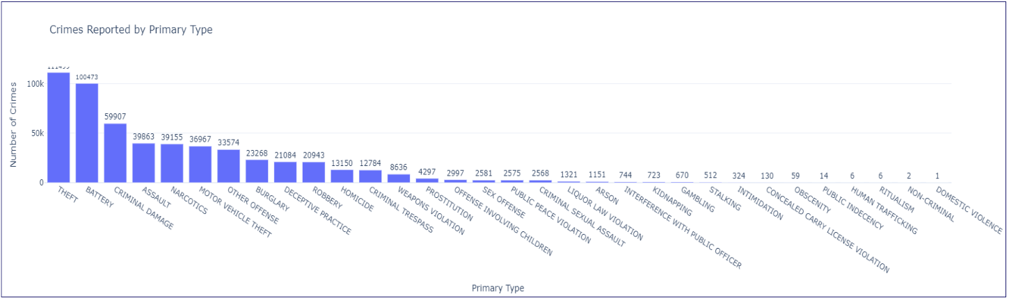

**Approach:**

To determine which crime types, occur most frequently, the dataset was grouped by **Primary Type**, and the total number of incidents for each category was calculated.

A **bar chart** was used to visualize crime distribution across different categories.

**Visualization Explanation:**

* The **x-axis** represents different crime types.
* The **y-axis** indicates the total number of reported incidents.
* **Bar heights** correspond to the frequency of each crime type, with labels displaying exact counts for better readability.

**Key Findings:**

* **Theft is the most reported crime** with over **111,499 incidents**, indicating a high prevalence of property-related offenses.
* **Battery (100,473)** and **criminal damage (59,907)** are also among the most common crimes.
* **Assault (39,863) and narcotics-related crimes (39,155)** indicate a substantial number of violent and drug-related offenses.
* **Less frequent crimes include human trafficking, public indecency, and ritualism**, though their impact may still be significant despite lower numbers.

**Actionable Insights:**

* Understanding which crimes occur most frequently allows for optimized policing efforts, ensuring priority is given to high-impact crime types.

**Arrest Analysis 🡪 *Insight 6*: Arrest Ratio Over the Years**

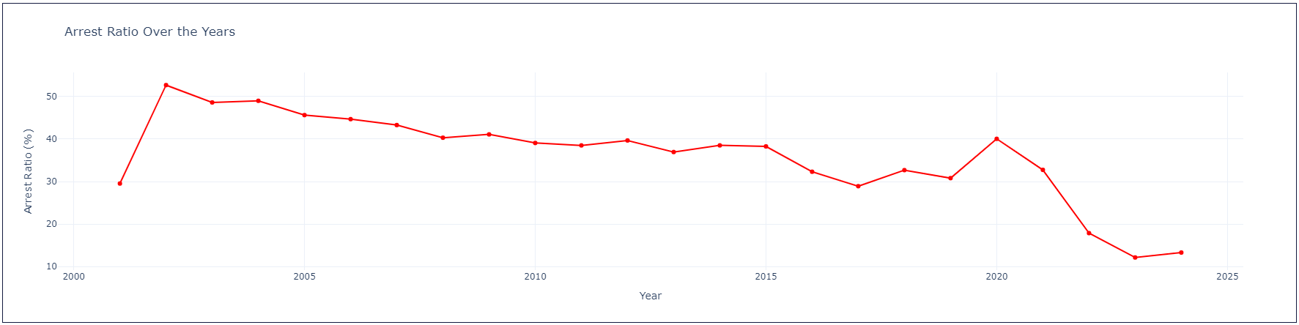

**Approach:**

To evaluate how arrest rates have changed over time, the dataset was analysed by grouping crimes by **year** and calculating:

* **Total number of crimes committed each year.**
* **Total number of arrests made each year.**
* **Arrest ratio (%)** = (Total Arrests / Total Crimes) × 100

A **line chart** was used to visualize the changes in arrest ratios over the years.

**Visualization Explanation:**

* The **x-axis** represents different years.
* The **y-axis** indicates the arrest ratio (%) for each year.
* A **red line with markers** highlights fluctuations in arrest rates.
* **Steep declines and increases** emphasize significant changes in Arrest Ratio

**Key Findings:**

* **Arrest ratios** were significantly **higher** in the **early 2000s**, peaking at over **50% in some years.**
* A **gradual decline in arrest rates** was observed between **2005 and 2019**, stabilizing around **30-40%** in most years.
* A **sharp drop in arrest ratios post-2020**, falling below **20%**, indicates a significant decrease in Arrest Ratio.

**Actionable Insights:**

* A lower arrest ratio suggests difficulties in solving crimes—investing in forensic technology, surveillance, and intelligence gathering can improve outcomes.

**Geospatial Analysis 🡪 *Insight 7*: Seasonal Crime Trends by District**

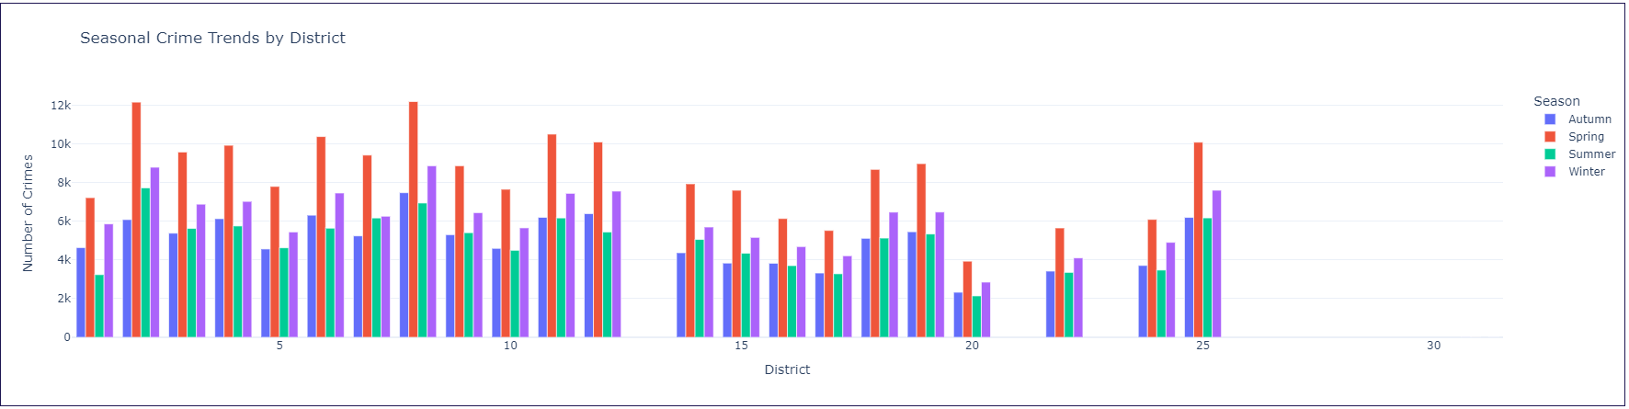

**Approach:**

To analyse how crime trends vary by season across different districts, the dataset was grouped by **district and season**, calculating the **total number of crimes** for each combination.

A **grouped bar chart** was used to visualize the seasonal crime trends in each district.

**Visualization Explanation:**

* The **x-axis** represents different districts.
* The **y-axis** shows the total number of crimes reported.
* Each bar represents crime counts, **color-coded by season** for clear differentiation.
* The **grouped bar format** allows for easy seasonal comparisons within each district.

**Key Findings:**

* **Spring and Autumn** have the **highest crime** rates across most districts, with **Autumn consistently showing the highest peak** in several areas.
* **Summer and Winter have relatively lower crime counts**, though some districts experience crime spikes in winter.
* Seasonal fluctuations vary across districts.
* Certain districts have uniform crime rates across all seasons.

**Actionable Insights:**

* Since **Autumn sees the highest crime activity**, law enforcement should **increase patrols and preventive measures** during this season.
* Public awareness campaigns can help reduce **seasonally influenced crimes**, such as theft during shopping seasons or violent crimes in extreme weather conditions.

**Geospatial Analysis 🡪 *Insight 8*: Crime Count by Community Area**

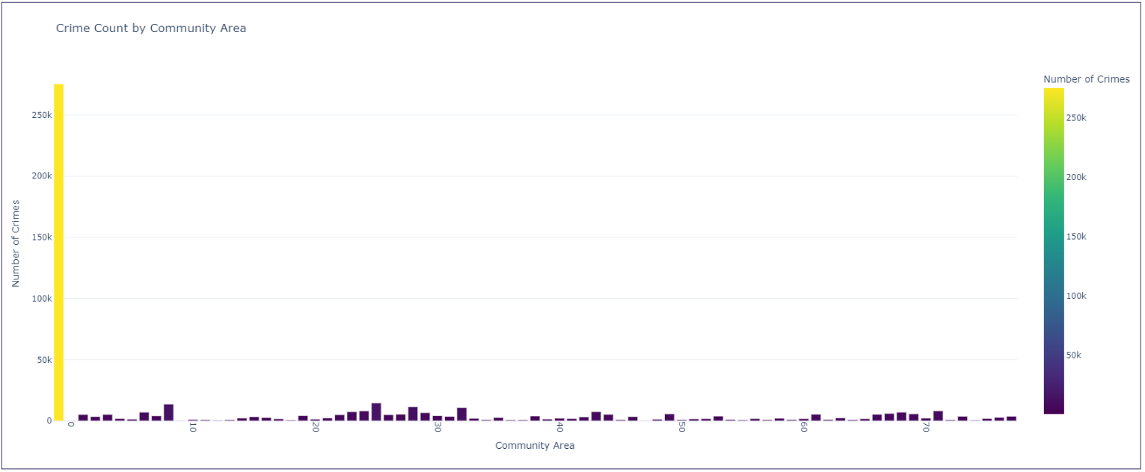

**Approach:**

To determine crime density across different community areas, the dataset was grouped by **Community Area**, calculating the **total number of crimes** reported in each area.

A **colour-encoded bar chart** was used to visualize variations in crime rates across these areas.

**Visualization Explanation:**

* The **x-axis** represents different community areas.
* The **y-axis** shows the total number of reported crimes.
* Bars are color-coded based on crime density, using a gradient where high-crime areas appear in brighter shades (yellow) and low-crime areas in darker shades (purple).
* A **colour scale on the right** provides a reference for crime intensity in different regions.

**Key Findings:**

* Crime is highly concentrated in certain community areas, with a few regions experiencing significantly higher crime rates than others.
* Several community areas have relatively low crime rates.

**Actionable Insights:**

* Law enforcement should **allocate more resources to high-crime community areas**, ensuring enhanced patrolling, surveillance, and crime prevention programs.
* Government initiatives such as **better infrastructure, youth programs, and economic development** in high-crime areas may help **reduce crime rates over time**.

**Arrest Analysis 🡪 *Insight 9*: Top 10 Crime Types by Arrest Rate**

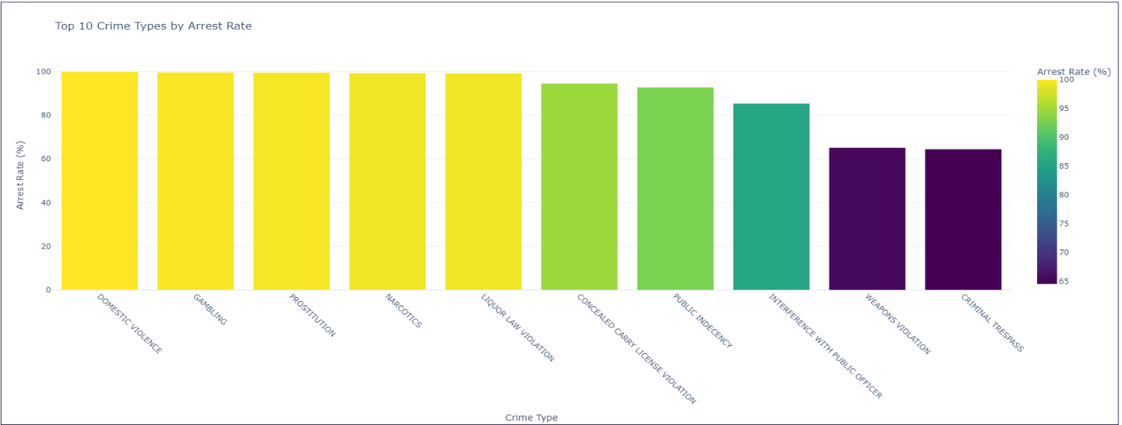

**Approach:**

To identify the crime types with the highest arrest rates, the dataset was grouped by **Primary Type**, calculating:

* **Total number of crimes** for each type.
* **Total number of arrests** for each type.
* **Arrest rate (%)** = (Total Arrests / Total Crimes) × 100

The top 10 crime types with the highest arrest rates were selected and visualized using a **colour-encoded bar chart**.

**Visualization Explanation:**

* The **x-axis** represents different crime types.
* The **y-axis** shows the percentage of reported crimes that resulted in arrests.
* Bars are color-coded based on arrest rates, using a gradient where **higher arrest rates appear in bright yellow** and **lower arrest rates in darker shades**.
* The **colour scale on the right** helps interpret variations in arrest rates.

**Key Findings:**

* **Domestic violence, gambling, prostitution, narcotics, and liquor law violations** have near 100% arrest rates, indicating that these crimes are actively pursued by law enforcement.
* Criminal trespass and weapons violations have lower arrest rates, suggesting challenges in identifying and apprehending offenders for these crimes.

**Actionable Insights:**

* Crimes like criminal trespass and weapons violations require better investigative methods and surveillance techniques to improve arrest rates.

**Location-Based Crime Analysis 🡪 *Insight 10*: Top 10 Areas with Highest Crime Occurrences**

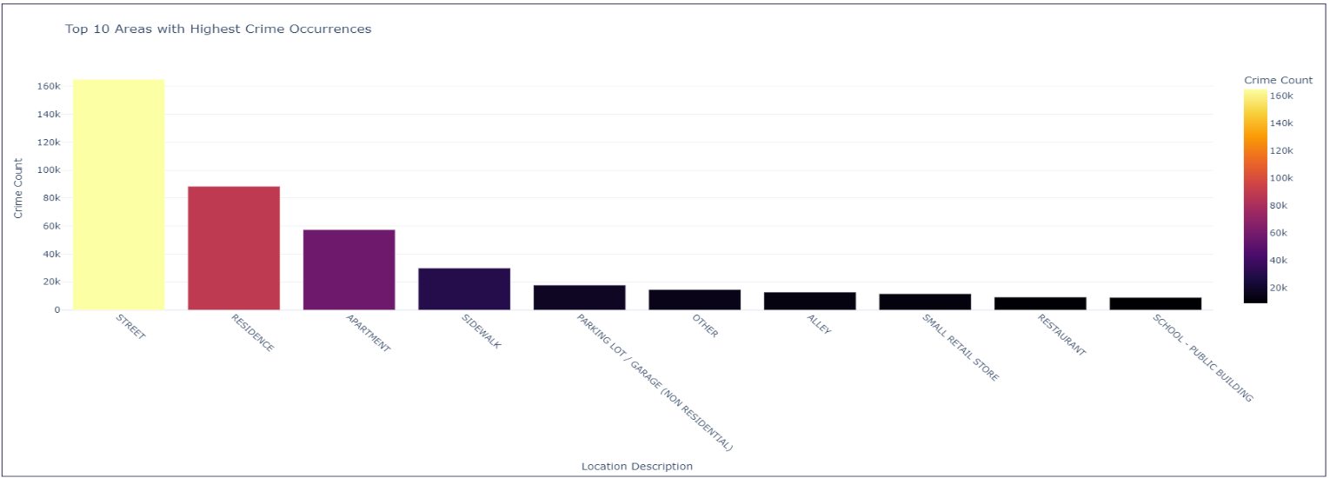

**Approach:**

To determine the locations with the highest crime occurrences, the dataset was grouped by **Location Description**, calculating the **total number of crimes** reported in each area.

The top 10 locations with the highest crime rates were selected and visualized using a **colour-encoded bar chart**.

**Visualization Explanation:**

* The **x-axis** represents different locations where crimes occurred.
* The **y-axis** shows the total number of reported crimes.
* **Bars** are **color-coded** **based on crime density**, using the Inferno scale where higher crime locations appear in bright yellow and lower crime locations in dark shades.
* A **colour scale on the right** helps interpret crime frequency across different areas.

**Key Findings:**

* **Streets account for the highest number of crimes**, with over **160,000 incidents**, making public spaces a major concern for law enforcement.
* **Residences (80,000+) and apartments (60,000+) also report high crime occurrences**, highlighting safety concerns in residential areas.
* **Sidewalks, parking lots, and alleys** are also among the top locations for crimes, possibly linked to theft, and violent incidents.

**Actionable Insights:**

* Given the high crime rate on streets, more security cameras, better street lighting, and increased police patrols can help deter criminal activities.
* Sidewalks, parking lots, and alleys should have better lighting, emergency call stations, and frequent patrols to ensure public safety.

**MySQL-based Insights Visualise from PowerBi:**

**Geospatial & Crime Type Analysis 🡪 *Insight 1***: Top Crime Types in the Most Affected Community Areas

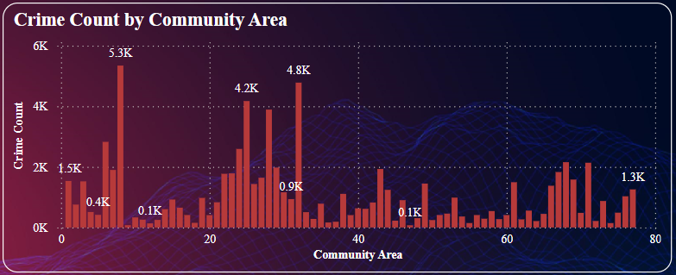

**Approach:** The analysis was performed using **MySQL queries** on the processed crime dataset to:

* Group crimes by year, community area, and crime type.
* Count the total number of crimes for each type in each community area.
* Identify the most reported crime type for each community area per year.
* Retrieve and visualize the highest crime type for each affected community area over time.

The **Power BI visualization** provides a **bar chart** displaying the crime count distribution across different community areas.

**Visualization Explanation:**

* The **x-axis** represents different community areas.
* The **y-axis** shows the total number of reported crimes per area.
* **Bar heights indicate crime frequency**, with labels for high-crime areas.

**Key Findings:**

* Certain community areas consistently report high crime rates, with some reaching over 5,000+ reported incidents per year.
* Some regions experience significant crime fluctuations, suggesting seasonal or policy-related impacts.

**Actionable Insights:**

* Government agencies can use this data to reallocate law enforcement personnel and implement crime prevention policies in affected regions.

**Crime Type Analysis 🡪 *Insight 2***: Most Common Crime Types in the Year

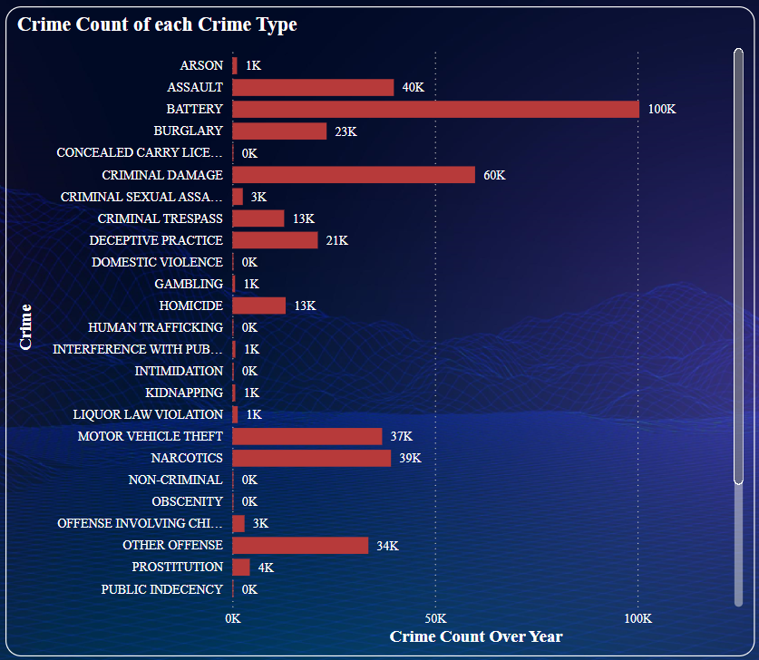

**Approach:**

The analysis was performed using MySQL queries to:

* Group crimes by year and crime type.
* Count the total number of crimes for each type.
* Sort the data to identify the most frequently reported crimes per year.

The **Power BI** visualization provides a **horizontal bar chart** displaying the crime count distribution for different crime types.

**Visualization Explanation:**

* The **y-axis** lists different crime types.
* The **x-axis** represents the number of reported crimes over the selected year.
* **Bar lengths indicate the frequency of each crime type**, with numerical labels enhancing readability.

**Key Findings:**

* **Battery** is the most reported crime, with over **100K cases**, indicating a high rate of physical altercations or assaults.
* **Criminal damage (60K) and assault (40K) are also among the top crimes**, showing a trend of property damage and personal attacks.
* **Motor vehicle theft (37K) and narcotics-related crimes (39K) remain significant**, suggesting the need for enhanced vehicle security and drug enforcement policies.
* **Less frequent crimes like arson, homicide, and kidnapping are still impactful**, requiring focused law enforcement efforts despite their lower numbers.

**Actionable Insights:**

* Battery, assault, and criminal damage require targeted law enforcement initiatives, stricter policies, and improved public safety measures.

**Crime Type Analysis 🡪 *Insight 3***: Most Common Crime Types in the Year

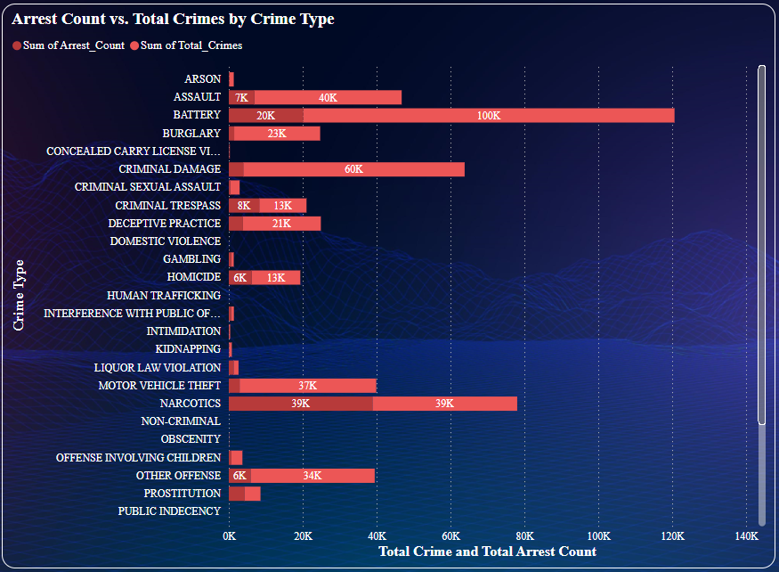

**Approach:**

Using MySQL queries, the dataset was analysed to:

* Group crimes by year and crime type.
* Count the total number of crimes and arrests for each type.
* Calculate the arrest percentage = (Total Arrests / Total Crimes) × 100.
* Sort the data by highest arrest percentage to determine which crimes are most and least likely to result in arrests.

The **Power BI visualization** provides a **stacked bar chart** comparing **total crime** occurrences vs. total arrests for each crime type.

**Visualization Explanation:**

* The **y-axis** lists different crime types.
* The **x-axis** represents the total number of crimes and arrests.
* **Red bars indicate total crimes**, while **smaller red-highlighted bars show arrests** for each crime type.
* The **difference in bar lengths** highlights the gap between reported crimes and successful arrests.

**Key Findings:**

* **Narcotics-related crimes and motor vehicle theft have nearly a 100% arrest rate**, suggesting these crimes are actively pursued by law enforcement.
* **Battery (100K cases) and Theft(110k) and assault (40K cases) have relatively low arrest counts**, indicating challenges in making arrests despite their high frequency.
* **Crimes such as domestic violence, public indecency, and human trafficking show almost no recorded arrests**, highlighting potential underreporting or difficulties in enforcement.

**Actionable Insights:**

1. Assault and battery have low arrest rates despite being among the most common crimes, requiring better investigative procedures, forensic analysis, and victim support.
2. High arrest rates for drug-related offenses and motor vehicle theft indicate effective policing that should continue.
3. High arrest rates for drug-related offenses and motor vehicle theft indicate effective policing that should continue.

**Crime Type Analysis 🡪 *Insight 4***: Arrest Rate Fluctuations Across Different Seasons

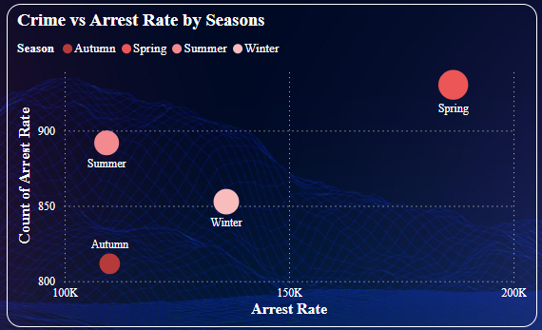

**Approach:**

Using MySQL queries, the dataset was analysed to:

* Group crimes by season and year.
* Count the total number of crimes and arrests for each season.
* Calculate the arrest rate (%) = (Total Arrests / Total Crimes) × 100.
* Compare seasonal fluctuations to identify high and low arrest periods.

The **Power BI** visualization provides a **bubble chart** displaying the relationship between crime volume and arrest rates across seasons.

**Visualization Explanation:**

* The **x-axis** represents the **arrest rate**, showing how effective law enforcement is in different seasons.
* The **y-axis** represents the **number of arrests** per season.
* **Bubble size** represents the total crime volume per season.
* **Colour’s represent different seasons** (Autumn, Spring, Summer, and Winter) for clear differentiation.

**Key Findings:**

* **Spring** has the **highest arrest rate**, with the largest bubble, indicating that law enforcement is more active during this season.
* Summer also has a high number of crimes, but with a slightly lower arrest rate, suggesting that increased criminal activities might reduce arrest efficiency.
* Winter and Autumn show lower arrest counts, with Winter having a relatively better arrest rate than Autumn.
* Seasonal variations in crime patterns influence arrest rates, requiring adaptive policing strategies.

**Actionable Insights:**

* Enhance Law Enforcement During Summer and Autumn, since these seasons have high crime volumes but lower arrest rates, additional policing, surveillance, and community engagement programs can improve crime resolution.

**Temporal Analysis 🡪 *Insight 5***: Monthly Distribution of Crimes

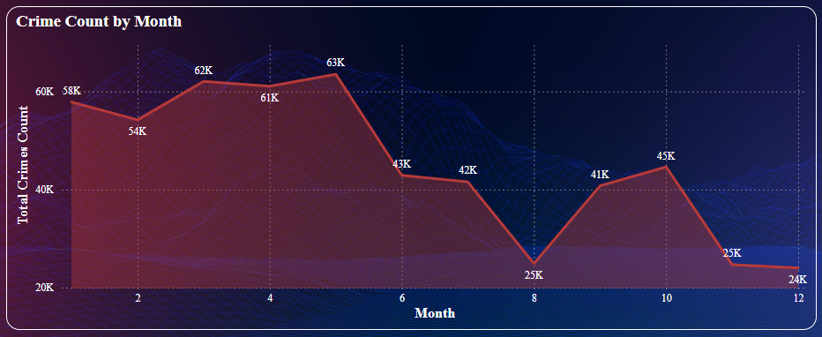

**Approach:**

Using MySQL queries, the dataset was analysed to:

* Group crimes by year and month.
* Count the total number of crimes reported each month.
* Sort the data in chronological order to identify trends.

The **Power BI** visualization provides an **area chart** showing monthly variations in crime occurrences throughout the year.

**Visualization Explanation:**

* The x-axis represents the months of the year (1-12).
* The y-axis represents the total crime count per month.
* The red trend line highlights fluctuations in crime occurrences, with peaks and dips clearly visible.
* Data labels indicate exact crime counts for each month, helping identify high and low crime periods.

**Key Findings:**

* **March to May** sees the **highest crime activity**, with **April peaking at 63K** cases.
* Crime rates significantly **drop** in **August** (25K cases) and **December** (24K cases), indicating seasonal dips.
* Crime starts increasing again in **October** (45K cases).
* A steady rise from January to mid-year followed by a decline suggests external factors like weather, holidays, or socio-economic conditions influencing crime trends.

**Actionable Insights:**

* Since March to May has the highest crime rates, law enforcement should increase patrols and surveillance during this period.
* Investigate Causes for Crime Drops in August and December, understanding why crime rates drop significantly during these months could help replicate successful factors across other months.

**Seasonal Crime and Arrest Rate Analysis 🡪 *Insight 6***: Seasonal Variations in Arrest Rates

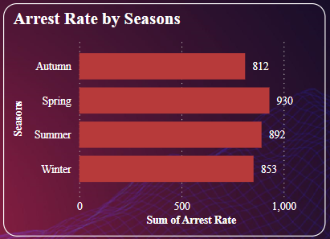

**Approach**:

Using **MySQL queries**, the dataset was analysed to:

* **Group crimes by season and year.**
* **Count the total number of crimes and arrests for each season.**
* **Calculate the arrest rate (%) = (Total Arrests / Total Crimes) × 100.**
* **Compare seasonal fluctuations to identify high and low arrest periods.**

The **Power BI visualization** provides a **Clustered-bar chart** comparing **arrest rates across different seasons**

**Visualization Explanation:**

* The x-axis represents the total arrest rate per season.
* The y-axis represents different seasons (Autumn, Spring, Summer, and Winter).
* Bar lengths indicate the total arrest rate**,** with exact values labelled for clarity.

**Key Findings:**

* **Spring** has the **highest arrest rate** (930 arrests), indicating that law enforcement is more effective during this season
* **Summer** follows closely (892 arrests), suggesting increased police activity during warmer months when crimes may rise.
* **Winter and Autumn** have **lower** **arrest rates** (853 and 812 arrests, respectively), possibly due to weather conditions affecting law enforcement activity or crime reporting.

**Actionable Insights:**

* Autumn and Winter: Since arrest rates are lower in Autumn and Winter, police departments should implement strategic patrolling and crime prevention measures to compensate.
* Law enforcement agencies should analyse factors influencing higher arrest rates in Spring and Summer, potentially replicating successful tactics in other seasons.

**Seasonal Crime Analysis 🡪 *Insight 7***: Crime Frequencies Across Seasons

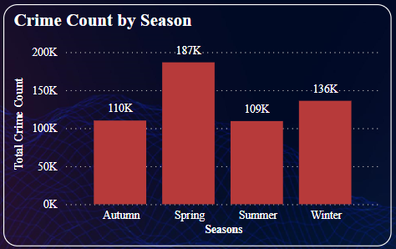

**Approach:**

Using MySQL queries, the dataset was analysed to:

* Group crimes by season and year.
* Count the total number of crimes reported in each season.
* Sort the data chronologically to track crime frequency trends over time.

The **Power BI** visualization provides a **bar chart** displaying the relationship between crime volume and arrest rates across seasons.

**Visualization Explanation:**

* The **x-axis** represents the **seasons**.
* The y-axis represents the total crime for each season.
* Bar heights indicate crime volumes, with numeric labels highlighting exact crime counts.

**Key Findings:**

* **Spring** experiences the **highest** **crime** **rate (187K cases),** making it the most active season for criminal activity.
* **Winter** has the **second-highest crime count (136K cases)**, possibly due to holiday-related crimes or indoor offenses.
* **Autumn** (110K) and **Summer** (109K) have relatively lower crime rates, but still show significant activity.
* The seasonal variations suggest that external factors such as weather, social behaviour, and economic conditions may influence crime rates.

**Actionable Insights:**

1. **Spring has the highest crime rate**, law enforcement agencies should allocate more patrol units, surveillance, and community safety initiatives during this season.
2. Despite cold weather, **crime rates remain high in Winter**, requiring targeted crime prevention strategies for theft, fraud, and domestic crimes.

**Seasonal Crime Analysis 🡪 *Insight 8***: Crime Frequencies Across Seasons

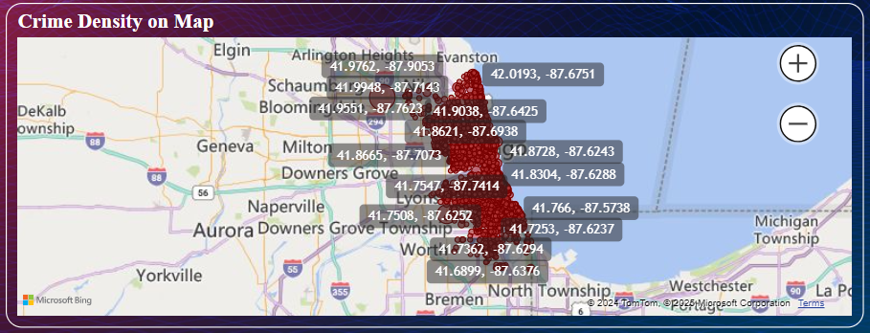

**Approach:**

Using MySQL queries, the dataset was analysed to:

* Extract latitude and longitude coordinates of reported crimes.
* Group crimes by year and location to track changes in crime density.
* Count the total number of crimes occurring at specific locations.
* Sort the data to identify the areas with the highest crime densities.

The **Power BI** visualization provides an interactive **map**, displaying high-risk areas based on geospatial coordinates.

**Visualization Explanation:**

* The map displays crime density using latitude and longitude coordinates.
* Darker and more clustered areas indicate higher crime concentrations.
* Interactive zooming allows law enforcement to focus on specific neighbourhoods.

**Key Findings:**

* Crime density is concentrated in specific urban regions, particularly in highly populated areas or commercial zones.
* Repeated high-crime areas indicate chronic criminal activity, suggesting law enforcement challenges in certain neighbourhoods.
* Crime density varies year over year, potentially due to law enforcement interventions, socio-economic changes, or migration patterns.

**Actionable Insights:**

* Law enforcement should deploy more patrols, surveillance cameras, and emergency response units in crime-heavy zones.
* Enhance Community Policing Initiatives: Engaging local residents and businesses in crime prevention efforts can help reduce criminal activities in hotspots.
* Use Predictive Policing Models: Geospatial data can be integrated with predictive analytics to forecast future crime trends and prevent crime before it happens.
* Adjust Urban Planning to Reduce Crime Risks: City planners can use this data to modify urban infrastructure, improve street lighting, and implement neighbourhood safety programs.

**Temporal Analysis 🡪 *Insight 9***: Crime Frequencies Across Seasons

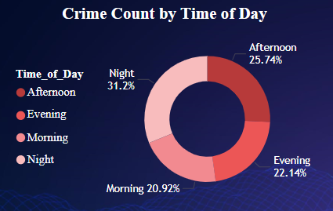

**Approach:**

Using MySQL queries, the dataset was analysed to:

* Group crimes by time of the day (Morning, Afternoon, Evening, Night).
* Count the total number of crimes occurring during each time period.
* Sort the data in descending order to identify peak crime periods.

The **Power BI visualization** provides a **donut chart** displaying the percentage distribution of crimes across different time periods.

**Visualization Explanation:**

* The **donut chart segments represent different time periods** (Morning, Afternoon, Evening, and Night).
* Colour variations distinguish crime frequency across different times of the day.
* Numeric labels provide exact percentage values for each time category.
* The chart highlights Night and Afternoon as the peak crime periods.

**Key Findings:**

* **Nighttime** has the **highest crime rate** (31.2%), making it the most crime-prone period.
* **Afternoon** (25.74%) and **Evening** (22.14%) also show significant crime occurrences, suggesting increased risk in these periods.
* **Morning** (20.92%) has the lowest crime rate, likely due to lower activity levels and increased daylight presence.

**Actionable Insights:**

* Since nighttime has the highest crime rate, police should deploy more officers, install surveillance, and improve street lighting in high-crime areas.
* Promote Community Safety Initiatives: Encouraging neighbourhood watch programs and self-defence training can help residents feel safer during high-crime hours.

**Crime Analysis 🡪 *Insight 10***: Domestic vs. Non-Domestic Crimes Over the Years

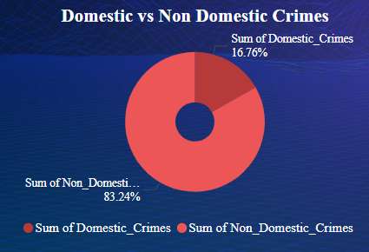

**Approach:**

Using MySQL queries, the dataset was analysed to:

* Group crimes by year and classify them as domestic or non-domestic.
* Count the number of crimes in each category per year.
* Calculate the percentage of domestic and non-domestic crimes for comparative analysis.

The **Power BI** visualization provides a **donut chart** displaying the percentage distribution of domestic and non-domestic crimes.

**Visualization Explanation:**

* The **donut chart segments represent domestic and non-domestic crime proportions.**
* Colour differentiation highlights the stark contrast between the two crime categories.
* Numeric labels provide the exact percentage breakdown of domestic (16.76%) and non-domestic (83.24%) crimes.

**Key Findings:**

* **Non-domestic** crimes account for the vast **majority (83.24%),** indicating that most reported crimes occur in public spaces or non-household environments.
* Domestic crimes make up only 16.76% of total crimes, but their presence highlights household-related safety concerns such as domestic violence or disputes.
* Non-domestic crimes likely include thefts, assaults, and other public offenses, which require distinct policing strategies compared to domestic crime interventions.

**Actionable Insights:**

* Despite being a smaller proportion, domestic crimes require targeted interventions such as domestic abuse helplines, legal aid, and victim support programs.
* Since public crimes dominate the dataset, law enforcement should focus on crime hotspots, patrolling strategies, and surveillance systems in high-crime areas.