**Project Name:**

**DataSpark – Illuminating Insights for Global Electronics**

### Introduction:

Global Electronics, a leading retailer of consumer electronics, is striving to leverage its vast data to enhance customer satisfaction, optimize operations, and drive overall business growth. This project, titled "DataSpark: Illuminating Insights for Global Electronics," aims to conduct a comprehensive Exploratory Data Analysis (EDA) on their data to uncover valuable insights and actionable recommendations.

### Problem Statement:

As part of Global Electronics' data analytics team, you are tasked with conducting a comprehensive Exploratory Data Analysis (EDA) to uncover valuable insights from the company’s data. Your goal is to provide actionable recommendations that can enhance customer satisfaction, optimize operations, and drive overall business growth.

Global Electronics, a leading retailer of consumer electronics, has provided you with several datasets containing information about their customers, products, sales, stores, and currency exchange rates.

The company seeks to leverage this data to better understand their business and identify areas for improvement.

### Packages Used:

* **Pandas:**

Pandas is a powerful and open-source Python library. The Pandas library is used for data manipulation and analysis. Pandas consist of data structures and functions to perform efficient operations on data.

To know more about Pandas. Click here → <https://pandas.pydata.org/docs/index.html>

### MySQL:

MySQL is an open-source relational database management system (RDBMS) that's used to store and manage data

To know more about MySQL. Click here → <https://dev.mysql.com/doc/>

### Install Packages:

* **Pandas** – pip install pandas
* **MySQL Connector**– pip install mysql-connector-python

### Software Used:

* **Visual Studio Code:**

Visual Studio Code, also commonly referred to as VS Code, is a source-code editor developed by Microsoft for Windows, Linux, macOS and web browsers. Features include support for debugging, syntax highlighting, intelligent code completion, snippets, code refactoring, and embedded version control with Git. Users can change the theme, keyboard shortcuts, preferences, and install extensions that add functionality.

Performed EDA in visual studio code.

To know more about visual studio code. Click here → <https://code.visualstudio.com/docs>

### MySQL Workbench:

MySQL Workbench is a visual tool that helps database architects, developers, and DBAs work with MySQL servers and databases. It's a cross-platform, open-source tool that combines SQL development, database design, and administration into a single environment. Stores the data and have written queries for insight

To know more about MySQL workbench. Click here →

<https://dev.mysql.com/doc/workbench/en/>

### Power Bi:

Power BI, or Power Business Intelligence, is a Microsoft platform that helps users analyse, visualize, and share data for business intelligence (BI) purposes. It's a collection of software services, apps, and connectors that can turn data from different sources into interactive insights. Power BI can connect to data from Excel spreadsheets, cloud-based data warehouses, and on-premises hybrid data warehouses. It can then help users build charts, graphs, and dashboards to visualize the data.

Created dashboard in Power Bi

To know more about Power Bi. Click here → <https://learn.microsoft.com/en-us/power-bi/>

### PowerPoint:

It is a presentation-based program that uses graphics, videos, etc. to make a presentation more interactive and interesting

Created report for the project

To know more about PowerPoint. Click here → [https://support.microsoft.com/en-](https://support.microsoft.com/en-us/powerpoint) [us/powerpoint](https://support.microsoft.com/en-us/powerpoint)

### Project files:

* datacleaning.py:
  1. This file will manage the data cleaning process and saving the data in the mysql database.
* project_dataspark_dataspark.sql:

1) This file contains MySQL queries to extract key insights from the data. These queries will address important business questions.

* dataspark_dashboard.pbix:

1) This file contains interactive power bi dashboard which helps to understand business insights related to sales, customer, store, product, exchange rates.

* Report.pptx:

1) This file contains the key insights of the global electronics with problem and solution statement

### Project Workflow:

1. Run the dalacleaning.py file in vs code using ‘python datacleaning.py’ command
2. Execute MySQL queries in MySQL Workbench
3. Open dataspark_dashboard.pbix to go through the customer, sales, stores, product, exchange rate insight of the global electronics.
4. Open the Report.pptx file to understand the key insights and problem and solution statement of the insights.

### Learnt things from this project:

* Gained a deep understanding of how to clean and prepare data for analysis, ensuring accuracy and reliability
* Improved proficiency in Exploratory Data Analysis (EDA), uncovering insights and patterns in data
* Strengthened expertise in MySQL, particularly in data storage, retrieval, and management.
* Developed advanced skills in Power BI, enabling the creation of impactful visualizations and dashboards.
* Improved the ability to craft compelling narratives around data, effectively communicating insights and recommendations.

### Power Bi Dashboard:

**Customer Analysis**

**Sales Analysis**

**Store Analysis**

**Product Analysis**

**Exchange Analysis**

# CUSTOMER INSIGHTS

Power BI Desktop

## Overivew

**Insights**

## Q&A's

**Interested Category Of Product By Age Group**

**Product category**

Audio

Interested People Count

4K Cameras and camcorders

Cell phones Computers

Games and Toys

2K

Home Appliances

Music, Movies and Audio Books TV and Video

0K

**Interested Subcategory of Product By Age Group**

**Age Group** 18-24 25-34 35-44 45-54 55-64 65-84 85+

Air Conditioners Bluetooth Headphones

Subcategory

Boxed Games Camcorders

Cameras & Camcorders Access…

Car Video

18-24 25-34 35-44 45-54 55-64 65-84 85+

Age Group

0K 5K 10K

Interested People Count

**Product Sold Count By Category**

Audio Cameras and … Cell phones Computers Games and …

|  |  |  |  |
| --- | --- | --- | --- |
| category | Female | Male | **Total** |
| Audio | 11280 | 12210 | **23490** |
| Cameras and camcorders | 8933 | 8676 | **17609** |
| Cell phones | 15496 | 15981 | **31477** |
| Computers | 21924 | 22227 | **44151** |
| Games and Toys | 11165 | 11426 | **22591** |
| Home Appliances | 8858 | 9543 | **18401** |
| Music, Movies and Audio Books | 14580 | 14222 | **28802** |
| TV and Video | 5458 | 5778 | **11236** |
| **Total** | **97694** | **100063** | **197757** |

**Category Interested Breakdown By Gender**

**Profit By State**

Music, Movies and …

Audio 23K

29K Cameras and …

18K

Home App…

18K

Cell phones 31K

Games and Toys

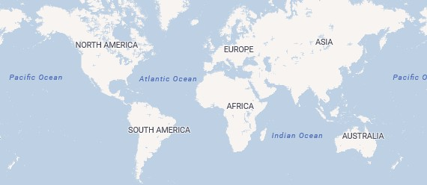

23K

Computers 44K

© 2024 Miiccrrossofftt Corrporrattiion

# SALES INSIGHTS

Power BI Desktop

|  |  |  |  |  |  |  |  |
| --- | --- | --- | --- | --- | --- | --- | --- |
| Customer Analysis Sales Analysis Store Analysis Product Analysis Exchange Analysis | | | | | | |  |
|  | | | | | | | |
| **Overview** |  | **Insights** |  | **Q&A's** |  |  | |

**country** Canada Online United States

**Top 10 States by Sales**

**country** Australia France Germany Italy

**Total Profit Across All Stores In A Country**

**Legend** Count of store_key Sum of total_sales_usd

**Least 10 States By Sales**

Connecticut

Kansas Nebraska Nevada

state

Newfoundland and…

**1.08M**

* 1. **M**

|  |
| --- |
|  |
|  |
|  |
|  |

* 1. **M**

**1.06M**

**1.26M**

0.2M

0.1M

Sum of total_sal…

0.0M

* 1. **M**
  2. **M**
  3. **M**

**0.08M**

**0.15M 0.13M**

* 1. **M**

**0.15M**

**0.01M**

**0.21M** 20

10

Count of store_…

0

20M

10M

Sum of total_sa…

0M

0M 5M 10M

Sum of total_sales_usd

state

country

**Overall Profit By Category Stores across the Country**

**category** Audio Cameras a… Cell phones Computers Games and… Home Appli… Music, Movi… **store_key** 0 1 2 4 5 6 8 9 10 12 13 14 15 16 17 18 19 20 21 22 23 24 26 27 28 29 30 31 32

Music, Movies and Audio Books

Audio 3.17M

Home Appliances

5.89M

Games and Toys

0.72M

3.13M Cameras and camcorders

5.29M

Cell phones 6.18M

Computers 16.08M

© 2024 Miiccrrossofftt Corrporrattiion



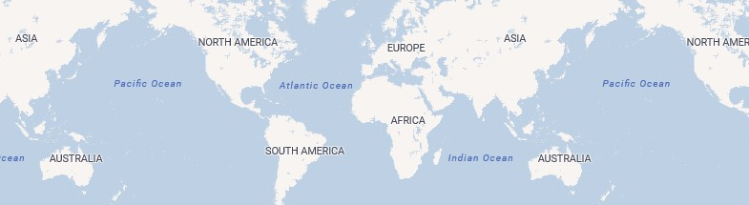

Customer Analysis

Sales Analysis

Store Analysis

Product Analysis

Exchange Analysis

# STORE INSIGHTS

Power BI Desktop

## Overview

**Insights**

## Q&A's

**Store's Sales Details**



All



All



Apr Aug Dec Feb Jan Jul Jun Mar May Nov Oct Sep

Month

$0M

$2M

$4M

$6M

**Total Sales By Store Per Month**

year



store_key



Total Sales

|  |  |  |  |  |  |  |
| --- | --- | --- | --- | --- | --- | --- |
| **country** | **Sum of customer_count** |  | **Sum of sales_per_store** | **Sum of store_count** |  | **Sum of total_sales_volume** |
| **Australia** | **2941** | | **1,534.83** | **6** | | **9209** |
| **Canada** | **5415** | | **3,358.60** | **5** | | **16793** |
| **France** | **1730** | | **769.29** | **7** | | **5385** |
| **Germany** | **5956** | | **2,104.78** | **9** | | **18943** |
| **Italy** | **2685** | | **2,823.33** | **3** | | **8470** |
| **Netherlands** | **2250** | | **1,450.40** | **5** | | **7252** |
| **United Kingdom** | **8140** | | **3,614.00** | **7** | | **25298** |
| **United States** | **33767** | | **4,433.63** | **24** | | **106407** |

**Least 10 Stores by Sales**

**store_key**

**Top 10 Stores by Sales**

65 **store_key**

**Sales By Store Age in a State**

Alaska Arkansas Armagh Australian Ca… Ayrshire Basse-Norm… Belfast

28 156.52K



18 171.98K

17

137.52K

16 149.79K

1 174.14K 1

2 9.38K 2

12 12

152.76K 13

14

13 15

122.83K

16

14 91.65K 17

15 168.47K

61 1M 1.02M

59 0.98M

57 0.97M

55 1.06M

54 1.07M

50 1.06M

45 1.08M

9 1.06M

0

9

45

50

0 8.94M 54

55

57

59

20

10

store_age

0M 5M 10M 15M 20M

Sum of total_sales

Customer Analysis

Sales Analysis

Store Analysis

Product Analysis

Exchange Analysis

# PRODUCT INSIGHTS

Power BI Desktop

## Overview

**Insights**

## Q&A's

**Total Sales By Category And Year Popular Product In A Country**

**year** 2016 2017 2018 2019 2020 2021 **product_name** Adventure Wor… Adventure W… Adventure W… Adventure … Contoso DVD … SV DVD 14-I… SV DVD Rec… WWI Deskto… WWI Deskto…

5M

Total Sales

0M

Category

© 2024 Miiccrrossofftt Corrporrattiion

**Category Sold In Years**

**Profit By Brand**

**Top 10 Products By Sales Volume**

**year** 2016 2017 2018 2019 2020 2021

|  |
| --- |
|  |
|  |
|  |
|  |

**Brand Name** A. Datum Adventure Works Contoso Fabrikam Litware

Adventure Works …

Product Name

521



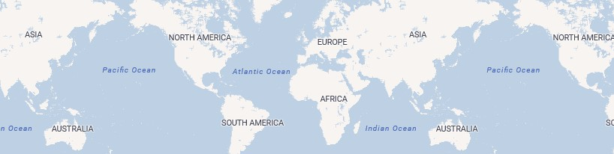

5M

Total Sales

0M

Category

Wide World Im… 32.13K The Phone Company

24.71K

Southridge Video

17.48K

Proseware

36.66K

Northwind Traders

10.15K

Litware 47.2K

A. Datum 20.75K

Adventure Works 42.75K

Contoso 87.24K

Fabrikam 63.12K

Adventure Works … Adventure Works … Adventure Works … Adventure Works … WWI Desktop PC1… WWI Desktop PC1…

0 200 400

Sales Volume

505

520

514

521

509

507

Customer Analysis

Sales Analysis

Store Analysis

Product Analysis

Exchange Analysis

# EXCHANGE RATES INSIGHTS

Power BI Desktop

## Insights

**Q&A's**

**Profitable Currency Type**

**Distribution of Sales By Currency Code**

**Exchange Rate Fluctuate on Different Year**

AUD CAD

Currency Code

0.6M

1.0M

20M

23M

8

Average Exchange …

2016 2017 2018 2019 2020 2021

EUR

GBP USD

0.9M

1.5M

4.6M

10M 9M 7

6M

Total Sales

4M

2M

0M 2M 4M

Profit

0M

AUD CAD EUR GBP USD

Currency Code

Month





|  |  |  |  |  |  |  |  |
| --- | --- | --- | --- | --- | --- | --- | --- |
| **country** | **product_name** | **unit_cost_usd** | **unit_price_usd** | **exchange_rate** | **local_cost** | **local_price** | **profit_margin** |
| Australia | A. Datum Advanced Digital Camera M300 Azure | $86.68 | $188.50 | 1.3898 | 120.46785988330842 | 261.9772910475731 | 141.50943116426467 |
| Australia | A. Datum All in One Digital Camera M200 Azure | $86.45 | $188.00 | 1.2787 | 110.5436144888401 | 240.39559888839722 | 129.85198439955713 |
| Australia | A. Datum All in One Digital Camera M200 Grey | $86.45 | $188.00 | 1.3728 | 118.67855935692788 | 258.086398601532 | 139.4078392446041 |
| Australia | A. Datum All in One Digital Camera M200 Silver | $86.45 | $188.00 | 1.4188 | 122.65525968670845 | 266.73439931869507 | 144.0791396319866 |
| Australia | A. Datum Bridge Digital Camera M300 Green | $85.95 | $186.90 | 1.4226 | 122.27247265577317 | 265.88394577503203 | 143.61147311925885 |
| Australia | A. Datum Bridge Digital Camera M300 Grey | $85.95 | $186.90 | 1.2846 | 110.41137167215348 | 240.0917436361313 | 129.68037196397782 |
| Australia | A. Datum Bridge Digital Camera M300 Grey | $85.95 | $186.90 | 1.2974 | 111.51152980327606 | 242.48405957221985 | 130.9725297689438 |
| Australia | A. Datum Bridge Digital Camera M300 Pink | $85.95 | $186.90 | 1.4498 | 124.61031124591828 | 270.9676227092743 | 146.35731146335598 |
| Australia | A. Datum Compact Digital Camera M200 Green | $59.32 | $129.00 | 1.2769 | 75.745711145401 | 164.72010684013367 | 88.97439569473266 |
| Australia | A. Datum Compact Digital Camera M200 Silver | $59.32 | $129.00 | 1.3879 | 82.33022769451141 | 179.03909933567047 | 96.70887164115906 |
| Australia | A Datum Compact Digital Camera M200 Silver | $59 32 | $129 00 | 1 4777 | 87 65716370582581 | 190 62329936027527 | 102 96613565444946 |