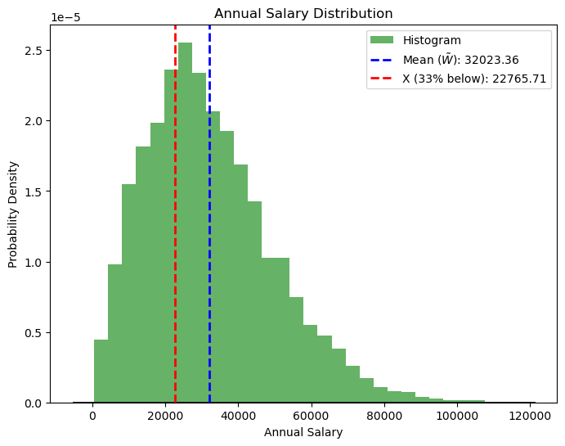
ANNUAL SALARY DISTRIBUTION ANALYSIS

Describe the data:
The given data is a list of annual salaries. It is loaded from a CSV file named 'data3-1.csv' using pandas, and the salaries are stored in a Data Frame column named 'Salaries'.
Describe the Distribution:
The distribution of annual salaries is visualized through a histogram and a fitted normal distribution. The histogram represents the empirical distribution of the data, while the fitted normal distribution provides a theoretical model that approximates the observed data. 'Salaries'.
Calculating the Mean (~W):
The mean annual salary (~W) serves as a pivotal measure, denoting the arithmetic average of the dataset. Computed through the numpy library's mean function, it encapsulates the collective financial center of the sampled population.

Mathematical Formula:
- Mean (~W) = 1/N ∑ salary, I =1 to N

The calculated mean annual salary(~W) 32023.36 is printed and displayed on the histogram plot.
Calculating the Value of X:
Delving further, the value X is strategically determined to represent the salary threshold below which 33% of individuals find themselves. Utilizing the numpy percentile function, this calculation enriches our understanding of income disparities within the sampled cohort.

- X33%​ = Percentile (Salaries,33)

The calculated value of (X) 22765.71 is printed and displayed on the histogram plot.

Result:
The analysis of the annual salary dataset reveals valuable insights. The mean annual salary (~W), representing the central tendency, is computed and found to be 32023.36. Additionally, a significant threshold value, denoted as X 22765.71, is determined, below which 33% of individuals fall, offering a nuanced perspective on income distribution within the dataset.

