CLOUD NETWORK & ACCESS CONTROL ARCHITECTURE FOR INTERNAL APPLICATIONS

NAME: Aswin.t.j
REGISTER NO.: 727723EUCY010
DEPARTMENT: B.E CSE (CYBER SECURITY)

1. INTRODUCTION
With the rapid adoption of cloud computing, organizations increasingly rely on cloud platforms to host internal and business-critical applications. While cloud environments provide scalability, flexibility, and cost efficiency, improper network configuration and access control can expose systems to serious security risks. Common misconfigurations such as publicly exposed servers, unrestricted firewall rules, and lack of network segmentation have been a major cause of cloud security incidents.
This project focuses on the design and implementation of a secure cloud network and access control architecture for an internal application hosted on Amazon Web Services (AWS). The primary objective is to ensure that the application remains accessible to authorized employees while being protected from external threats through proper network isolation, controlled routing, and strict access control mechanisms.
A Virtual Private Cloud (VPC) is designed with clearly separated public and private subnets to isolate administrative access from application workloads. An Internet Gateway and route tables are configured to allow controlled internet connectivity only where required. Security Groups are used as virtual firewalls to enforce port-based and source-based access control.
As part of this implementation, the project intentionally simulates common real-world cloud security misconfigurations—such as open ports and unrestricted access—and then demonstrates how these issues can be corrected using cloud security best practices. This approach provides practical insight into both insecure and secure cloud network designs, highlighting the importance of proper planning and configuration in building secure and resilient cloud environments.

2. PROJECT OBJECTIVES
The primary objectives of this project are:
- To design a secure Virtual Private Cloud (VPC) architecture for hosting an internal application.
- To implement network segmentation using public and private subnets.
- To configure controlled internet connectivity using an Internet Gateway and route tables.
- To deploy an EC2 application server within a secure private network.
- To enforce access control and traffic filtering using AWS Security Groups.
- To restrict administrative access and minimize exposure of sensitive services.
- To simulate common cloud security misconfigurations and demonstrate their correction using best practices.

3. REQUIREMENT SPECIFICATION
3.1 Functional Requirements
- The system shall provide secure access to an internal application for authorized employees.
- The application shall be accessible only through explicitly allowed ports such as HTTP/HTTPS.
- The cloud network shall consist of:
  - One application server
  - One administrative access path
- Administrative access (SSH/RDP) shall not be publicly exposed and must be restricted.
- Security Groups shall be used to control inbound and outbound traffic.
- The system shall support the simulation of insecure configurations such as:
  - Open ports
  - Unrestricted access (0.0.0.0/0)
- The system shall allow correction of these insecure configurations using AWS security best practices.

3.2 Non-Functional Requirements
- The architecture shall follow the principle of least privilege.
- Network segmentation shall be implemented to reduce the attack surface.
- The solution shall be simple, scalable, and easy to manage.
- Only basic cloud-native security controls shall be used.
- No advanced IDS/IPS or third-party security tools shall be included.
- The design shall be suitable for small to medium-scale internal applications.

3.3 Network Requirements
- A Virtual Private Cloud (VPC) shall be created with a private IP address range.
- The network shall be divided into:
  - Public Subnet – for administrative access
  - Private Subnet – for application hosting
- IP address ranges shall be:
  - Properly planned
  - Non-overlapping
  - Clearly documented
- An Internet Gateway shall be attached to the VPC.
- Separate route tables shall be configured and associated with each subnet.

3.4 Security Requirements
- All inbound traffic shall be denied by default.
- Only required ports shall be explicitly allowed.
- Administrative ports (SSH/RDP) shall:
  - Not be open to all IP addresses
  - Be restricted to a trusted admin IP or access path
- Security Groups shall enforce:
  - Port-based access control
  - Source-based filtering
- No unnecessary services or ports shall be exposed.

- 3.5 Access Control Requirements
- Employees shall access the application only via the public endpoint and allowed ports.
- Administrators shall access servers only through the defined secure access path.
- Direct public access to private subnet resources shall be blocked.
- Administrative access shall be logically separated from application access.

4. IMPLEMENTATION STEPS & WORKFLOW

1. A Virtual Private Cloud (VPC) was created with a defined private IP address range.
2. Public and private subnets were configured to enable proper network segmentation.
3. An Internet Gateway was created and attached to the VPC to enable controlled internet access.
4. Route tables were created and associated with the appropriate subnets to manage traffic flow.
5. An EC2 instance was launched in the private subnet to host the internal application.
6. Security Groups were applied to restrict inbound and outbound traffic based on defined rules.
7. Common cloud security misconfigurations were simulated and then corrected using best practices.
8. Administrative access was restricted using a dedicated access path to reduce the attack surface.

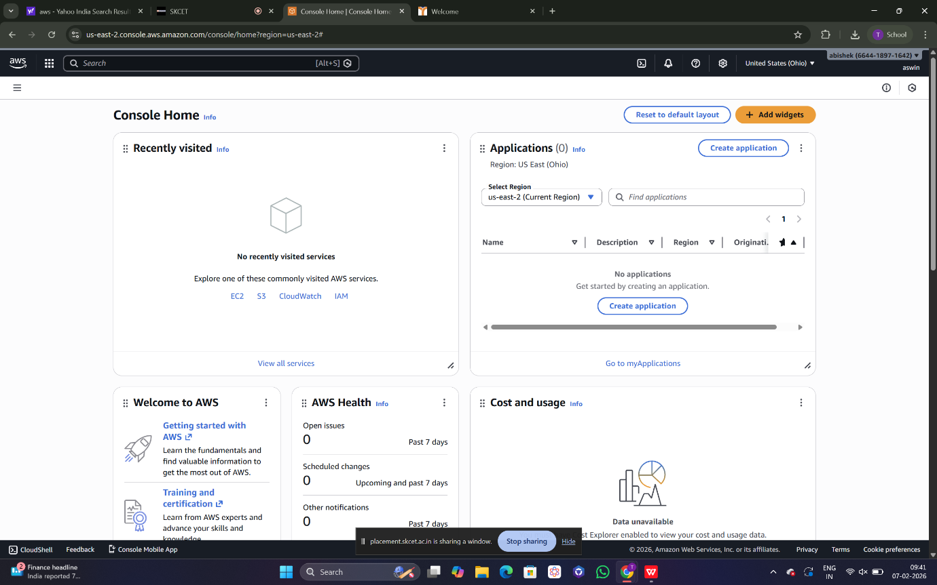

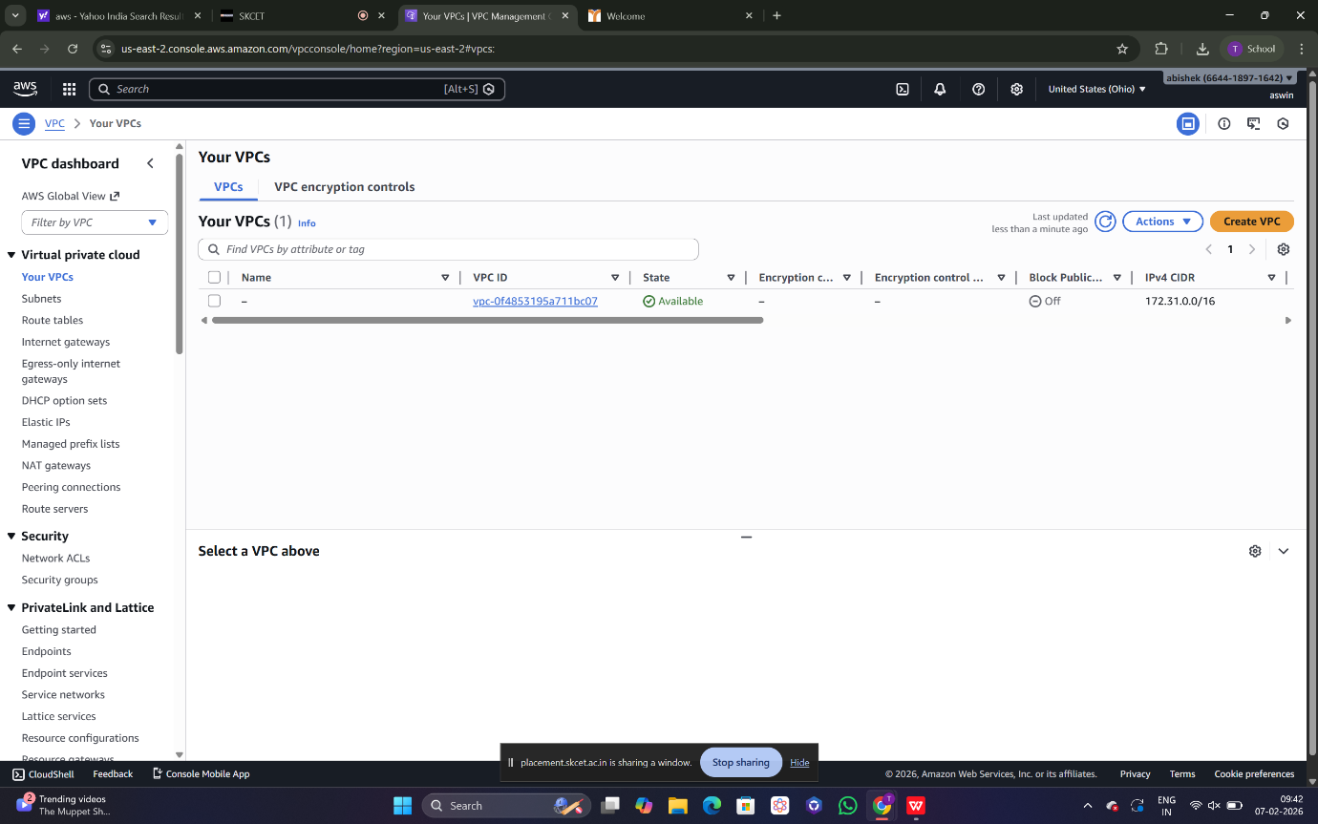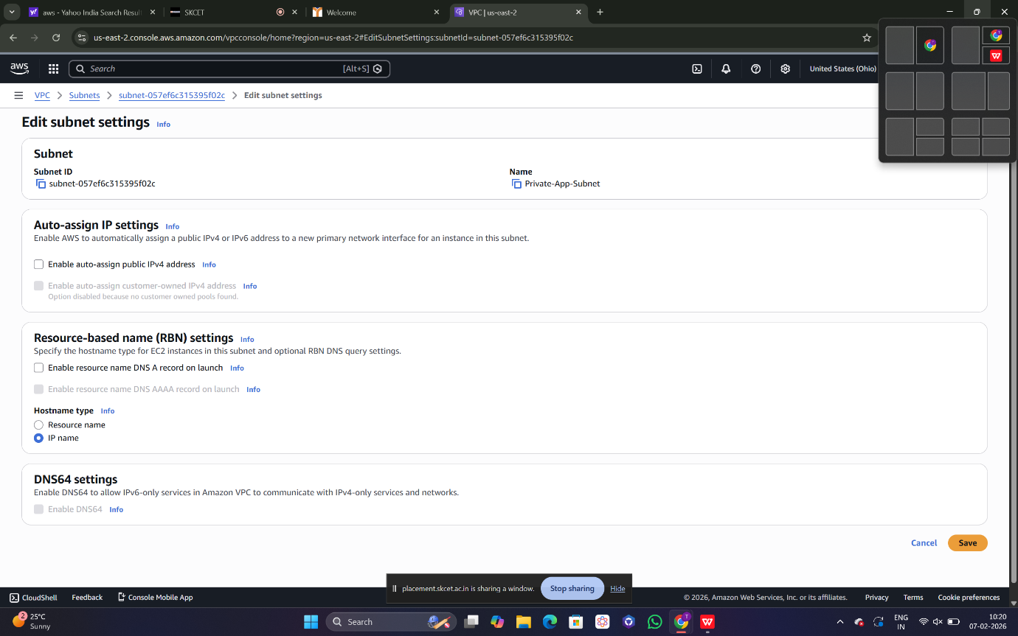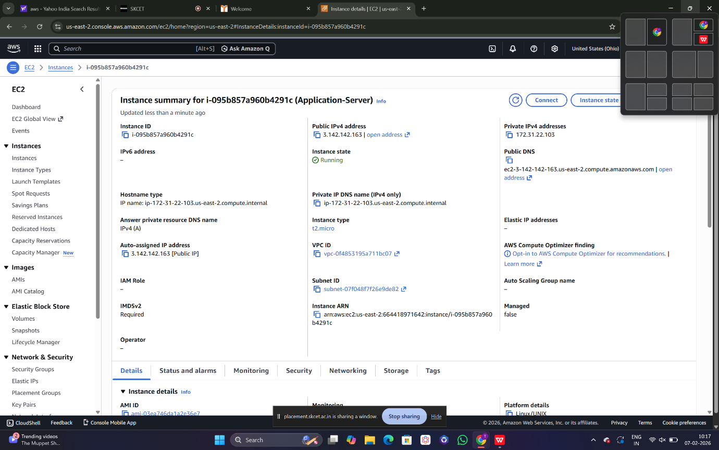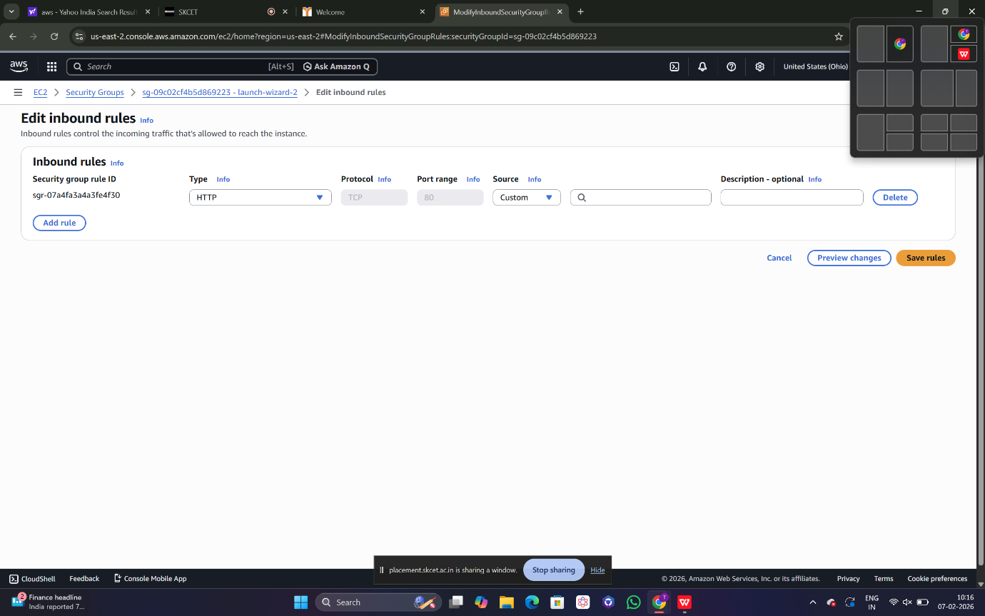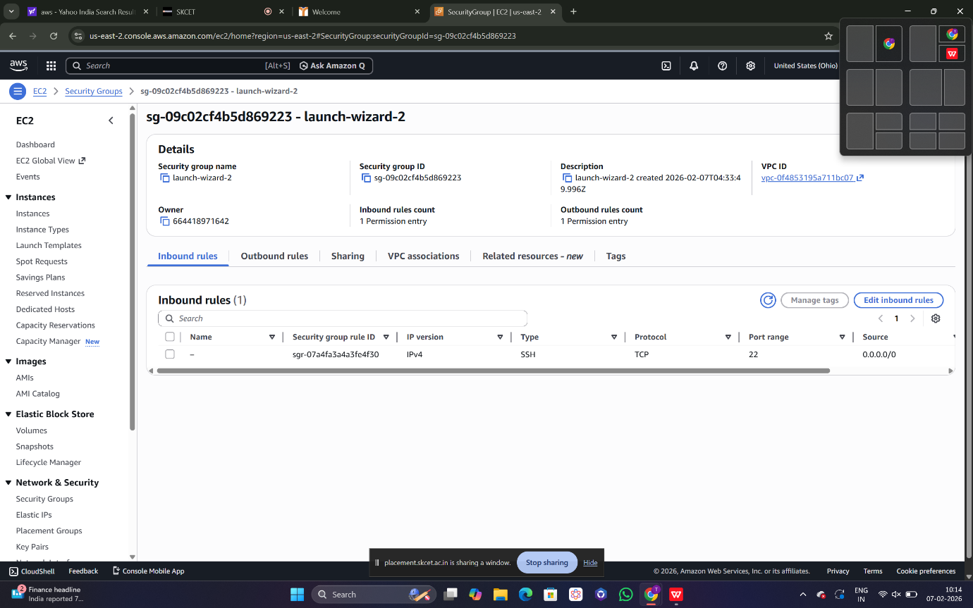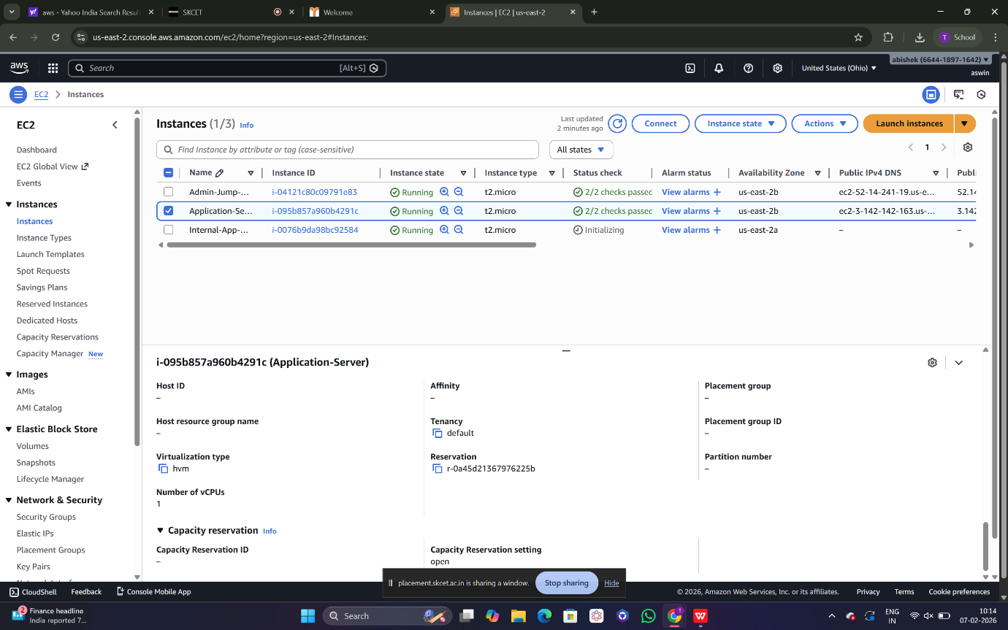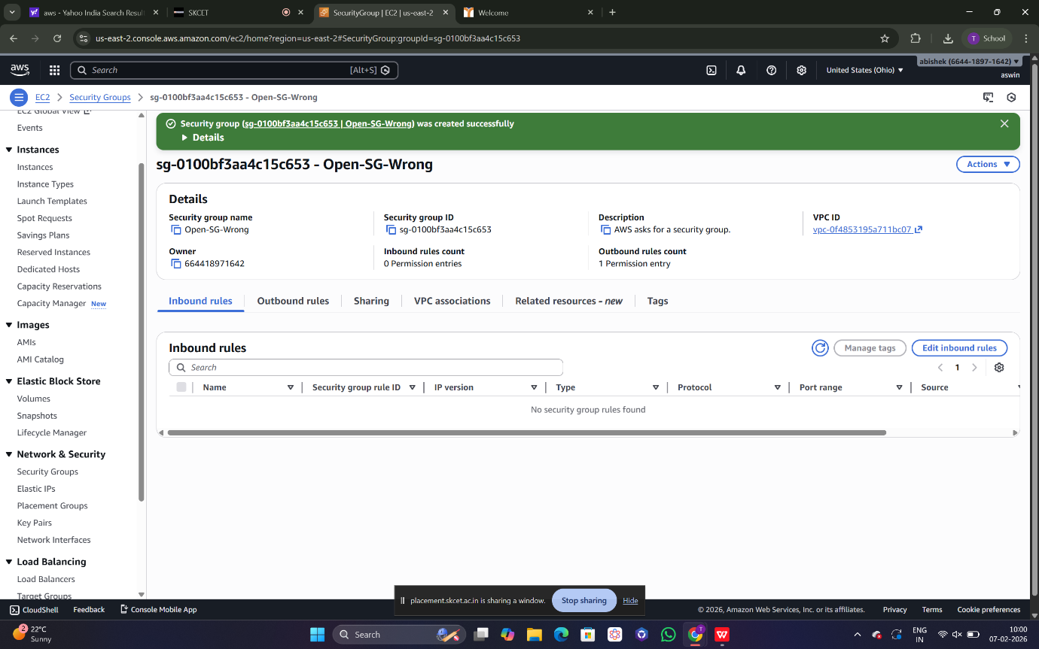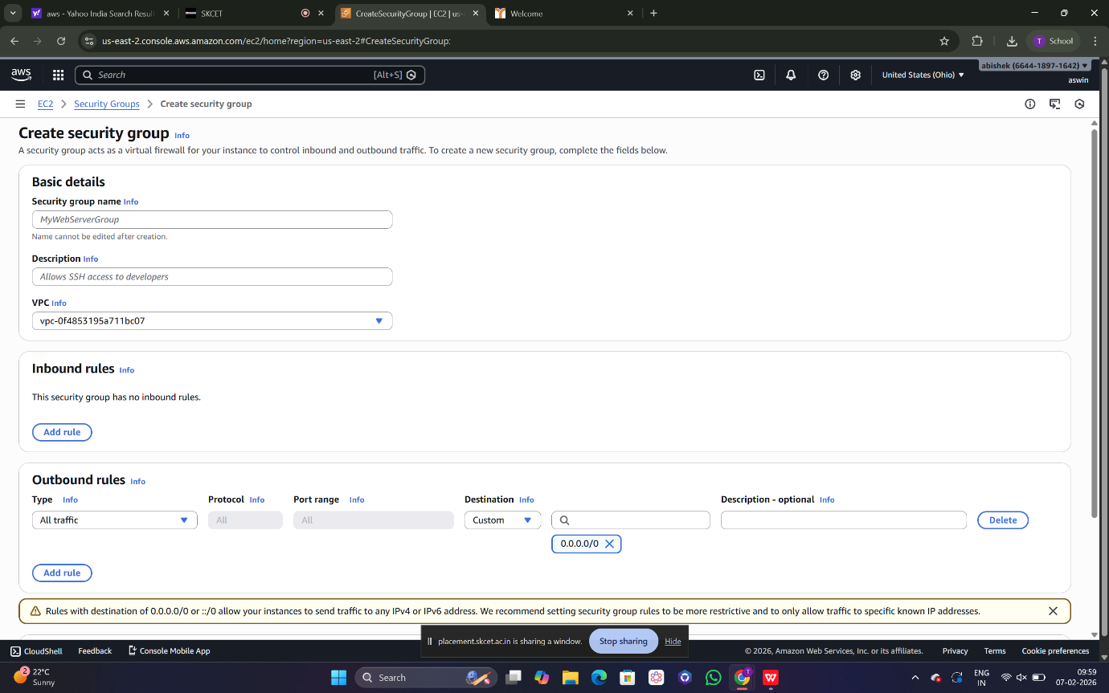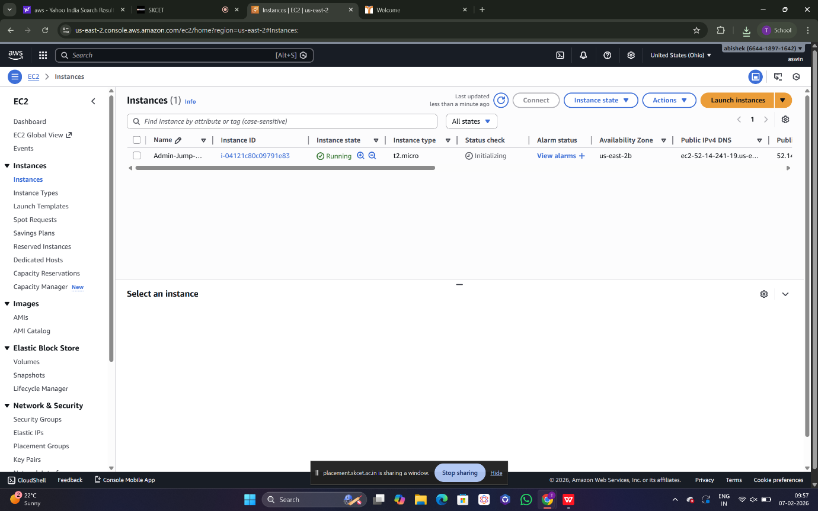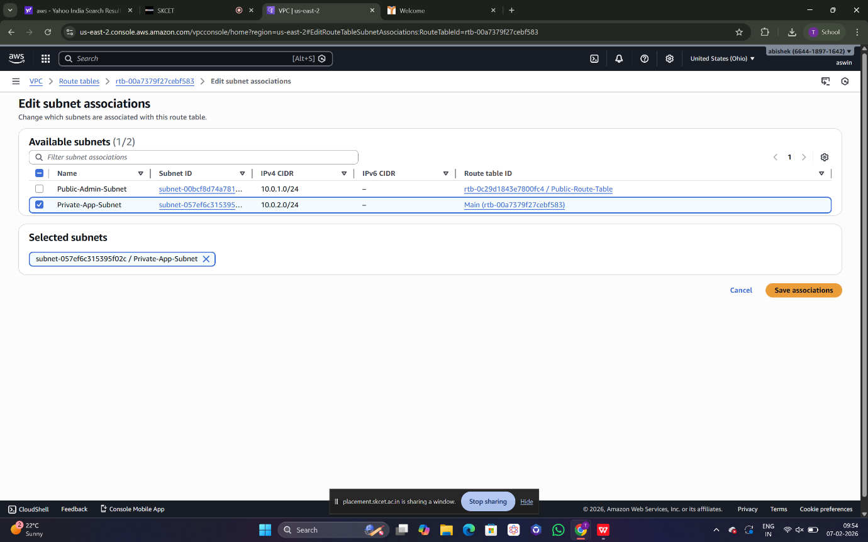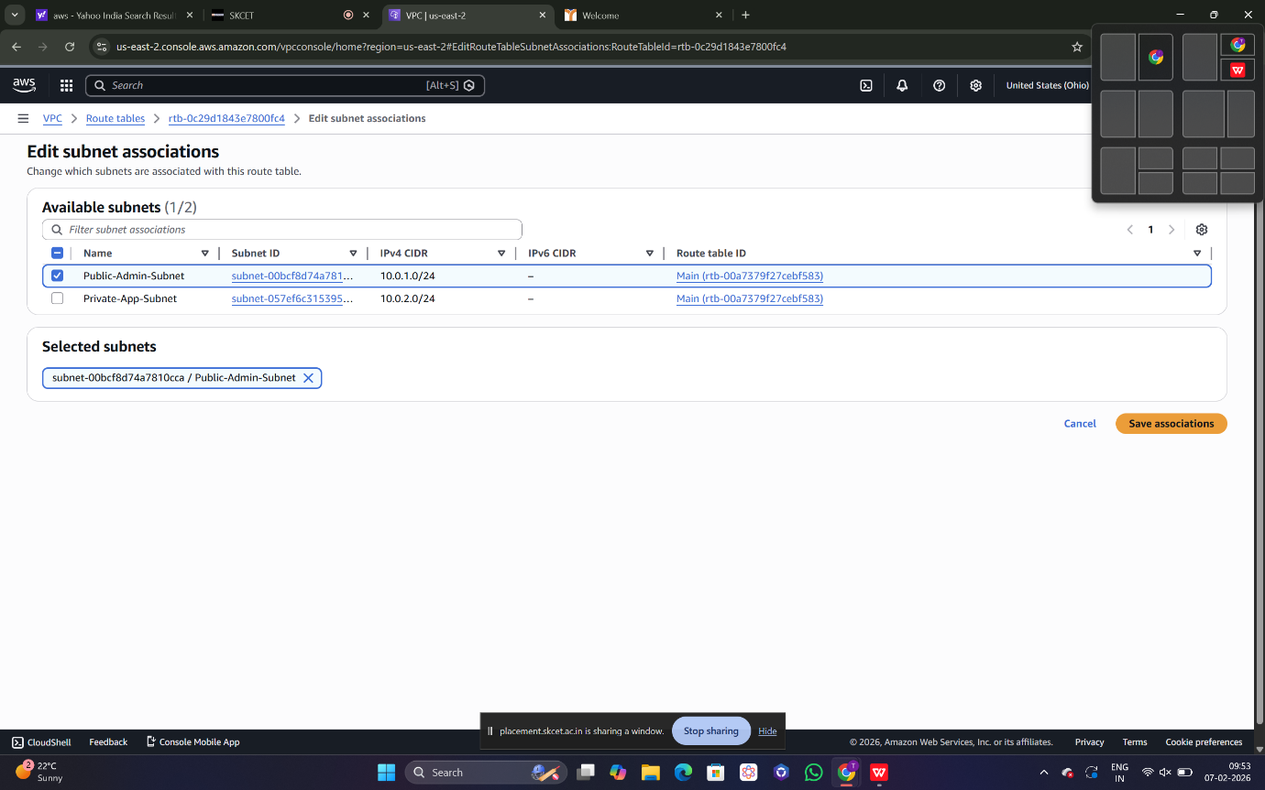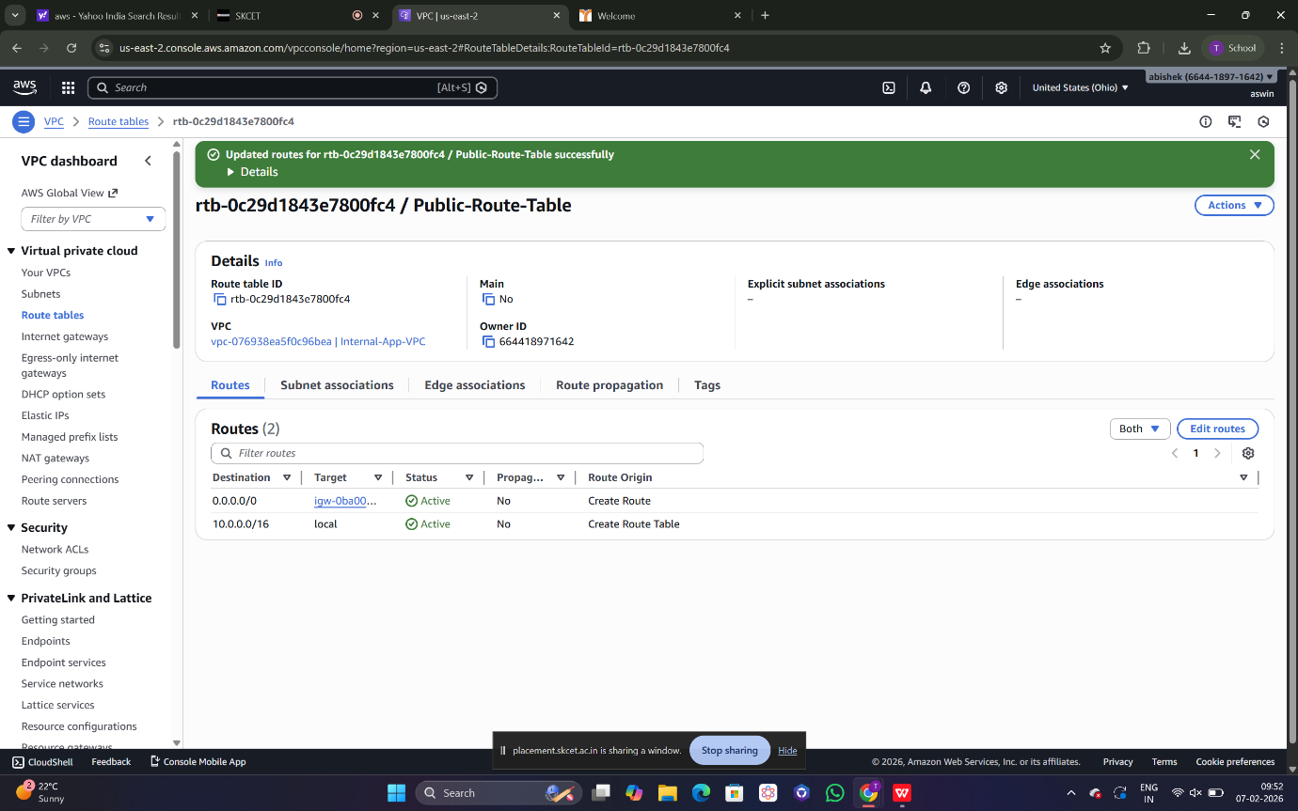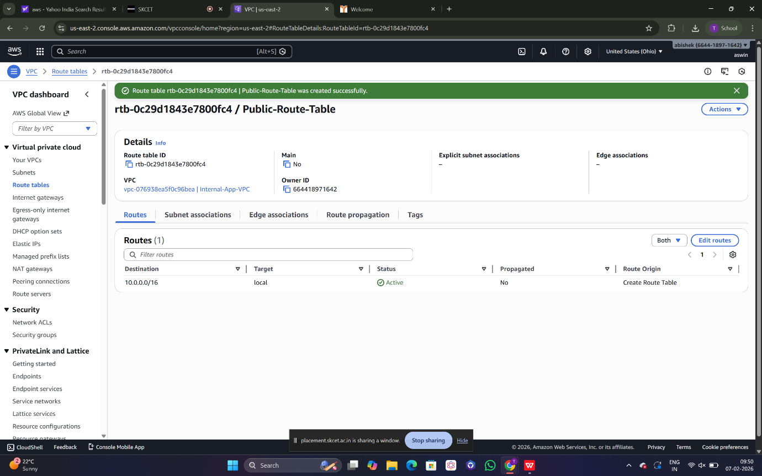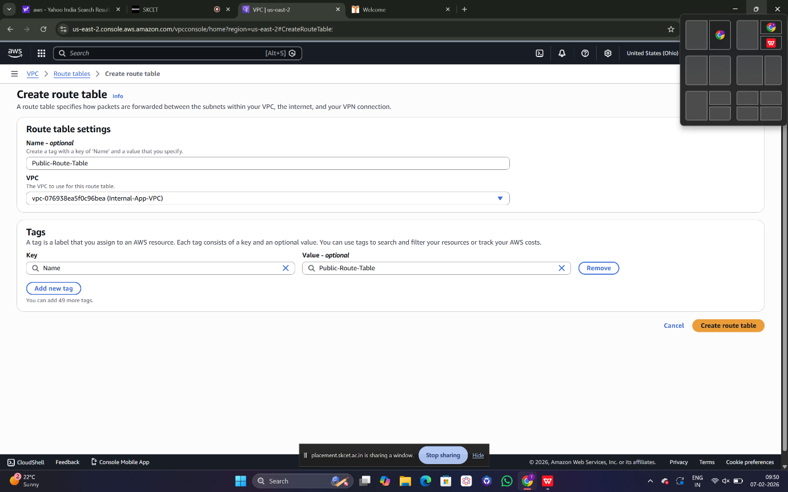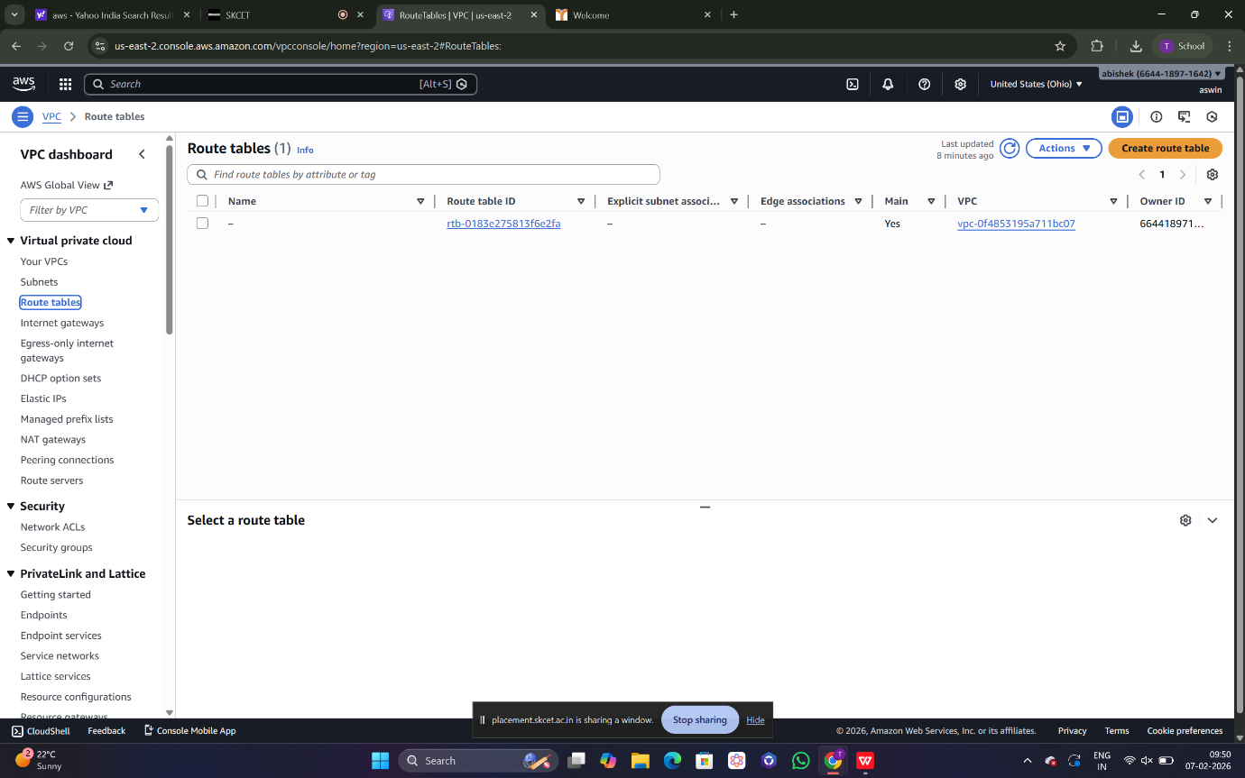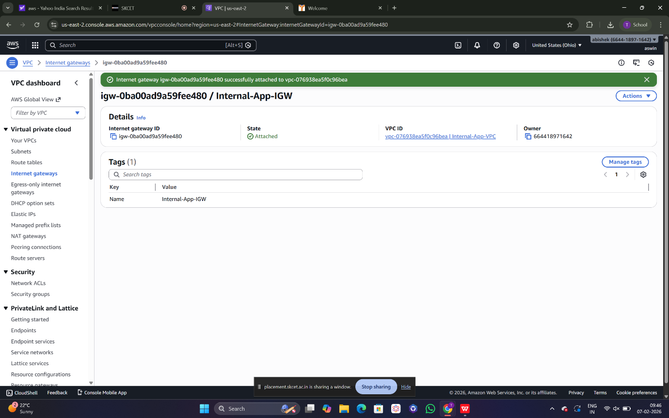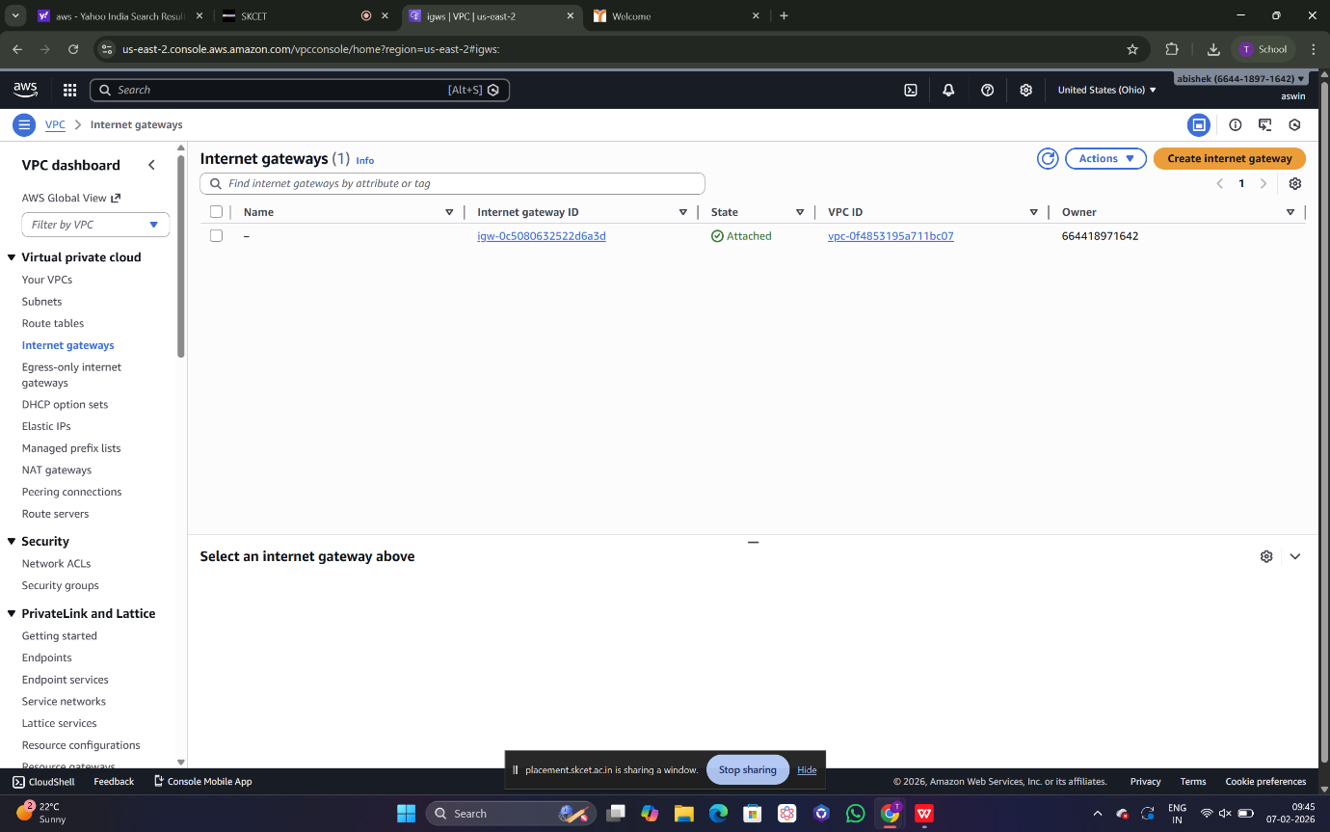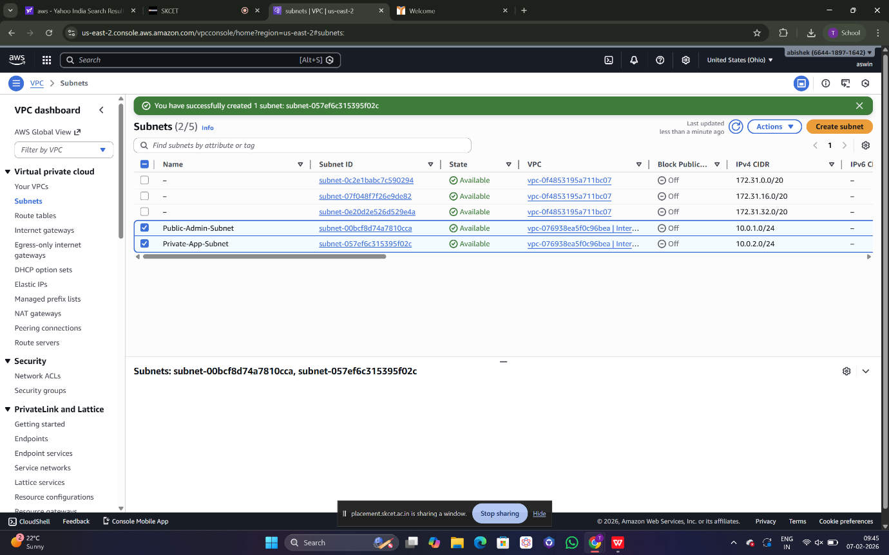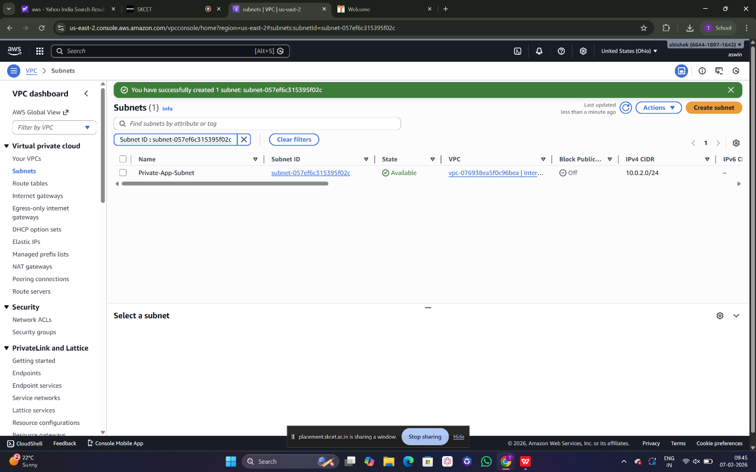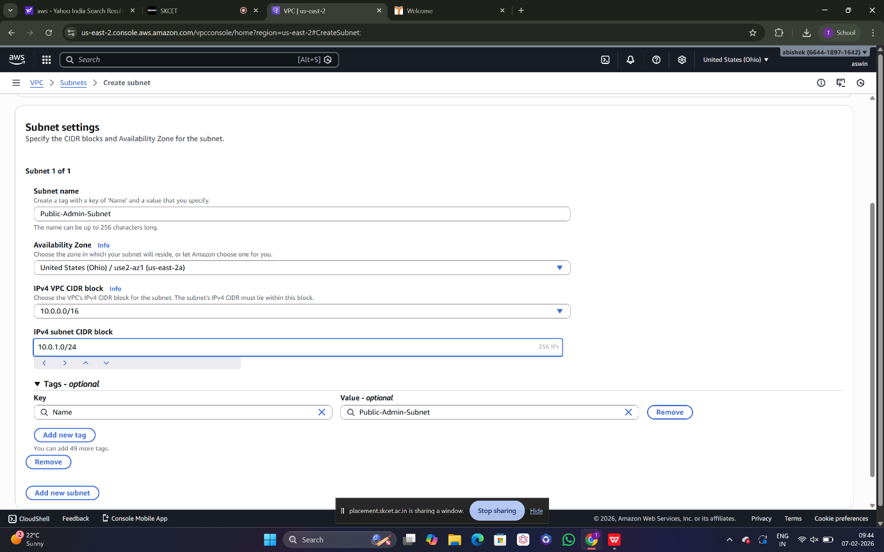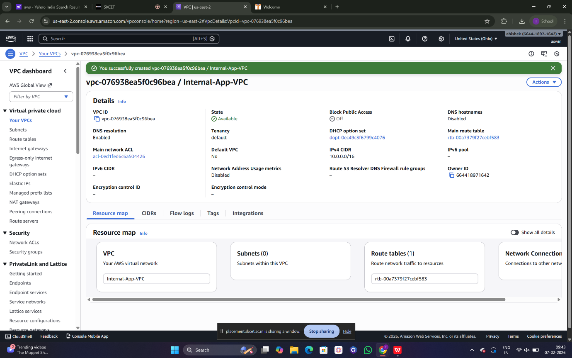

5.CONCLUSION
This project successfully demonstrates the design and implementation of a secure cloud network and access control architecture for an internal application using AWS. By applying proper network segmentation, controlled routing, and strict security group configurations, the application is protected from unauthorized access while remaining accessible to authorized users.
The project highlights the security risks associated with common cloud misconfigurations such as publicly exposed servers and unrestricted firewall rules. By correcting these issues using best practices, the project emphasizes the importance of secure cloud network design and access control.
Overall, this implementation provides a strong practical understanding of cloud networking and security fundamentals and reflects a real-world approach to securing cloud-based internal applications.

