**WriteUp**

* created instance on AWS with ubuntu 20.01 OS
* installed docker,maven,jenkin in the particular OS.
* Configure the jenkin as following screenshots:

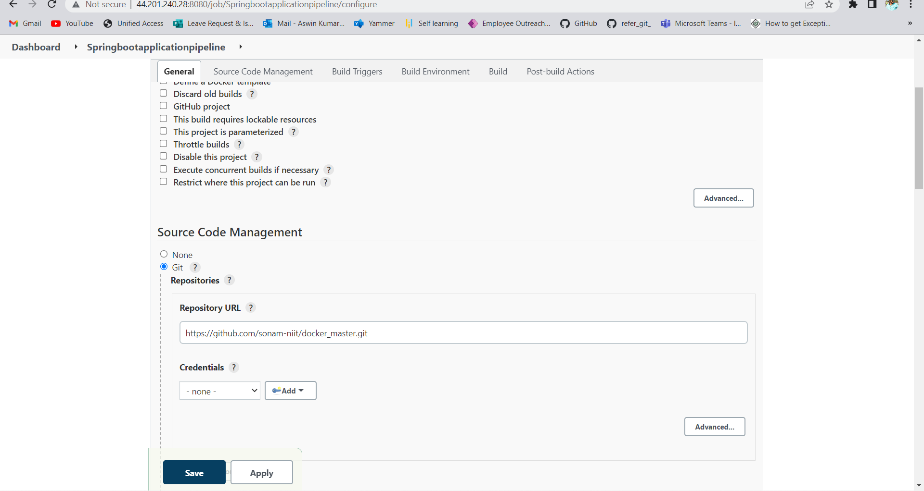

In Source Code management add git repo URL

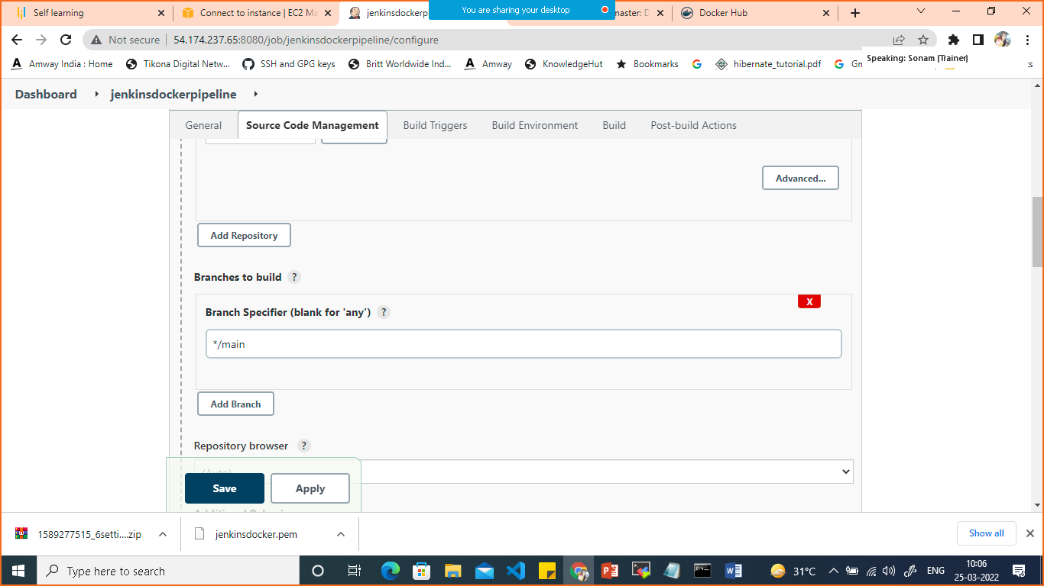

Give the branch name as main

Click on Poll SCM

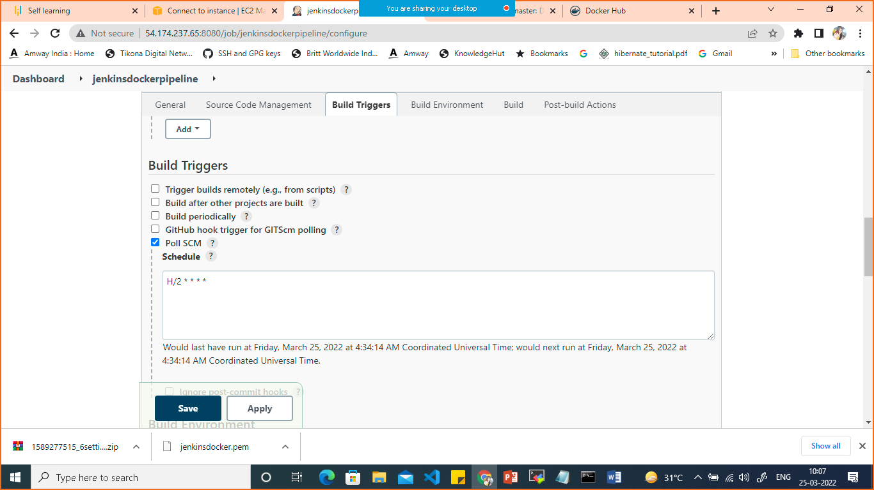

Scroll down in build select add and publish docker

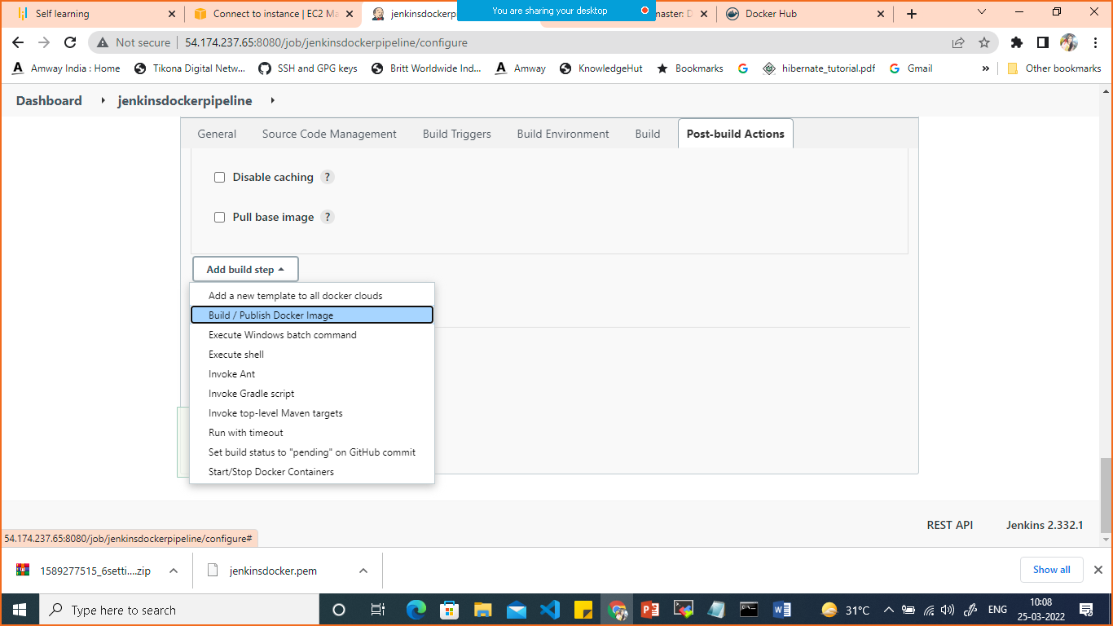

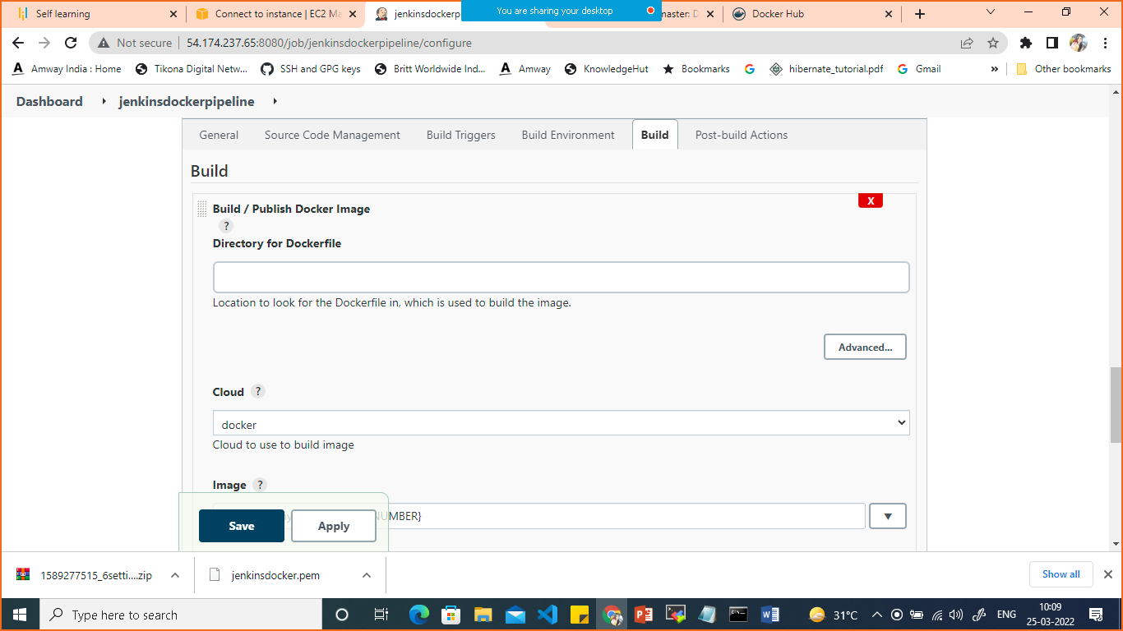

In cloud select docker

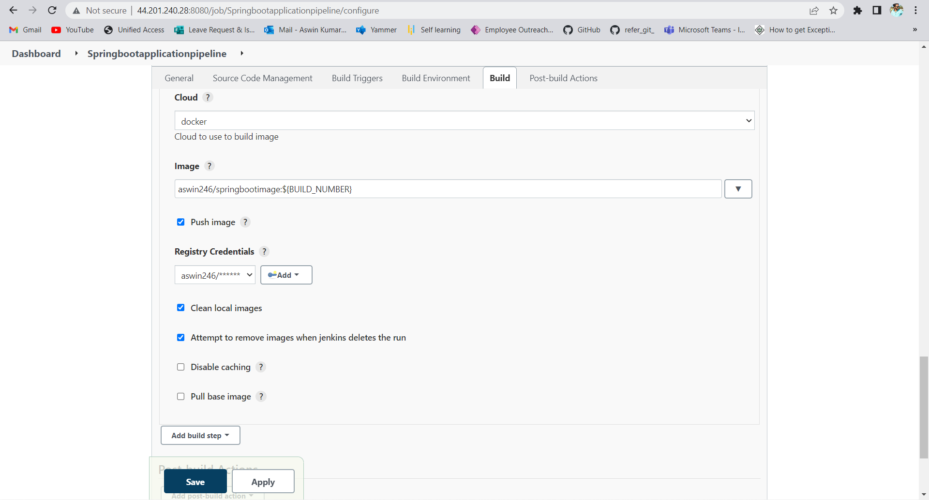

For adding docker credentials

Click on add credentials >Jenkins

Select Kind> username and password

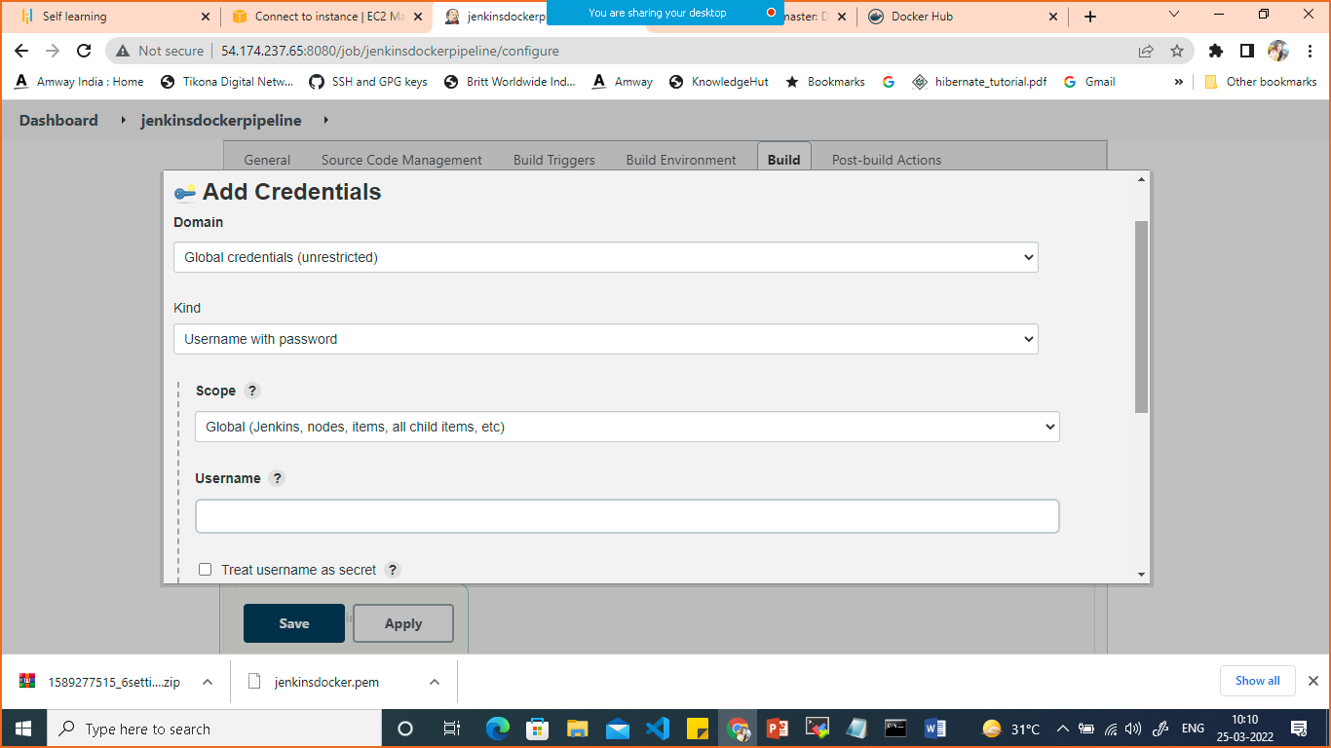

Give dockerhub username and password

Then select your credentials in registry credentials which you have added.

Save.

Click on buid now

It will build the image and push it on dockerhub

If you make any changes in your github automatically it will build a new image.

