

YENEPOYA INSTITUTE OF ARTS, SCIENCE, COMMERCE AND MANAGEMENT

Project – High Level Design
On
Cloud Cost Intelligence Platform for Supply Chain

SUBMITTED BY

Aswin Raj M - 23BCAICD030
BCA (AI, Cloud Computing, DevOps)

UNDER THE GUIDANCE OF

Industry Mentor: Shashank Korrram
Guided by: Ms. Manjula

TABLE OF CONTENTS

- Introduction.....................................................................3-5
- System Design...............................................................5-11
- Data Design.................................................................11-13
- Interfaces...........................................................................14
- State and Session Management...................................15-16
- Caching........................................................................16-17
- Non-Functional Requirements....................................17-19
- References.........................................................................19

1. INTRODUCTION
The Cloud Cost Intelligence Platform is a Python-based analytics solution that enables supply-chain organizations to monitor, analyze, and optimize their multi-cloud spending. It ingests daily billing records, applies automated data cleaning, performs exploratory analysis, detects cost anomalies, and presents interactive dashboards for data-driven FinOps decisions.

1.1 Scope of the Document
This High-Level Design document covers:

- End-to-end system architecture of the Cloud Cost Intelligence Platform.
- Application design, process flows, and component responsibilities.
- Data model, access patterns, retention, and migration strategies.
- Interface contracts between internal modules and external systems.
- Caching, session management, and non-functional requirements (security, performance).

Out of Scope: Low-level implementation details (class diagrams, function signatures), CI/CD pipeline configuration, and infrastructure-as-code templates.

1.2 Intended Audience
Audience | Purpose
Solution Architects | Validate architecture patterns and scalability
Development Team | Understand component boundaries and data flow
DevOps / Platform Eng. | Plan deployment, caching, and infrastructure
QA / Testing Team | Design integration and performance test strategies
Product / Business Owners | Review functional coverage and optimization features
FinOps Stakeholders | Understand cost visibility and reporting capabilities

1.3 System Overview
The platform consists of four major subsystems:
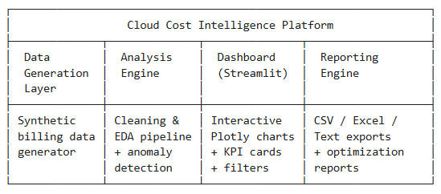
Key Capabilities:
- Synthetic data generation simulating 15 AWS services across 5 regions and 6 supply-chain departments.
- Automated data cleaning (deduplication, missing value imputation, type coercion).
- 7 publication-quality static charts and 6 interactive Plotly visualizations.
- Real-time sidebar filtering by Date, Month, Service, Region, and Department.
- Cost anomaly detection using statistical thresholds (mean + 2σ).
- Actionable optimization recommendations (Reserved Instances, right-sizing, Spot, storage tiering).
- Multi-format export: CSV, multi-sheet Excel workbook, and text reports.

2. SYSTEM DESIGN
2.1 Application Design
The platform follows a layered monolithic architecture with clear separation of concerns:
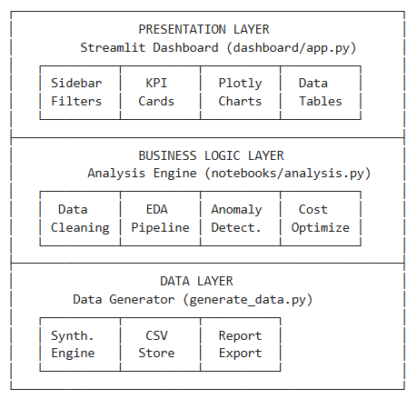
Technology Stack:
Layer | Technology | Purpose
Presentation | Streamlit 1.28+, Plotly 5.18+ | Interactive web dashboard
Business Logi | Pandas 1.5+, NumPy, Matplotlib | Data processing & static charts
Data Storage | CSV flat files | Lightweight, portable storage
Export | openpyxl 3.1+ | Multi-sheet Excel workbooks
Deployment | Streamlit Community Cloud | Free hosting with GitHub CI

2.2 Process Flow
2.2.1 Data Pipeline Flow
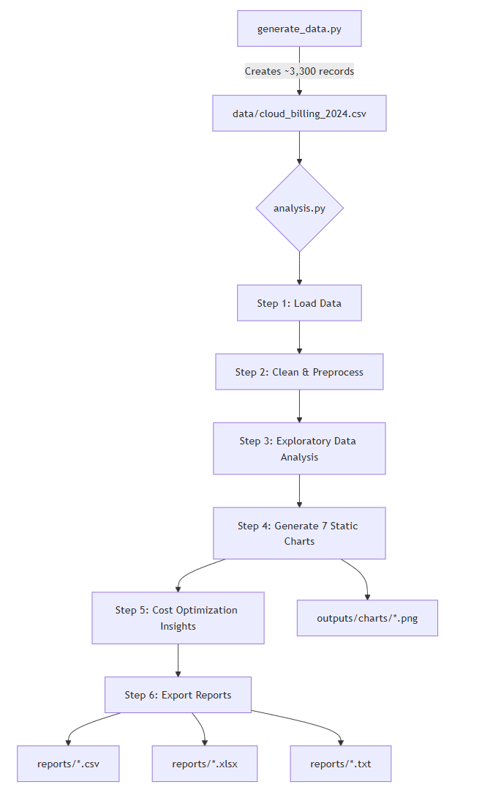
2.2.2 Dashboard Runtime Flow
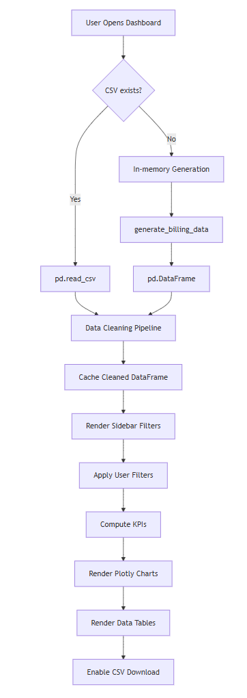
2.3 Information Flow
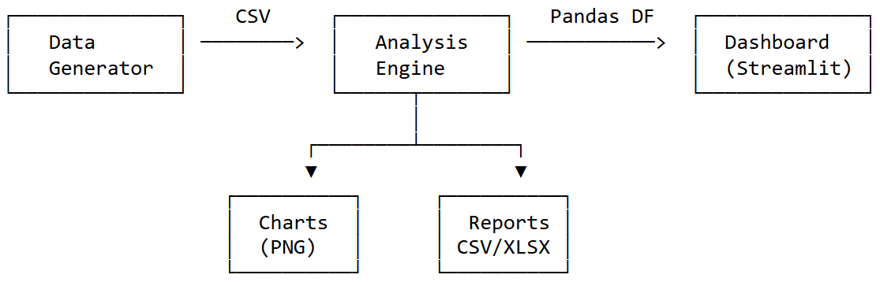

Flow Path | Data Format | Protocol
Generator → CSV File | CSV (UTF-8) | File I/O
CSV File → Analysis Engine | Pandas DataFrame | File I/O
CSV File → Dashboard | Pandas DataFrame | File I/O
Dashboard → Browser | HTML/JS/JSON | HTTP (8501)
Analysis → Charts | PNG images | File I/O
Analysis → Reports | CSV / XLSX / TXT | File I/O
User → Dashboard | HTTP requests | WebSocket

2.4 Components Design
Component 1: Synthetic Data Generator (generate_data.py)
Attribute | Detail
Purpose | Generate realistic cloud billing records for 2024
Input | Configuration constants (services, regions, cost ranges)
Output | data/cloud_billing_2024.csv (~3,300 records)
Key Logic | Seasonal spikes (Nov-Dec), 3% anomaly injection, intentional data quality issues (15 duplicates, 20 missing values)

Component 2: Analysis Engine (notebooks/analysis.py)
Attribute | Detail
Purpose | End-to-end offline analysis pipeline
Input | data/cloud_billing_2024.csv
Output | 7 PNG charts, 4 CSV summaries, 1 Excel workbook, 1 optimization report
Pipeline | Load → Clean → EDA → Visualize → Optimize → Export

Component 3: Interactive Dashboard (dashboard/app.py)
Attribute | Detail
Purpose | Real-time interactive cost exploration
Input | CSV file or in-memory generated data
Output | Web UI at localhost:8501
UI Sections | Sidebar Filters, 5 KPI Cards, 6 Plotly Charts, Top Services Table, Filtered Data Table, Optimization Insights Tab

Component 4: Reporting Engine (embedded in analysis.py)
Attribute | Detail
Purpose | Generate exportable business reports
Outputs | cleaned_billing_data.csv, summary_by_service.csv,  summary_by_month.csv, summary_by_region.csv,  optimization_report.txt, cloud_cost_report.xlsx

2.5 Key Design Considerations
Consideration | Decision | Rationale
Data Storage | CSV flat files | Zero infrastructure, Git-friendly, portable
In-Memory Fallback | Generate data via Python when CSV unavailable | Streamlit Cloud has read-only filesystem
Visualization Dual | Matplotlib (static) + Plotly (interactive) | Static for reports, interactive for dashboard
Cleaning Strategy | Mode for categorical, median for numerical | Robust against outliers
Anomaly Detection | Statistical threshold (mean + 2σ) | Simple, interpretable, no ML dependency
Deployment | Streamlit Community Cloud | Free, GitHub-integrated, zero DevOps
Styling | Custom CSS with CSS variables | Consistent dark theme across all components

2.6 API Catalogue
This is a monolithic application without REST APIs. The internal function interfaces serve as the API contracts.
Function | Module | Parameters | Returns
generate_billing_data() | generate_data | start_date, end_date, records_per_day | list[dict]
save_csv() | generate_data | rows: list[dict], path: str | None (writes file)
load_data() | dashboard/app | None (reads from DATA_PATH or generates) | pd.DataFrame

Dashboard Filter Interface (Streamlit Widgets):
Filter | Widget Type | Key | Default
Date Range | date_input | date_range | Full range
Month | multiselect | months | All months
Service Type | multiselect | services | All services
Region | multiselect | regions | All regions
Department | multiselect | departments | All depts

3. DATA DESIGN
3.1 Data Model
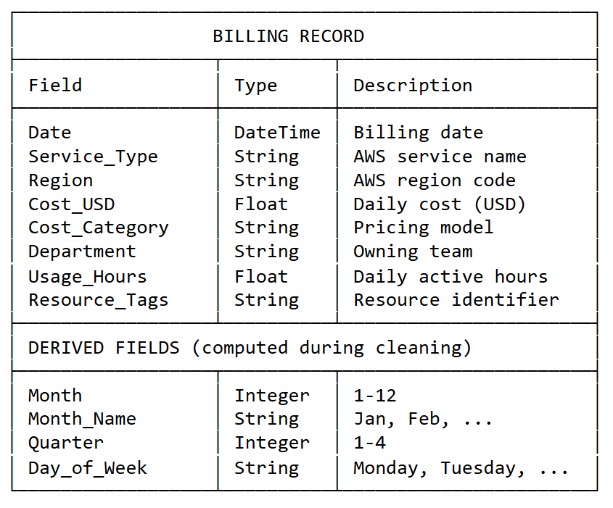
Primary Entity: Billing Record

Dimension Tables (Logical)
Dimension | Values
Service Type | EC2, S3, RDS, Lambda, CloudFront, EKS, SageMaker, Redshift, DynamoDB, ElastiCache, SNS, SQS, API Gateway, CloudWatch, Route 53
Region | us-east-1, us-west-2, eu-west-1, ap-south-1, ap-southeast-1
Cost Category | On-Demand, Reserved, Spot, Savings Plan
Department | Logistics, Warehouse Ops, Procurement, Fleet Management, Data Engineering, Platform / DevOps

3.2 Data Access Mechanism
Operation | Method | Library
Read raw CSV | pd.read_csv(DATA_PATH) | Pandas
In-memory generation | pd.DataFrame(rows) | Pandas
Filtered data access | Boolean indexing on DataFrame | Pandas
Aggregation (groupby) | df.groupby().agg() | Pandas
Write CSV | csv.DictWriter / df.to_csv | csv / Pandas
Write Excel | pd.ExcelWriter (openpyxl) | Pandas

Access Pattern: All data fits in memory (~330 KB CSV). No database is required. The entire dataset is loaded once, cached, and filtered client-side via Streamlit's reactive model.
3.3 Data Retention Policies
Data Type | Retention Period | Storage Location | Policy
Raw billing CSV | Indefinite | data/ | Regenerable on demand
Cleaned CSV | Overwritten | reports/ | Refreshed per analysis
Static charts (PNG) | Overwritten | outputs/charts/ | Refreshed per analysis
Summary reports | Overwritten | reports/ | Refreshed per analysis
Excel workbook | Overwritten | reports/ | Refreshed per analysis
Dashboard session data | Session lifetime | In-memory (Streamlit) | Cleared on session end
3.4 Data Migration
Since this platform uses synthetic data with CSV-based storage:
Schema Change | Update generate_data.py constants → regenerate CSV
Date Range Extension | Modify start_date / end_date params → regenerate
New Service/Region | Add to configuration constants → regenerate
Production Data Ingestion | Replace generate_data.py with cloud provider API or S3 connector
Database Migration | Replace pd.read_csv with pd.read_sql or ORM queries
4. INTERFACES
4.1 User Interface
Interface | Type | Details
Streamlit Dashboard | Web UI | Browser-based, http://localhost:8501
CLI – Data Gen | CLI | python generate_data.py
CLI – Analysis | CLI | python notebooks/analysis.py

4.2 Internal Module Interfaces
generate_data.py ──(CSV file)──> analysis.py
generate_data.py ──(CSV file / in-memory import)──> dashboard/app.py
analysis.py ──(PNG files)──> outputs/charts/
analysis.py ──(CSV/XLSX/TXT)──> reports/
4.3 External Interfaces (Future Scope)
Interface | Protocol | Purpose
AWS Cost Explorer API | REST/HTTPS | Ingest real billing data
Azure Cost Management | REST/HTTPS | Multi-cloud support
GCP Billing Export | BigQuery/CSV | Google Cloud cost data
Slack / Email Alerts | Webhook/SMTP | Anomaly notification
S3 / Blob Storage | SDK | Centralized data lake storage

5. STATE AND SESSION MANAGEMENT
5.1 Streamlit Session State
Streamlit manages state via its reactive execution model — the entire script re-runs on every user interaction.
State Element | Mechanism | Scope | Key
Date Range filter | st.date_input | Per session | date_range
Month filter | st.multiselect | Per session | months
Service filter | st.multiselect | Per session | services
Region filter | st.multiselect | Per session | regions
Department filter | st.multiselect | Per session | departments
Loaded DataFrame | @st.cache_data | Cross-session | Automatic hash

5.2 Session Lifecycle
User Opens URL ──> New Streamlit Session Created
│
├── Cached data loaded (or generated)
├── Default filters applied (all selected)
├── User interacts with filters
│ └── Script re-executes with new widget values
├── User downloads CSV
│ └── One-time file generation, no state change
│
User Closes Tab ──> Session destroyed after timeout

5.3 State Persistence
Aspect | Behavior
Filter selections | Persist within session; reset on page refresh
Data cache | Persists across re-runs until data file changes
Cross-user state | None — each user gets isolated session
Server restart | All sessions and cache cleared

6. CACHING
6.1 Caching Strategy
Cache Layer | Mechanism | What is Cached | Invalidation
Data Loading | @st.cache_data | Cleaned DataFrame | File hash change or app restart
Browser Assets | Streamlit built-in | CSS, JS, fonts | App version change
Chart Rendering | None (real-time) | Charts regenerate per filter change | Every interaction

6.2 Cache Behavior
@st.cache_data # Streamlit's built-in caching decorator
def load_data():
# This function runs ONCE, then returns cached result
# on subsequent calls within the same or different sessions
...
- Cache Key: Automatically derived from function name + input arguments (none in this case).
- Cache Storage: In-memory (server process).
- Cache Size: ~1-3 MB (single DataFrame).
- TTL: No explicit TTL; persists until process restart or code change.

7. NON-FUNCTIONAL REQUIREMENTS
7.1 Security Aspects
Aspect | Current State | Recommendation (Production)
Authentication | None (open access) | Add Streamlit auth or SSO
Authorization | None | Role-based department-level filtering
Data Encryption | None (synthetic data) | TLS for transit, AES for rest
Input Validation | Streamlit widgets (bounded) | Server-side validation layer
Dependency Security | requirements.txt pinned | Regular pip audit scans
Secrets Management | None required | Streamlit Secrets for API keys
CORS | Streamlit default | Configure for production domain
SQL Injection | N/A (no database) | Parameterized queries if DB added

7.2 Performance Aspects
Metric | Current Value | Target (Production)
Data Load Time | < 1 second | < 3 seconds
Dashboard Render | < 2 seconds | < 5 seconds
Filter Response | < 500 ms | < 1 second
Dataset Size | ~3,300 records (330 KB) | Up to 1M records
Concurrent Users | 1-5 (Streamlit Cloud) | 50+ (production)
Memory Usage | ~100 MB | < 1 GB
Chart Rendering | Real-time (Plotly) | < 2 seconds per chart

Performance Optimization Techniques Used:
Technique | Implementation
Data caching | @st.cache_data prevents redundant CSV reads
Lazy chart rendering | Charts render only for filtered subset
Efficient aggregation | Pandas groupby().agg() vectorized operations
Minimal DOM updates | Streamlit's diffing engine
Lightweight data format | CSV over database for small datasets

Scalability Path:
Scale Level | Dataset Size | Recommended Change
Small (current) | < 10K rows | CSV + Pandas (no changes needed)
Medium | 10K - 1M rows | SQLite/PostgreSQL + indexed queries
Large | 1M - 100M rows | Data warehouse (Redshift/BigQuery) + Spark
Enterprise | 100M+ rows | Distributed processing + pre-aggregated tables

8. REFERENCES
# | Reference | URL / Location
1 | Streamlit Documentation | https://docs.streamlit.io
2 | Plotly Python Documentation | https://plotly.com/python/
3 | Pandas User Guide | https://pandas.pydata.org/docs/user_guide/
4 | AWS Cost Explorer | https://aws.amazon.com/aws-cost-management/
5 | FinOps Foundation | https://www.finops.org/
6 | Streamlit Caching Documentation | https://docs.streamlit.io/develop/concepts/architecture/caching
7 | Project Repository | https://github.com/aswinn47/Cloud-Cost-Intelligence
8 | Project LLD Document | docs/LLD.docx

