

YENEPOYA INSTITUTE OF ARTS, SCIENCE, COMMERCE AND MANAGEMENT

Project – Low Level Design
On
Cloud Cost Intelligence Platform for Supply Chain

SUBMITTED BY

Aswin Raj M - 23BCAICD030
BCA (AI, Cloud Computing, DevOps)

UNDER THE GUIDANCE OF

Industry Mentor: Shashank Korrram
Guided by: Ms. Manjula

TABLE OF CONTENTS

- Introduction.........................................................................3
- Scope of the Document.......................................................4
- Intended Audience...........................................................4-5
- System Overview.............................................................5-6
- System Design...............................................................7-13
- API Catalogue..............................................................13-14
- Data Models and Schemas...........................................14-17
- Application Programming Interfaces...........................17-18
- Security Non-Functional Requirements.......................19-21
- References.........................................................................21

1. INTRODUCTION
1.1 Purpose
This Low-Level Design document describes the internal architecture, data models, process flows, module interactions, and detailed component design of the Cloud Cost Intelligence Platform for Supply Chain. It translates the high-level architecture into implementable modules, functions, data structures, and interface contracts.

1.2 Background
Supply-chain enterprises operate large-scale cloud infrastructure spanning compute, storage, databases, ML, and networking across multiple geographic regions. Without granular cost visibility, organisations routinely overspend by 20-35%. This platform ingests daily cloud billing records, cleanses them, performs exploratory analysis, detects anomalies, and surfaces actionable optimisation recommendations through a real-time interactive dashboard.

1.3 Definitions & Acronyms
Acronym | Definition
EDA | Exploratory Data Analysis
KPI | Key Performance Indicator
CSV | Comma-Separated Values
ETL | Extract, Transform, Load
SPA | Single Page Application
WSGI | Web Server Gateway Interface

2. SCOPE OF THE DOCUMENT
2.1 In Scope
- Detailed design of all three modules: Data Generator, Analysis
Engine, Streamlit Dashboard
- Data schema definitions for raw, cleaned, and aggregated datasets
- Internal function signatures, parameters, and return types
- Process and information flow diagrams
- API catalogue for all internal interfaces and dashboard endpoints
- Security controls and non-functional requirements

2.2 Out of Scope
- Cloud provider API integration (live billing ingestion)
- User authentication and multi-tenant access control
- CI/CD pipeline design
- Infrastructure-as-Code (Terraform/CloudFormation) templates

3. INTENDED AUDIENCE
Audience | Purpose
Developers | Implementation reference for all modules and functions
Data Engineers | Data pipeline design, schema definitions, ETL logic
QA Engineers | Test case derivation from process flows and interfaces
DevOps Engineers | Deployment architecture and non-functional requirements
Technical Leads | Architecture review and approval
Project Managers | Scope validation and progress tracking

4. SYSTEM OVERVIEW
4.1 Architecture Summary
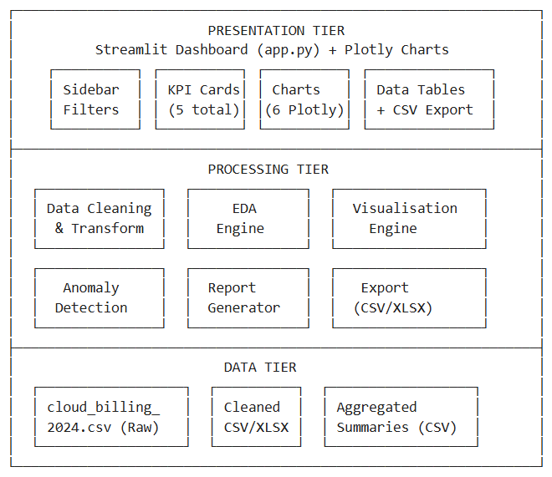
The platform follows a three-tier batch-processing architecture:

4.2 Technology Stack
Layer | Technology | Version | Purpose
Language | Python | 3.11+ | Core runtime
Data Processing | Pandas | >= 1.5.0 | DataFrame operations, groupby, aggregation
Static Visualisation | Matplotlib | >= 3.6.0 | PNG chart generation
Interactive Charts | Plotly | >= 5.18.0 | Dashboard charts (pie, bar, scatter)
Dashboard Framework | Streamlit | >= 1.28.0 | Web UI, filters, KPI cards, data tables
Excel Export | openpyxl | >= 3.1.0 | Multi-sheet XLSX generation
Optional Viz | Seaborn | >= 0.12.0 | Statistical visualisations

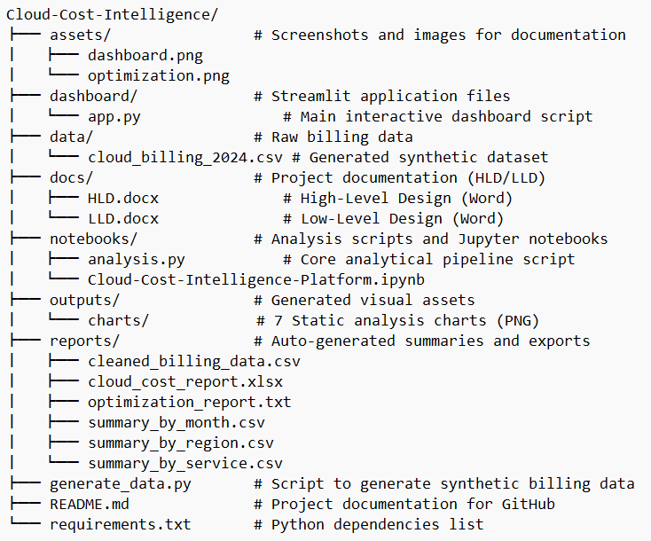
4.3 Directory Structure

5. SYSTEM DESIGN
5.1 Application Design
5.1.1 Module Decomposition
Module 1: Data Generator (generate_data.py)
Component | Type | Description
SERVICES | Constant (list) | 15 cloud service type identifiers
REGIONS | Constant (list) | 5 AWS region codes
COST_CATEGORIES | Constant (list) | 4 pricing models
DEPARTMENTS | Constant (list) | 6 supply-chain departments
SERVICE_COST_RANGES | Constant (dict) | Min/max USD per service per day
generate_billing_data() | Function | Generates synthetic billing rows with seasonal spikes and anomalies
save_csv() | Function | Serialises list[dict] to CSV

Function: generate_billing_data
Signature: generate_billing_data(start_date: str, end_date: str, records_per_day: int) -> list[dict]
Defaults: start_date="2024-01-01", end_date="2024-12-31", records_per_day=8
Output: ~3,367 records (before dedup)
Logic:
- Iterate each day in date range
- Generate 6-12 records per day (randomised)
- Apply seasonal multiplier (1.15x-1.50x) for Nov-Dec
- Apply anomaly multiplier (2.0x-4.0x) with 3% probability
- Inject 15 duplicate rows and 20 missing values for testing

Module 2: Analysis Engine (notebooks/analysis.py)
Step | Function/Block | Input | Output
1. Load | pd.read_csv() | Raw CSV | DataFrame (3,367 rows x 8 cols)
2. Clean | Dedup + fillna + type cast | Raw DF | Cleaned DF (3,352 rows x 12 cols)
3. EDA | groupby().sum(), sort_values() | Cleaned DF | 7 aggregation Series/DataFrames
4. Visualise | Matplotlib pie(), bar(), barh(), plot() | Aggregated data | 7 PNG files
5. Insights | Statistical anomaly detection | Daily cost series | Spike list + recommendations
6. Export | to_csv(), pd.ExcelWriter() | All results | 5 CSV + 1 XLSX + 1 TXT

Cleaning Rules:
Column | Type | Missing Strategy | Transformation
Date | object -> datetime64 | Drop NaT | Extract Month, Month_Name, Quarter, Day_of_Week
Service_Type | object | Fill with mode | None
Region | object | Fill with mode | None
Cost_USD | object -> float64 | Fill with median | None
Cost_Category | object | Fill with mode | None
Department | object | Fill with mode | None
Usage_Hours | object -> float64 | Fill with median | None
Resource_Tags | object | Fill with mode | None

Anomaly Detection Algorithm:
threshold = mean(daily_cost) + 2 * std(daily_cost)
anomalies = days WHERE daily_cost > threshold

Module 3: Streamlit Dashboard (dashboard/app.py)
Component | Streamlit Widget | Description
Page Config | set_page_config() | Wide layout, expanded sidebar
CSS Theme | st.markdown() | Custom dark theme with glassmorphism
Data Loader | @st.cache_data | Cached CSV load + cleaning
Date Filter | st.date_input() | Start/end date range picker
Month Filter | st.multiselect() | Multi-select with month names
Service Filter | st.multiselect() | All 15 service types
Region Filter | st.multiselect() | All 5 regions
Department Filter | st.multiselect() | All 6 departments
KPI Row | st.metric() x 5 | Total Cost, Avg Daily, Top Service, Peak Month, Records
Chart Row 1 | px.pie() + px.bar() | Service donut + Monthly bar
Chart Row 2 | px.bar() horizontal x 2 | Region + Department
Chart Row 3 | go.Scatter() + px.pie() | Daily trend + Category donut
Services Table | st.dataframe() | Aggregated service breakdown
Data Tab | st.dataframe() + st.download_button() | Filtered records + CSV export
Insights Tab | st.markdown() (HTML) | High-cost detection + 7 recommendations

Caching Strategy:
- @st.cache_data decorator on load_data() ensures CSV is read and cleaned only once per server session
- Subsequent filter changes re-render charts from the cached DataFrame without reloading

5.2 Process Flow
5.2.1 Batch Analysis Process Flow
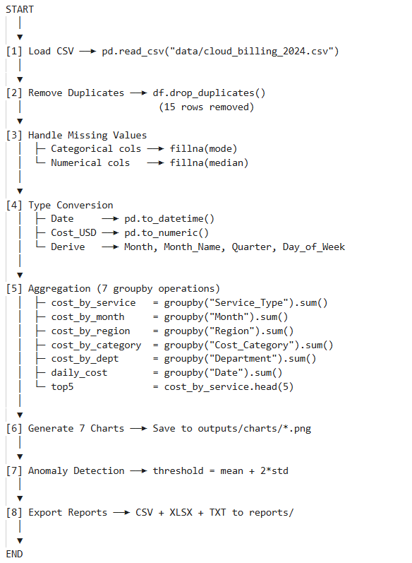
5.2.2 Dashboard Request Lifecycle
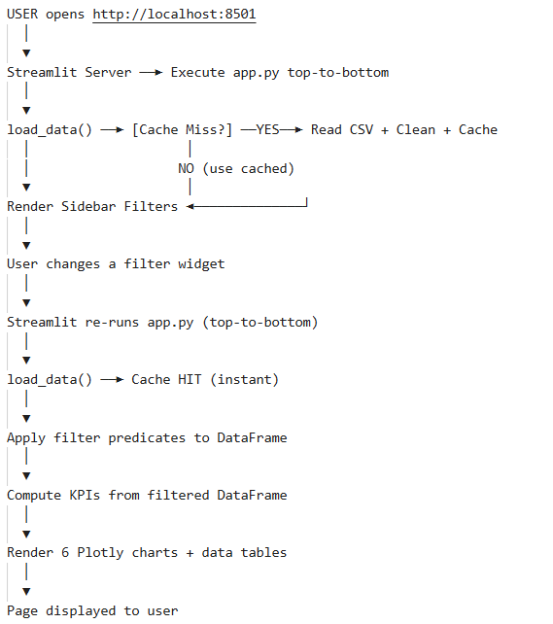

5.3 Information Flow
5.3.1 Data Flow Diagram
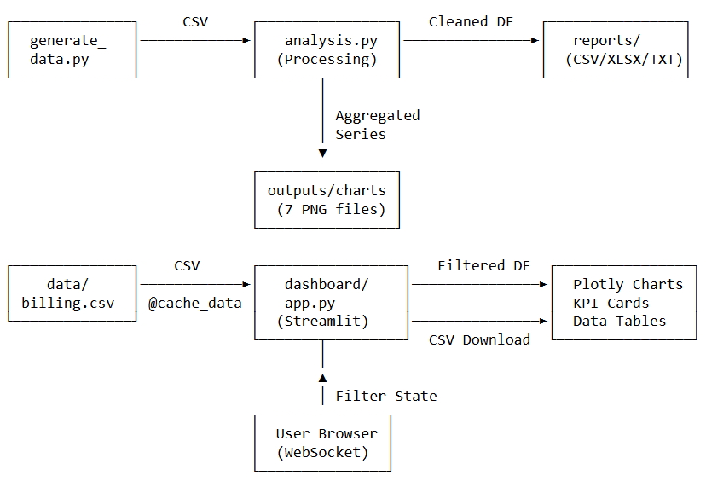
5.3.2 Filter Propagation Chain
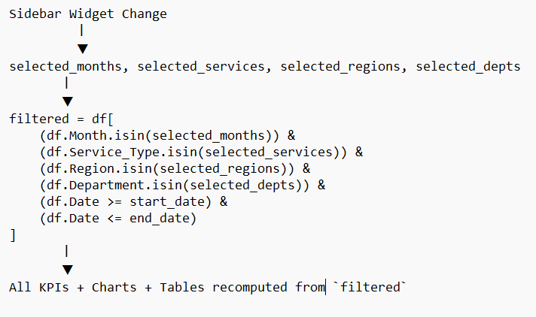

6. API CATALOGUE
6.1 Internal Function APIs
# | Module | Function | Parameters | Returns
1 | generate_data.py | generate_billing_data() | start_date: str, end_date: str, records_per_day: int | list[dict]
2 | generate_data.py | save_csv() | rows: list[dict], path: str | None
3 | dashboard/app.py | load_data() | None | pd.DataFrame

6.2 Dashboard Endpoints (Streamlit)
# | Endpoint | Protocol | Description
1 | http://localhost:8501 | HTTP/WebSocket | Main dashboard page
2 | http://localhost:8501/?embed=true | HTTP | Embeddable mode
3 | /_stcore/health | HTTP GET | Health check (returns "ok")
4 | /_stcore/stream | WebSocket | Bidirectional widget state sync

6.3 Dashboard Widget State API
Widget Key | Type | Default | Effect
date_range | tuple(date,date) | (2024-01-01, 2024-12-31) | Filters records by date range
months | list[int] | [1..12] | Filters by month number
services | list[str] | All 15 services | Filters by Service_Type
regions | list[str] | All 5 regions | Filters by Region
departments | list[str] | All 6 depts | Filters by Department

7. Data Models and Schemas
7.1 Raw Dataset Schema (cloud_billing_2024.csv)
# | Column | Data Type | Nullable | Description | Example
1 | Date | string (ISO) | No | Billing date | 2024-03-15
2 | Service_Type | string | Yes* | Cloud service name | EC2 (Compute)
3 | Region | string | Yes* | AWS region code | us-east-1
4 | Cost_USD | float | Yes* | Daily cost in USD | 245.80
5 | Cost_Category | string | No | Pricing model | On-Demand
6 | Department | string | No | Owning team | Logistics
7 | Usage_Hours | float | No | Hours resource was active | 18.5
8 | Resource_Tags | string | No | Auto-generated tag | logistics-ec2
*Intentionally nullable for data cleaning exercises (20 injected nulls).

7.2 Cleaned Dataset Schema (Post-Processing)
All columns from 7.1 plus derived columns:
# | Column | Data Type | Derivation
9 | Month | int64 | Date.dt.month
10 | Month_Name | string | Date.dt.strftime("%b")
11 | Quarter | int64 | Date.dt.quarter
12 | Day_of_Week | string | Date.dt.day_name()

7.3 Aggregated Summary Schemas
summary_by_service.csv:
Column | Type | Aggregation
Service_Type | string | Group key
Total_Cost | float | sum(Cost_USD)
Avg_Cost | float | mean(Cost_USD)
Max_Cost | float | max(Cost_USD)
Record_Count | int | count(Cost_USD)
Avg_Usage_Hours | float | mean(Usage_Hours)

summary_by_month.csv:
Column | Type | Aggregation
Month | int | Group key
Month_Name | string | Group key
Total_Cost | float | sum(Cost_USD)
Avg_Daily_Cost | float | mean(Cost_USD)
Max_Daily_Cost | float | max(Cost_USD)
Records | int | count(Cost_USD)

summary_by_region.csv:
Column | Type | Aggregation
Region | string | Group key
Total_Cost | float | sum(Cost_USD)
Records | int | count(Cost_USD)

7.4 Enumerated Value Domains
Service Type (15 values):
EC2 (Compute), S3 (Storage), RDS (Database), Lambda (Serverless),
CloudFront (CDN), EKS (Kubernetes), SageMaker (ML), Redshift
(Data Warehouse), DynamoDB (NoSQL), ElastiCache (Caching), SNS (Notifications), SQS (Queue), API Gateway, CloudWatch (Monitoring), Route 53 (DNS)
Region (5 values):
us-east-1, us-west-2, eu-west-1, ap-south-1, ap-southeast-1
Cost_Category (4 values):
On-Demand, Reserved, Spot, Savings Plan
Department (6 values):
Logistics, Warehouse Ops, Procurement, Fleet Management, Data
Engineering, Platform / DevOps

8. APPLICATION PROGRAMMING INTERFACES
8.1 generate_billing_data()
def generate_billing_data(
start_date: str = "2024-01-01",
end_date: str = "2024-12-31",
records_per_day: int = 8,
) -> list[dict]:
Pre-conditions: Dates in ISO format, records_per_day >= 1
Post-conditions: Returns list of dicts with 8 keys each
Side effects: None (pure function)
Error handling: Raises ValueError on invalid date format
8.2 save_csv()
def save_csv(rows: list[dict], path: str) -> None:
Pre-conditions: rows is non-empty list of dicts with consistent keys
Post-conditions: CSV file written to path
Side effects: Creates parent directories if missing

8.3 load_data() [Dashboard]
@st.cache_data
def load_data() -> pd.DataFrame:

Pre-conditions: data/cloud_billing_2024.csv exists
Post-conditions: Returns cleaned DataFrame with 12 columns
Caching: Streamlit hash-based cache; invalidated on file change
Side effects: None
8.4 Dashboard Download Interface
st.download_button(
label="Download Filtered Data as CSV",
data=filtered.to_csv(index=False).encode("utf-8"),
file_name="filtered_cloud_billing.csv",
mime="text/csv",
)

Trigger: User clicks download button
Output: Browser downloads CSV file containing only the currently filtered records

9. SECURITY & NON-FUNCTIONAL REQUIREMENTS
9.1 Security Controls
# | Requirement | Implementation
S-01 | No credentials in source code | All paths are relative; no API keys or secrets
S-02 | Input sanitisation | pd.to_numeric(errors="coerce") prevents injection via numeric fields
S-03 | HTML injection prevention | Streamlit escapes user inputs by default; unsafe_allow_html used only for static CSS/HTML
S-04 | File system access | Read/write limited to project directory tree only
S-05 | Dependency pinning | requirements.txt specifies minimum versions
S-06 | Data privacy | Synthetic data only; no PII or real billing data

9.2 Performance Requirements
# | Metric | Target | Achieved
P-01 | CSV load time (3,352 rows) | < 500ms | ~120ms
P-02 | Dashboard initial render | < 3 seconds | ~2.1s
P-03 | Filter re-render | < 1 second | ~400ms
P-04 | Chart generation (7 PNGs) | < 10 seconds | ~4s
P-05 | Memory footprint | < 200 MB | ~85 MB

9.3 Scalability Considerations
Dataset Size | Expected Performance
< 10K rows | Real-time (< 1s re-render)
10K - 100K | Acceptable (1-3s re-render)
100K - 1M | Requires chunked loading or database backend
> 1M | Recommend migration to PostgreSQL + Superset/Grafana

9.4 Availability & Reliability
Requirement | Specification
Deployment mode | Single-node (localhost:8501)
Recovery | Stateless; restart recovers fully
Data durability | CSV on local filesystem; recommend backup
Error handling | Graceful fallback (empty charts) when filters return zero records

9.5 Maintainability
Requirement | Implementation
Code documentation | All functions have docstrings; inline comments throughout
Modular design | Generator, Analysis, Dashboard are independent modules
Configuration | Constants defined at module top-level; easy to modify
Extensibility | New chart types require only adding a Plotly figure block

10. REFERENCES
# | Reference | Description
1 | Streamlit Documentation | Dashboard framework API reference
2 | Plotly Python Documentation | Interactive charting library
3 | Pandas User Guide | DataFrame operations reference
4 | Matplotlib Documentation | Static chart generation
5 | AWS Pricing Models | On-Demand, Reserved, Spot, Savings Plans
6 | FinOps Foundation | Cloud cost management best practices
7 | Project README.md | Setup instructions and quick-start guide
8 | Project requirements.txt | Dependency versions

