## CASE STUDY REPORT

**DATA ANALYTICS WITH POWER BI**

## “ ANALYTICS OF COMMERCIAL ELECTRICITY CONSUMPTION “

**SRI PARAMAKALYANI COLLEGE,ALWARKURICHI**

|  |  |
| --- | --- |
| **NM ID** | **NAME** |
| **54EB0BC7C3F230EB5F54E3E077C88906** | **S.Aswin Babu** |

## Trainer Name: M.Uma Maheshwari

**Master Trainer : M.Uma Maheshwari**

# ANALYSIS OF COMMERCIAL ELECTRICITY CONSUMPTION

**Abstract:**

The demand for energy has been increasing over the years in India, which may be the result of its rapid economic growth trajectory. In this context, this study examines the direction of the Granger-causal relationship between electricity consumption and economic growth at the state and sectoral levels in India. In doing so, the panel cointegration tests with the structural break, the heterogeneous panel causality test, and the panel VAR based impulse-response model are employed. The study covers overall economic growth and growth in agricultural and industrial sectors for eighteen major Indian states for the period 1960–61 to 2014–15. The results provide

## Introduction:

As an input into the production of goods and services, energy (specifically electricity) plays a major role in determining economic growth and the development of a nation (Asafu-Adjaye, 2000; Shiu and Lam, 2004; IAEA, 2009). As India is the fastest growing economy in the world, its dependence on energy resources has been huge and continues to mount. Since 2000, India has been responsible for around 10% of the increase in the global demand for energy (Mahalik and Mallick, 2014). Between 2000 and 2013, India&#39;s share in the global energy demand almost doubled. In the coming decade, India is expected to become the primary source of energy demand growth in Asia, overtaking China (IEA, 2015).

## Energy scenario in India:

Our country India is also one of developing country in the world among others and here several kinds of sectors are performing well for nation’s achievements. India’s future depends on existing energy inclusion of wealth of human resources. At the same, amount of availing Energy and consumption over it, is a great challenge for Indian

economy to do further economic activities. Non-renewable sources plays vital among rural India for various purpose including cooking due to various inconvenience situation of alternative energy. As commercial sources, Oil is major demandable energy for all sectors. But it was appeared as scarce during 1970s and it’s price also mounted up in 1975 highly but not like 1973-74 due to the disputes of imposing duties on importing goods.

## Energy Consumption :

While compare the energy consumption with commercial and non-commercial energy, people are utilizing less of non-commercial and higher of commercial energy because of having sufficient income sources and ability for consume energy. For cooking and heating purposes people has been using commercial fuels only such as electricity, LPG, natural gas, coal etc. Therefore, demand for it, is always high and provision also less of its requires because of scarce of natural energy. Already natural or non-commercial energy is using by the people from rural not after considering energy for all including use as capital for production.

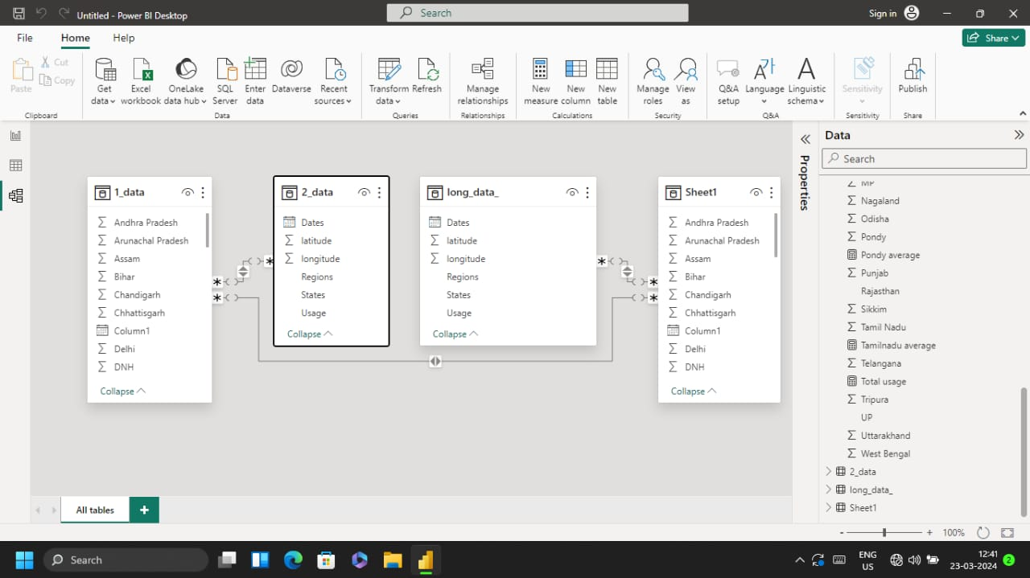

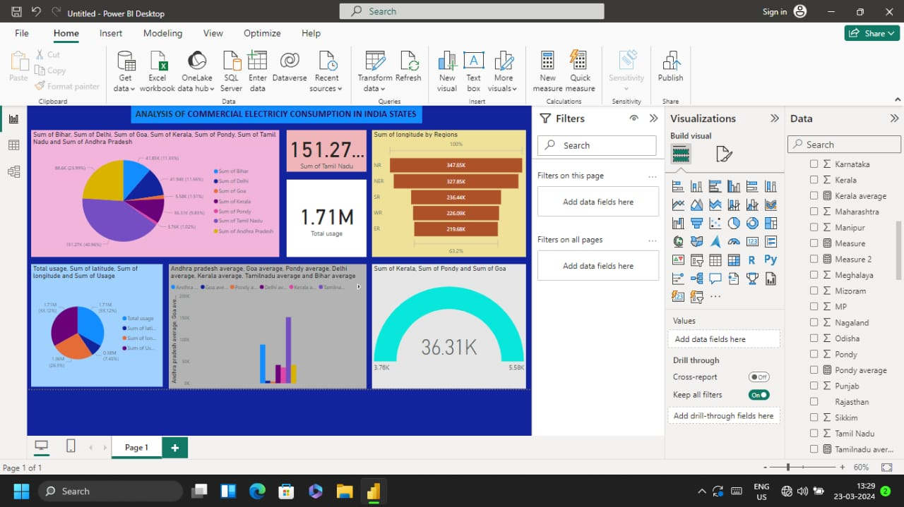

## CONCLUSION :

Based on the engraved statistical inferences pertained to commercial energy consumption in India has been fluctuating that resulted from found growth rate therein but 2014th result shows that begin to get develop compare to 2013th growth rate. While consider the total consumption of commercial energy, that has been mounting up year by year and found at 5.48percentin compound annual growth rate result. Consumption trends of Natural gas shows from 2008 onwards.

# REFERENCE:

[https://www.researchgate.net/publication/261046177](https://www.researchgate.net/publication/261046177analysis) [analysis](https://www.researchgate.net/publication/261046177analysis) commercial electricity consumption