
RAJALAKSHMI INSTITUTE OF TECHNOLOGY
(An Autonomous Institution, Affiliated to Anna University, Chennai)

DEPARTMENT OF ARTIFICIAL INTELLIGENCE AND DATA SCIENCE
ACADEMIC YEAR 2025 - 2026
SEMESTER IV
AL23421 - MACHINE LEARNING LABORATORY
MINI PROJECT REPORT

REGISTER NUMBER | 2117240070030
NAME | ASWIN ANANTH S
PROJECT TITLE | Network Intrusion Detection using Random Forest Algorithms
DATE OF SUBMISSION
FACULTY IN-CHARGE | Mrs. M. Divya

Signature of Faculty In-charge Signature of HOD

INTRODUCTION
Machine Learning (ML) plays a crucial role in cybersecurity by enabling systems to automatically detect abnormal patterns in network traffic. In this project, the Random Forest algorithm is used to classify network traffic as either normal or malicious (attack) based on learned patterns from historical data.
Traditional rule-based systems fail to detect modern and evolving cyber threats. Therefore, ML-based systems provide a dynamic and adaptive approach to intrusion detection.
This project aims to develop a real-time Network Intrusion Detection System (NIDS) that:
- Monitors network traffic
- Extracts features
- Uses ML to classify threats
- Displays results through a web interface
PROBLEM STATEMENT
Design and implement a system that can detect malicious network activities in real-time using Machine Learning techniques, and classify them accurately as normal or attack traffic.
GOAL
The goal of this project is to:
- Build a real-time intrusion detection system
- Achieve high accuracy in classification
- Reduce false positives
- Provide live monitoring through a dashboard
Expected Results:
- Accurate detection (>95%)
- Real-time visualization
- Scalable architecture
THEORETICAL BACKGROUND
Intrusion Detection System (IDS)
An IDS monitors network traffic to identify suspicious activity.

Random Forest Algorithm
Random Forest is an ensemble learning method that builds multiple decision trees and combines their outputs.
Mathematical Representation:
Let there be N decision trees:
Prediction:
$$\hat{y}=\text{mode}(T_{1}(x),T_{2}(x),...,T_{N}(x))$$
Where:
- $T_{i}(x)$= prediction of ith tree
- mode = majority voting

Gini Index (used for splitting)
$$Gini=1-\sum_{i=1}^{n}{p_{i}^{2}}$$
Where:
- $p_{i}$= probability of class i

Literature Survey
Method | Description
SVM | Works well but slower
Neural Networks | High accuracy but complex
KNN | Simple but inefficient
Random Forest | Balanced performance

Justification
Random Forest is chosen because:
- High accuracy
- Handles large datasets
- Less overfitting
- Provides feature importance
ALGORITHM EXPLANATION WITH EXAMPLE
Example Input:
duration | src_bytes | dst_bytes | count | srv_count
2 | 500 | 200 | 10 | 10
Process:
- Input features passed into multiple trees
- Each tree gives prediction
- Majority voting decides final output
Output:
- Normal / Attack
Graph Explanation (concept)
- Pie chart → traffic distribution
- Bar chart → feature importance
IMPLEMENTATION CODE AND DATASET USED
Category | Description
Dataset Name | NSL-KDD
Domain | Cybersecurity
Objective | Classification
Data Source | Public
Number of Samples | ~125,973
Data Type | Tabular
Instance Description | One network connection
Features | duration, protocol, bytes, etc.
Feature Types | Numerical + Categorical
Target Variable | Normal / Attack
Number of Classes | 2
License | Open
Version | NSL-KDD
Dataset Link
https://www.kaggle.com/datasets/hassan06/nslkdd
Python code

OUTPUT

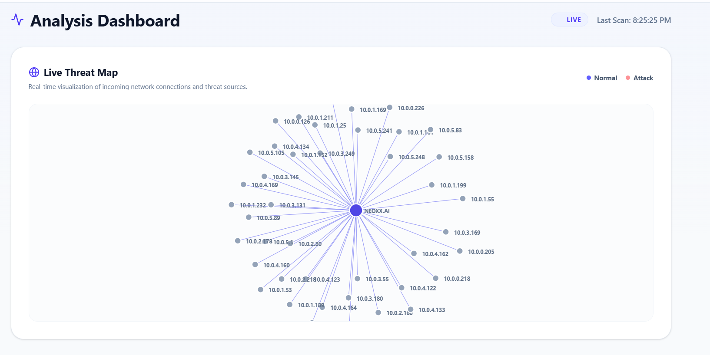
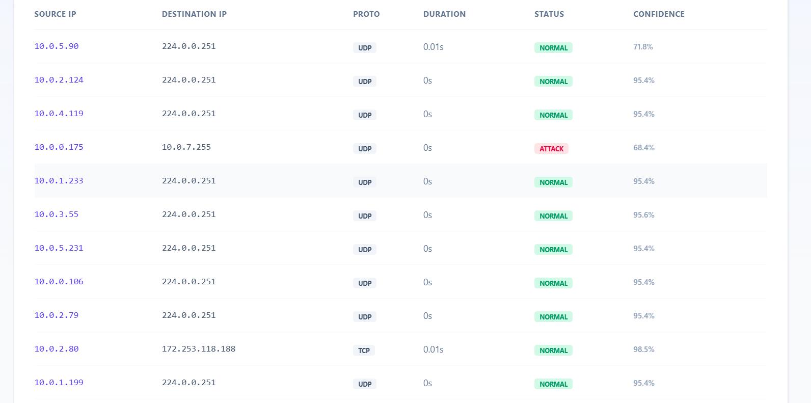
Metric | Value
Accuracy | 98.02%
Precision | 97.8%
Recall | 96.5%
F1 Score | 97%

RESULTS AND FUTURE ENHANCEMENT
Results
- High accuracy detection
- Real-time monitoring achieved
- Stable system performance

Future Enhancements
- Use Deep Learning models
- Improve feature extraction
- Add real attack simulation
- Deploy on cloud

Comparison
Method | Accuracy | Complexity
KNN | Medium | Low
SVM | High | Medium
Random Forest | High | Medium
Neural Network | Very High | High

Git Hub Link of the project along with the report
REFERENCES
- NSL-KDD Dataset – Kaggle
- Scikit-learn Documentation
- "Pattern Recognition and Machine Learning" – Bishop
- Research Paper on IDS using ML (IEEE)
- Towards Data Science – Random Forest Guide

