Student Name

CS 579 Fall 2024 Written Assignment #01
Due: April 27, 2024, 11:59 PM CST
Points: 30

Instructions:
- Use this document template to report your answers. Name the complete document as follows:

LastName_FirstName_CS579_Written01.doc or pdf
(only MS Word or PDF files accepted!)

- Submit the final document to Blackboard Assignments section before the due date.

Objectives:
- (20 points) Demonstrate your understanding of Bayes Networks.
- (10 points) Demonstrate your understanding of MDPs and Value Iteration Algorithm.

Problem 1 [10 pts]:
We are given the following Bayesian network over A, B, C, D, E, G, H, J, K, L, X, Y, Z (node G’s background color can be ignored)

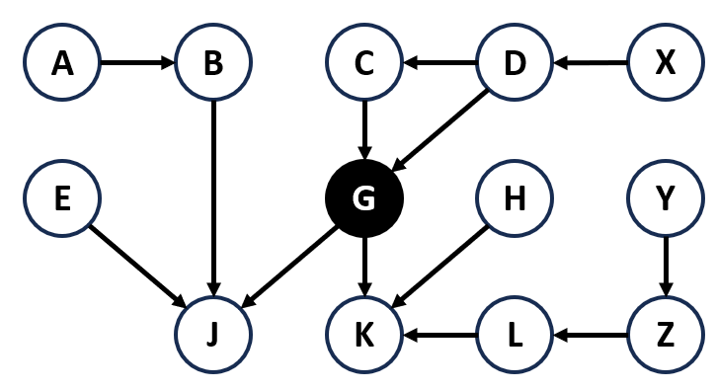

What is the Bayesian network factorization of the joint probability P(A, B, C, D, E, G, H, J, K, L, X, Y, Z)?

Your solution:

Problem 2 [20 pts]:
Consider the following decision network (note three decisions for D: x, y, z):

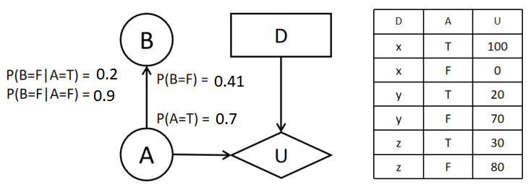

- Complete conditional probability tables for each chance node. [2 pt]:

- Which decision (x, y, or z) is best given evidence B = T? Justify your answer. [9 pts]:
- What is the value of information for B? Justify your answer. [9 pts]:

