# Software Project Management - Kanban Board

## Objective
To create a Kanban Board to visualize project tasks and simulate the workflow using Trello.

## Tool Used
- Trello

## Kanban Board Columns
- To Do
- Doing
- Done

## Sample Tasks
1. Requirement Analysis
2. UI Design
3. Database Design
4. Testing
5. Deployment

## Workflow
Initially, all five tasks were added to the **To Do** column.

Then:
- **UI Design** was moved to **Doing**.
- **Requirement Analysis** was moved to **Done**.

This demonstrates how tasks move through different stages of a project using the Kanban methodology.

## Screenshots

### Before Moving Tasks
!( kanban-before.png)
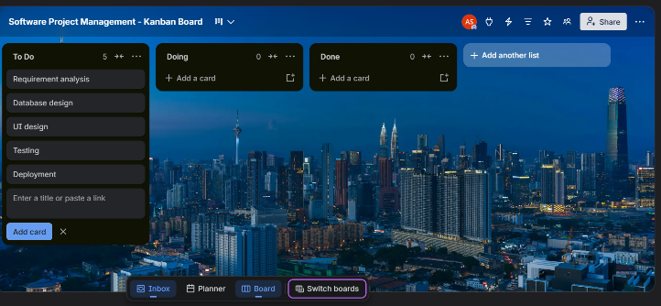

### After Moving Tasks
![Kanban After](kanban-after.png)
