ASWITHA .S
192471001
ASSIGNMENT-2
CSA1001 -SOFTWARE ENGINEERING
Problem 1: Requirements Elicitation & Prioritisation in a College Attendance System
Scenario
A college plans to develop an Attendance Management System to improve the process of recording and monitoring student attendance. Different stakeholders have different expectations:
- Students want a mobile application to check attendance anytime.
- Teachers prefer biometric attendance to avoid proxy attendance.
- Management wants the system to be cost-effective and delivered quickly.
Since the stakeholders have conflicting needs, requirements must be properly elicited, analysed, and prioritised.

1. Requirements Elicitation
Requirements elicitation is the process of gathering requirements from stakeholders through interviews, meetings, surveys, and observations.
Stakeholders and Their Requirements
Stakeholder | Requirement | Type
Students | View attendance through a mobile application | Functional Requirement
Teachers | Record attendance using biometric authentication | Functional Requirement
Management | Generate attendance reports automatically | Functional Requirement
Management | Complete the project within budget and schedule | Non-Functional Requirement

2. Four Well-Defined Requirements
Requirement ID | Requirement
R1 | Students shall be able to view their attendance records using a mobile application.
R2 | Teachers shall record attendance using biometric authentication to prevent proxy attendance.
R3 | The system shall automatically generate daily, weekly, and monthly attendance reports.
R4 | The system shall be developed within the approved budget and completed before the academic semester begins.

3. Moscow Prioritisation
Priority | Features | Reason
Must Have | Biometric attendance, Attendance database | Essential for accurate attendance recording.
Should Have | Mobile attendance viewing, Attendance reports | Improves usability and decision-making.
Could Have | Attendance notifications, Graphical dashboard | Enhances user experience but not mandatory.
Won't Have (Current Release) | AI-based attendance prediction | Planned for future versions.

4. Kano Model Classification
Feature | Category | Explanation
Biometric attendance | Basic Requirement | Users expect secure and accurate attendance recording.
Mobile attendance checking | Performance Requirement | Better performance increases user satisfaction.
Attendance analytics dashboard | Excitement Requirement | Unexpected feature that delights users and adds value.

5. Stakeholder Conflict
Conflict
Teachers insist on using biometric attendance because it is secure and prevents fake attendance. However, management prefers a low-cost solution that can be implemented quickly. Purchasing biometric devices increases the project cost and development time.

6. Resolution Plan
The Business Analyst should organize meetings with all stakeholders and prioritize requirements based on business value.
Phase 1
- Develop the attendance management system.
- Provide a mobile application for students.
- Use QR code-based attendance to reduce costs.
Phase 2
- Integrate biometric devices after budget approval.
- Train faculty members to use the biometric system.
This phased approach satisfies the needs of both teachers and management while staying within budget.

7. Real-World Example
Many universities such as Vellore Institute of Technology (VIT), SRM Institute of Science and Technology, and Amity University use biometric attendance systems for faculty and provide mobile or web portals where students can check their attendance percentage. These systems reduce manual errors, prevent proxy attendance, and improve attendance tracking.

8. Advantages
- Improves attendance accuracy.
- Prevents proxy attendance.
- Saves teachers' time.
- Students can monitor attendance anytime.
- Generates reports automatically.
- Supports better decision-making for management.

9. Disadvantages
- Biometric devices increase project cost.
- Fingerprint scanners may fail due to hardware issues.
- Initial setup requires additional time.
- Privacy concerns regarding biometric data.
- Internet connectivity is required for cloud-based attendance systems.

10. Example
Without Prioritization
- Students request a mobile app.
- Teachers request biometric devices.
- Management requests a low-cost solution.
Result:
- Delays in development.
- Budget exceeds expectations.
- Stakeholder dissatisfaction.
With Moscow Prioritisation
- Core attendance system is developed first.
- Mobile application is included.
- Biometric integration is added later.
Result:
- Faster delivery.
- Lower initial cost.
- Higher stakeholder satisfaction.
- 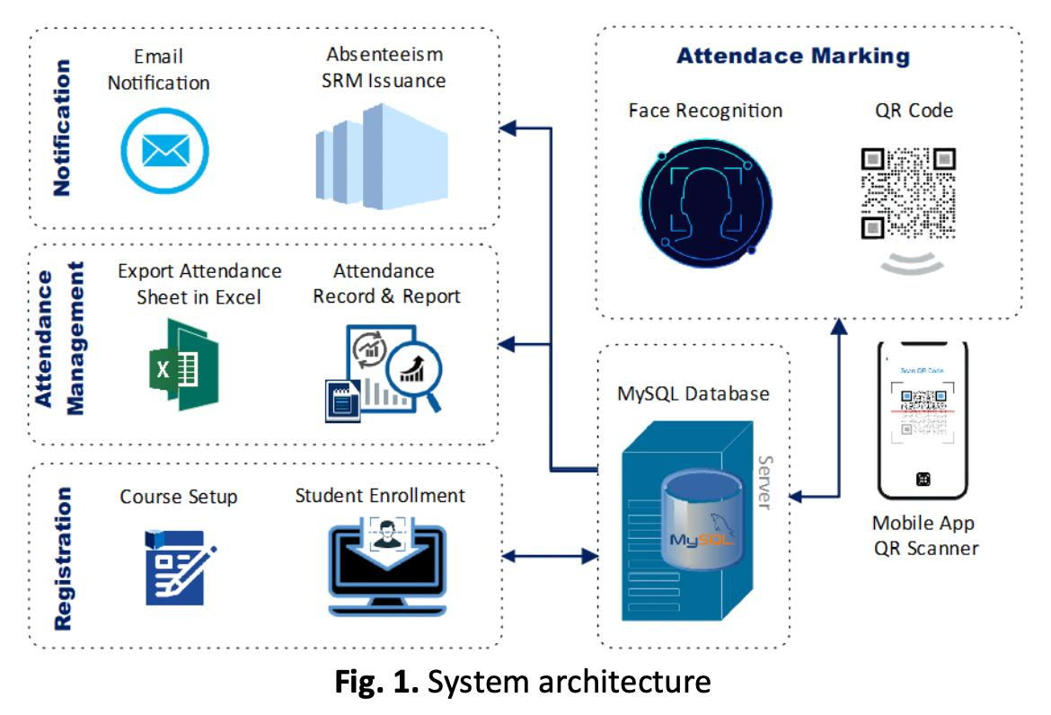

11. Conclusion
The College Attendance Management System demonstrates how requirements from multiple stakeholders can be collected, analysed, and prioritised using the Moscow technique and the Kano Model. Resolving stakeholder conflicts through phased implementation ensures that the system is cost-effective, meets essential business needs, and provides opportunities for future enhancements. This approach improves software quality, stakeholder satisfaction, and project success.

Problem 2: Improving Collaboration with Jira & Confluence in a Hospital System
Scenario
A software development team is building a Hospital Appointment Booking System. Developers use Jira to manage project tasks and track issues, while UI/UX designers use Confluence to maintain design documents and project documentation. Since both teams work on separate platforms without proper integration, communication gaps occur, resulting in duplicated work, outdated documentation, and missed project updates. This creates conflicts among team members and delays project delivery.

1. Conflict Type Identification
The primary conflict is a Process and Communication Conflict.
Explanation
- Developers update tasks only in Jira.
- Designers update documentation only in Confluence.
- Information is not synchronised.
- Teams work with outdated information.
- Duplicate work increases project time and cost.
- Miscommunication leads to misunderstandings and blames among team members.

2. Jira and Confluence Integration
Jira is a project management and issue-tracking tool, while Confluence is a collaboration and documentation platform.
Integrating Jira and Confluence enables both teams to collaborate on a shared information source.
How They Work Together
- Every project requirement is documented in Confluence.
- Each requirement is linked to a corresponding Jira User Story or Task.
- Developers can open the related Confluence document directly from Jira.
- Designers can track development progress from Confluence through linked Jira issues.
- Any update in Jira is visible in Confluence, reducing duplication and confusion.
- All stakeholders access the latest project information from a single connected workspace.

3. Advantages of Jira + Confluence Integration
- Improves communication between developers and designers.
- Eliminates duplicate documentation.
- Provides a single source of truth.
- Tracks project progress in real time.
- Improves collaboration across Agile teams.
- Makes requirement traceability easier.
- Reduces project delays and misunderstandings.

4. Disadvantages
- Initial integration setup requires time and effort.
- Team members need training to use both tools effectively.
- Licensing costs may increase for larger organisations.
- Poor documentation practices can still lead to confusion if not maintained.

5. Two Conflict Resolution Steps
Step 1: Centralise Documentation
Maintain all project requirements, UI designs, meeting notes, and technical documents in Confluence. Every Jira task should include a link to its related Confluence page.
Benefit:
Everyone accesses the same updated information, reducing misunderstandings.

Step 2: Conduct Regular Sprint Meetings
At the beginning and end of every sprint:
- Review Jira tasks.
- Verify Confluence documentation.
- Discuss changes with developers, designers, testers, and project managers.
- Update both platforms immediately after meetings.
Benefit:
Ensures all team members stay informed and reduces communication gaps.

6. Sample Workflow for Task and Document Linking
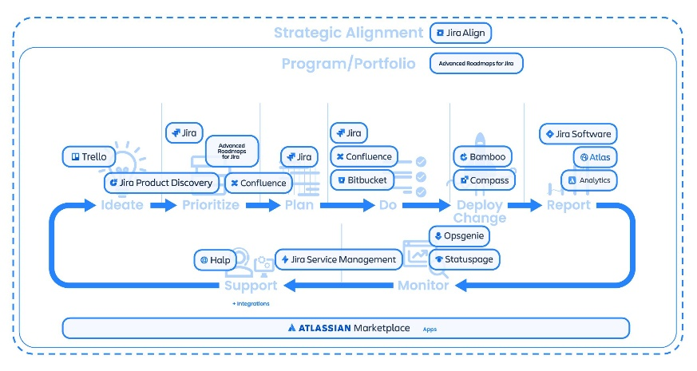
7. Real-World Example
Many healthcare organizations use Atlassian Jira and Confluence together to develop hospital management systems and patient appointment platforms.
For example:
- Requirements are documented in Confluence.
- Development tasks are managed in Jira.
- Test cases are linked to Jira issues.
- Project managers monitor sprint progress using Jira dashboards.
- Documentation is automatically updated in Confluence.
This integration helps teams deliver projects faster with fewer communication issues.

8. Example of Task Linking
Confluence Document | Linked Jira Issue
Appointment Booking Requirements | HOSP-101
Patient Registration Design | HOSP-102
Doctor Availability Module | HOSP-103
Payment Gateway Documentation | HOSP-104

9. Example Scenario
Without Jira + Confluence Integration
- Designers modify the appointment booking screen.
- Developers are unaware of the design changes.
- Old UI is developed.
- Testing fails.
- Rework is required.
- Project delivery is delayed.
With Jira + Confluence Integration
- Designers update the Confluence page.
- Jira automatically links to the updated document.
- Developers receive notifications.
- Correct implementation is completed.
- Testing succeeds.
- Project is delivered on time.

10. Reasoning
This scenario demonstrates how communication and process conflicts can affect software development projects. Integrating Jira and Confluence creates a centralized environment where documentation, project tasks, and development activities remain synchronized. This improves collaboration, reduces duplication of work, enhances requirement traceability, and enables Agile teams to deliver high-quality software efficiently.

11. Conclusion
Using Jira and Confluence together significantly improves collaboration between developers, designers, testers, and project managers. Linking tasks with documentation ensures that every team member has access to accurate and up-to-date information. Regular communication, shared documentation, and integrated workflows reduce conflicts, improve productivity, and contribute to the successful delivery of software projects such as hospital appointment booking systems

Problem 3: Choosing Architecture for a Scalable Food Delivery Platform
Scenario
A startup plans to develop a food delivery platform similar to Swiggy or Zomato. The platform should be capable of processing thousands of food orders every minute, especially during peak hours such as lunch and dinner. The Chief Technology Officer (CTO) is considering Microservices Architecture, Serverless Architecture, or Monolithic Architecture. The system must be scalable, reliable, and easy to maintain.

1. Recommended Architecture Choice
Recommended Architecture: Microservices Architecture with Event-Driven Architecture
Microservices Architecture is the most suitable choice because it divides the application into multiple independent services that communicate through APIs and events. Each service can be developed, deployed, and scaled independently.

2. Comparison of Architectures
Architecture | Advantages | Disadvantages | Suitable For
Monolithic | Easy to develop initially, simple deployment | Difficult to scale, entire application affected by failures | Small applications
Serverless | Automatic scaling, no server management | Vendor lock-in, cold-start latency | Event-driven and lightweight applications
Microservices | High scalability, fault isolation, independent deployment | More complex to manage and monitor | Large-scale applications like Swiggy and Zomato

3. Three Technical Reasons for Choosing Microservices
Reason 1: Independent Scalability
Each microservice can be scaled separately according to demand.
Example:
During lunch hours, only the Order Service needs additional resources instead of scaling the entire application.

Reason 2: Fault Isolation
If one service fails, other services continue functioning.
Example:
If the Payment Service experiences an issue, users can still browse restaurants and add items to their cart.

Reason 3: Faster Development and Deployment
Different development teams can work on different microservices simultaneously without affecting other components.
Example:
The Payment team can update payment features while the Delivery team improves delivery tracking.

4. Benefits of Event-Driven Architecture
- Supports asynchronous communication.
- Improves system scalability.
- Reduces dependency between services.
- Faster order processing.
- Better fault tolerance.
- Enables real-time notifications.

5. Suitable Microservices
Microservice | Responsibility
Order Service | Creates, updates, and manages customer orders.
Payment Service | Processes online payments and refunds securely.
Delivery Service | Assigns delivery partners and tracks order status.
Additional Microservices (Optional)
- User Service
- Restaurant Service
- Notification Service
- Review and Rating Service
- Inventory Service

6. Advantages of Microservices
- High scalability
- Independent deployment
- Better fault tolerance
- Easier maintenance
- Faster software releases
- Technology flexibility

7. Disadvantages of Microservices
- Higher development complexity
- Increased infrastructure cost
- Difficult monitoring and debugging
- More network communication
- Requires DevOps expertise
- 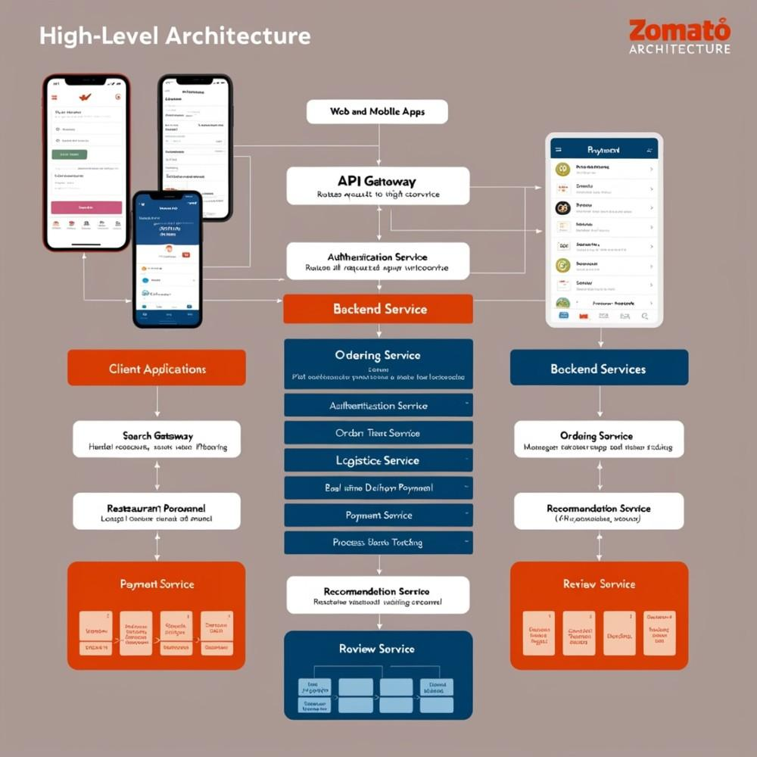

8. Real-World Example
Companies such as Swiggy, Zomato, Uber Eats, and Amazon use Microservices Architecture because millions of users access their platforms simultaneously. During festivals or weekends, individual services such as ordering and payments scale automatically without affecting the rest of the application.

9. Example Scenario
Without Microservices (Monolithic)
- A large number of users place orders.
- The entire application slows down.
- Payment processing also becomes slow.
- One module failure can affect the complete application.
With Microservices
- Only the Order Service scales.
- Payment and Delivery continue independently.
- Faster response time.
- Better customer experience.

10. Conclusion
Microservices Architecture combined with Event-Driven Architecture is the best choice for large-scale food delivery platforms. It offers scalability, flexibility, fault tolerance, and faster deployment while supporting thousands of concurrent users efficiently.

Problem 4: API-First Development for a Hotel Booking Platform
Scenario
A software development team is building a Hotel Booking Platform. The frontend, backend, and mobile application teams need to work simultaneously. To avoid delays and ensure consistency, the project manager decides to adopt an API-First Development approach using OpenAI (Swagger).

1. API-First Advantage
API-First Development means designing APIs before writing application code.
This allows all teams to understand how the system communicates before implementation begins.
Advantages
- Frontend and backend teams work simultaneously.
- Faster software development.
- Clear API documentation.
- Better communication among teams.
- Easier testing using Swagger.
- Improved software quality.
- Reduces development delays.

2. Swagger-Style API Outline
Room Availability Check API
Endpoint
GET /Api/v1/rooms/availability
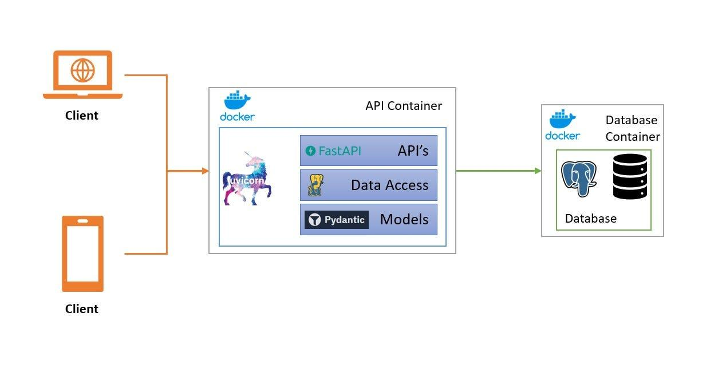

Request Parameters
Parameter | Type | Description
city | String | Hotel location
checkInDate | Date | Check-in date
checkout Date | Date | Check-out date
guests | Integer | Number of guests
Advantages
- Maintains backward compatibility.
- Supports gradual upgrades.
- Prevents breaking existing applications.
- Allows multiple API versions to run simultaneously.
Conclusion
API-First Development using OpenAI (Swagger) improves collaboration, speeds up development, and ensures consistency across frontend, backend, and mobile applications. Combined with Docker containerization, it provides a scalable, portable, and reliable deployment solution for modern hotel booking platforms.

