SIMATS ENGINEERING
ASSESSMENT TOOL 1

COURSE NAME: INTERNET PROGRAMMING
COURSE CODE: CSA43

COURSE OUTCOME COVERED

CO 3: Implement dynamic web applications by utilizing DOM-based client-side scripting and employing Java Servlets for server-side request processing and response handling. (L3)

Assessment Tool : Scenario-Based Assessment

Weightage: 40%

QUESTIONS: Total Marks: 30

Question 1
Suppose that a college wants to develop an online student registration system where students submit their details through a web form, and the data is processed using a Java Servlet.
Explain the architecture of a servlet-based application. Design and implement a servlet to handle form data using both GET and POST methods. Describe the servlet life cycle (init, service, destroy) and justify which method is more appropriate for handling sensitive data.

Question 2
Suppose that a website requires users to log in and maintain their session across multiple pages after authentication.
Design a session management system using HttpSession and Cookies in Servlets. Explain how session tracking works in web applications and compare session-based tracking with cookies

Question 3
Suppose that an e-commerce platform needs to store and retrieve product details from a database using a Java-based web application.
Design a JDBC-based application to connect to a database, insert product data, and retrieve it using SQL queries. Explain the JDBC architecture and describe the steps involved in database connectivity along with proper exception handling.

Code of Conduct:

I ASWITHA .S (192471001) (Name / Reg No) certify that this submission is my original work and that I have adhered to the guidelines specified for this assessment.
I understand that any violation of academic integrity rules will result in disciplinary action.

Signature of the student:
ASWITHA.S

Question
Suppose that a college wants to develop an online student registration system where students submit their details through a web form, and the data is processed using a Java Servlet.
1. Aim
To design and implement an online student registration system using a Java Servlet that processes student details submitted through a web form using GET and POST methods.
2. Scenario
A college requires an online registration system where students can enter their name, registration number, email, department, and year. The submitted data is sent to a Java Servlet, which processes the request and displays the registration details.
3. Servlet Application Architecture
The architecture of the application is:
Student
↓
Web Browser
↓
HTML Registration Form
↓
HTTP Request
↓
Servlet Container
↓
Java Servlet
↓
Process Form Data
↓
HTTP Response
↓
Web Browser
Main Components
- Client: Student's web browser.
- HTML Form: Collects student information.
- HTTP Request: Sends the form data to the server.
- Servlet: Processes the submitted data.
- Servlet Container: Manages the execution and life cycle of the servlet.
- HTTP Response: Sends the result back to the student.

Screenshot -1
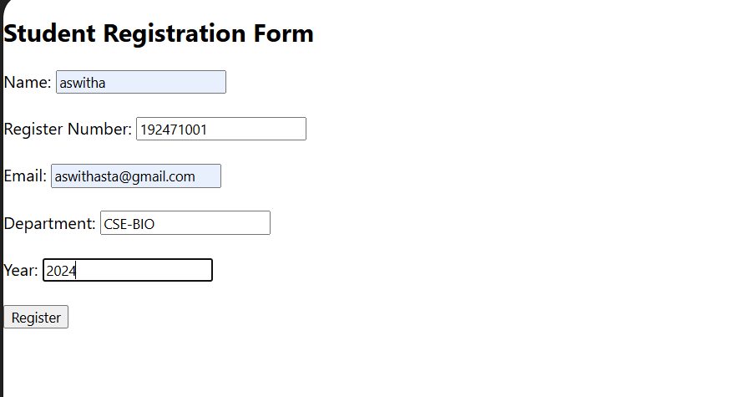
4. Servlet Mapping
The servlet can be mapped using the following annotation:
@WebServlet("/register")
If annotations are used, add it above the class:
@WebServlet("/register")
public class StudentRegistrationServlet extends HttpServlet {
The mapping connects the HTML form:

/register
with the Java Servlet.
5. GET Method
The doGet() method handles GET requests.
protected void doGet(HttpServletRequest request,
HttpServletResponse response)
The submitted data can appear in the URL.
Example:
/register?name=Aswitha&regno=101
GET is generally used for retrieving or sending non-sensitive information.
6. POST Method
The doPost() method handles POST requests.
protected void doPost(HttpServletRequest request,
HttpServletResponse response)
The form data is sent in the HTTP request body instead of being appended to the URL.
POST is more suitable for registration forms and sensitive information.
7. GET vs POST
GET | POST
Data may appear in URL | Data is sent in request body
Suitable for retrieving data | Suitable for submitting data
Can be bookmarked | Normally not bookmarked with submitted data
Less suitable for sensitive information | More appropriate for sensitive information
Limited by URL length | Can send larger amounts of data

8. Servlet Life Cycle
The servlet has three important life-cycle methods:
1. init()
The init() method is called when the servlet is created.
It is used for initialization.
2. service()
The service() method handles incoming client requests.
It determines the HTTP request type and calls methods such as:
do Get()
do Post()
3. destroy()
The destroy() method is called when the servlet is removed from service.
It is used to release resources.
Life Cycle
Servlet Created
↓
init()
↓
service()
↓
do Get() / do Post()
↓
Response
↓
destroy()
9. Which Method Is Better for Sensitive Data?
POST is more appropriate for sensitive data because the data is not directly displayed in the URL.
For example, login passwords and registration information should preferably be submitted using POST.
However, POST by itself does not encrypt data. For proper security, HTTPS should also be used.
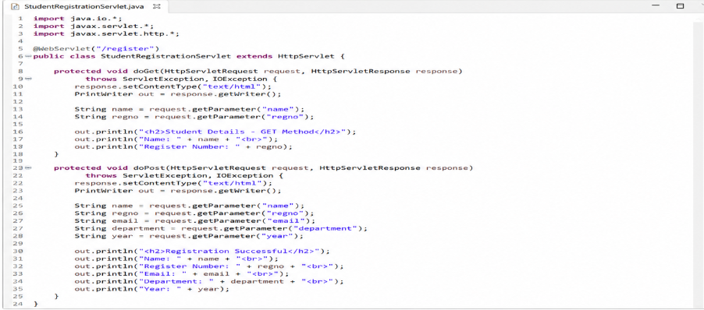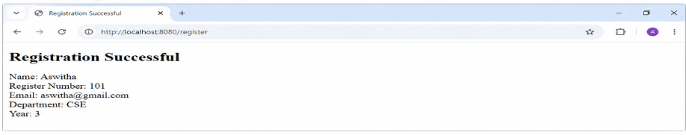
Result
The online student registration system was successfully designed using Java Servlet. The application processes student information using both GET and POST methods. The servlet life cycle and the appropriate use of POST for sensitive information were also studied.

QUESTION 2 – SESSION MANAGEMENT USING HTTPSESSION AND COOKIES
Scenario
Suppose that a website requires users to log in and maintain their session across multiple pages after authentication.

1. Aim
To design and implement a session management system using HttpSession and Cookies in Java Servlets and to understand how session tracking maintains user information across multiple web pages.

2. Introduction
HTTP is a stateless protocol, which means that each request from a user is treated as a separate request by the server.
For example, when a user logs in and then opens another page, the server needs a way to identify that the request belongs to the same user.
Session tracking is used to maintain the user's identity and information across multiple requests.
Two common techniques are:
- HttpSession
- Cookies

3. Session Management Architecture
User
↓
Login Page
↓
Login Servlet
↓
Username & Password Verification
↓
Create HttpSession
↓
Store Username in Session
↓
Access Other Pages
↓
Session ID Identifies User
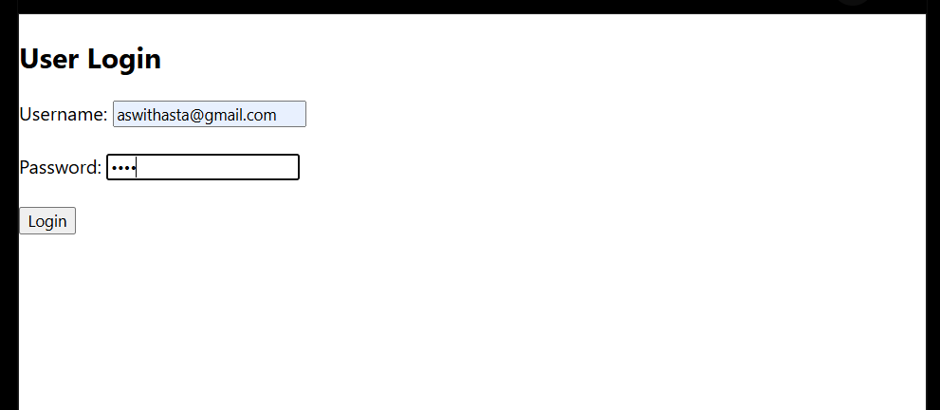
4. Explanation of HttpSession:
HttpSession is used to maintain information about a user across multiple requests.
The following statement creates a session:
HttpSession session = request.getSession();
The username can be stored in the session using:
session.setAttribute("username", username);
The stored username can later be retrieved using:
session.getAttribute("username");

5. WORKING:
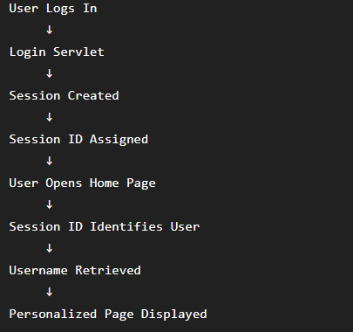

6. Session-Based Tracking vs Cookies
Feature | HttpSession | Cookies
Storage | Session information is maintained on the server | Data is stored in the browser
Security | Better for storing session information | Data is available on the client
Size | Can store more application information | Limited storage
Main Use | Login and user sessions | Preferences and user identification
Lifetime | Usually expires after timeout | Can be temporary or persistent
Server Side | Yes | No, cookie data is client-side
Example | Logged-in username | Remembering user preferences
7. Advantages of HttpSession
- Easy to implement in Servlets.
- Suitable for login authentication.
- Stores user information on the server.
- Maintains user state across multiple pages.
- Multiple attributes can be stored in a session.

8. Advantages of Cookies
- Simple to create and use.
- Stored in the user's browser.
- Can remember user preferences.
- Can identify returning users.
- Useful for storing small amounts of information.

9. Expected Output
Login Page
------------------------------
User Login
------------------------------

Username: [ admin ]

Password: [ **** ]

[ Login ]
Use:
Username: admin
Password: 1234
After Login
Login Successful

Welcome admin

Go to Home Page
Home Page
Home Page

Welcome admin

You are successfully logged in.

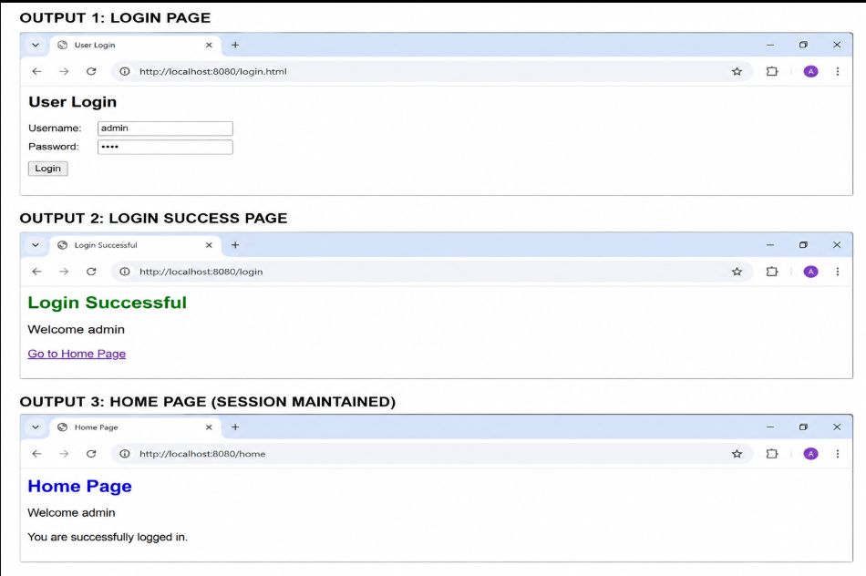

14. Result
The session management system was successfully designed using HttpSession and Cookies. The system maintains the user's login information across multiple requests and demonstrates how session tracking is implemented in Java web applications.
QUESTION 3 – JDBC-BASED PRODUCT MANAGEMENT SYSTEM
Scenario
Suppose that an e-commerce platform needs to store and retrieve product details from a database using a Java-based web application.
1. Aim
To design and implement a JDBC-based Java application that connects to a database, inserts product details, and retrieves product information using SQL queries.
2. Introduction
JDBC (Java Database Connectivity) is a Java API used to connect Java applications with databases.
In an e-commerce application, JDBC can be used to:
- Connect to the database.
- Insert product information.
- Retrieve product information.
- Execute SQL queries.
- Handle database exceptions.
3. JDBC Architecture
The JDBC architecture consists of the following components:
Java Application
↓
JDBC API
↓
DriverManager
↓
JDBC Driver
↓
Database
4.Components
1.JDBCApplication
The application sends requests to the database.
2.JDBCAPI
Provides classes and interfaces required for database connectivity.
3.DriverManager
Manages the JDBC drivers and establishes a connection.
4.JDBCDriver
Acts as a bridge between the Java application and the database.
5.Database
Stores product information.

5. Database Creation
For this example, MySQL is used.
Create Database
CREATE DATABASE ecommerce;
Select Database
USE ecommerce;
Create Product Table
CREATE TABLE product (
id INT PRIMARY KEY,
name VARCHAR(50),
price DOUBLE,
quantity INT
);
6. Sample Product Data
The following products can be stored in the database:
Product ID | Product Name | Price | Quantity
101 | Laptop | 55000 | 10
102 | Mouse | 800 | 25

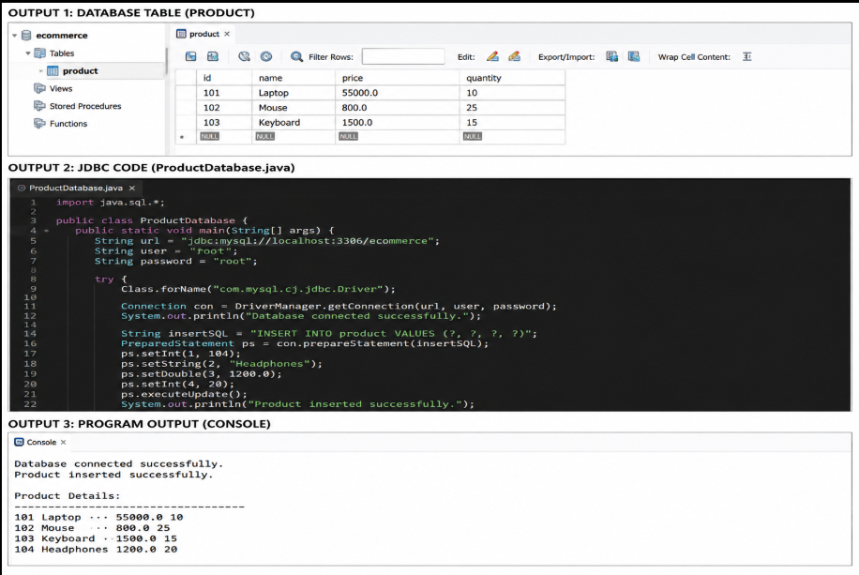
12. Result
The JDBC-based product management application was successfully designed. The application establishes a connection with the MySQL database, inserts product information using PreparedStatement, retrieves product details using SQL queries, and handles database exceptions using appropriate exception handling.

