Problem 3 – StockFlow
Working with Remote Data
For the solution of some of the following tasks, you will need to use an up-to-date version of the local REST service provided in the lesson’s resources archive. You can read the documentation here.
Environment Specifics
Please be aware that every JS environment may behave differently when executing code. Certain things that work in the browser are not supported in Node.js, which is the environment used by Judge.
The following actions are NOT supported:
- .forEach() with NodeList (returned by querySelector() and querySelectorAll())
- .forEach() with HTMLCollection (returned by getElementsByClassName() and element.children)
- using the spread-operator (...) to convert a NodeList into an array
- append() (use only appendChild())
- prepend()
- replaceWith()
- replaceAll()
- closest()
- replaceChildren()
If you want to perform these operations, you may use Array.from() to first convert the collection into an array.

Requirements
Write a JS program that can load, create, remove and edit a list of stock orders. You will be given an HTML template to which you must bind the needed functionality.
First, you need to install all dependencies using the npm install command
Then, you can start the front-end application with the npm start command
You also must start the server.js file in the server folder using the node server.js command in another console (BOTH THE CLIENT AND THE SERVER MUST RUN AT THE SAME TIME).
At any point, you can open up another console and run npm test to test the current state of your application. It’s preferable for all of your tests to pass locally before you submit to the Judge platform, like this:
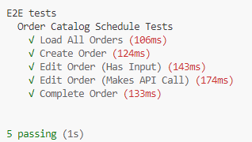

Endpoints
- http://localhost:3030/jsonstore/orders/
- http://localhost:3030/jsonstore/orders/:id

Load All Orders
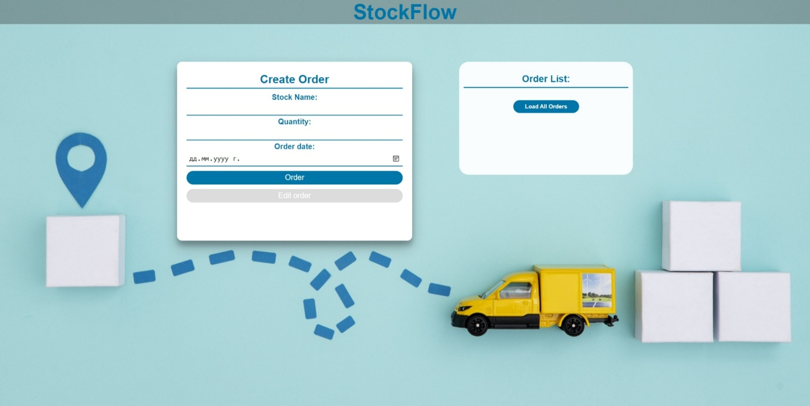
Clicking the [Load All Orders] button should send a GET request to the server to fetch all stock orders from your local database. You must add each task to the <div> with id="list". [Edit order] button should be deactivated.
Each order has the following HTML structure:

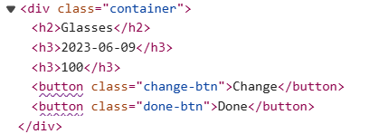

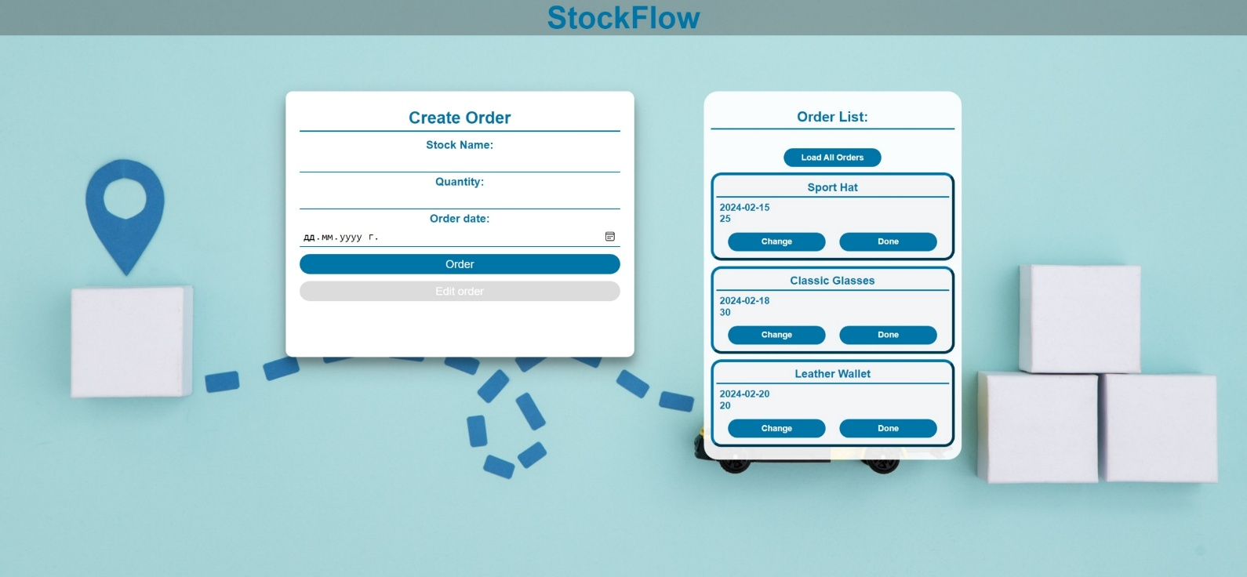

Create an Order
Clicking the [Order] button should send a POST request to the server, creating a new stock order with the stock name, quantity, and order date from the input values. After a successful creation, you should send another GET request to fetch all the stock orders, including the newly created into the Order List column. You should also clear all the input fields after the creation!
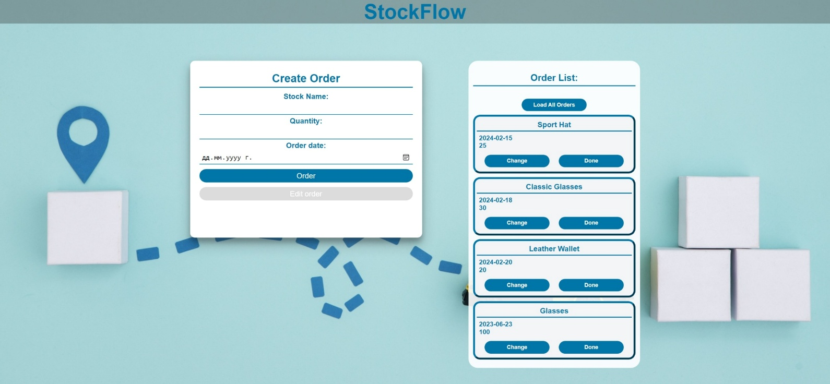

Edit an Order
Clicking the [Change] button on a record should remove the record from the DOM structure and the information about the task should be populated into the input fields above. The [Edit order] button in the form should be activated and the [Order] one should be deactivated.
After clicking the [Edit order] button in the form, you should send a PUT request to the server to modify the stock name, quantity and the date of the changed order. After the successful request, you should fetch the orders again and see that the changes have been made. After that, the [Edit order] button should be deactivated and the [Order] one should be activated.
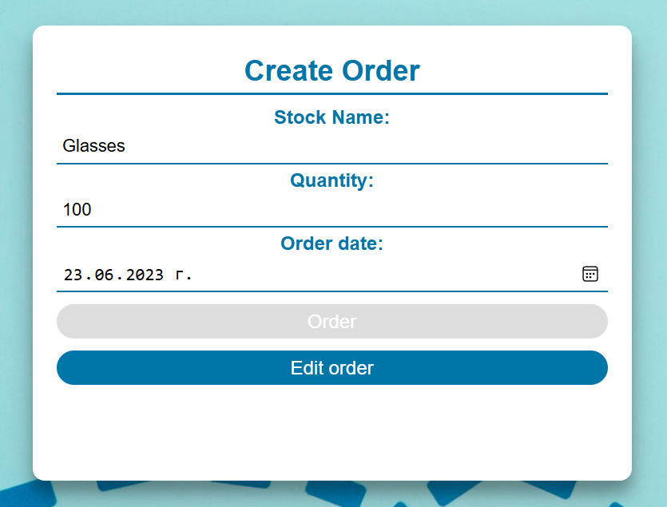

Mark as Done
Clicking the [Done] button should send a DELETE request to the server and remove the order from your local database. After you've removed it successfully, fetch the items again.

Submitting Your Solution
Select the content of your working folder (the given resources). Exclude the node_modules & tests folders. Archive the rest into a ZIP file and upload the archive to Judge.
