2. Adopt Me
Environment Specifics
Please be aware that every JS environment may behave differently when executing code. Certain things that work in the browser are not supported in Node.js, which is the environment used by Judge.
The following actions are NOT supported:
- .forEach() with NodeList (returned by querySelector() and querySelectorAll())
- .forEach() with HTMLCollection (returned by getElementsByClassName() and element.children)
- using the spread-operator (...) to convert a NodeList into an array
- append() (use only appendChild())
- prepend()
- replaceWith()
- replaceAll()
- closest()
- replaceChildren()
If you want to perform these operations, you may use Array.from() to first convert the collection into an array.
Use the provided skeleton to solve this problem.
Note: You can't and you have no permission to change directly the given HTML code (index.html file).

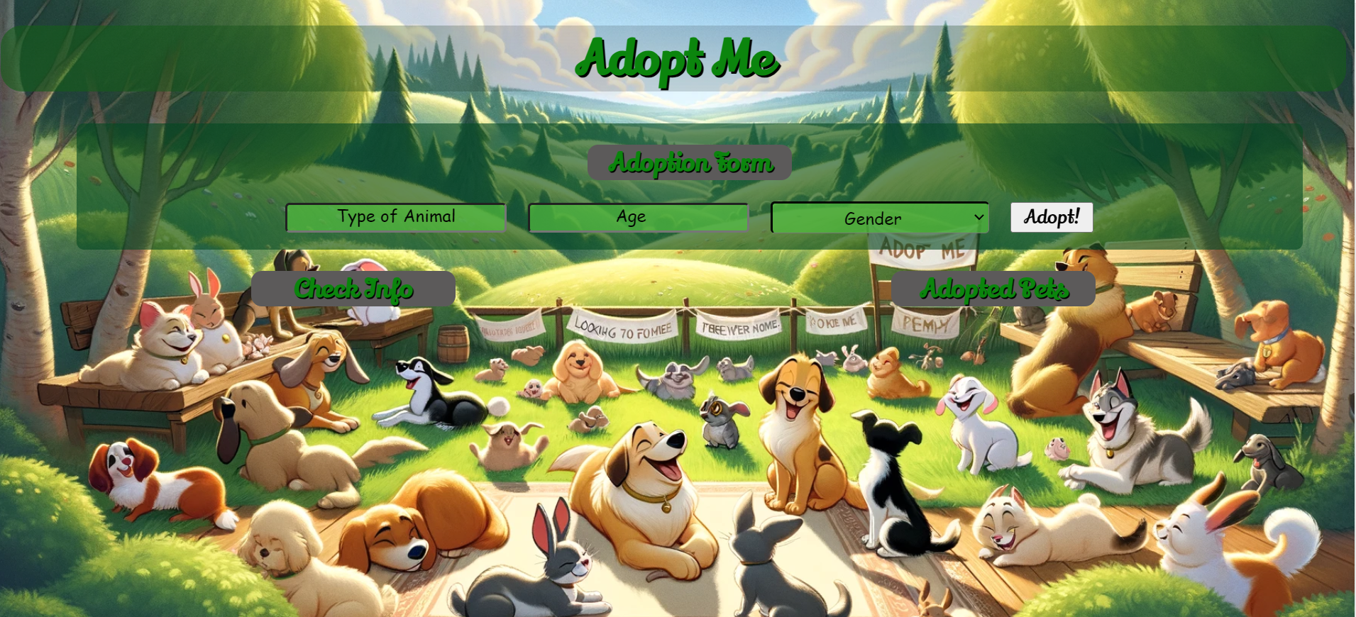

Your Task
Write the missing JavaScript code to make the Adopt Me application work as expected:
  - Type Of Animal, Age, and Gender should be non-empty strings. If any of them are empty, the program should not do anything.

1.Getting the information from the form

When you click the [Adopt!] button, the information from the input fields must be added to the <ul> with the id "adoption-info"and the input fields should be cleared.
The HTML structure should look like this:
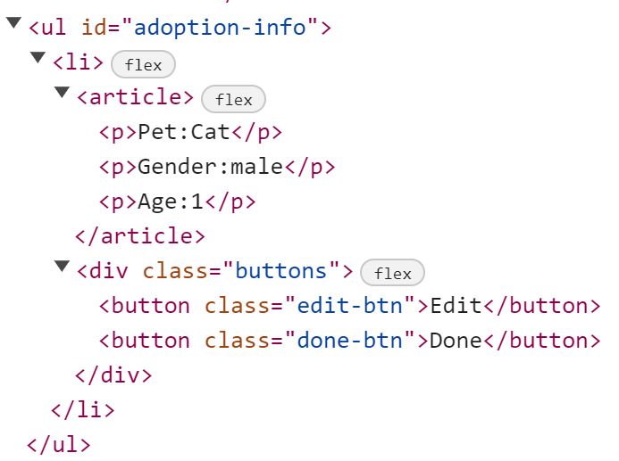
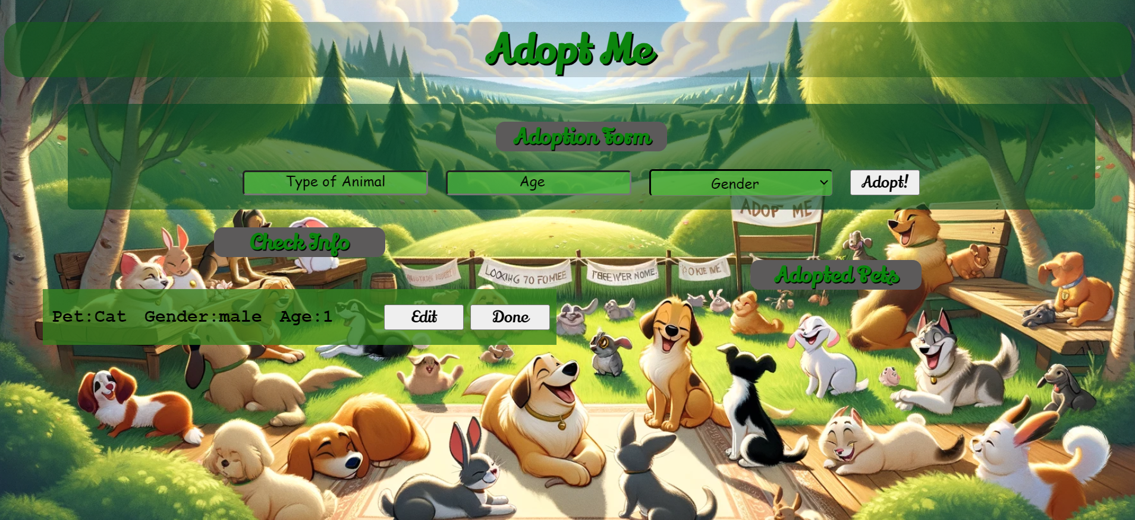

2.Edit Info
When the [Edit] button is clicked, the information from the check info must be sent to the input fields and the record should be deleted from the <ul> "adoption-info".
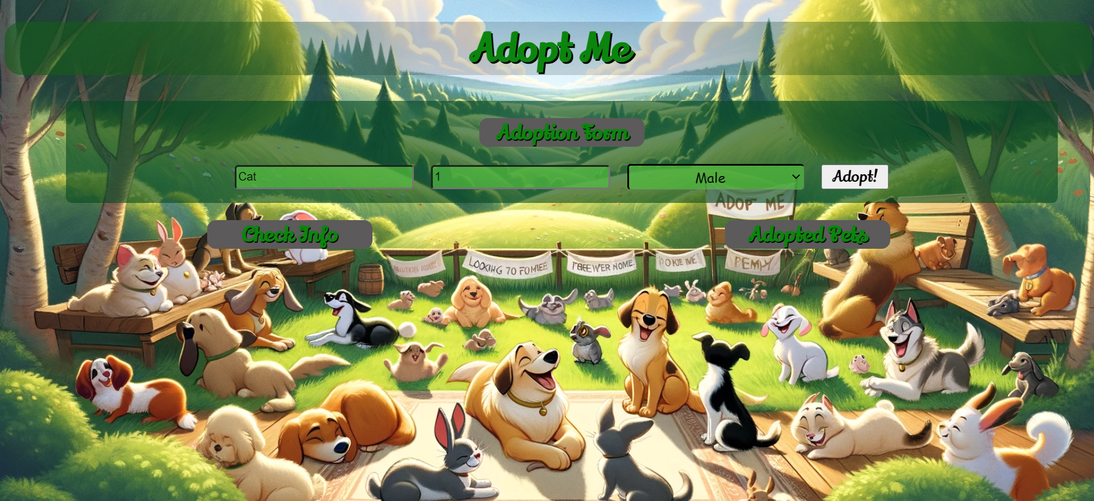
After editing the information, add a new item to the <ul> with the updated information.
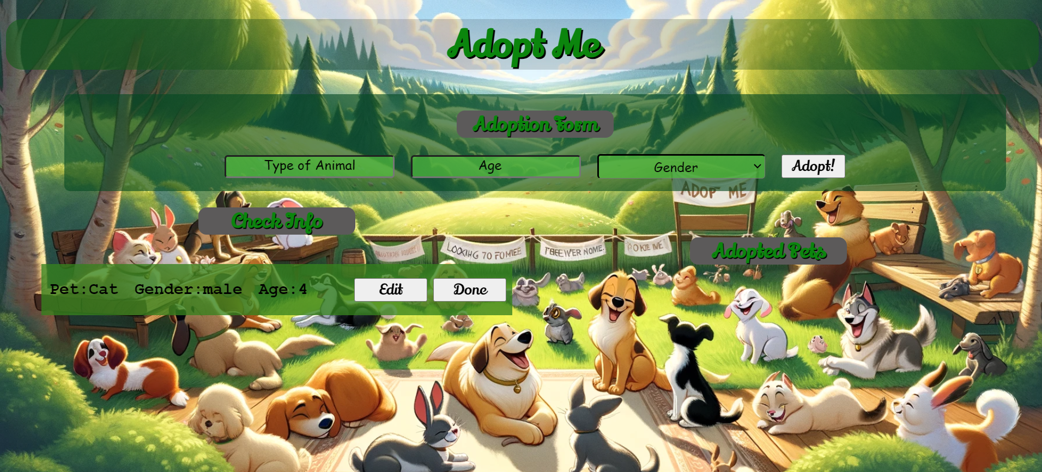

3.Finish Adoption
When you click the [Done] button, the task must be deleted from the <ul> with id "adoption-info" and appended to the <ul> with id "adopted-list".
The buttons [Edit] and [Done] should be removed from the <li> element and the button [Clear] shoud be added.
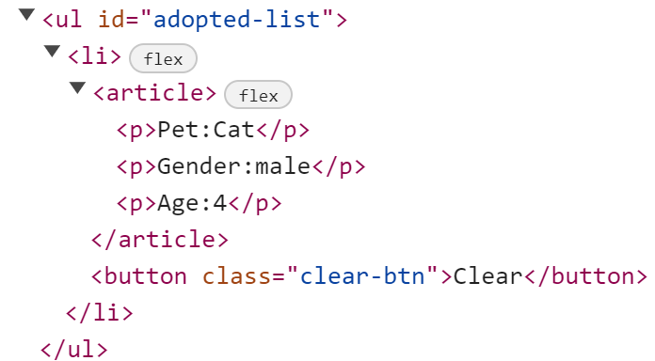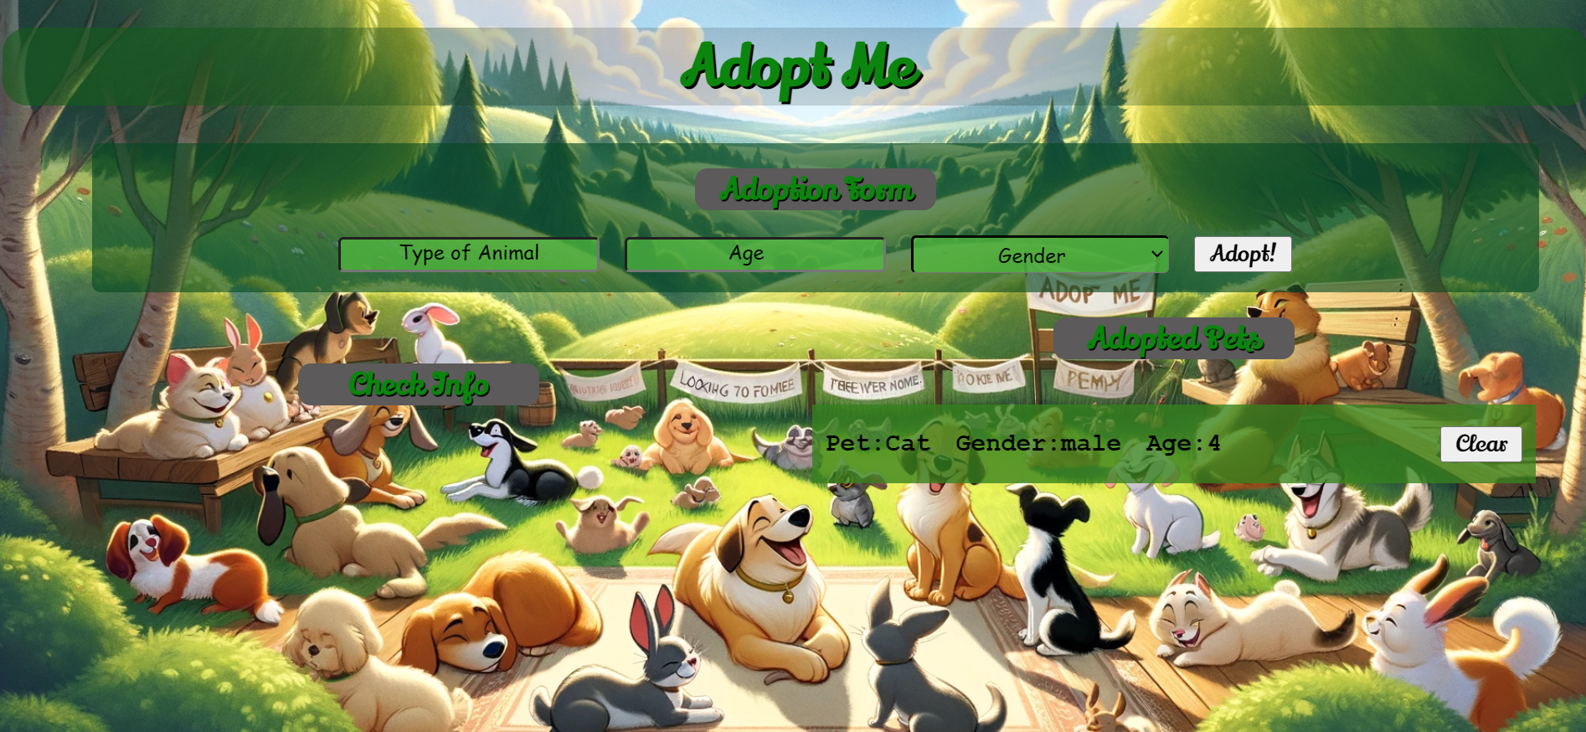

4.Clear List
When you click the [Clear] button, the task must be deleted from the <ul> with id "adopted-list" .


Submission
Submit only your solve() function.

