Problem 3 – Sprint Board
Working with Remote Data
For the solution of some of the following tasks, you will need to use an up-to-date version of the local REST service provided in the lesson’s resources archive. You can read the documentation here.
Environment Specifics
Please be aware that every JS environment may behave differently when executing code. Certain things that work in the browser are not supported in Node.js, which is the environment used by Judge.
The following actions are NOT supported:
- .forEach() with NodeList (returned by querySelector() and querySelectorAll())
- .forEach() with HTMLCollection (returned by getElementsByClassName() and element.children)
- using the spread-operator (...) to convert a NodeList into an array
- append() (use only appendChild())
- prepend()
- replaceWith()
- replaceAll()
- closest()
- replaceChildren()
If you want to perform these operations, you may use Array.from() to first convert the collection into an array.

Requirements
Write a JS program that can load, create, remove, and edit a list of tasks. You will be given an HTML template to which you must bind the needed functionality.
First, you need to install all dependencies using the npm install command.
Then, you can start the front-end application with the npm start command.
You also must start the server.js file in the server folder using the node server.js command in another console (BOTH THE CLIENT AND THE SERVER MUST RUN AT THE SAME TIME).
At any point, you can open up another console and run npm test to test the current state of your application. It’s preferable for all of your tests to pass locally before you submit to the Judge platform, like this:
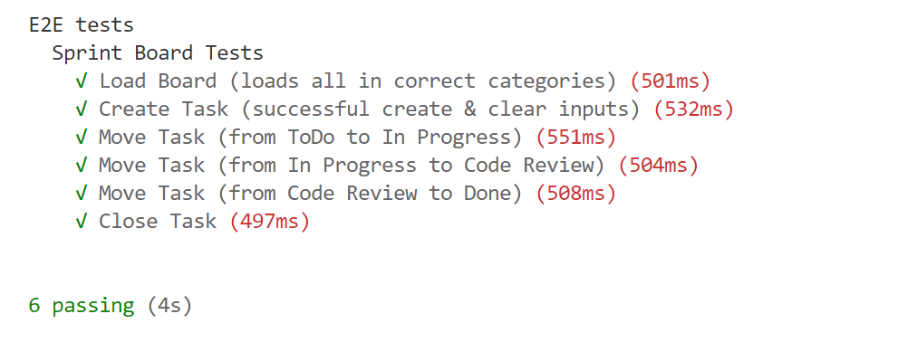

Endpoints
- http://localhost:3030/jsonstore/tasks/
- http://localhost:3030/jsonstore/tasks/:id

Load the Board
Clicking the [Load Board] button on the top left should send a GET request to the server to fetch all sprint tasks in your local database. You have to add each task to its specified column list (ToDo, In Progress, Code Review, or Done). The tasks should have different text contents inside their respective buttons depending on which column they are in:
- ToDo – “Move to In Progress”
- In Progress – “Move to Code Review”
- Code Review – “Move to Done”
- Done – “Close”
Each Sprint task has the following HTML structure:
<li class="task">
<h3>Fix Bug</h3>
<p>We have a new bug to fix</p>
<button>Move to In Progress/Move to Code Review/Move to Done/Close</button>
</li>
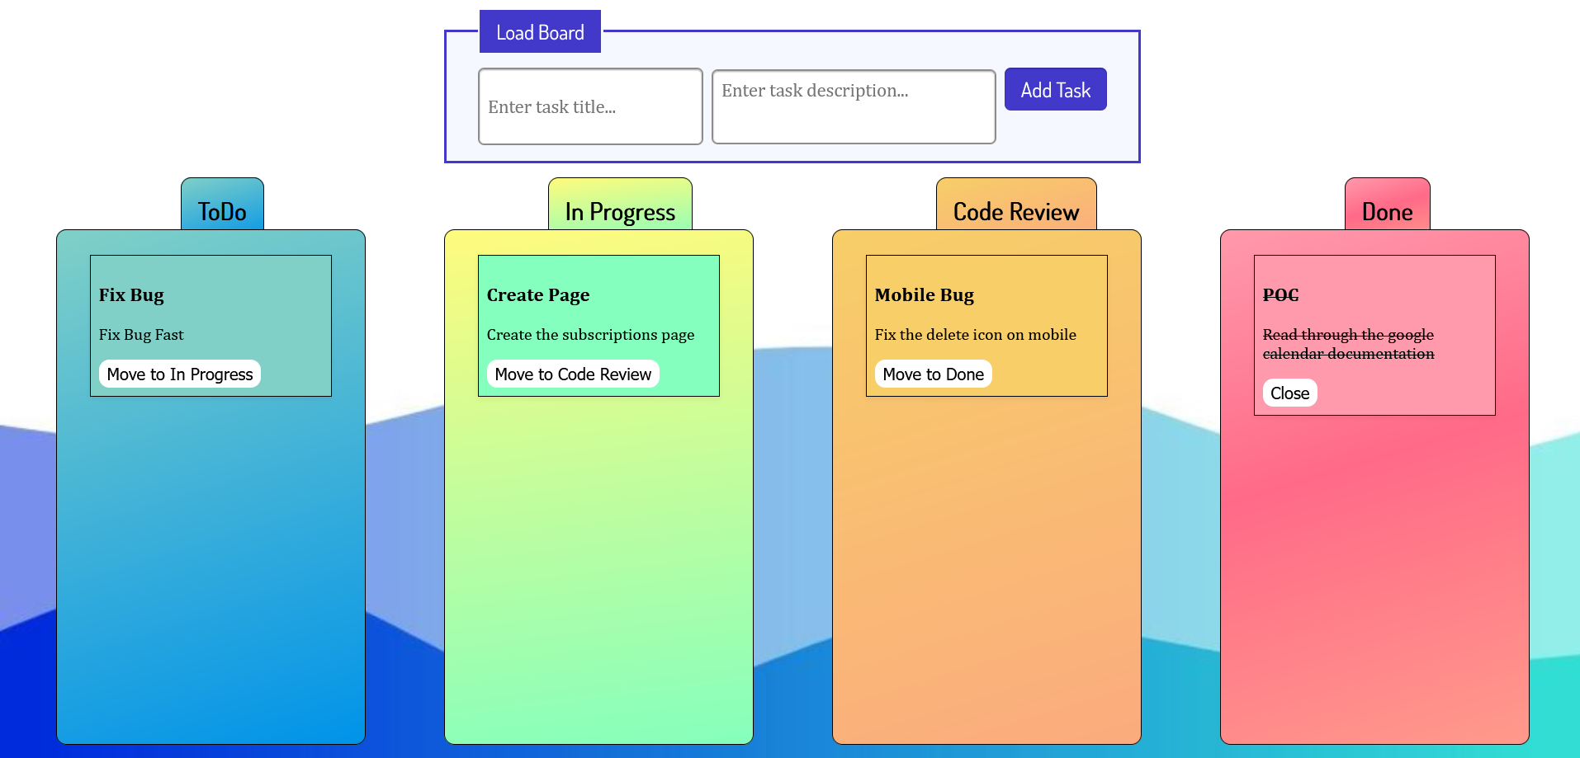

Add a Task
Clicking the [Add Task] button should send a POST request to the server creating a new task with a title and description from the input values (the status should have an initial value of 'ToDo'). After a successful creation, you should send another GET request to fetch all the tasks, including the newly added one into the ToDo column. You should also clear all input fields after the creation!
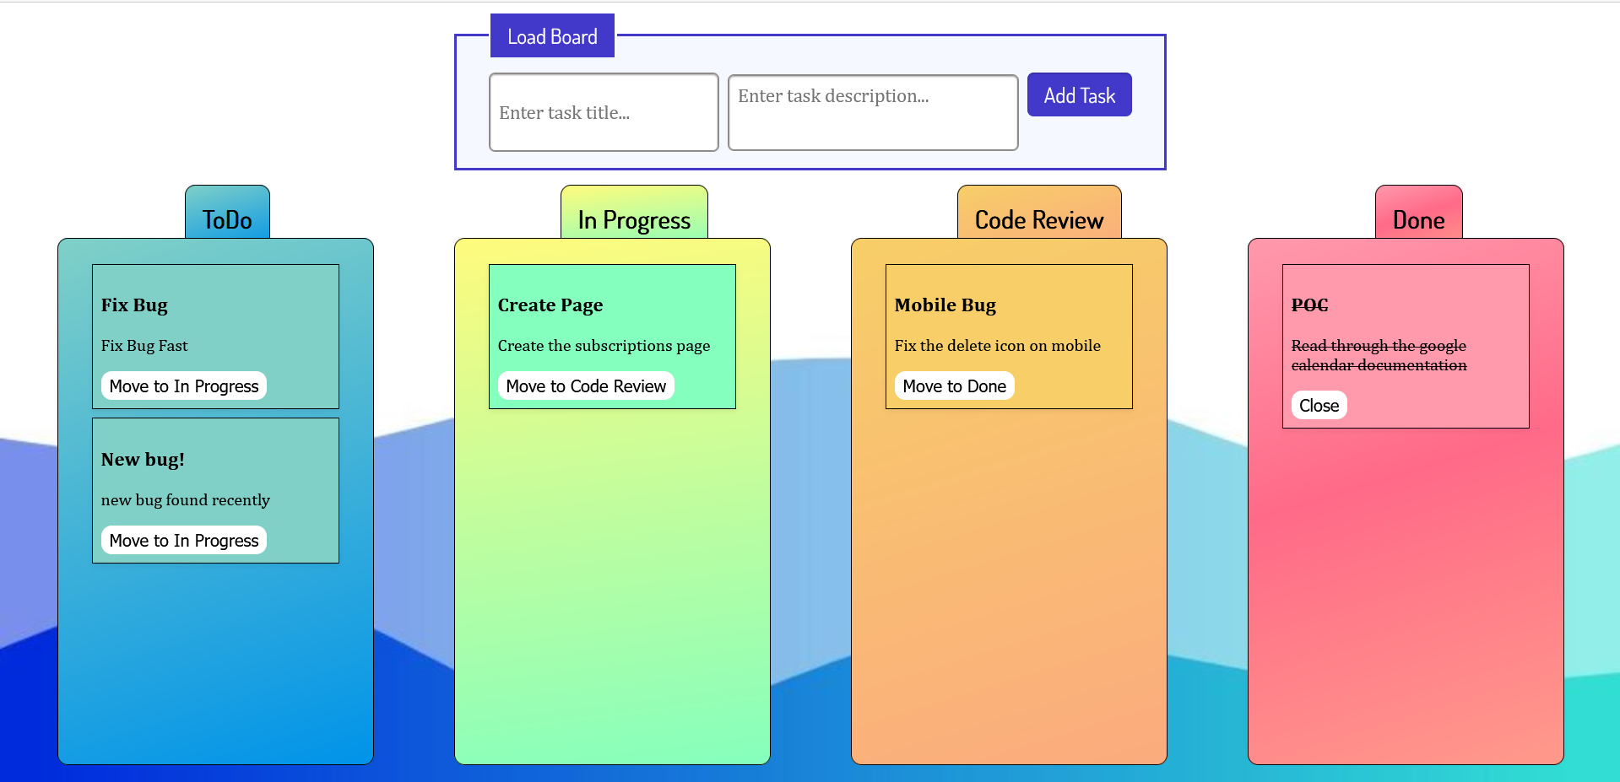

Move a Task
Clicking the [Move] button on the individual tasks from the first 3 columns should move the task from one column to the next – from ToDo to In Progress to Code Review and finally to Done.
After clicking the [Move] button, you should send a PATCH request to the server to modify the status of the changed item. After the successful request, you should fetch the items again and see that the change has been made.

Close a Task
Clicking the [Close] button on the tasks in the Done section should send a DELETE request to the server and remove the item from your local database. After you’ve removed it successfully, fetch the items again.
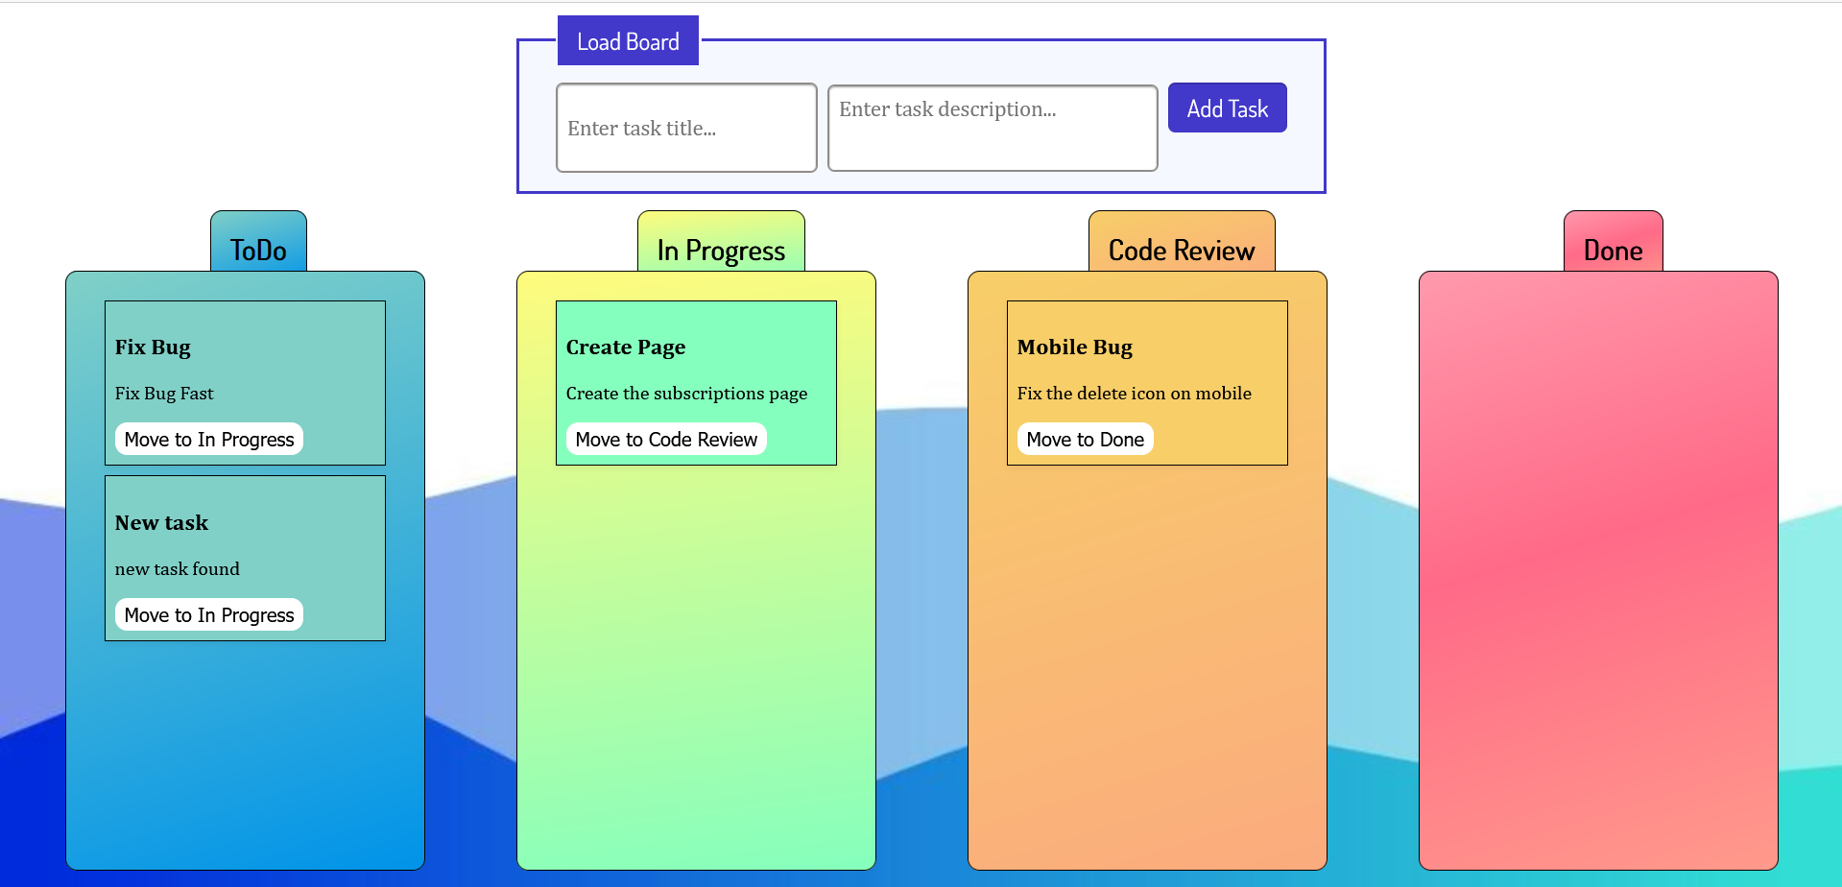

Submitting Your Solution
Select the content of your working folder (the given resources). Exclude the node_modules & tests folders. Archive the rest into a ZIP file and upload the archive to Judge.
