Exercise: HTTP and AJAX
Submit your solutions in the SoftUni judge system at:
https://alpha.judge.softuni.org/contests/http-and-ajax-exercise/3799
Working with Remote Data
For the solution of some of the following tasks, you will need to use an up-to-date version of the local REST service, provided in the lesson’s resources archive. You can read the documentation here.

Requirements
For each task, you need to install all dependencies using the "npm install" command.
Then you can start the front-end application with the “npm start” command
You also must also start the server.js file in the server folder using the “node server.js” command in another console (BOTH THE CLIENT AND THE SERVER MUST RUN AT THE SAME TIME)
At any point, you can open up another console and run "npm test" inside the tests subfolder for the problem to test the current state of your application, it’s preferable for all of your tests to pass locally before you submit them to the judge platform, like this:
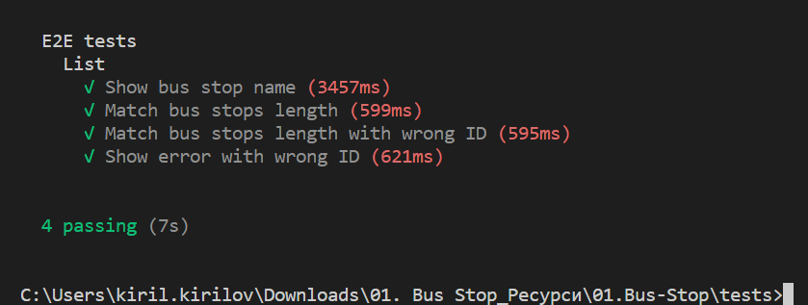

Blog
Write a program for reading blog content. It needs to make requests to the server and display all blog posts and their comments.
Request URL’s:
Posts - http://localhost:3030/jsonstore/blog/posts
Comments - http://localhost:3030/jsonstore/blog/comments
The button with ID "btnLoadPosts" should make a GET request to "/posts". The response from the server will be an Object of objects.
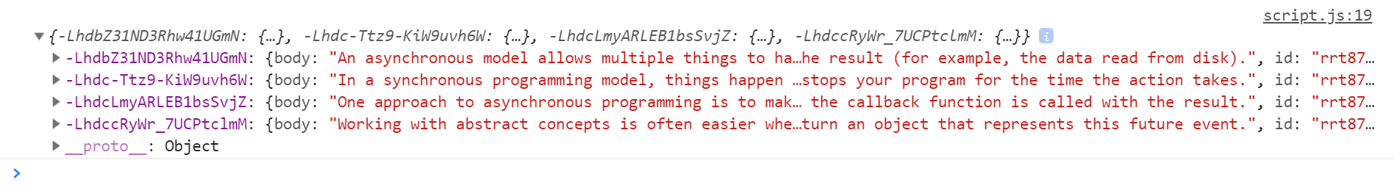
Each object will be in the following format:
{
body: {postBody},
id: {postId},
title: {postTitle}
}
Create an <option> for each post using its object key as value and current object title property as text inside the node with ID "posts".
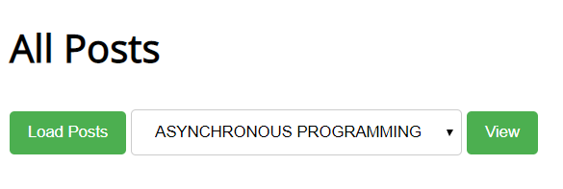
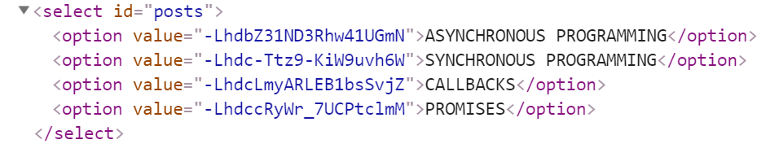
When the button with ID "btnViewPost" is clicked, a GET request should be made to:
- "/posts" to retrieve all available posts and find the selected post from the dropdown menu. This request returns an object where each key represents a post ID, and each value contains post details (title, body and id).
- "/comments" to retrieve all comments. This request returns an object of objects, where each comment includes a postId field. The response is then filtered to include only comments that match the selected post's ID.
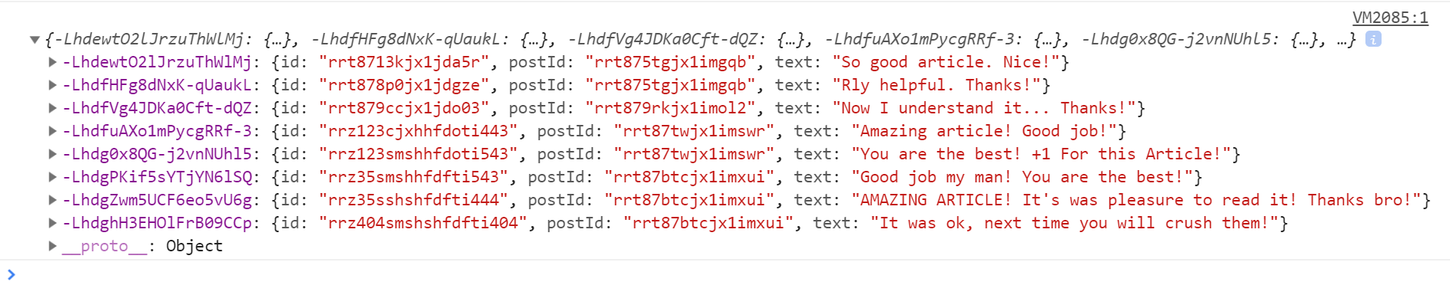
Each object will be in the following format:
{
id: {commentId},
postId: {postId},
text: {commentText}
}
You have to find this comments that are for the current post (check the postId property)
Display the post title inside h1 with ID "post-title" and the post content inside p with ID "post-body". Display each comment as a <li> inside ul with ID "post-comments". Do not forget to clear its content beforehand.
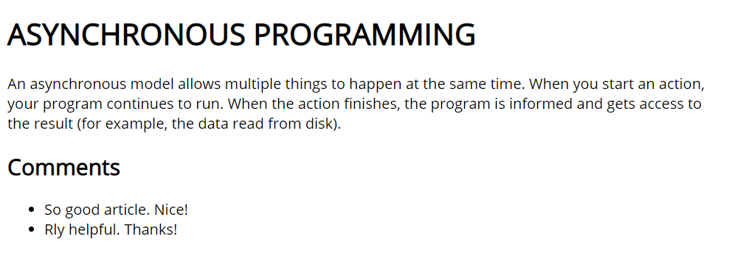
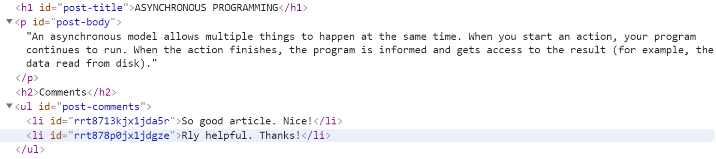

Submitting Your Solution
Place in a ZIP file the content of the given resources including your solution. Exclude the node_modules folder if there is one. Upload the archive to Judge.
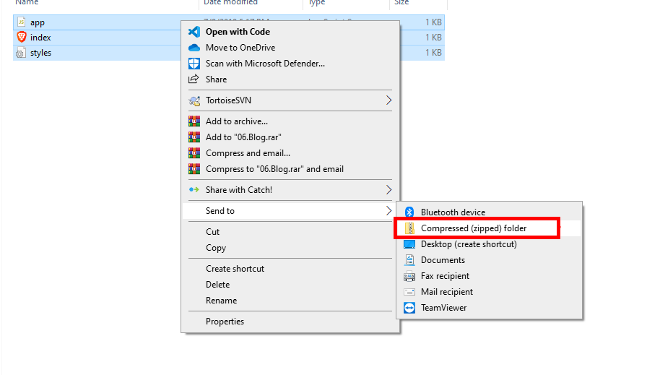
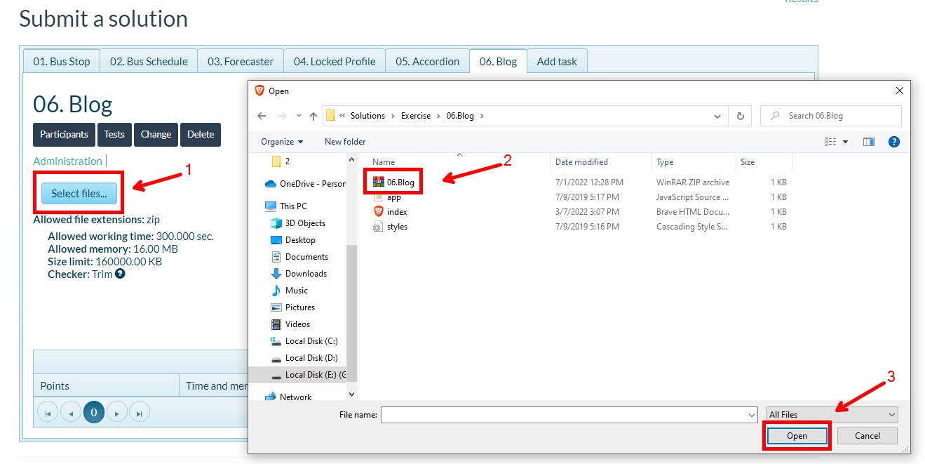
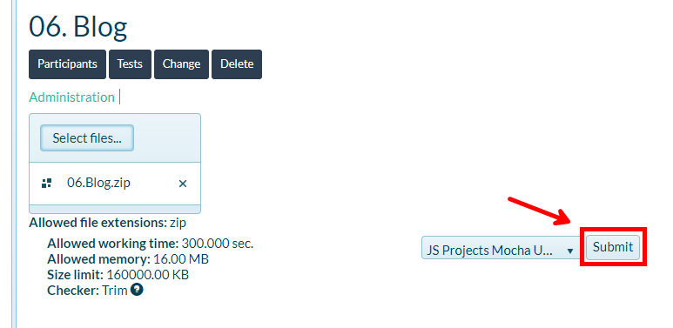

Messenger
Write a JS program that records and displays messages. The user can post a message, supplying a name and content and retrieve all currently recorded messages.
The url for the requests - http://localhost:3030/jsonstore/messenger
When [Send] button is clicked you should create a new object and send a post request to the given url. Use the following message structure:
{
author: authorName,
content: msgText,
}
If you click over [Refresh] button you should get all messages with GET request and display them into the textarea. Use the following message format:
"{author}: {message}"

Examples
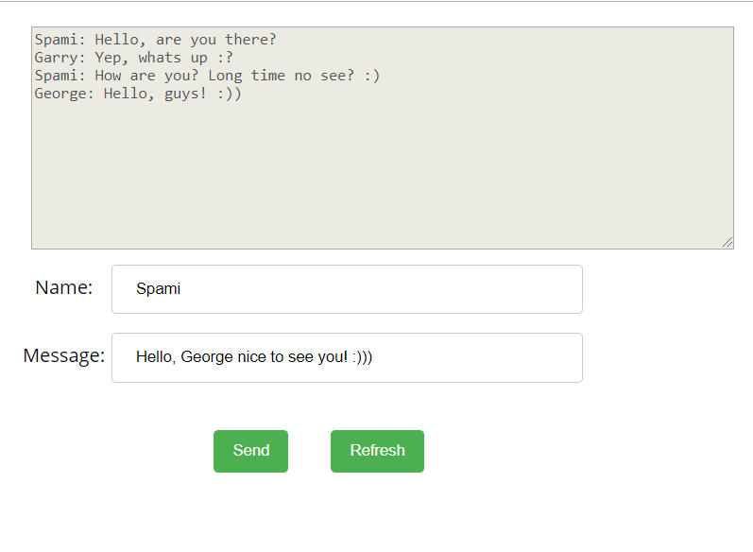
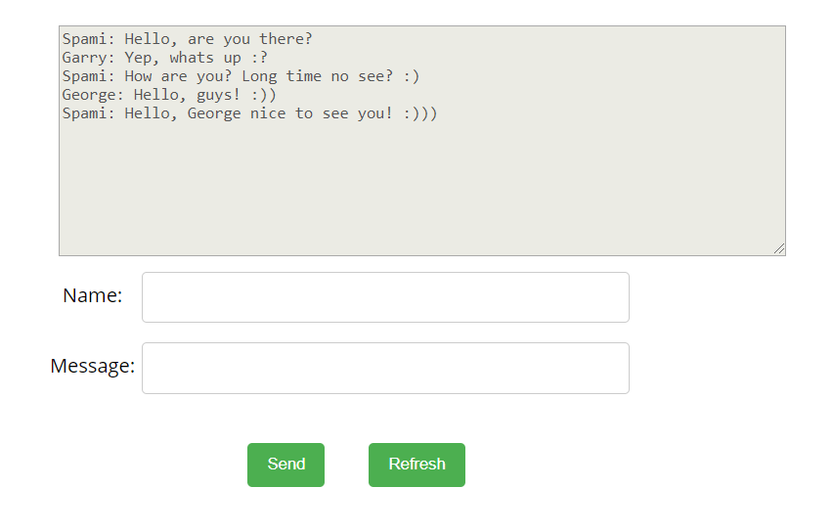

Phonebook

Write a JS program that can load, create and delete entries from a Phonebook. You will be given an HTML template to which you must bind the needed functionality.
When the [Load] button is clicked, a GET request should be made to the server to get all phonebook entries. Each received entry should be in a li inside the ul with id="phonebook" in the following format with text "<person>: <phone> " and a [Delete] button attached. Pressing the [Delete] button should send a DELETE request to the server and delete the entry. The received response will be an object in the following format:
{<key>:{person:<person>, phone:<phone>}, <key2>:{person:<person2>, phone:<phone2>,…} where <key> is an unique key given by the server and <person> and <phone> are the actual values.
When the [Create] button is clicked, a new POST request should be made to the server with the information from the Person and Phone textboxes, the Person and Phone textboxes should be cleared and the Phonebook should be automatically reloaded (like if the [Load] button was pressed).
The data sent on a POST request should be a valid JSON object, containing properties person and phone. Example format:
{
"person": "<person>",
"phone": "<phone>"
}
The url to which your program should make requests is:
http://localhost:3030/jsonstore/phonebook
- GET and POST requests should go to http://localhost:3030/jsonstore/phonebook, while
- DELETE requests should go to http://localhost:3030/jsonstore/phonebook/:key> , where :key is the unique key of the entry (you can find out the key from the key property in the GET request)

Screenshots:
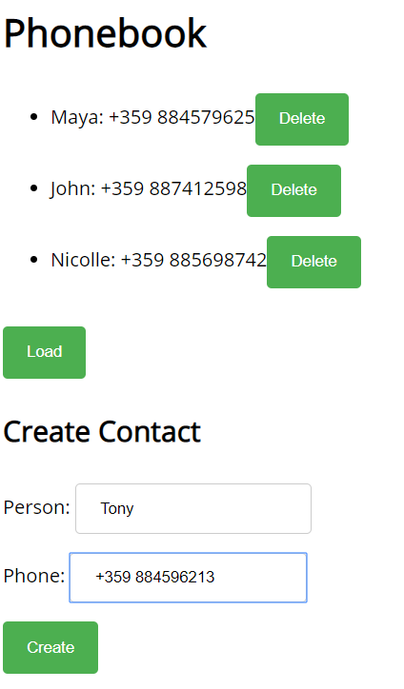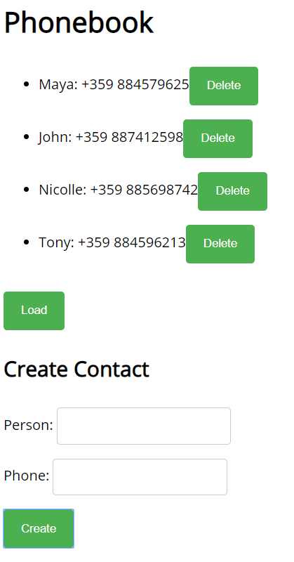

Students
Your task is to implement functionality for creating and listing students from a database. Create a new collection called "students",
Each student has:
- firstName - string, non-empty
- lastName - string, non-empty
- facultyNumber - string of numbers, non-empty
- grade - number, non-empty
You need to write functionality for creating students. When creating a new student, make sure you name the properties accordingly.
You will also need to extract students. You will be given an HTML template with a table in it. Create an AJAX request that extracts all the students.
URL for this task: http://localhost:3030/jsonstore/collections/students

Screenshots
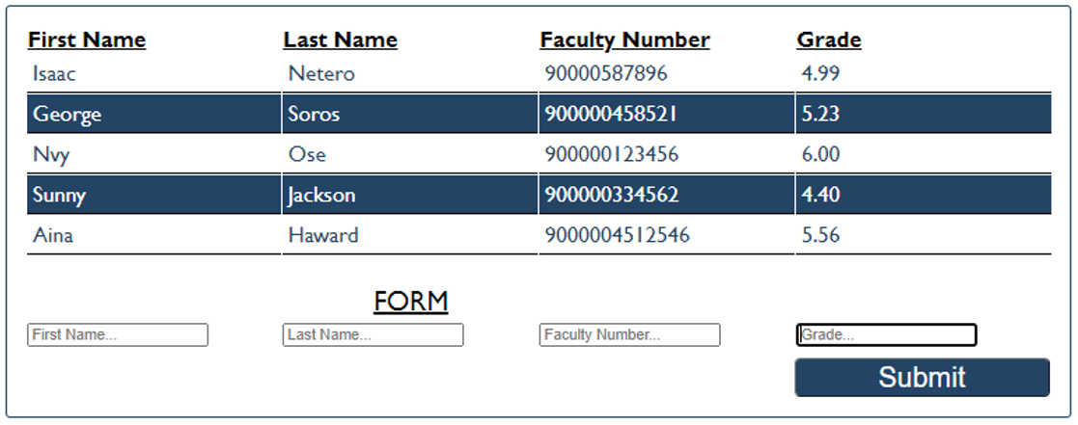

Locked Profile
In this problem, you must create a JS program which shows and hides the additional information about users, which you can find by making a GET request to the server at address:
http://localhost:3030/jsonstore/advanced/profiles
The response will be an object with the information for all users. Create a profile card for every user and display it on the web page. Every item should have the following structure:
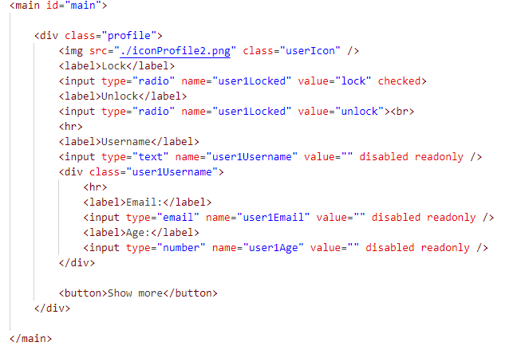
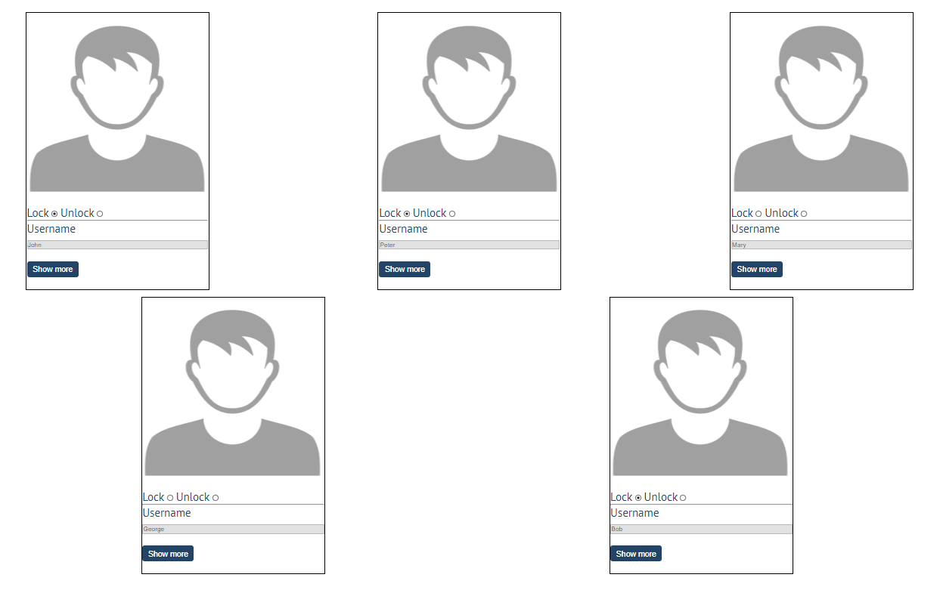
When one of the [Show more] buttons is clicked, the hiden information inside the div should be shown, only if the profile is not locked! If the current profile is locked, nothing should happen.
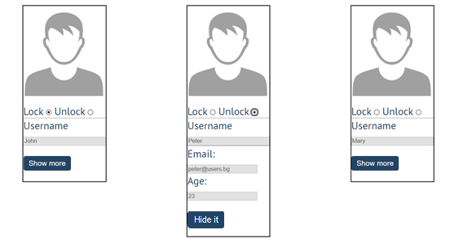
If the hidden information is displayed and we lock the profile again, the [Hide it] button should not be working! Otherwise, when the profile is unlocked and we click on the [Hide it] button, the new fields must hide again.

Accordion

An html file is given and your task is to show more/less information for the selected article. At the start you should do a GET request to the server at adress: http://localhost:3030/jsonstore/advanced/articles/list where the response will be an object with the titles of the articles.
By clicking the [More] button for the selected article, it should reveal the content of a hidden div and changes the text of the button to [Less]. Obtain the content by making a GET request to the server at adress: http://localhost:3030/jsonstore/advanced/articles/details/:id where the response will be an object with property id, title, content. When the same button is clicked again (now reading Less), hide the div and change the text of the button to More. Link action should be toggleable (you should be able to click the button infinite amount of times).
Example 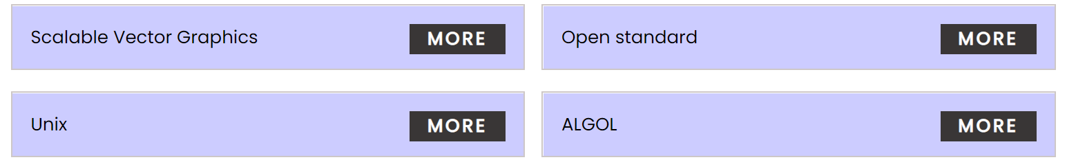
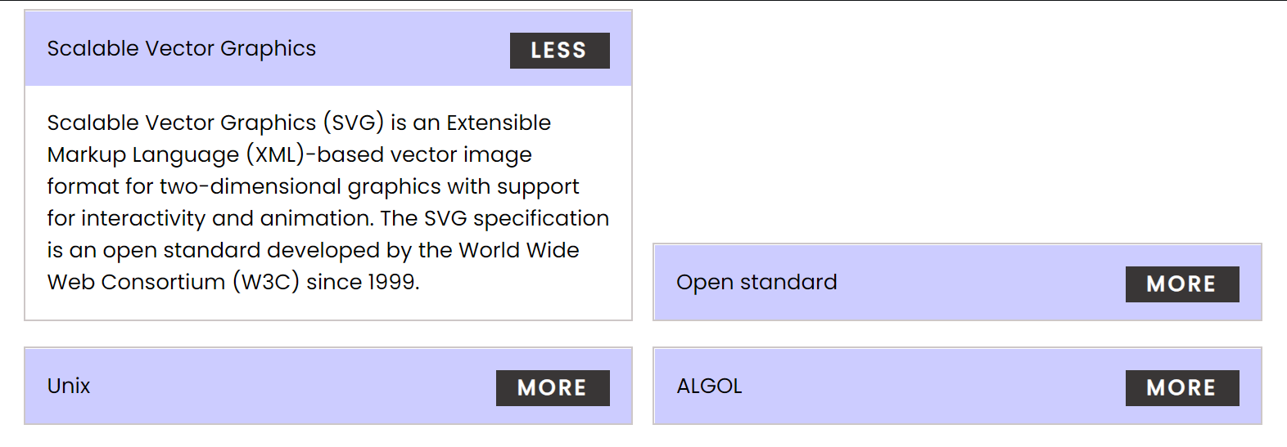
Every item should have the following structure:
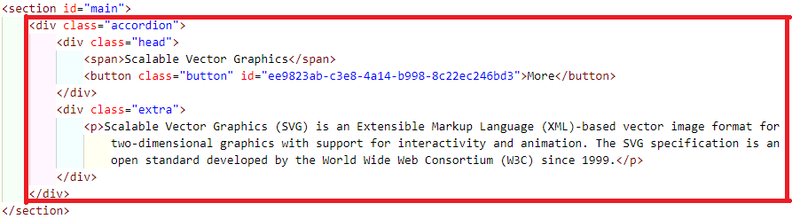
You are allowed to add new attributes, but do not change the existing ones.

