Lecture Plus Database Design
ICT Assignment 3
Project | Lecture Plus web service
Team | Askat, Merei, Asyl and Zangarbek
Database | Supabase PostgreSQL with 12 application tables
Date | 12 October 2026

Project purpose
Lecture Plus is a web service for students. A student can record a lecture, upload a file or paste notes. The service creates a transcript, a clear explanation, possible future topics, a quiz, tasks and reminders. The database keeps these parts connected. It also lets a signed-in student open private history on another device.
The main result is a database model with twelve application tables. Supabase Auth stores login data in an external system table. Row Level Security protects each student's records. A public demonstration page shows only the database structure and fixed examples.

How the system works
- Input: lecture audio, a document or written notes.
- Process: AI creates structured learning information.
- Storage: PostgreSQL saves connected rows with primary and foreign keys.
- Output: the student opens analysis, quiz progress, tasks and reminders in Profile.

Entity relationship diagram
The diagram shows how the twelve tables connect. PK means primary key. FK means foreign key.
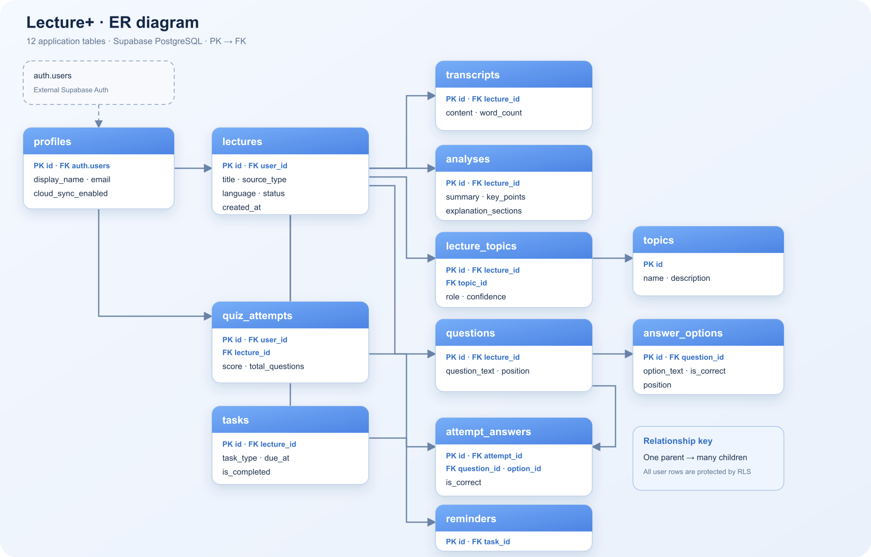
Figure 1 Lecture Plus ER diagram

Editable diagram and live model
Editable DBML source: lecture-plus-ict.vercel.app/lecture-plus.dbml
Public database page: lecture-plus-ict.vercel.app/database.html
The DBML file can be imported into dbdiagram.io and edited without changing the real student database.

Main relationships
- One profile can own many lectures and quiz attempts.
- One lecture has one transcript and one analysis.
- Lectures and topics have a many-to-many relationship through lecture_topics.
- One question has many answer options.
- One quiz attempt has many selected answers.
- One task can have many reminders.

Data dictionary
Each table has one clear job. The table below gives the purpose and the most important keys.
No | Table | Purpose | Main keys
1 | profiles | Student profile and cloud sync choice | PK id, FK auth.users
2 | lectures | One uploaded or recorded lecture | PK id, FK user_id
3 | transcripts | Extracted lecture text | PK id, FK lecture_id
4 | analyses | AI summary and explanation sections | PK id, FK lecture_id
5 | topics | Reusable current and future topic names | PK id
6 | lecture_topics | Links a lecture to a topic and role | FK lecture_id, FK topic_id
7 | questions | Quiz questions for one lecture | PK id, FK lecture_id
8 | answer_options | Possible and correct answers | PK id, FK question_id
9 | quiz_attempts | One student's score for one lecture | FK user_id, FK lecture_id
10 | attempt_answers | The option selected for each question | FK attempt_id, question_id, option_id
11 | tasks | Teacher work or optional AI practice | PK id, FK lecture_id
12 | reminders | A reminder connected to a task | PK id, FK task_id

Why twelve tables are useful
The model does not put all information into one large table. This reduces repeated data and makes each relationship clear. For example, one lecture can have many questions, but each question can also have many answer options. Separate tables keep this logic simple.

Business rules
- One authenticated user has one profile.
- One profile can own many lectures and quiz attempts.
- One lecture has at most one transcript and one analysis.
- A lecture can have current topics and predicted future topics.
- Each quiz question has two or more options and one correct option.
- One quiz attempt belongs to one student and one lecture.
- Teacher tasks and AI practice tasks use different task types.
- A task can have many reminders.
- Deleting a lecture also deletes its dependent learning data.
- A student can read and change only their own rows.

Scenario verification
Scenario: Askat uploads an operating systems lecture. The service saves the lecture, its learning guide, a quiz and a task. The expected rows show that every part has a valid parent.
Table group | Rows | Example
lectures | 1 | Operating Systems
transcripts and analyses | 2 | Lecture text and study guide
topics and lecture_topics | 6 | Kernel, Processes and Networks
questions and answer_options | 10 | Two questions with four options each
quiz_attempts and attempt_answers | 3 | One attempt and two answers
tasks and reminders | 3 | Worksheet, practice task and reminder
Verification result: the real Supabase database created all twelve tables. Tests saved and loaded a lecture, checked a quiz, blocked another user from reading it, and removed the test data. Supabase Advisors reported no issues.

Security and privacy
Students can use the AI tools without an account. Cloud saving starts only after sign-in and the student turns on private sync. The browser uses a public Supabase publishable key. It cannot bypass database rules. Secret keys stay in Vercel environment variables.
- Row Level Security checks the signed-in user ID.
- A student cannot read or delete another student's lectures.
- The public database page uses fixed examples and a safe status function.
- The public page never shows emails, transcripts or real student rows.
- Audio is sent to Groq for analysis but is not stored by Lecture Plus.

Team contribution
Team member | Contribution
Askat | System architecture, database logic and integration
Merei | Business rules and table descriptions
Asyl | ER diagram and relationship checking
Zangarbek | Scenario verification and document layout
All members | Final review and presentation preparation

Conclusion
The database supports the complete Lecture Plus learning flow. It keeps the lecture, analysis, future topics, quiz, tasks and reminders connected. The model is easy to explain, protects student data and can grow with the web service.

