**TECHNICAL DOCUMENTATION**

Members:

* Muhammad Diandra Adzka Surya(202410370110024)
* Farrel Anizar Razzani(202410370110165)
* Shetma Ikmal Zakka(202410370110185)

1. System Architecture

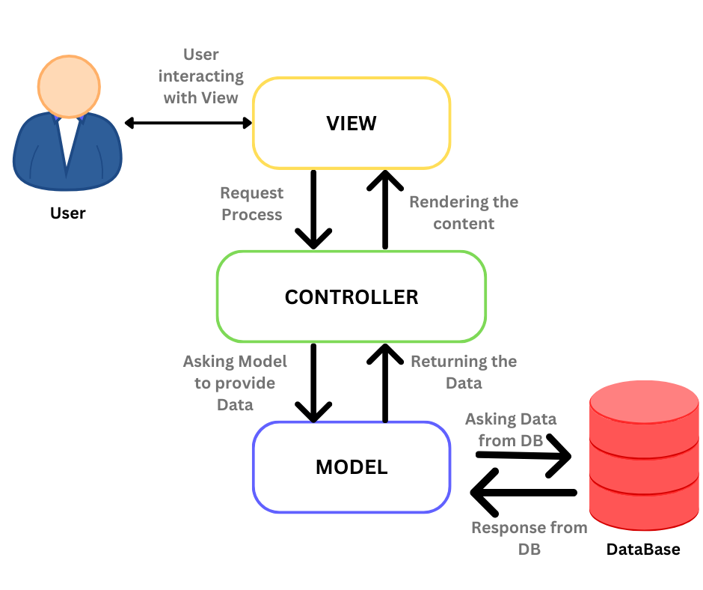

This system is designed using the Model-View-Controller (MVC) pattern adapted to the JavaFX approach. In this project, the Model component consists of data classes such as User, which serves as a superclass/parent class to its child classes Student and Admin, as well as classes like Book and Connection that handle reading CSV files used as the database. These classes provide data to be processed by other parts of the system.

The View component consists of Java classes that build the GUI for each page, such as the login, register, student dashboard, and admin dashboard interfaces, by directly arranging GUI elements and layouts like labels, text fields, buttons, and so on. This View layer also contains interaction logic, such as input validation, deleting, and editing users or books.

The Controller is responsible for managing the flow between pages/menus and handling navigation logic. Classes such as LoginController and RegisterController manage transitions between the login and register screens, while the Navigator class acts as the main bridge for displaying views according to the user's role (admin or student) and navigating between menus within the dashboard.

1. 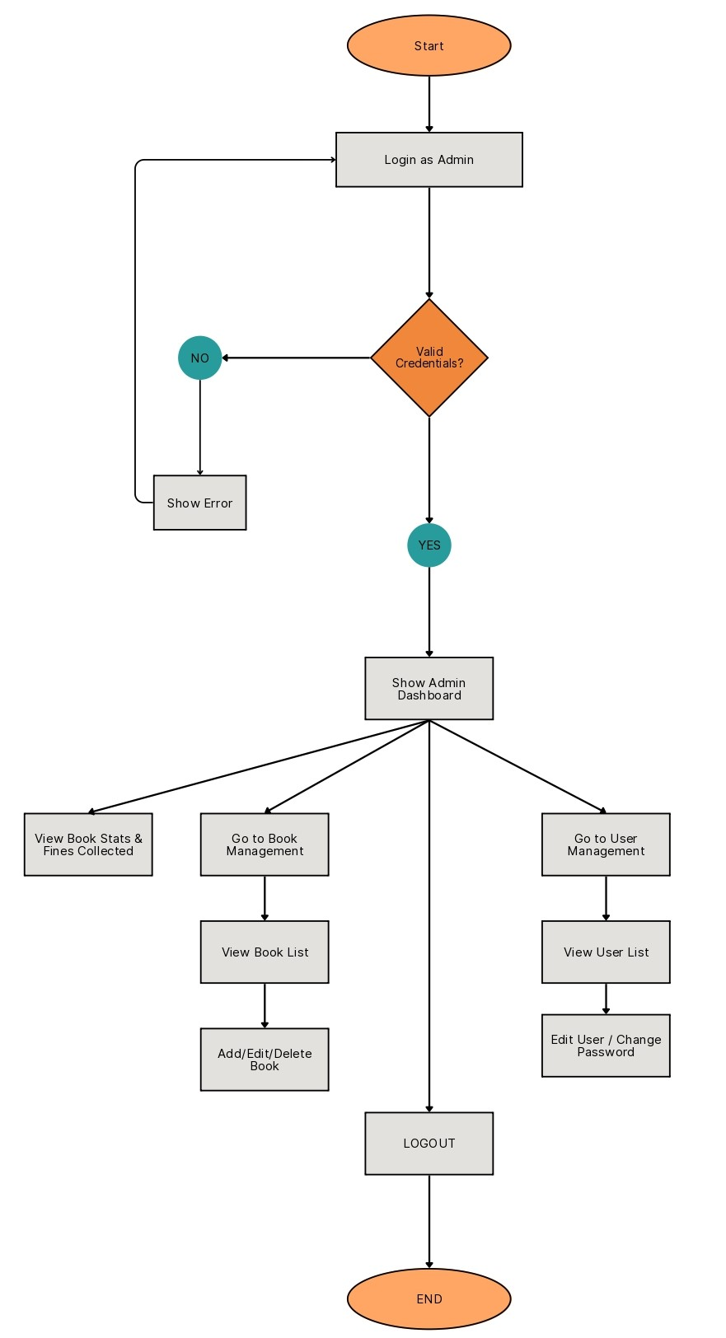Userflow

This user flow outlines the navigation logic for an **Admin Panel** within a library or education management system. It describes how an admin authenticates, accesses system features, and performs book and user management tasks.

**1. Authentication Process**

* **Start**
  + The system begins at the **Login as Admin** screen.
* **Credentials Check**
  + If the entered credentials are **valid**, the system proceeds to the admin dashboard.
  + If credentials are **invalid**, an **error message is displayed**, and the user remains on the login screen.

**2. Admin Dashboard**

Once authenticated, the **Admin Dashboard** provides access to:

* **Book Statistics**
* **Fines Collected**

The admin can choose to navigate to the following modules:

**3. Book Management**

* **View Book List**
  + Displays all books in the system.
* **Add/Edit/Delete Book**
  + Admins can manage book data by:
    - Adding new books
    - Editing existing book details
    - Deleting records as needed

**4. User Management**

* **View User List**
  + Displays a list of registered users (students or other admins).
* **Edit User / Change Password**
  + Allows updating of user information and password management.

**5. Logout**

* **LOGOUT**
  + Ends the admin session and returns to the login screen.

**6. End**

* Marks the completion of the admin session.