**Prithivi Narayan Campus, Pokhara**

**Tribhuvan University**

**Institute of Science & Technology**



**Final Year Project Proposal**

**On**

**“SECOND OPINION” – AN AI BRAIN TUMOR CLASSIFIER**

*In partial fulfillment of the requirements for the Degree of Bachelor of Science in Computer Science and Information Technology*

**Submitted By;**

Srijan Basnet (30077/78)

Suraj Dhakal (30079/78)

Yojjal Sharma (30084/78)

**Supervisor:**

Tara Bahadur Thapa

**ABSTRACT**

This project aims to develop an automated brain tumor classification system that improves diagnostic accuracy and supports effective treatment planning by classifying tumors from Magnetic Resonance Imaging (MRI) scans. Brain tumors, which can be benign or malignant and commonly include gliomas, meningiomas, and pituitary tumors, affect approximately 11,700 people annually. Due to the complex and time-consuming nature of manual MRI interpretation by experts, this system leverages a deep learning approach using the Vision Transformer (ViT) architecture. Specifically, it employs the ViT-B/16 model with transfer learning to extract powerful image features for accurate tumor classification. The project demonstrates the potential of Vision Transformers in medical image analysis and computational pathology, enabling precise categorization of tumors into glioma, meningioma, and pituitary tumor types. This work addresses the need for efficient, reliable diagnostic tools in brain tumor imaging and lays the foundation for future advancements in computer-aided medical diagnosis.

**Keywords**: ViT-B/16, MRI, Brain Tumor Classification, Classifier Model, Vision Transformer, Glioma, Meningioma, pituitary Brain tumors are a significant health concern, accounting for 85 to 90 percent of all primary

**Table of Contents**

1. Introduction 1

2. Problem Statement 2

3. Objectives 3

4. Methodology 4

4.1. Requirement Identification 5

4.1.1. Study of Existing System / Literature Review 5

4.1.2. Requirement Analysis 6

4.2. Feasibility Study 8

4.2.1. Technical 8

4.2.2. Operational 8

4.2.3. Economic 8

4.2.4. Schedule 9

4.3. High Level Design of The System 9

4.3.1. Working Mechanism of Proposed System 10

4.3.2. Descripiton of Algorithm 10

4.3.3. Flow Chart 11

5. Expected Outcome 12

6. References 13

**List of Figures**

Figure 1: Block diagram of Agile Methodology 4

Figure 2: Gantt Chart 9

Figure 3: Block Diagram of High Level Design of The System 9

Figure 4: Flow Chart for The System 11

# **Introduction**

Brain tumors are among the most critical and life-threatening conditions, requiring timely and accurate diagnosis for effective treatment. Magnetic Resonance Imaging (MRI) is the standard imaging technique used by radiologists to detect and classify brain tumors. However, manual interpretation of MRI scans can be time-consuming, subjective, and prone to human error, especially in resource-limited settings.

Recent advances in deep learning and computer vision have shown promise in automating medical image analysis, potentially improving diagnostic accuracy and efficiency. This project proposes the development of an AI-powered tool that leverages state-of-the-art Vision Transformer (ViT) models to classify brain MRI images into categories such as Glioma Tumor, Meningioma Tumor, Pituitary Tumor, and Normal Brain. The goal is to create an accessible web-based application that can assist clinicians by providing a second opinion on MRI scans, thereby supporting faster and more reliable decision-making.

The proposed system will utilize transfer learning with pre-trained transformer models, adapting them to the specific task of brain tumor classification. If successful, this tool could help reduce diagnostic workload, minimize errors, and improve patient outcomes in clinical practice.

# **Problem Statement**

Despite the growing burden of brain tumors in Nepal, the current healthcare infrastructure faces significant challenges in providing timely and accurate diagnosis, particularly in rural and remote regions. The lack of advanced imaging facilities, trained specialists, and efficient diagnostic workflows results in delayed detection and suboptimal patient outcomes. There is an urgent need for an accessible, cost-effective, and scalable solution to improve brain tumor diagnosis across the country.

In Nepal, brain tumors represent a significant health challenge, with increasing incidence rates and limited access to advanced diagnostic facilities, particularly in rural and underserved regions. In Nepal, the diagnosis of brain tumors predominantly depends on MRI imaging interpreted by a few specialized radiologists concentrated in urban centers, leading to delayed detection and treatment especially in rural and remote areas where access to expertise and advanced imaging is limited [1] . This delay exacerbates morbidity and mortality from brain tumors, underscoring the urgent need for timely and accurate diagnostics.

Contemporary research from South Asia demonstrates that state‑of‑the‑art AI methods such as ensemble systems can classify three to four primary tumor types (glioma, meningioma, pituitary, and healthy) with high accuracy (between 98–99%). However, systems tested abroad (e.g., Bangladesh, India) may not directly translate to Nepal, due to differences in MRI acquisition protocols, tumor epidemiology, and health system infrastructure [2] .

The absence of automated, accurate, and accessible diagnostic tools exacerbates these challenges, particularly in remote areas where healthcare infrastructure is limited. An AI-based brain tumor classifier, leveraging machine learning and deep learning techniques, could address these issues by providing a cost-effective, scalable, and accurate solution for early detection and classification of brain tumors from medical imaging [1] [3] .

# **Objectives**

The primary goal of this project is to develop and deploy a deep learning model for the automated classification of brain tumors from MRI scans. The specific objectives are:

1. **To Develop a Classification Model:**

To build a Vision Transformer (ViT) based model capable of classifying brain MRI images into four distinct categories: "Glioma Tumor," "Meningioma Tumor," "Pituitary Tumor," and "Normal Brain."

1. **To Systematically Evaluate Model Performance:**

To rigorously assess the model's accuracy, loss, and other relevant classification metrics on an independent test dataset to validate its effectiveness and reliability.

1. **To Create an Accessible and Interactive Web Application:**

To deploy the trained model into a user-friendly web interface using ReactJS and Tailwindcss. This "Second Opinion" tool will allow users to upload an MRI scan and receive an instant classification, making the technology accessible to medical professionals for assistive purposes.

# **Methodology**

In line with the demands and dynamic nature of our project, we have adopted the agile development methodology for the AI-based brain tumor classifier. Agile is well-suited for computer vision projects like brain tumor classification, as it supports iterative development, continuous feedback, and adaptability to evolving requirements. Throughout the project, development will proceed in short, focused cycles, allowing us to incrementally build, test, and refine system components such as image preprocessing, tumor detection, and classification algorithms.

This approach ensures that feedback can be incorporated at every stage, enabling us to quickly identify issues and optimize the system based on real-world medical imaging data. By starting with a functional prototype and gradually enhancing its features, we can efficiently address challenges related to data quality, model accuracy, and integration with healthcare systems. Agile also enables us to embrace changes and improvements during development, such as adapting to new imaging modalities or refining model performance, without significant delays or added costs. Ultimately, this methodology will help us deliver a robust, adaptable, and effective AI brain tumor meeting the needs of both urban and rural medical environments.

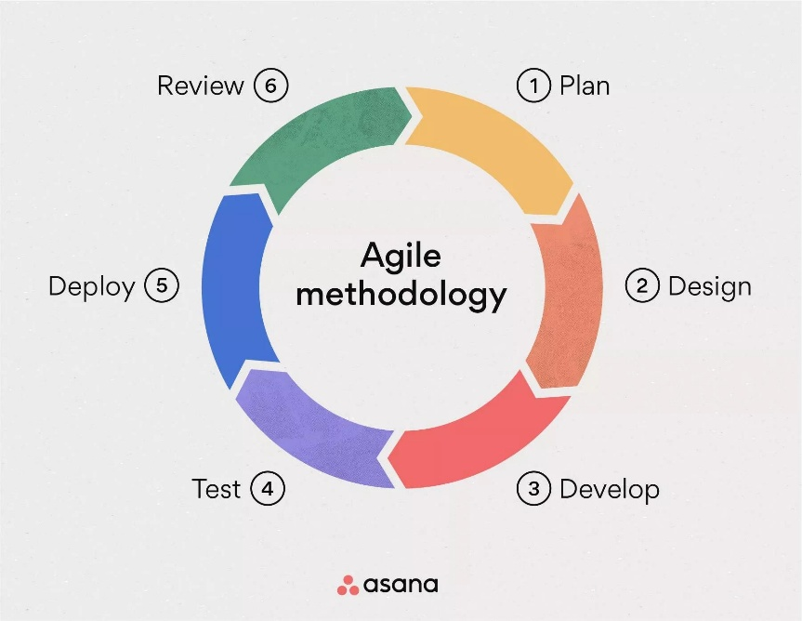

**Figure 1: Block diagram of Agile Methodology**

## **Requirement Identification**

### **4.1.1. Study of Existing System / Literature Review**

Recent advancements in artificial intelligence (AI) have significantly impacted the field of medical imaging, particularly in the classification of brain tumors using MRI scans. Traditionally, tumor diagnosis has relied on manual interpretation by radiologists, which can be both time-consuming and prone to subjective errors. Early AI-based systems employed conventional machine learning algorithms such as Support Vector Machines (SVM) and K-Nearest Neighbors (KNN), which depended heavily on handcrafted features like texture and shape. However, these approaches lacked scalability and often yielded suboptimal performance. The emergence of deep learning, especially Convolutional Neural Networks (CNNs), has revolutionized this domain by enabling end-to-end learning directly from raw MRI data. Pereira et al. (2016) demonstrated the effectiveness of CNNs in brain tumor segmentation tasks, achieving high accuracy by extracting hierarchical features from MRI slices [4]. Similarly, Swati et al. (2019) applied transfer learning using pre-trained models such as VGG16 and fine-tuned them for multi-class brain tumor classification, achieving notable improvements in accuracy and efficiency [5]. Despite these advancements, current systems face several limitations, including their reliance on large, annotated datasets, reduced generalizability across institutions due to scanner variability, and lack of explainability in AI-driven decisions. Additionally, many existing models are either optimized for binary classification or focus solely on tumor segmentation, limiting their practical application in comprehensive diagnostic workflows. Our proposed system aims to address these gaps by incorporating advanced deep learning techniques capable of 4 class classification, improved generalization, and efficient accuracy.

### **4.1.2. Requirement Analysis**

#### **4.1.2.1 Functional Requirements:**

The proposed system is designed to fulfill a set of functional requirements that define its core operations and user-facing capabilities.

* **Web-Based Interface**  
  The system will offer a user-friendly graphical interface accessible via a web browser. This interface will support intuitive navigation and interaction for all users.
* **Image Upload**  
  Users will be able to upload a single brain MRI scan image through the web interface for classification purposes.
* **Display of Results**  
  Upon classification, the system will present the predicted category of the MRI scan along with a confidence score indicating the probability associated with the prediction. These results will be clearly and concisely displayed.
* **Handling Low Confidence**  
  If the model's highest confidence score falls below a predefined threshold, the system will classify the result as "Unknown." This safeguard is intended to minimize the risk of misdiagnosis due to uncertain predictions.
* **Model Initialization**  
  A pre-trained Vision Transformer (ViT) model will be automatically loaded during system startup to facilitate classification tasks.
* **Image Preprocessing:**  
  Before classification, the system will apply appropriate image preprocessing steps. These include resizing and normalization to ensure compatibility with the input requirements of the ViT model.
* **Multi-Class Classification**  
  The system will be capable of classifying brain MRI scans into one of four distinct categories:
  1. Glioma Tumor
  2. Meningioma Tumor
  3. Normal Brain
  4. Pituitary Tumor

#### **4.1.2.2 Non-Functional Requirements:**

Non-functional requirements define the quality characteristics and operational standards that the system must meet. These ensure that the system is efficient, user-friendly, reliable, and maintainable under real-world conditions.

* **Prediction Latency**  
  The system should provide classification results promptly. From the moment an image is uploaded to when the prediction is displayed, the response time should ideally be under 5 seconds on standard CPU-based hardware.
* **Ease of Use**  
  The web interface must be intuitive, user-friendly, and accessible without requiring prior technical training. Users should be able to interact with the system and interpret results with minimal guidance.
* **Clarity of Output**  
  The output must be presented in a clear and structured format, explicitly distinguishing between the predicted class label and its associated confidence score.
* **System Stability**  
  The application must operate reliably without crashes or unhandled exceptions during standard use cases, such as image uploading and prediction retrieval.
* **Predictable Behavior**  
  For consistent performance, the system must yield the same output for identical input images under the same conditions. Deterministic behavior should be ensured through appropriate use of random seed initialization.
* **Modular Architecture**  
  The system’s architecture shall follow a modular design pattern, where components such as data processing, model definition, training logic, and user interface are logically separated to ease development, debugging, and future enhancements.
* **Code Readability**  
  The codebase must be clean, well-documented, and readable. Clear comments and descriptive docstrings should be used to facilitate understanding and collaboration among developers.
* **Hardware Independence**  
  The system must be capable of running on commonly available hardware configurations without requiring GPU acceleration, ensuring broader accessibility and deployment flexibility.

## **Feasibility Study**

### **4.2.1. Technical**

The project is technically feasible due to its reliance on a proven and well-documented technology stack, including Python, PyTorch, and Torchvision. These open-source tools are widely adopted in deep learning and already effectively used in the existing codebase. The core model, Vision Transformer (ViT-B/16), is available with pre-trained weights, reducing the need for training from scratch. The deployment is designed to run efficiently on a standard CPU, removing the dependency on specialized GPU hardware. Moreover, the modular code structure and existing scripts for data processing, training, and deployment demonstrate that the necessary expertise is already in place.

### **4.2.2. Operational**

Operationally, the project has a clear and manageable development workflow, spanning data loading, model training, and deployment. This structured approach minimizes implementation risks and supports smooth progress throughout the development cycle. The end product is an interactive, user-friendly web application, making the system easy to demonstrate, use, and integrate into real-world settings.

### **4.2.3. Economic**

The project is economically viable as it incurs minimal financial cost. All essential software components, including the development frameworks and deployment tools, are free and open-source. The primary investment is developer time, with no need for expensive software licenses or hardware purchases. Additionally, the dataset needed for training and evaluation is already available, avoiding costs related to data acquisition or preprocessing.

### **4.2.4. Schedule**

The project is considered schedule-feasible due to its well-defined scope, modular design, and use of existing tools and pre-trained models, which significantly reduce development time. With distinct phases such as data preparation, model training, testing, and deployment already outlined, each task can be executed in parallel or sequentially within a reasonable timeline. Given adequate planning and consistent effort, the project can be completed within a typical academic or short-term development cycle.

**Figure 2: Gantt Chart**

## **High Level Design of The System**

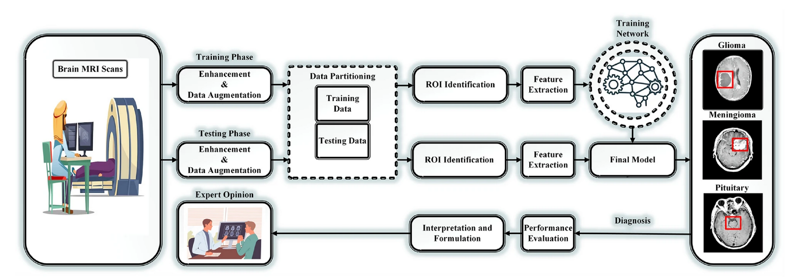

**Figure 3: Block Diagram of High Level Design of The System**

### **Working Mechanism of Proposed System**

The proposed system operates through a user-friendly web interface where a user uploads a brain MRI scan. This image is preprocessed to match the input requirements of a Vision Transformer (ViT-B/16) model that has been fine-tuned for this specific task. The ViT model leverages a powerful self-attention mechanism to analyze the entire image for patterns indicative of different tumor types. Finally, the model's custom classifier head calculates the probabilities for each class:- Glioma, Meningioma, Pituitary, or Normal and presents the most likely diagnosis and its confidence score to the user, providing an efficient and accessible tool for automated medical image analysis.

### **Descripiton of Algorithms**

**1. Vision Transformer (ViT) - Primary Model**

The Vision Transformer (ViT) is the primary model for the Second Opinion system. It treats an input image as a sequence of patches and processes it using a Transformer network, similar to how text is handled in natural language processing. This design enables the model to capture long-range dependencies and global patterns across the image, which is particularly important for detecting subtle features in brain MRI scans.

**2. Adam Optimizer - Optimization Technique**

The Adam optimizer is an adaptive learning rate optimization algorithm widely used in training deep neural networks. It combines momentum and adaptive learning rate techniques to efficiently update model parameters.

**3. Cross-Entropy Loss – Loss Function:**

Cross-Entropy Loss is a standard objective function for multi-class classification tasks. It evaluates the difference between predicted probability distributions and actual class labels, guiding the model toward better accuracy.

### **Flow Chart**

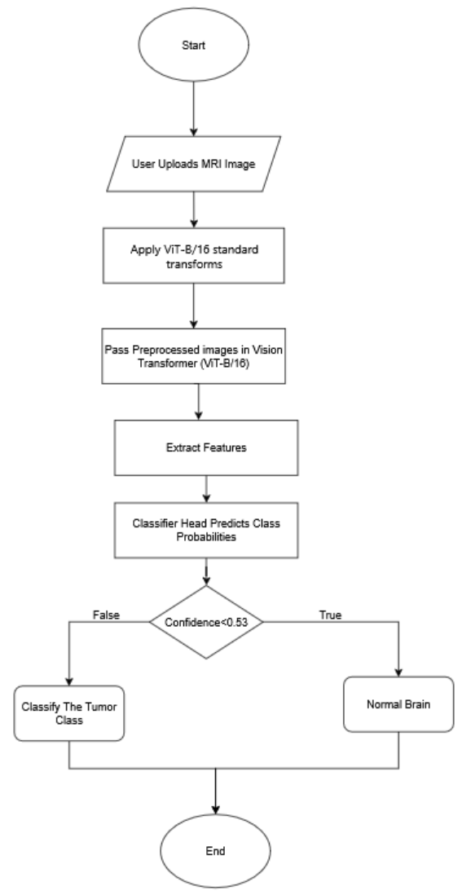

**Figure 4: Flow Chart for The System**

# **Expected Outcome**

Upon successful completion of this project, the following tangible outcomes are anticipated:

* 1. **Trained And Optimized Vision Transformer Model**

The primary deliverable of this project will be a trained and optimized Vision Transformer (ViT) model designed specifically for the classification of brain MRI scans. The model will be capable of accurately categorizing input images into four distinct classes: Glioma Tumor, Meningioma Tumor, Pituitary Tumor, and Normal Brain. The training process will involve data preprocessing, augmentation techniques, and fine-tuning to ensure high classification performance and generalizability across diverse imaging conditions.

* 1. **Functional Web Based Interactive**

The key outcome of this project will be the development of a user-friendly, web-based application that showcases the practical utility of the trained AI model. The application will feature a responsive and accessible frontend developed using modern web technologies, including React for building interactive user interfaces and Tailwind CSS for rapid, utility-first styling. The backend system will be powered by FastAPI, enabling efficient communication between the user interface and the AI classification engine. Through this application, end-users such as clinicians, radiologists, or researchers will be able to upload brain MRI images and receive immediate, AI-generated classification results. Designed to function as a reliable “second opinion” tool, the platform aims to support medical professionals in making informed diagnostic decisions by delivering fast, accurate, and interpretable tumor classifications.

# **References**

|  |  |
| --- | --- |
| [1] | P. Shrestha and B. Pant, "Management of brain tumor in Nepal," 2004. [Online]. Available: https://www.sciencedirect.com/science/article/abs/pii/S0531513103014055. |
| [2] | S. Sarker, "Transfer Learning and Explainable AI for Brain Tumor Classification: A Study Using MRI Data from Bangladesh," 8 June 2025. [Online]. Available: https://arxiv.org/abs/2506.07228. |
| [3] | S. akila, "AUTOMATED DETECTION OF BRAIN TUMOR USING DEEP LEARNING AND MAGNETIC RESONANCE IMAGING (MRI) FOR CLASSIFICATION," [Online]. Available: https://docs.neu.edu.tr/library/7031521744.pdf. |
| [4] | S. Pereira, A. Pinto and V. Alves, "Brain Tumor Segmentation Using Convolutional Neural Networks in MRI Images," 4 March 2016. [Online]. Available: https://ieeexplore.ieee.org/document/7426413. |
| [5] | Z. N. K. Swati, Q. Zhao, Z. Ali and M. Kabir, "Brain tumor classification for MR images using transfer learning and fine-tuning," 2018. [Online]. Available: https://www.sciencedirect.com/science/article/abs/pii/S0895611118305937. |