Kathmandu University
Department of Computer Science and Engineering
Dhulikhel, Kavre


A Mini Project
on
“ResearchProjects_DB”

[Code No: COMP232]
(For partial fulfillment of II Year/ II Semester in Computer Science)

Submitted by
Abhinav Adhikari(2)

Submitted to
Sanjog Sigdel
Lecturer
Department of Computer Science and Engineering

Submission Date:
January 1 2025

Problem/ Task

Make a 3NF table on the topic of “ResearchProjects_DB”. Also, show the use of SQL instruction you have learned.

1. Database Design

For us to make a database we need to first decide what kind of organization we are modelling. The topic research projects is vauge. Is it a organization that does research like Bells Labs, or does it publish research like JSTOR, or it funds research through grant like NIST.
For our purpose we will choose a organizaiton that does research.
Now, what will we have to store. That depends on the type of organization. So, we will suppose a fictional organization and then make our data. Let’s say in our organization, we empolyee reserachers based on a field (i.e. area of study).
A research paper is published under the name the researchers. A single research paper may include multiple people from different fields that we hire for but it must be of one field (to know what kind a journal to publish the letter in), but any resracher isn’t required to part of the field.
Suppose we release a math paper. It must be specified as a math paper; the authors can be from any group.

1.1 Unormalized Form

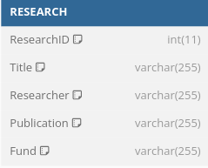
In our unormalized table all the data are grouped into one table. ResearchID and Title are the only atomic values. Other all store all the necessary for the table.

1.2 First Normal Form(1NF)

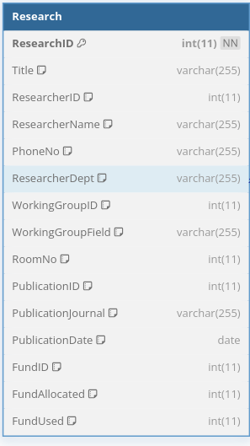
Now all the attribute are atomic. We are 1NF as no attribute domain has relations as elements. Now the table is in 1NF.

1.3 Second Normal Form(2NF)

For 2NF we divide the single table into mutiple table based on the candidate keys in the 1NF table such that, so that all the attribute of the realtion are dependent on the candidate of the table.
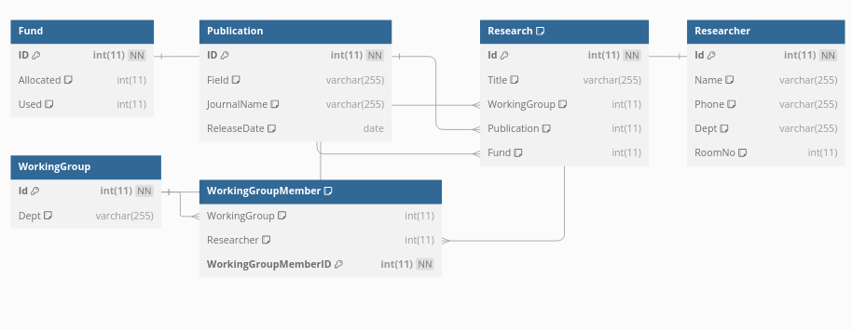

1.4 Third Normal Form(3NF)

To convert to 3NF we take all the instances of transitive dependency and make a seperate table for them all

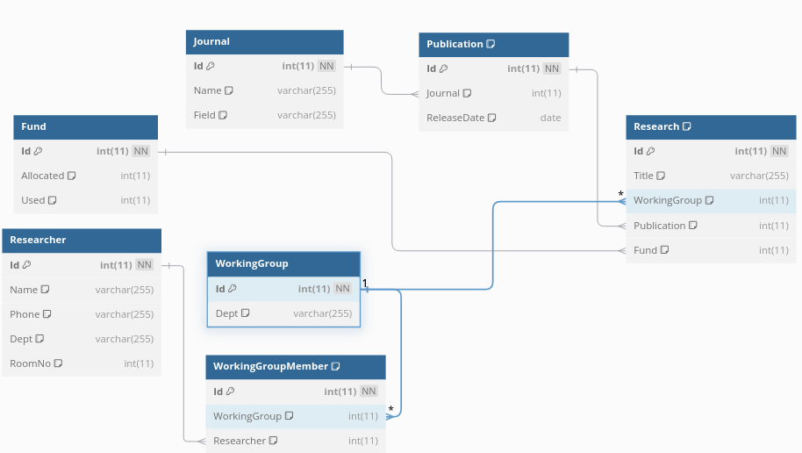

1.5 Boyce-Codd Normal Form

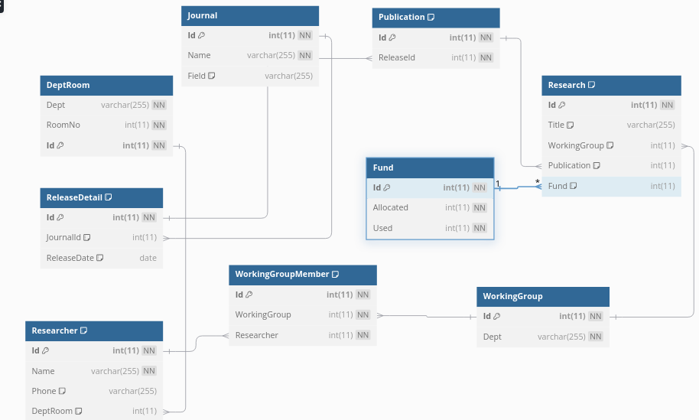
A relational schema R is in Boyce–Codd normal form if and only if for every one of its functional dependencies X → Y, at least one of the following conditions hold:
- X → Y is a trivial functional dependency (Y ⊆ X),
- X is a superkey for schema R.

Since Room belongs to Dept is assigned dept we divide Dept and RoomNo

1.6 Implementating the Table

Now we make your Table in SQL. Your SQL for your construction is
CREATE TABLE DeptRoom (
RoomNo int(11) NOT NULL,
Id int(11) NOT NULL,
Dept int(11) NOT NULL,
PRIMARY KEY (Id),
KEY Dept (Dept),
FOREIGN KEY (Dept) REFERENCES Department (Id)
);
CREATE TABLE DeptRoom (
Dept varchar(255) NOT NULL,
RoomNo int(11) NOT NULL,
Id int(11) NOT NULL,
PRIMARY KEY (Id)
);
CREATE TABLE Fund (
Id int(11) NOT NULL,
Allocated int(11) NOT NULL,
Used int(11) NOT NULL,
PRIMARY KEY (Id)
);
CREATE TABLE Journal (
Id int(11) NOT NULL,
Name varchar(255) NOT NULL,
Field varchar(255) DEFAULT NULL,
PRIMARY KEY (Id)
);
CREATE TABLE Publication (
Id int(11) NOT NULL,
ReleaseId int(11) NOT NULL,
PRIMARY KEY (Id),
KEY ReleaseId (ReleaseId),
FOREIGN KEY (ReleaseId) REFERENCES ReleaseDetail (Id)
);
CREATE TABLE ReleaseDetail (
Id int(11) NOT NULL,
JournalId int(11) DEFAULT NULL,
ReleaseDate date DEFAULT NULL,
PRIMARY KEY (Id),
KEY JournalId (JournalId),
FOREIGN KEY (JournalId) REFERENCES Journal (Id)
);
CREATE TABLE Research (
Id int(11) NOT NULL,
Title varchar(255) DEFAULT NULL,
WorkingGroup int(11) DEFAULT NULL,
Publication int(11) DEFAULT NULL,
Fund int(11) DEFAULT NULL,
PRIMARY KEY (Id),
KEY Publication (Publication),
KEY WorkingGroup (WorkingGroup),
KEY Fund (Fund),
FOREIGN KEY (Publication) REFERENCES Publication (Id),
FOREIGN KEY (WorkingGroup) REFERENCES WorkingGroup (Id),
FOREIGN KEY (Fund) REFERENCES Fund (Id)
);
CREATE TABLE WorkingGroup (
Id int(11) NOT NULL,
Dept varchar(255) NOT NULL,
PRIMARY KEY (Id)
);
CREATE TABLE WorkingGroupMember (
Id int(11) NOT NULL,
WorkingGroup int(11) NOT NULL,
Researcher int(11) NOT NULL,
PRIMARY KEY (Id),
KEY WorkingGroup (WorkingGroup),
KEY Researcher (Researcher),
FOREIGN KEY (WorkingGroup) REFERENCES WorkingGroup (Id),
FOREIGN KEY (Researcher) REFERENCES Researcher (Id)
);
This will result in following table. We can see the description for a table by using the desc command. So,
desc DeptRoom;
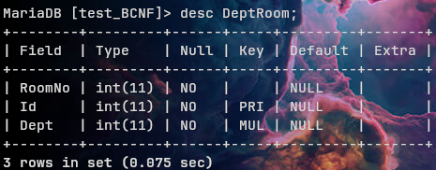
desc Fund;
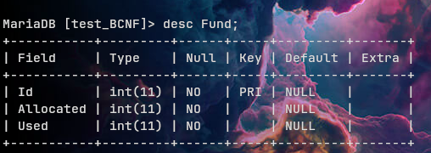
desc Journal;
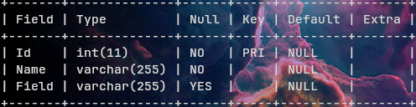
desc Publication;
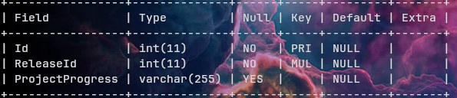
desc ReleaseDetail;
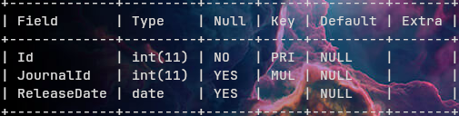
desc Research;
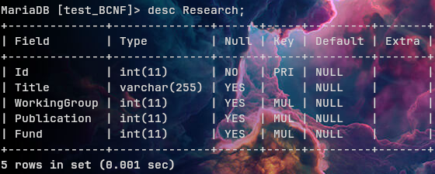

desc Researcher;
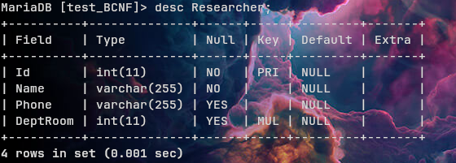
desc WorkingGroup;
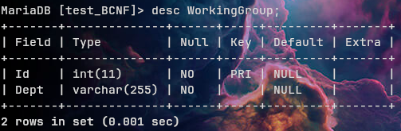
desc WorkingGroupMember;
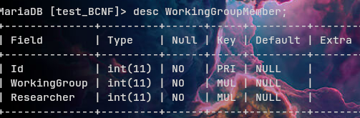

2. Basic SQL Commands

2.1 SELECT

Let us consider that we want the name of every researcher then we can do
SELECT Name FROM Department;
The result is a relation consisting of a single attribute with the heading name.
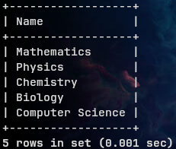
Now consider another query, “Find the department names of all instructors” which can be written as
The SELECT command doesn't do duplicate elimination. In case of you need to eliminate duplicate you can use the DISTINCT command.

SELECT Name From Researcher;
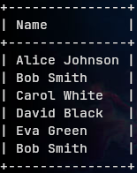
gives this result. Notice how thier are two Bob Smith. This is because we thier are two people named Bob Simth. But if you don't want duplicates you can do
SELECT DISTINCT Name From Researcher;
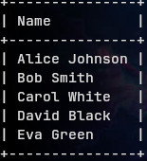
Notice no duplication.
If a command does do duplicate exclusion then you can remove it by using the ALL command instead of DISTINCT.
You can also make condition using the WHERE command like this.

SELECT * FROM Publication WHERE ProjectProgress="Not Started";
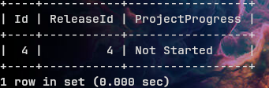
* represents all column in the table.
We can all chain multiple table in a single SELECT table like this
SELECT DISTINCT Journal.Name FROM ReleaseDetail, Journal where ReleaseDetail.JournalId = Journal.Id;
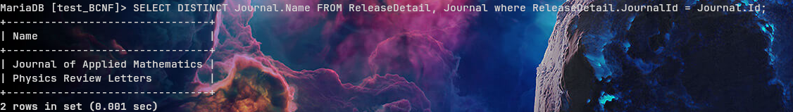
We can rename the table name temporaliy for this purpose using AS command. The above statement is equal to
SELECT DISTINCT J.Name FROM ReleaseDetail As R, Journal As J where R.JournalId = J.Id;

We can order the list by using the ORDER BY command.
SELECT Name FROM Department ORDER BY Name;

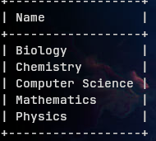

2.2 Set Operations

The SQL operations union, intersect, and except operate on relations and correspond to the mathematical set operations ∪(UNION), ∩(INTERSECT), and −(EXCEPT).
Set operations are duplication elimianting.
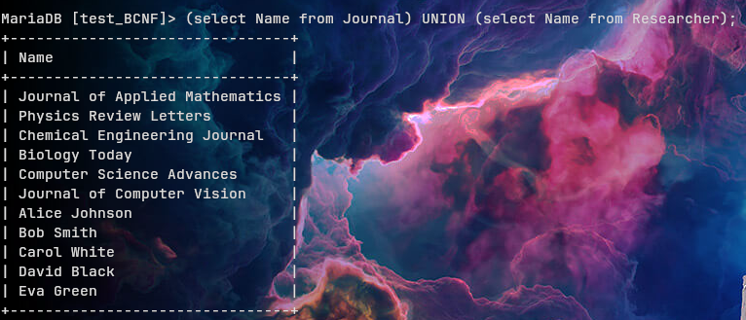
To remove Duplication use UNION ALL

2.3 Null Values

Null values represent a lack of value. We known whether a value of null or not using the IS NULL and IS NOT NULL command.
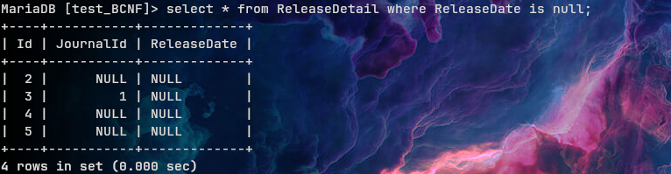

2.4 Aggregate Function

Aggregate functions are functions that take a collection (a set or multiset) of values as a input and return a single value.
We have the following five standard built-in aggregate functions:
• Average: avg
• Minimum: min
• Maximum: max
• Total: sum
• Count: count
So we can do
SELECT avg(Used) From Fund;
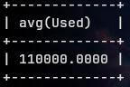

2.5 Join Expressions

JOIN syntax for the table_references part of SELECT statements and multiple-table DELETE and UPDATE statements:
It takes a two table an merges them together. Join statements should be used with caution as they check all the required row in a table and may check the left table in (LEFT JOIN), right table in (RIGHT JOIN) and all the table in (other JOIN statements).
It is to be noted that JOIN, NATURAL JOIN, INNER JOIN and OUTER JOIN are syntactically equivalent in MySQL.
So, we want to list all the department and their room we can do:
SELECT DISTINCT Department.ID As DepartmentId, Department.Name As DepartmentName, DeptRoom.RoomNo As Room FROM Department INNER JOIN DeptRoom ON Department.Id = DeptRoom.Dept;
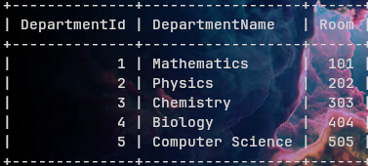
It should be noted that JOIN don’t exclude duplicity by default.

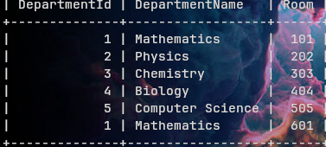
We can also do fancy things like list research projects associated with a journal and release details:
SELECT j.Name AS JournalName, r.Title AS ResearchTitle, rd.ReleaseDate FROM Journal j LEFT JOIN ReleaseDetail rd ON j.Id = rd.JournalId LEFT JOIN Publication p ON rd.Id = p.ReleaseId LEFT JOIN Research r ON p.Id = r.Publication;

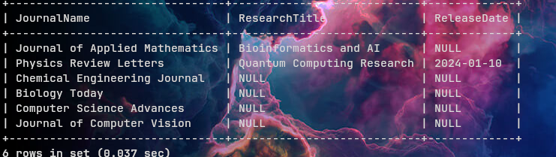

3 Transcation

We need to make some operation atomic. In our case, suppose that a researcher has been determined to be better in another department. Since a reseracher can belong to only one department, we need to remove him from his original department and then add to the new department. This posits us with a challenge. If we remove the user from a Department and the system crashes he is in no Department. So, we need to make it so that we do the operation in full or the operation never occurs.
This can be done using tarnscations.

DELIMITER ;;
CREATE DEFINER=`specialist`@`localhost` PROCEDURE `ChangeResearcherDepartment`(IN researcher_id INT, IN new_room INT, IN new_department_name VARCHAR(255))
BEGIN

DECLARE deptroom_id INT;
DECLARE EXIT HANDLER FOR SQLEXCEPTION
BEGIN

ROLLBACK;
SHOW ERRORS;
END;

DECLARE EXIT HANDLER FOR NOT FOUND
BEGIN
ROLLBACK;
SHOW ERRORS;
END;

START TRANSACTION;

SELECT DeptRoom As deptroom_id FROM Researcher WHERE Id = researcher_id;
UPDATE DeptRoom SET RoomNo = new_room where Id = deptroom_id;
UPDATE DeptRoom SET Dept = new_department_name where Id = deptroom_id;

COMMIT;

SELECT 'Researcher department updated successfully.' AS message;
END ;;
DELIMITER ;
This will cause the transcation to be not continued if thier is any error. If we call the function
CALL ChangeResearcherDepartment(1, 526, 5);

We can check for the result using
Select R.Id, R.Name, Dr.RoomNo, Dr.Dept, Department.Name FROM Researcher R JOIN DeptRoom Dr ON R.DeptRoom = Dr.Id LEFT JOIN Department ON Dr.Dept = Department.Id;
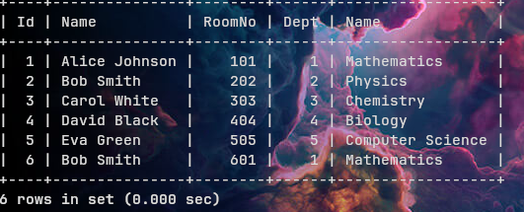
turns into this
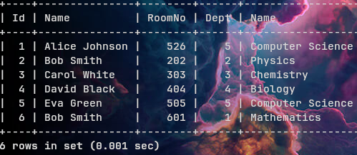

4. Dump File

The dump file is at https://github.com/AsyncMan/Database-Project/blob/main/comp232_project.pdf

