**Problem 1 and 2 code:**

%% CHEN 320-202 Homework 1

% Questions 1 and 2

% Author: Nathaniel Thomas

% Date: 08/25/2022

%% Problem 1 (Part 1)

fprintf("Problem 1 (Part 1):\n");

% Given values

p = 1000; % kg/m^3

% Source: https://www.engineeringtoolbox.com/water-dynamic-kinematic-viscosity-d_596.html

mu = 0.0008891; % N*s/m^2

d = 0.5; % m

% Get user input

u = input("Please enter a flow velocity (m/s): ");

% Calculate friction factor

re = reynolds_number(p, u, mu, d);

f = friction_factor(re);

fprintf("Friction factor: %.5f \n", f);

fprintf("\n")

%% Problem 1 (Part 2)

vel = (0.001:0.05:1);

re_mult = reynolds_number(p, vel, mu, d);

f_mult = friction_factor(re_mult);

% Plot the values

plot(vel, f_mult);

title("Friction factor vs Fluid velocity for water in a 0.5m pipe" + ...

" at $25\ ^\circ C$", "Interpreter", "latex");

xlabel("Velocity $\frac{m}{s}$", "Interpreter", "latex");

ylabel("Friction factor", "Interpreter", "latex");

%% Problem 2

fprintf("Problem 2:\n");

pi = pi_sum();

fprintf("Value of pi: %.10f\n", pi);

fprintf("\n")

%% Functions for Homework 1

%% Question 1 functions

% Function for calculating Reynolds number

% Input parameters:

% p = density (kg/m^3)

% u = flow velocity (m/s)

% mu = dynamic viscosity (N*s/m^2)

% d = inner diameter (m)

%

% Output:

% re = Reynolds number

function re = reynolds_number(p, u, mu, d)

% Uses dot operators to allow use on arrays

re = p .* u .* d ./ mu;

end

% Function for calculating friction factor

% Input parameters:

% re = Reynolds number

%

% Output:

% f = friction factor

function f = friction_factor(re)

f = zeros(1, length(re));

% Control flow is not elemental, hence the for-loop

for i = (1:length(f))

if re(i) <= 2100

f(i) = 16./re(i);

elseif re(i) < 1E5

f(i) = 0.0791./(re(i).^0.25);

else

f(i) = 0.004;

end

end

end

%% Question 2 functions

% Function for calculating pi

%

% Output:

% pi = pi estimate, where

% (last term of the summation) / (pi estimate) < 10 ^ -8

function pi = pi_sum()

k = 0;

pi = 0;

last = 1;

% Dividing 1 / 0 gives "inf" value in MATLAB, first iteration OK

while abs(last / pi) >= 1E-8

last = sqrt(12) .* (-3).^-k / (2.*k + 1);

pi = pi + last;

k = k + 1;

end

end

**Problem 1 ouput (Part 1):**

**Please enter a flow velocity (m/s): 0.01**

**Friction factor: 0.00913**

**Problem 1 (Part 2) graph:**

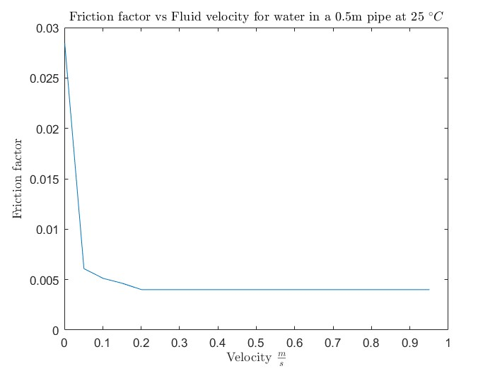

**Problem 2 output:**

**Value of pi: 3.1415926595**

**Problem 3 code:**

%% CHEN 320-202 Homework 1

% Question 3

% Author: Nathaniel Thomas

% Date: 08/25/2022

%% Question 3 Plain Plot

x = (0:0.01:pi);

y = sin(x);

plot(x, y);

hold off

%% Question 3 Enhanced Plot

x = (0:0.01:pi);

y = sin(x);

% Plot

hold on

plot(x, y, "-k");

% Visual enhancements

grid on

xlim([0, pi]);

ylim([0, 1.01]);

title("Plot of sin(x), $0 < x < \pi$", "Interpreter", "latex");

xlabel("x");

ylabel("y");

**Problem 3 (Plain Graph):**

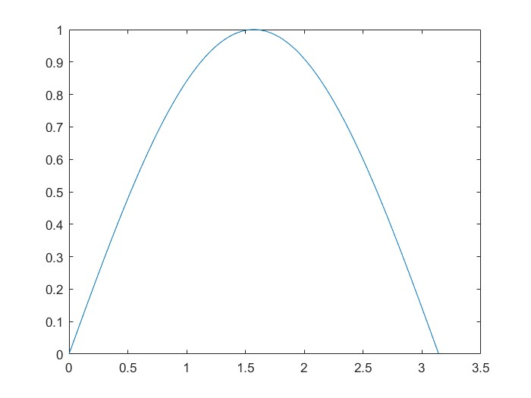

**Problem 3 (Enhanced Graph):**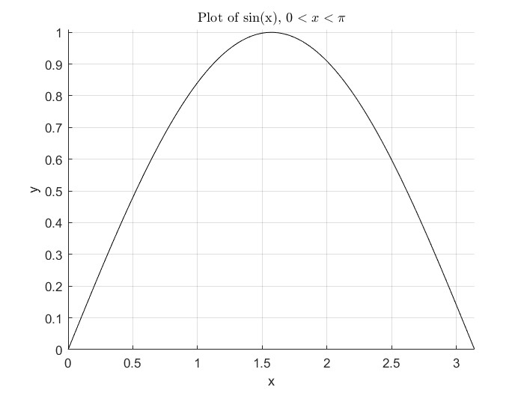

**Problem 4 code:**

%% CHEN 320-202 Homework 1

% Question 4

% Author: Nathaniel Thomas

% Date: 08/25/2022

%% Question 4

% Generate values to plot

x = (0:0.01:pi);

y1 = sin(x);

y2 = cos(x);

% Plot graphs

hold on

plot(x, y1, "-r");

plot(x, y2, "-b");

% Visual enhancements

grid on

xlim([0, pi]);

ylim([-1.01, 1.01]);

% Draw the x axis

line(xlim, [0, 0], 'Color', 'k', 'LineWidth', 2);

% Use LaTeX interpreter to print pi symbol

title("Plots of sin(x) and cos(x) from $0 < x < \pi$", "Interpreter", ...

"latex");

xlabel("x");

ylabel("y");

legend(["sin(x)","cos(x)"]);

Problem 4 graph:

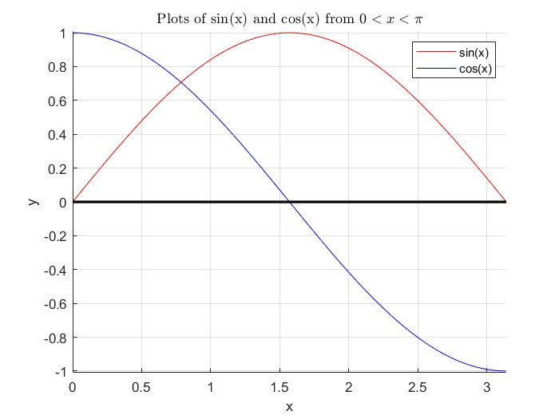

**Problem 5 code:**

%% CHEN 320-202 Homework 1

% Question 5

% Author: Nathaniel Thomas

% Date: 08/25/2022

%% Question 5

syms x;

exp = x .^ 2 + 9 * x + 8;

result = factor(exp);

fprintf("Expression: %s\n", exp);

fprintf("Factor: %s\n", result);

**Problem 5 output:**

**Expression: 9*x + x^2 + 8**

**Factor: x + 8**

**Factor: x + 1**

**Problem 6 code:**

%% CHEN 320-202 Homework 1

% Question 6

% Author: Nathaniel Thomas

% Date: 08/25/2022

%% Question 6

syms a b x;

exp = 1 / (a.^2 + (b.^2).*(x.^2));

res = int(exp, x);

fprintf("Expression: %s\n", exp);

fprintf("Integral: %s\n", res);

**Problem 6 output:**

**Expression: 1/(a^2 + b^2*x^2)**

**Integral: atan((b*x)/a)/(a*b)**