TABLE OF CONTENTS

PROJECT AIM

LIST OF FIGURES

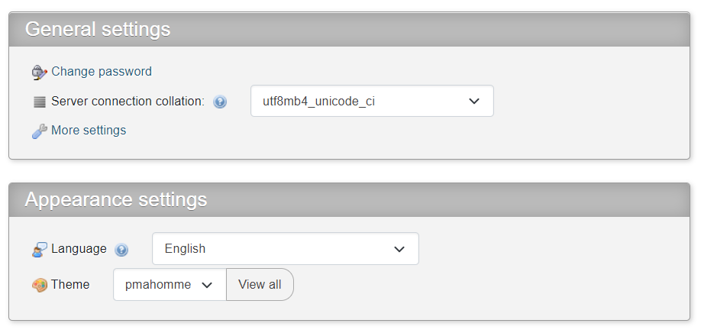

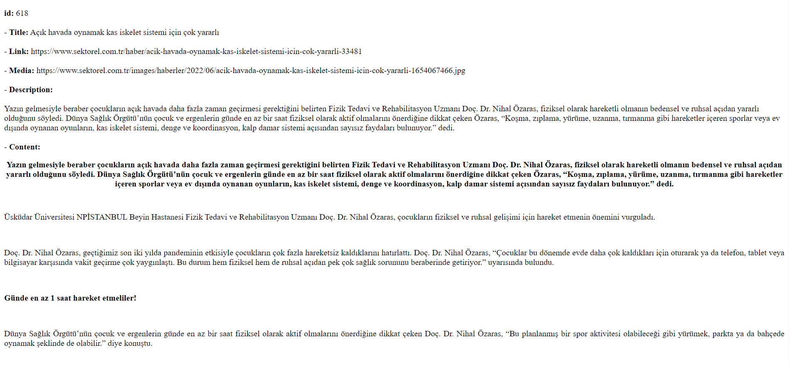

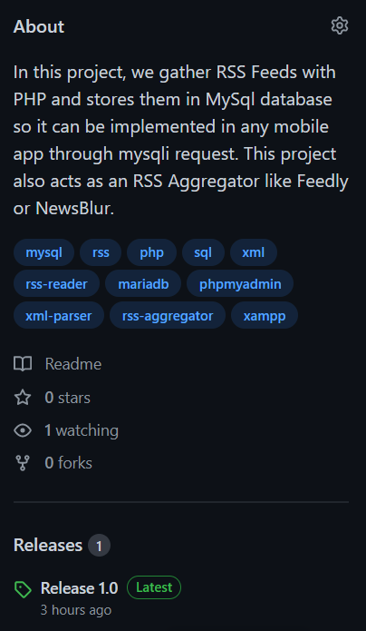



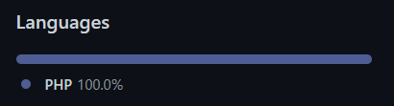

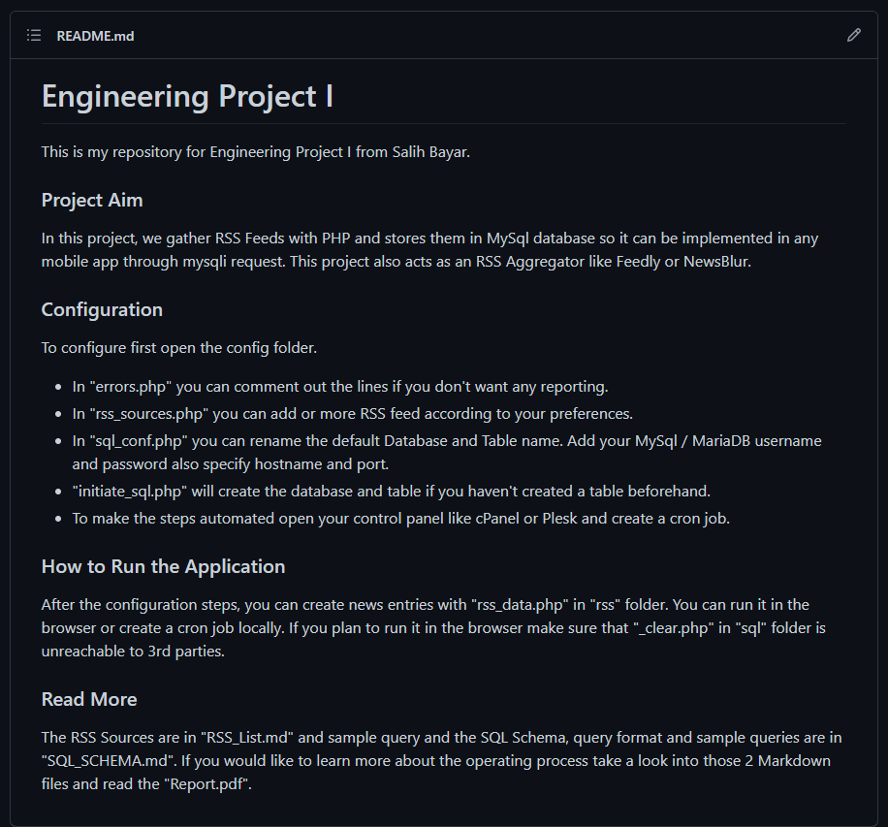

LIST OF TABLES

1. INTRODUCTION – TECHNOLOGIES USED
2. PLANNING

ASCII Characters (Printable)

<https://www.freeformatter.com/html-entities.html>

UTF-8 CHARACTERS

utf8 vs utf8mb4

PHP

PHP htmlspecialchars() Function

PHP OOP vs Mysqli vs Mysql

PHP Keywords

<https://www.php.net/manual/en/reserved.keywords.php>

Compile-time constants

<https://www.php.net/manual/en/reserved.keywords.php>

MYSQL

MariaDB

GitHub

GitHub is a code hosting platform for collaboration and version control.

GitHub lets you (and others) work together on projects.

GitHub essentials are:

Repositories

Branches

Commits

Pull Requests

Git (the version control software GitHub is built on)

Repository

A GitHub repository can be used to store a development project.

It can contain folders and any type of files (HTML, CSS, JavaScript, Documents, Data, Images).

A GitHub repository should also include a licence file and a README file about the project.

A GitHub repository can also be used to store ideas, or any resources that you want to share.

Branch

A GitHub branch is used to work with different versions of a repository at the same time.

By default a repository has a master branch (a production branch).

Any other branch is a copy of the master branch (as it was at a point in time).

New Branches are for bug fixes and feature work separate from the master branch. When changes are ready, they can be merged into the master branch. If you make changes to the master branch while working on a new branch, these updates can be pulled in.

Commits

At GitHub, changes are called commits.

Each commit (change) has a description explaining why a change was made.

Pull Requests

Pull Requests are the heart of GitHub collaboration.

With a pull request you are proposing that your changes should be merged (pulled in) with the master.

Pull requests show content differences, changes, additions, and subtractions in colors (green and red).

As soon as you have a commit, you can open a pull request and start a discussion, even before the code is finished.

A great way to learn GitHub, before working on larger projects, is to open pull requests in your own repository and merge them yourself.

You merge any changes into the master by clicking a "Merge pull request" button.

Hosting

VPS

Oracle Cloud

RSS

With RSS it is possible to distribute up-to-date web content from one web site to thousands of other web sites around the world.

RSS allows fast browsing for news and updates.

What is RSS?

RSS stands for Really Simple Syndication

RSS allows you to syndicate your site content

RSS defines an easy way to share and view headlines and content

RSS files can be automatically updated

RSS allows personalized views for different sites

RSS is written in XML

Why use RSS?

RSS was designed to show selected data.

Without RSS, users will have to check your site daily for new updates. This may be too time-consuming for many users. With an RSS feed (RSS is often called a News feed or RSS feed) they can check your site faster using an RSS aggregator (a site or program that gathers and sorts out RSS feeds).

Since RSS data is small and fast-loading, it can easily be used with services like cell phones or PDA's.

Web-rings with similar information can easily share data on their web sites to make them better and more useful.

Who Should use RSS?

Webmasters who seldom update their web sites do not need RSS!

RSS is useful for web sites that are updated frequently, like:

News sites - Lists news with title, date and descriptions

Companies - Lists news and new products

Calendars - Lists upcoming events and important days

Site changes - Lists changed pages or new pages

Benefits of RSS

Here are some benefits of using RSS:

Choose your news

With RSS you can choose to view the news you want, the news that interest you and are relevant to your work.

Remove unwanted information

With RSS you can (finally) separate wanted information from unwanted information (spam)!

Increase your site traffic

With RSS you can create your own news channel, and publish it to the Internet!

Is RSS a Web Standard?

There is no official standard for RSS.

About 50 % of all RSS feeds use RSS 0.91

About 25 % use RSS 1.0

The last 25 % is split between RSS 0.9x versions and RSS 2.0

How RSS Works

RSS is used to share content between websites.

With RSS, you register your content with companies called aggregators.

So, to be a part of it: First, create an RSS document and save it with an .xml extension. Then, upload the file to your website. Next, register with an RSS aggregator. Each day the aggregator searches the registered websites for RSS documents, verifies the link, and displays information about the feed so clients can link to documents that interests them.

Tip: Read our RSS Publishing chapter to view free RSS aggregation services.

XML

XML stands for eXtensible Markup Language.

XML was designed to store and transport data.

XML was designed to be both human- and machine-readable.

XML plays an important role in many different IT systems.

XML is often used for distributing data over the Internet.

It is important (for all types of software developers!) to have a good understanding of XML.

XML is a software- and hardware-independent tool for storing and transporting data.

What is XML?

XML stands for eXtensible Markup Language

XML is a markup language much like HTML

XML was designed to store and transport data

XML was designed to be self-descriptive

XML is a W3C Recommendation

XML Does Not DO Anything

Maybe it is a little hard to understand, but XML does not DO anything.

This note is a note to Tove from Jani, stored as XML:

The XML above is quite self-descriptive:

It has sender information

It has receiver information

It has a heading

It has a message body

But still, the XML above does not DO anything. XML is just information wrapped in tags.

Someone must write a piece of software to send, receive, store, or display it:

The Difference Between XML and HTML

XML and HTML were designed with different goals:

XML was designed to carry data - with focus on what data is

HTML was designed to display data - with focus on how data looks

XML tags are not predefined like HTML tags are

XML Does Not Use Predefined Tags

The XML language has no predefined tags.

The tags in the example above (like <to> and <from>) are not defined in any XML standard. These tags are "invented" by the author of the XML document.

HTML works with predefined tags like <p>, <h1>, <table>, etc.

With XML, the author must define both the tags and the document structure.

XML is Extensible

Most XML applications will work as expected even if new data is added (or removed).

Imagine an application designed to display the original version of note.xml (<to> <from> <heading> <body>).

Then imagine a newer version of note.xml with added <date> and <hour> elements, and a removed <heading>.

The way XML is constructed, older version of the application can still work:

XML Simplifies Things

XML simplifies data sharing

XML simplifies data transport

XML simplifies platform changes

XML simplifies data availability

Many computer systems contain data in incompatible formats. Exchanging data between incompatible systems (or upgraded systems) is a time-consuming task for web developers. Large amounts of data must be converted, and incompatible data is often lost.

XML stores data in plain text format. This provides a software- and hardware-independent way of storing, transporting, and sharing data.

XML also makes it easier to expand or upgrade to new operating systems, new applications, or new browsers, without losing data.

With XML, data can be available to all kinds of "reading machines" like people, computers, voice machines, news feeds, etc.

XML is a W3C Recommendation

XML became a W3C Recommendation as early as in February 1998.

XAMPP

What is XAMPP?

XAMPP is the most popular PHP development environment

XAMPP is a completely free, easy to install Apache distribution containing MariaDB, PHP, and Perl. The XAMPP open source package has been set up to be incredibly easy to install and to use.

XAMPP is one of the widely used cross-platform web servers, which helps developers to create and test their programs on a local webserver. It was developed by the Apache Friends, and its native source code can be revised or modified by the audience. It consists of Apache HTTP Server, MariaDB, and interpreter for the different programming languages like PHP and Perl. It is available in 11 languages and supported by different platforms such as the IA-32 package of Windows & x64 package of macOS and Linux.

What is XAMPP?

XAMPP is an abbreviation where X stands for Cross-Platform, A stands for Apache, M stands for MYSQL, and the Ps stand for PHP and Perl, respectively. It is an open-source package of web solutions that includes Apache distribution for many servers and command-line executables along with modules such as Apache server, MariaDB, PHP, and Perl.

XAMPP helps a local host or server to test its website and clients via computers and laptops before releasing it to the main server. It is a platform that furnishes a suitable environment to test and verify the working of projects based on Apache, Perl, MySQL database, and PHP through the system of the host itself. Among these technologies, Perl is a programming language used for web development, PHP is a backend scripting language, and MariaDB is the most vividly used database developed by MySQL. The detailed description of these components is given below.

Components of XAMPP

As defined earlier, XAMPP is used to symbolize the classification of solutions for different technologies. It provides a base for testing of projects based on different technologies through a personal server. XAMPP is an abbreviated form of each alphabet representing each of its major components. This collection of software contains a web server named Apache, a database management system named MariaDB and scripting/ programming languages such as PHP and Perl. X denotes Cross-platform, which means that it can work on different platforms such as Windows, Linux, and macOS.

Many other components are also part of this collection of software and are explained below.

Cross-Platform: Different local systems have different configurations of operating systems installed in it. The component of cross-platform has been included to increase the utility and audience for this package of Apache distributions. It supports various platforms such as packages of Windows, Linus, and MAC OS.

Apache: It is an HTTP a cross-platform web server. It is used worldwide for delivering web content. The server application has made free for installation and used for the community of developers under the aegis of Apache Software Foundation. The remote server of Apache delivers the requested files, images, and other documents to the user.

MariaDB: Originally, MySQL DBMS was a part of XAMPP, but now it has been replaced by MariaDB. It is one of the most widely used relational DBMS, developed by MySQL. It offers online services of data storage, manipulation, retrieval, arrangement, and deletion.

PHP: It is the backend scripting language primarily used for web development. PHP allows users to create dynamic websites and applications. It can be installed on every platform and supports a variety of database management systems. It was implemented using C language. PHP stands for Hypertext Processor. It is said to be derived from Personal Home Page tools, which explains its simplicity and functionality.

Perl: It is a combination of two high-level dynamic languages, namely Perl 5 and Perl 6. Perl can be applied for finding solutions for problems based on system administration, web development, and networking. Perl allows its users to program dynamic web applications. It is very flexible and robust.

phpMyAdmin: It is a tool used for dealing with MariaDB. Its version 4.0.4 is currently being used in XAMPP. Administration of DBMS is its main role.

OpenSSL: It is the open-source implementation of the Secure Socket Layer Protocol and Transport Layer Protocol. Presently version 0.9.8 is a part of XAMPP.

XAMPP Control Panel: It is a panel that helps to operate and regulate upon other components of the XAMPP. Version 3.2.1 is the most recent update. A detailed description of the control panel will be done in the next section of the tutorial.

Webalizer: It is a Web Analytics software solution used for User logs and provide details about the usage.

Mercury: It is a mail transport system, and its latest version is 4.62. It is a mail server, which helps to manage the mails across the web.

Tomcat: Version 7.0.42 is currently being used in XAMPP. It is a servlet based on JAVA to provide JAVA functionalities.

Filezilla: It is a File Transfer Protocol Server, which supports and eases the transfer operations performed on files. Its recently updated version is 0.9.41.