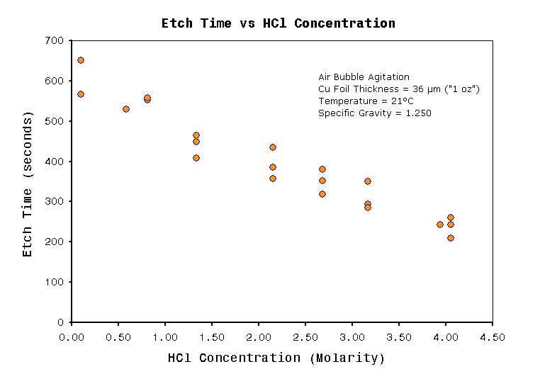
http://jimlaurwilliams.org/projects/seychellePaper/index.html#Tips_on_Efficient_Regeneration_by_Air

