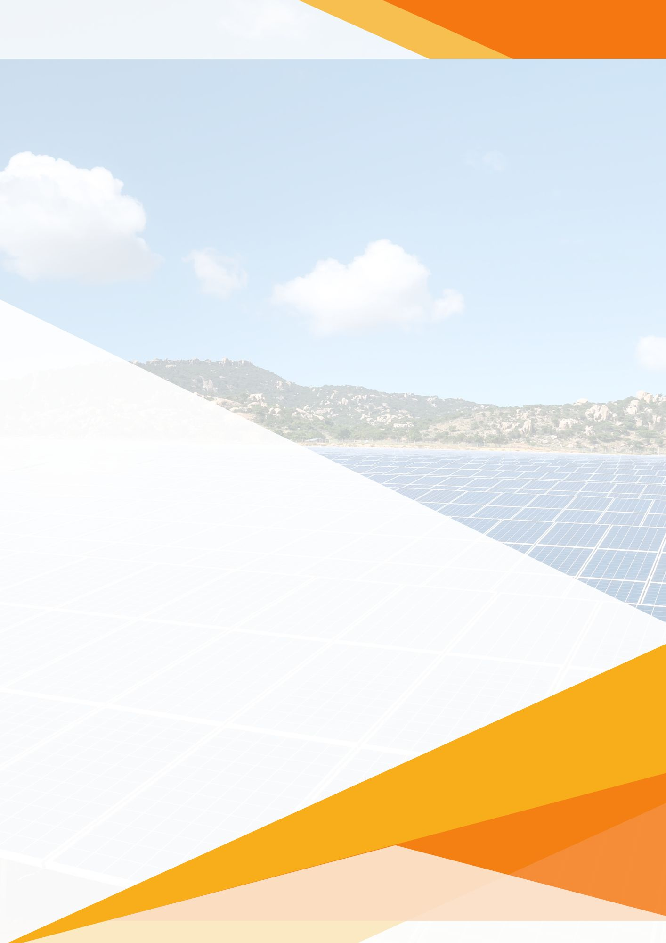


Ref No: undefined
Date: undefined
undefined(kW)
Solar Proposal
Prepared For:
undefined,
undefined,
undefined.

Prepared By:
undefined,
undefined,
undefined,
undefined.

Welcome

Ref. No.: undefined
Date: undefined

To,
undefined,
undefined.
Sub: Proposal for Supply & Installation of undefined Grid Connected Solar PV Power Plant.
With reference to above said subject, we are very much thankful to you for showing your interest in our service. Based on the information provide by you, we are pleased to quote our offer for supply & Installation of Grid Connected Solar PV Power Plant.
Inter-connected with the electric utility grid or the meters, these systems are also called ‘GridTie Systems’. The DC power is converted into AC power by an inverter. These systems allow users to mobilize the energy provided by the Sun and feed the left overs to the grid which helps in cutting down costs. During the evening or in the absence of sunlight, power can be drawn from the grid, thus eliminating the need for battery banks.
The benefits include:
- Limitless power supply which is free of cost.
- Net metering in ‘Grid-Tie Systems’ helps in calculating exported surplus power to the grid which contributes to a reduction in your electricity bill.
- It is easy to maintain and low on operation investments.
Thanks & Regards,
undefined
undefined
undefined

On Grid Solar PV Systems
(Diagram for reference)

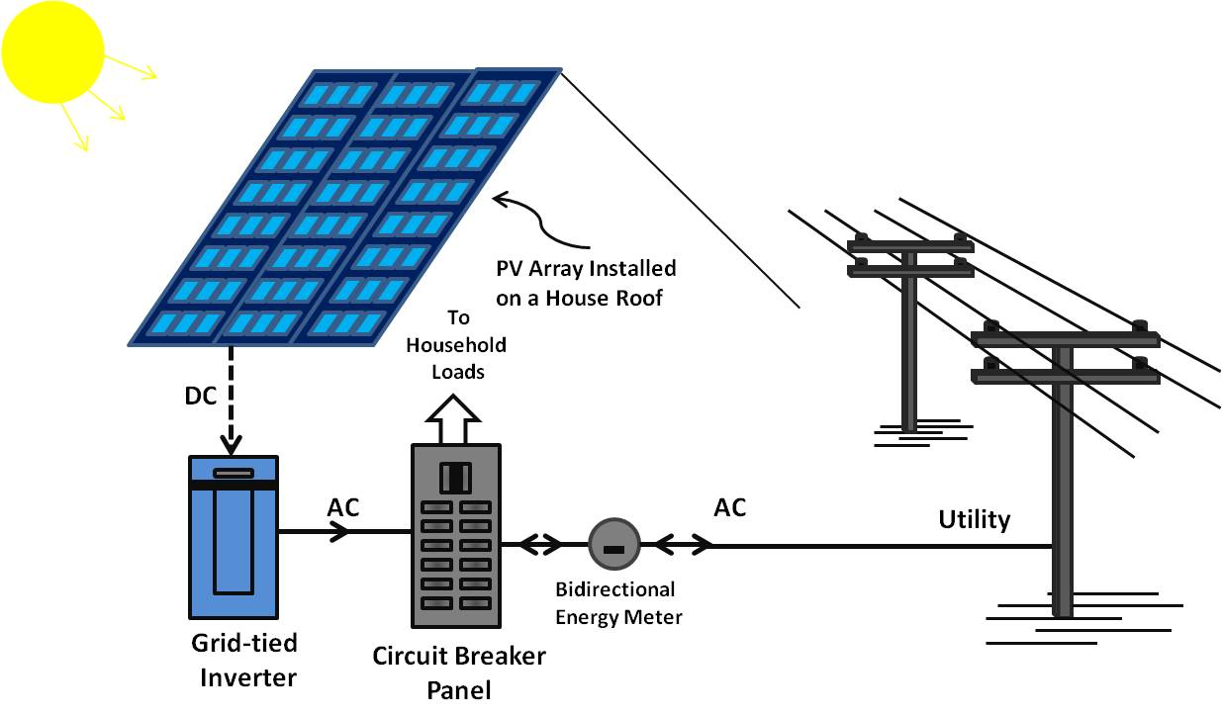
Why «CompanyName» !!
- We are MNRE Approved EPC
- Free Walk Through Energy Audit.
- Customized solutions that work for you.
- Net-metering & Tax Deprecation Support.
- Assistance for Government Subsidy.
- Prompt Service Supports.
- Transparent Business.
- Monitoring system.
Solar Components:
- PV Module / Panel
- Module Mounting Structure
- Cables
- AC & DC Distribution Box
- Solar Grid-tied Inverter
- AC Distribution Box
- Earthing System

Bills of Material

Panel:

Watt Peak: «Watt Peak»
Panel Qty: «No. of Panels»
Make/Brand: «Panel Make/Brand»
Panel Type: «Panel Type»

Inverter:

Size: «Size (kW)»
Quantity: «Quantity»
Make/Brand: «Inverter Make/Brand»
Phase: «Phase»

Cable: Warranty:

Make/Brand: «Cable Make/Brand»
AC Cable: «AC»
DC Cable: «DC»
Panel: «Panel Warranty»
Inverter: «Inverter Warranty»
Balance Of System: «BOS Warranty»

Structure:
Description: «Structure Description»

Balance of System:

Solar Savings & Payback Period
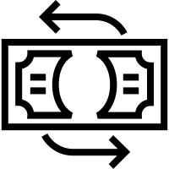
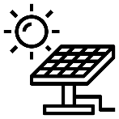


Payback
Period
«Pay Back Period» Years

Average Yearly Generation
«Annual Generation» Units

Average Annual
Savings
Rs. «Annual Saving»





Project Cost
Rs. «Project Cost»

Trees Saved
«Tree Saved»

Co2 Reduction
«Co2 Reduction» Tonnes

Expected Monthly Generation & Savings

<<imagePlaceholder>>


Commercial Offer & Payment Schedule

Price Quote & Payment schedule for «ProjectSize» Grid Tie Rooftop Solar System:

Payment Terms:
Bank Details:

Project Timeline

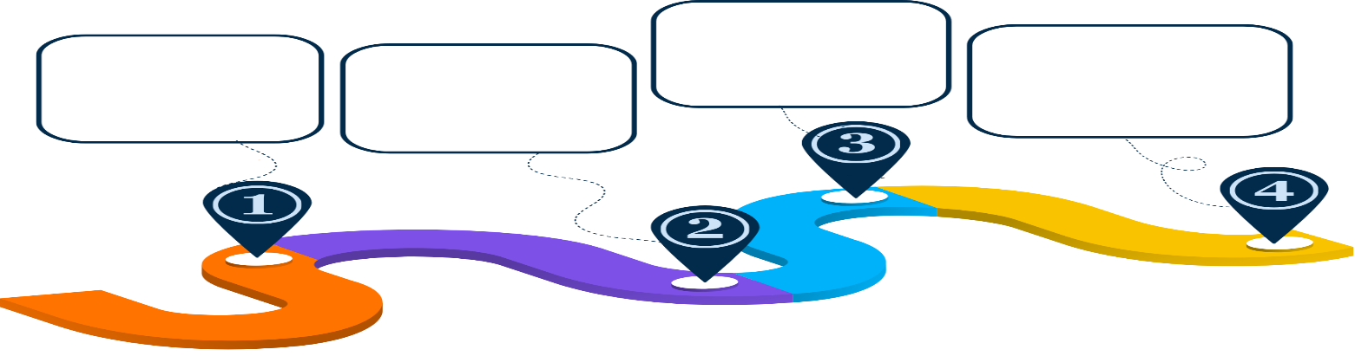
Scope of Work
Finalization of Design and Drawings
Engineering, Procurement, and Supply of Material
Solar Plant Installation
Commissioning and Testing
7 Days
15 Days
20 Days
14 Days

General Terms & Conditions

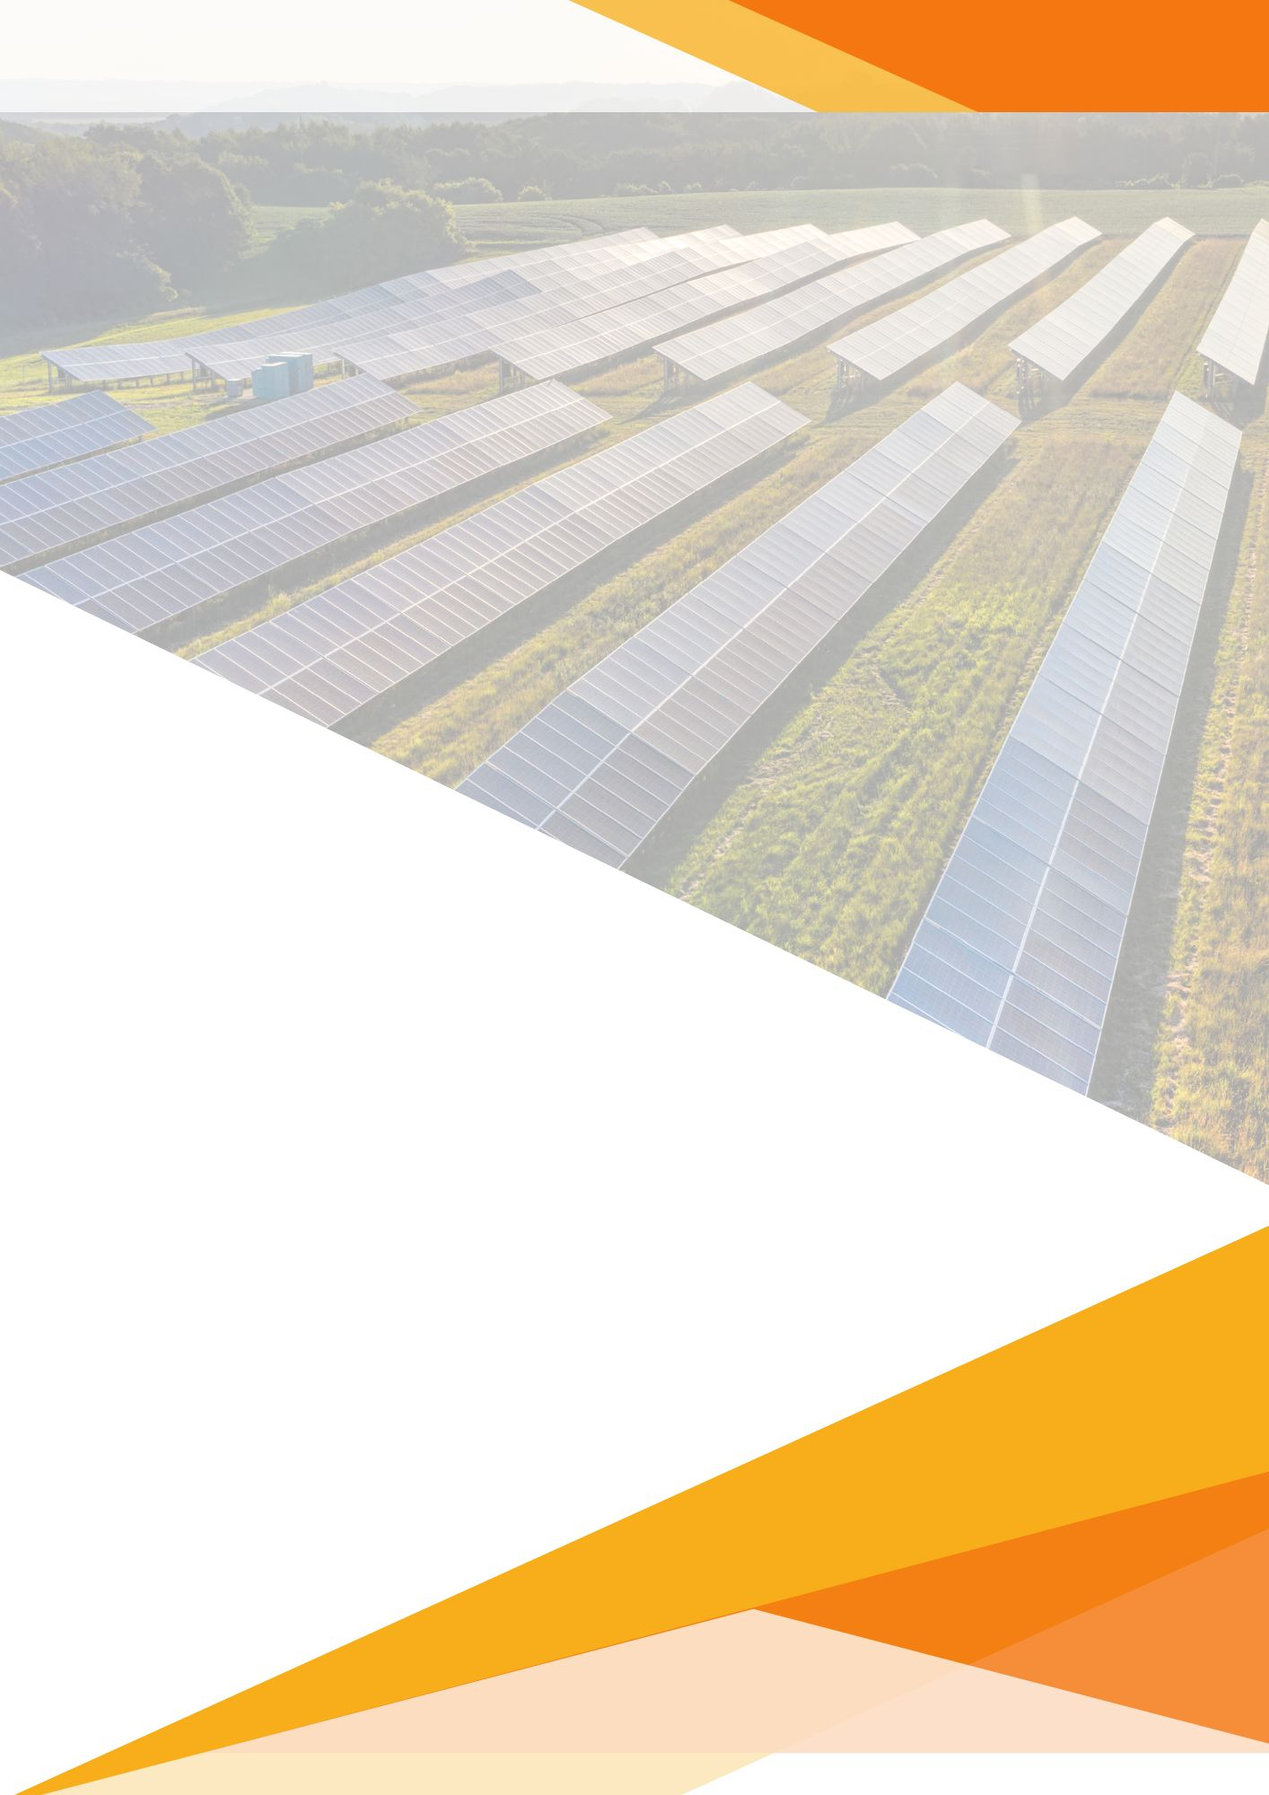

Thank You!
For Further Inquiries Connect with us at:
Address: undefined
Phone: undefined
Mail: undefined
GSTIN: undefined

