

Shahid Beheshty University

Department of Mechanical and Energy Engineering

An Introduction to Finite Element Method (FEM)

Assignment # 3

Subject: Beam Element

MATLAB and ABAQUS Results Comparison

By: **Atabak Bahadorniya**

Student ID: **96236019**

Second Semi- term of 2020-2021

Problem 4.21

4.21-1 deflection Comparison

|  |  |  |  |  |
| --- | --- | --- | --- | --- |
| Difference | ABAQUS Results (m) | MATLAB Results (m) | Parameter | Node |
| -1.20E-32 | 12E-33 | 0 | U2 | 1 |
| -2.80E-32 | 28E-33 | 0 | U2 | 2 |
| 0.00127 | -0.0134616 | -0.0121904761904762 | U2 | 3 |

4.21-2 Slope of beams

|  |  |  |  |  |
| --- | --- | --- | --- | --- |
| Difference | ABAQUS Results (Pa) | MATLAB Results (Pa) | Parameter | Node |
| -1.60E-32 | 16.0000E-33 | 0 | S11 | 1 |
| 4.76E-10 | -0.00152381 | -0.00152380952380952 | S11 | 2 |
| -7.17E-03 | 0.00361905 | -0.00355555555555556 | S11 | 3 |



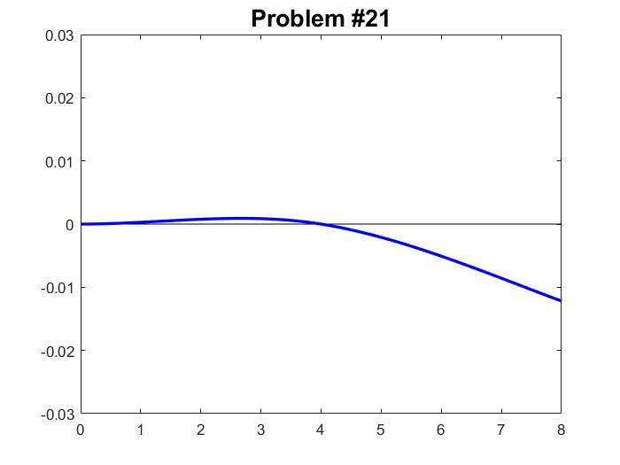

Problem 4.24

4.24-1 deflection Comparison

|  |  |  |  |  |
| --- | --- | --- | --- | --- |
| Difference | ABAQUS Results (m) | MATLAB Results (m) | Parameter | Node |
| 20.5021E-33 | 20.5021E-33 | 0 | U2 | 1 |
| -60.0021E-33 | -60.0021E-33 | 0 | U2 | 2 |
| 0.103866563 | -0.376970 | -0.273103437241380 | U2 | 3 |

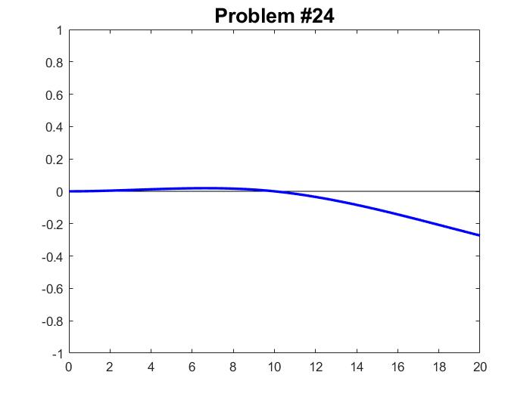4.24-2 Slope of beams

|  |  |  |  |  |
| --- | --- | --- | --- | --- |
| Difference | ABAQUS Results (Pa) | MATLAB Results (Pa) | Parameter | Node |
| -7.16E-32 | 71.6469E-33 | 0 | S11 | 1 |
| 3.38E-06 | -0.0129689 | -0.0129655166896552 | S11 | 2 |
| 2.73E-05 | -0.0323032 | -0.0322758604137931 | S11 | 3 |

Problem 4.28

4.28-1 deflection Comparison

|  |  |  |  |  |
| --- | --- | --- | --- | --- |
| Difference | ABAQUS Results (m) | MATLAB Results (m) | Parameter | Node |
| 4.87500E-33 | -4.87500E-33 | 0 | U2 | 1 |
| 58.3125E-33 | -58.3125E-33 | 0 | U2 | 2 |
| 24.5625E-33 | -24.5625E-33 | 0 | U2 | 3 |

4.28-2 Slope of beams

|  |  |  |  |  |
| --- | --- | --- | --- | --- |
| Difference | ABAQUS Results (Pa) | MATLAB Results (Pa) | Parameter | Node |
| 0 | 312.500E-06 | 0.000312500000000000 | S11 | 1 |
| 0 | -1.87500E-03 | -0.0018750000000000 | S11 | 2 |
| 0 | 3.43750E-03 | 0.00343750000000000 | S11 | 3 |



