

Shahid Beheshty University

Department of Mechanical and Energy Engineering

An Introduction to Finite Element Method (FEM)

Assignment # 5

Subject: Grade and frame element

ABAQUS Results Comparison

By: **Atabak Bahadorniya**

Student ID: **96236019**

Second Semi- term of 2020-2021

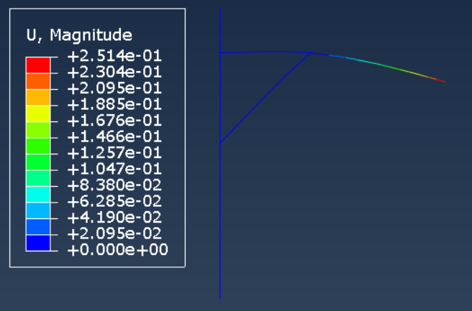**60)**

|  |  |
| --- | --- |
| **Cross brace** | **S6 × 12.5** |
| **Horizontal load beam** | **S12 × 50** |
| **Vertical support beam** | **S12 × 50** |

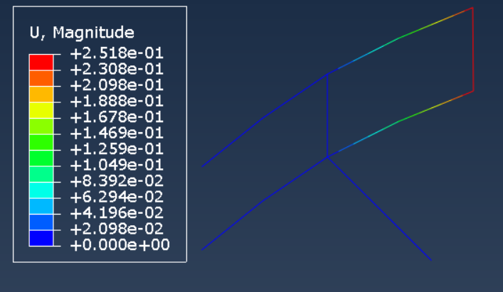**61)**

|  |  |
| --- | --- |
| **All elements** | **rectangular tubing.**  **5 in×3 in × $\frac{3}{8}$ in** |

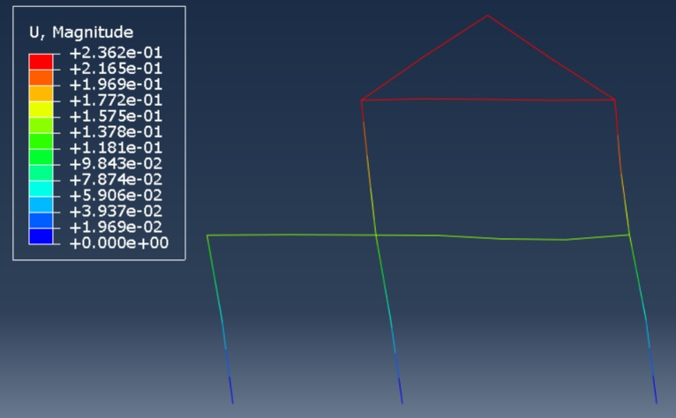**62)**

|  |  |
| --- | --- |
| **horizontal and diagonal members** | **W 16 × 26** |
| **Vertical and column members** | **W 10 × 49** |

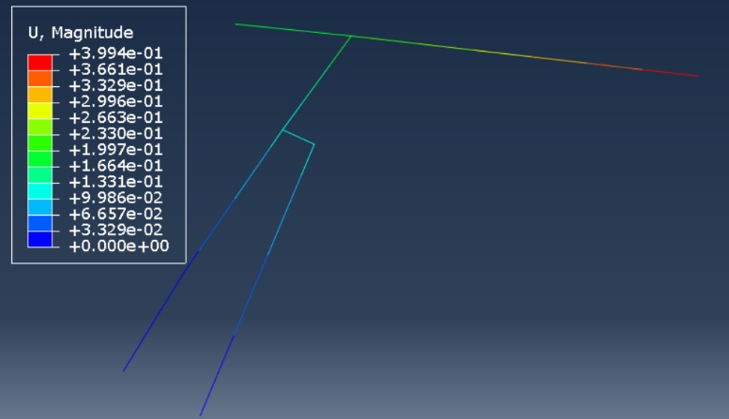**63)**

|  |  |
| --- | --- |
| **horizontal beam** | **Rectangular 4×16×0.25** |
| **Vertical beam** | **Square 15 × 15 × 0.5** |

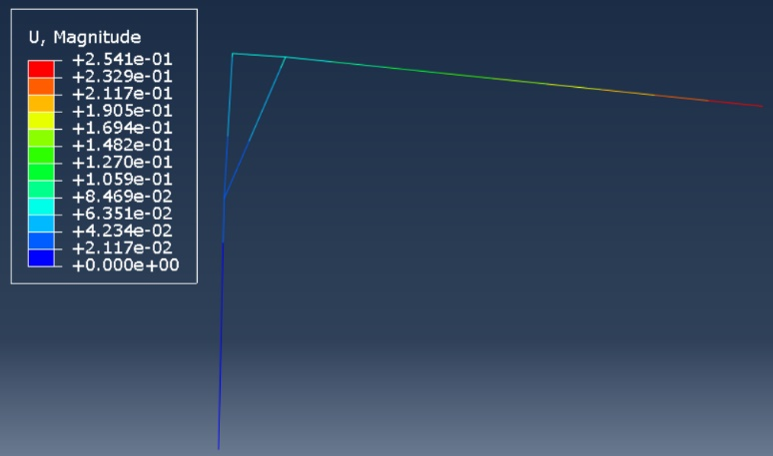**65)**

|  |  |
| --- | --- |
| **Beam and column** | **W 10 × 12** |