

SE-445
HW-3 REPORT

Project Name: Social Content Repurposer

Instructor: Ruken ZİLAN

Student Name: Atacan İSHAN
Student Number(s):
Major: 23244710028,
My student ID number in the minor program where I took the course: 25243510116

GitHub Repository Link: https://github.com/Atacan-Ishan/SE-445-Content-Repurposer
Google Sheets Link: https://docs.google.com/spreadsheets/d/1vck7ei3kqcGHYjxJKbwG8KEJYPbPKKERsqx_gstz5NM/edit?usp=sharing

Introduction
In this assignment, I significantly improved the capabilities of our Social Content Repurposer application. While the previous version managed to establish a basic data pipeline that extracted a single, general summary from a long text, it lacked the flexibility required by modern digital marketing. Different social media platforms demand entirely different styles, formats, and engagement strategies. To address this need, I integrated two key features into the system architecture: a robust input validation system to ensure data integrity and avoid unnecessary API costs, and an intelligent AI categorization system. The application now automatically analyzes the source text using Gemini AI's advanced 'JSON Mode' and simultaneously generates platform-specific, highly optimized content for Twitter, LinkedIn, and Instagram, fully automating the content creation workflow.

Validation Rules Used in the Code
To prevent system crashes and ensure we only process good data, I've added a validation step before the AI ​​analysis. The validation rules are:
- Email Format Check: The system checks if the author's email contains an "@" symbol. If it doesn't, the data is marked as invalid.
- Text Length Check: The source text must be at least 20 characters long. If the user enters text that is too short, it will also be rejected. If the input is invalid, the backend immediately stops processing, returns an HTTP 400 error to the frontend, and saves the data to Google Sheets with the status "Invalid" (e.g., Invalid (Bad Email)). This ensures we don't waste AI API calls on bad data.

Screenshot from website:

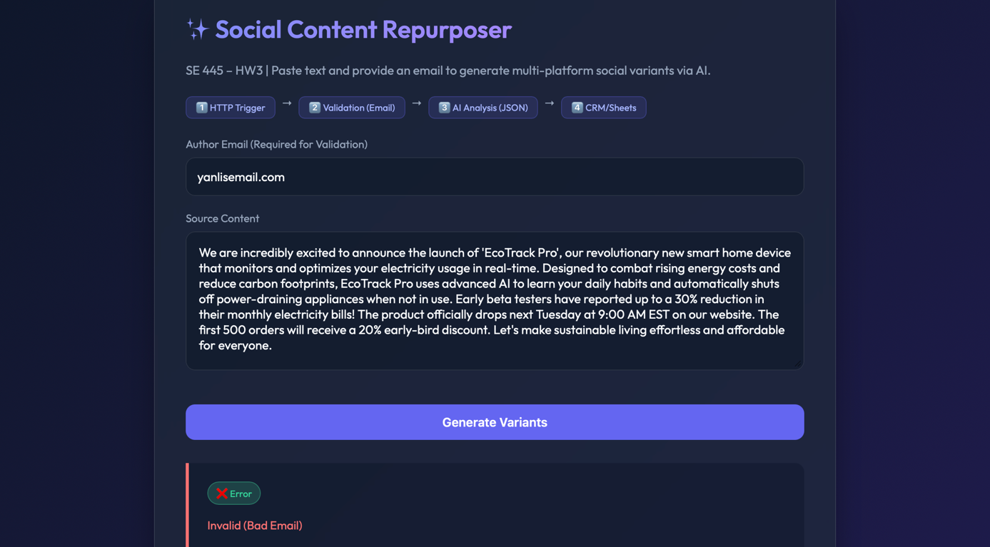

Screenshot from Google Sheets:

AI Prompt Strategy and Categorization
I completely changed the prompt strategy to get structured and categorized data from Gemini AI. Instead of simply asking for a summary, I used a technique called JSON mode. In the command, I told the AI ​​to act like an expert social media manager. I gave it precise instructions to analyze the source text and return a JSON object with exactly four specific keys:
- twitter_variant: A short, energetic post with emojis and hashtags.
- linkedin_variant: A professional and detailed post suitable for business networking.
- instagram_variant: A visually appealing post with plenty of emojis.
- detected_tone: The main feeling or purpose of the text (e.g., Promotional, Urgent, Informative).

By forcing the AI ​​to respond only in JSON format, my backend code can easily parse the response and save each variation in separate columns in Google Sheets.

Screenshot from website:

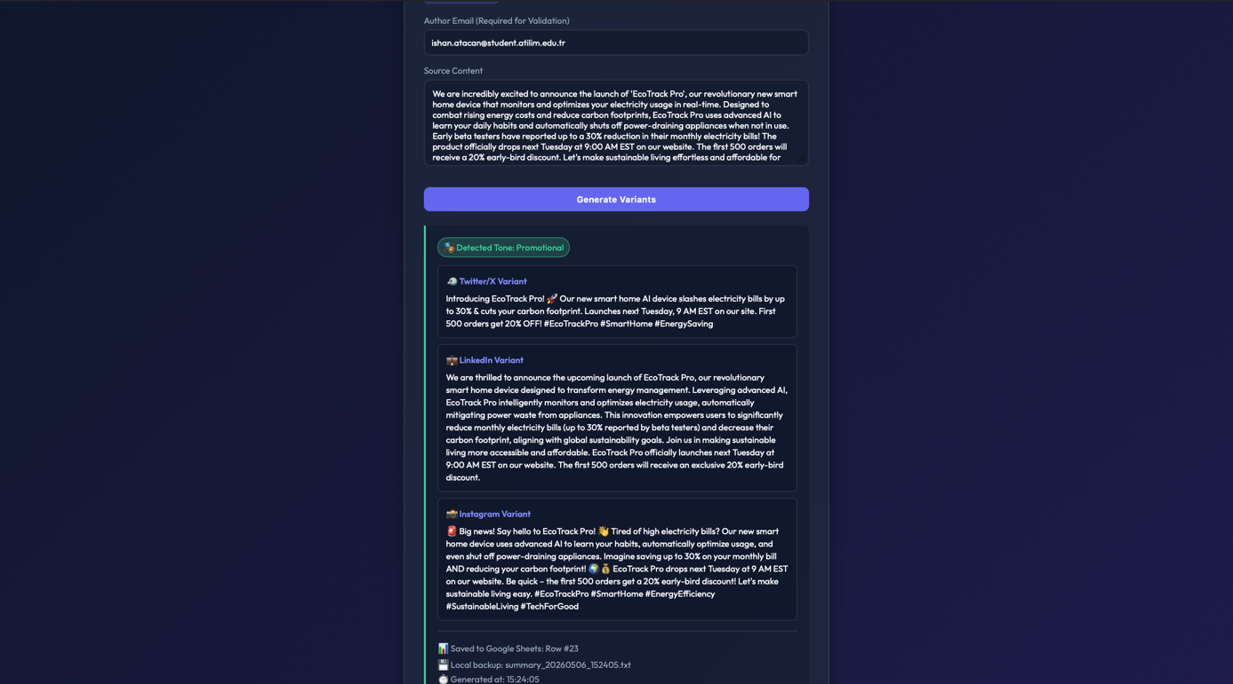

Screenshot from Google Sheets:

