ENSF 608 DATABASES

Data Base Design EER

Due Date: October 2, 2023.

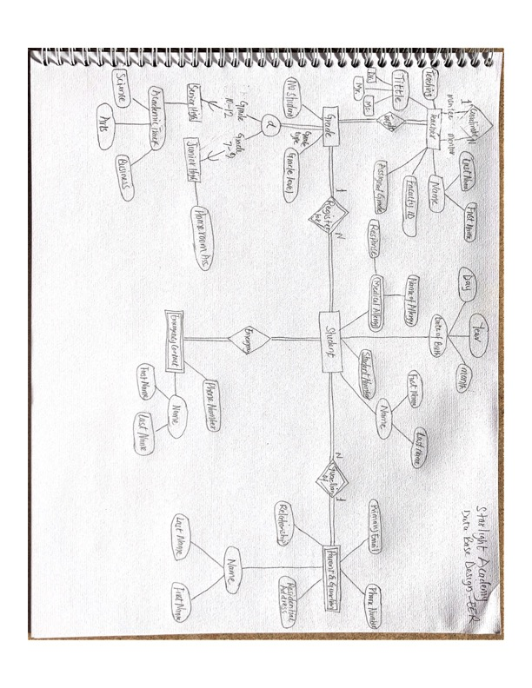

The assumptions I made about my design include the following.

1. I assumed that students are related to their parents as well as the guardian which can also be different guardians and relationships.
2. Student’s emergency contact can be different from a guardian and a grade teacher can be a guardian if he/she is the parent of the student.
3. A student must only be in one grade at a given year.
4. Similarly, many students are registered in every year to any grade that they meet the criteria.
5. A single teacher can teach many grades in one academic section as well as a coordinating teach can also teach a grade in one academic year.
6. A student from same family can also have one guardian and parent representing them, one to many relationships.

Entity and attribute

1. Student and Student Number: The student number attribute is unique because every student must have a student number or ID that is unique. One student can have similar names but not the same student ID. This is underline in the diagram.
2. Emergency contact and Phone number: The emergency contacts phone number is unique with the student.

Relationship to Entity

1. Relationship and Entity types: Guardian relationship has students’ relationship as every student has a relationship with the Guardian, who might not be a parent.

Derived Attribute

1. Medical Allergy and Name of Allergy. The Name of the allergy can be derived from the medical allergy.

Technical Criteria

Entity

1. Entity Type(s) – The main entity in the diagram is the student, which form core component.
2. Weak Entity Type(s) – In the flow diagram, the emergency contact cannot stand alone without the student.

Relationship

1. Relationship(s) – Guardian Relationship to student forms a relationship in the diagram.
2. Identifying Relationship Type(s) – Another relationship is the student registration for a particular grade,

Attribute

1. Simple Attribute(s) – In the diagram student is a simple attribute.
2. Key Attribute(s) – Faculty ID is a key attribute as it is unique to every teacher.
3. Multivalued Attribute – Mentor, coordinators and teachers are examples of multivalued attributes.
4. Composite Attribute(s) – Academic Track, Date of Birth and Names are some of the composite attributes.
5. Derived Attribute(s) – Age is a derived attributes as it is obtained from the date of birth.
6. Partial Key Attributes – Primary email, phone number and residential address are partial attributes.

Participation Constraints

1. Total Participation – Grades Taught is an example of a total participation.
2. Partial Participation - Coordinators and mentors forms partial.

Cardinality Constraints (not Min/Max notation)

1. 1:1 Cardinality – Grade to Grade coordinators
2. 1: N Cardinality - Grade to Faculty cardinality and coordinator and teacher relationship.
3. N:1 Cardinality – Contacts in the diagram.
4. M: N Cardinality – No many-to-many relationship in the diagram

Specialization/Generalization (with constraint shown)

1. Disjoint & Total – The Academic Track (Senior High Students)
2. Disjoint & Partial - None
3. Overlapping & Total - None
4. Overlapping and Partial – Grade coordinator allow a faculty member to be a grade coordinator in multiple grades.

Attribute Inheritance

1. Evidence that attributes are inherited, not duplicated – Attributes are inherited by the subtypes in the Academic Track.
2. The provided diagram includes proper labelling, line that connect entities and relationship. Clear and thoughtful markings for cardinality and participations. It is designed to capture the Starlight Academy and to ensure the integrity of the data management system.